NOTE TO INVESTIGATORS: This is the child assent 8-12 form with UR CABIN language included. We request that you submit to the RSRB a consent form where the text you have added is in black and all blue text is left unchanged.

We acknowledge there may be some deviations from the established language (all blue text) based on the nature of your study. Be sure to delete all brackets and this page before submission. Delete those paragraphs within the brackets which are for clarification.
Assent Script v. 2/01/2016
[Children ages 8-12]
The information highlighted in yellow is guidance. DELETE THIS AND ALL OTHER HIGHLIGHTED INSTRUCTIONS BEFORE SUBMITTING.

RSRB Requirements:
- Use of “Subject”: The assent script must use the term research “subject” rather than “participant” or “volunteer”.
- Use of 2nd Person: The assent script must be written in the 2nd person, just as you will be talking with the child who is a potential subject (e.g., “You are being asked to take part in a research study about…”).
- Pagination: Maintain page numbering already inserted in the footer (e.g., “2 of 4”).
- Version Date: Manually type the date in the footer, rather than selecting “Insert Date” from the toolbar to avoid automatic updates each time the document is opened.
- Margins: Maintain the bottom margin of at least 2 inches to provide space for watermarking upon approval.

Assent Script

[Insert Title of Study]

Principal Investigator: [Insert]

We are doing a research study.

These are some things we want you to know about research studies:
Your parent needs to give permission for you to be in this study.

You do not have to be in this study if you don’t want to, even if your parent has already given permission.
If you start, you may stop being in the study at any time. If you decide to stop, no one will be angry or upset with you. [If a treatment protocol, add: “Your doctors will still continue to take good care of you”.]

[Delete last two paragraphs if not applicable, e.g., pediatric cancer treatment.]

Why are you being asked to be in this research study?
Provide a simple explanation of why the child is invited to participate (if appropriate) and briefly describe the general purpose of the study.
What will happen during this study?
Provide a simple explanation of procedures. Avoid describing study procedures in lengthy detail (lists often work well). Indicate the length of time of the individual subject’s active involvement and any applicable risks/discomforts.

You will get a scan called an "MRI," which stands for Magnetic Resonance Imaging.

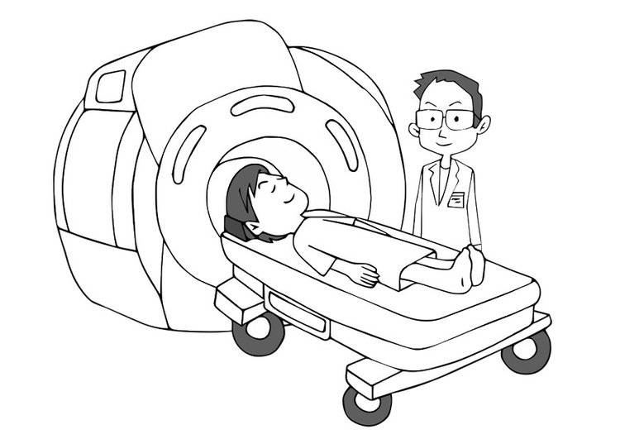
When you get an MRI, you lie down on a narrow table that is called a "scanner bed." We slide the bed into the "scanner." The scanner is a very big tube that is open at each end. The scanner makes pictures of your [brain, or other body part].

Before you can go into the scanner, we want to make sure it is safe. We will ask your parents to fill out an MRI form. This form lists the different things that can make it unsafe for you to be in the scanner.

If the form shows it is safe for you to get an MRI, we will go ahead to the next steps.

1. First, we will train you in a "pretend scanner". This lets you get used to what it is like in the real scanner. You will see how it feels to lie down in a narrow space and practice keeping still, which is very important for the real scan. This training will take about [minutes/hours]. (If you will not be using the mock scanner for your study, you may omit this paragraph and renumber the steps below)

- Then, after you rest, we will ask you to go in the real scanner. For the real scan, you will lie still on the scanner bed. We will put cushions around the sides of your [head or other body part] to help keep it from moving. Since the scanner can be very noisy, we will give you earplugs to protect your hearing. We will make sure that you are comfortable.

- We will slowly slide the scanner bed you are lying on into the scanner. Once you are inside… [explain what will happen/what subject will be asked to do].

- While you are doing these exercises, the MRI scanner will be making pictures of your [brain or other body part].

- If you want to stop at any time, just say so. We will give you a squeeze ball that you will use to let us know you want to stop.

- The real MRI scan will take about [minutes/hours].

You might be uncomfortable while you are in the MRI scanner. This happens to some people when they lie very still in a small space.

You might feel something like a tap on your body or a tingling while the scanner is running. If you do, it is not a problem and it shouldn't last very long.

If you do not like being in the scanner for any reason, please [instruct the subject how to indicate he/she is uncomfortable or wants to take a break, e.g., speak out loud/ into an intercom, squeeze a squeeze-ball, etc.], and we will stop the testing right away.

Who will be told the things we learn about you in this study?

Describe who will have access to the information collected. Be clear about whether pregnancy, illegal activity, psychological tendencies will be reported and to whom. Be clear about what parents and teachers will be told (e.g. “The information we collect about you will be kept private. Only the people working on this study will be able to look at the information we collect. It will not affect how your doctor [or teacher, etc.] treats you.”).

What if you or your parents don’t want you to be in this study? (If applicable)
For biomedical research, use this section to briefly discuss appropriate procedures or courses of treatment, if any, that might be advantageous to the subject (e.g., standard treatment, no treatment, comfort care or participation in another study). For other types of research, use this section to discuss appropriate procedures or options, if any, that might be advantageous to the subject (e.g., not participating or alternative options).

If the study is minimal risk and the only alternative is to not to participate this section is not necessary and should be deleted.

Will you get any money or gifts for being in this study?
Choose ONE applicable sentence.
You will not receive any money or gifts for being in this study.
-OR-
You will be given XX for being in this study. If subjects are to be paid for participation, specify the amount, schedule of payment and conditions for payment. When applicable, payments should be based on a prorated system. If subjects will be given some token “gift” (e.g., a toy), instead of payment, describe in appropriate terms.

Remember, being in this study is up to you and your parents. If you don’t feel like you want to do this right now, just tell us. Even if your parent says it is all right for you to be in this study, you don’t have to.

If you start, you may stop being in the study at any time. If you decide to stop, no one will be angry or upset with you.

It is important that you understand what you will do in this study. Please ask us any questions you have at any time.

What questions do you have?
It is the responsibility of the person obtaining assent to ensure that the child understands the study to an age-appropriate degree. Asking questions can help children decide.

Do you want to be in the study?

Subject Name: ___________________________________________________
(PRINTED BY Person Obtaining Assent)

Person Obtaining Assent
I have read this form to the subject and/or the subject has read this form. An explanation of the research was given and questions from the subject were solicited and answered to the subject’s satisfaction. In my judgment, the child has demonstrated comprehension of the information. I have given the child adequate time to consider the study before providing assent. My signature below documents the subject’s assent to participate in this research study.

Name and Title (Print)

Signature of Person Obtaining Assent Date

