“Tox In” The City:
Exploring Environmental Health Science Issues

Developed by
Judy Moffitt & Colleen Hagadorn
South Glens Falls High School
South Glen Falls, NY

For the

My Environment, My Health, My Choices project



University of Rochester

Rochester, NY

Abstract:

This learning experience is an introduction to Environmental Health Science. It is intended to provide a basic introduction to environmental health vocabulary and concepts that will allow students to further explore specific environmental health topics in greater depth. The purpose of the introduction is to present an opportunity for students to think about their environment, their choices and their health using Biology and Chemistry concepts. A variety of engaging activities are incorporated in the introduction that will address multiple learning styles.
Table of Contents

Student Pre/Post Test | 3-4
Teacher Key for Pre/Post Test | 5-6
Learning Context | 7
Procedure: Timeline and Supplies | 8
Teacher: “Springboard Bingo” Cartoon Activity | 8-9
Teacher: Activities 1 and 2 | 9-10
Student: Springboard Bingo and Key to Cartoon Activity | 11-12
Student: Activity 1 and 2 | 13-19
Teacher: Activity 3 and Extension | 20
Student: Activity 3 and Extension | 21-27
Teacher: Activity 4 | 28
Student: Activity 4 | 29-30
Teacher: Key for Activity 4 | 31
Teacher: Activity 5 | 32
Teacher: Alternative Assessment Options | 33-34
Teacher: Resources | 35
New York State Learning Standards | 36
Appendix A: Understanding Cartoon Science | 37-42
Appendix B: Brainstorming | 43
Appendix C: Think-Pair-Share | 44
Appendix D: Carousel Brainstorming | 45-46

Teachers, we would appreciate your feedback. Please complete our brief, online Environmental Health Science Activity Evaluation Survey after you implement these lessons in your classroom.
The survey is available online at: www.surveymonkey.com/s.asp?u=502132677711

“Tox In” the City
Introduction to Environmental Health Science
Pre/Post Test

Name _________________________________________________ Class ____

- Which statement below is a more accurate description of chemicals and their effects on humans?
  - Human-made chemicals are more dangerous to human health than naturally occurring chemicals.
  - Naturally occurring chemicals are more dangerous to human health than human-made chemicals.
  - Both natural and human-made chemicals are potentially dangerous to humans.
  - Human-made and naturally occurring chemicals that have been laboratory tested are not dangerous to human health.

- One of the items below is a hazardous substance. Three are sources of a hazardous substance. Which of these is a hazardous substance?
  - thermometer
  - paint
  - cigarettes
  - carbon monoxide

- Which of the following would NOT be a direct concern of an environmental health scientist?
  - Acid rain effects on the ecosystem of a river.
  - Mold levels in a daycare center
  - Lead contamination of an old apartment building
  - Smog levels in a major city

- The measure of the capacity of a chemical to harm an organism is known as
  - epidemiology
  - exposure
  - toxicity
  - dose

- The term used to describe the total amount of a hazard that comes in direct contact with your body is known as
  - exposure
  - toxicity
  - epidemiology
  - risk

- Which of the following are possible sources of entry for a hazard?
  - inhalation, absorption, toxin
  - inhalation, absorption, ingestion
  - absorption, toxin ingestion
  - ingestion, toxin, inhalation

- Who took the largest dose of Tylenol?
  - An adult man who weighs 220 lbs and took 300 mg of Tylenol.
  - An adult woman who weighs 150 lbs and took 300 mg of Tylenol.
  - A teenage boy who weighs 200 lbs and took 600 mg of Tylenol.
  - A young boy who weighs 50 lbs and took 200 mg of Tylenol.

- A family has a clogged furnace that is producing a hazardous gas. Which family member is likely to be harmed the most?
  - Dad who works at the local pharmacy
  - Mom who stays at home with the baby
  - Brother who is 15 years old and goes to school
  - Baby who is 6 months old at home with Mom

- Which of the following would be an example of an acute exposure?
  - A coal mine worker who works in a coal mine for 30 years
  - A swimming pool worker who breaths in chlorine gas during an accidental gas spill at work.
  - A spouse who is exposed to cigarette smoke throughout his 20 years of marriage
  - A person who lives in smog filled city.

10. In order to determine the risks vs. benefits of taking a substance, one would
take into consideration the following, except:
(1) what are the advantages and do they outweigh the risks?
(2) what are the risks and do they outweigh the advantages?
(3) what dosage is necessary to obtain the desired results?
(4) is the substance natural-made or is it human-made?
Pre/Post Test
TEACHER ANSWER KEY

1. Which statement below is a more accurate description of chemicals and their
effects on humans?

(1) Human-made chemicals are more dangerous to human health than
Naturally occurring chemicals.
(2) Naturally-occurring chemicals are more dangerous to human health than
human-made chemicals.
(3) Both natural and human-made chemicals are potentially dangerous
to humans.
(4) Human-made and naturally-occurring chemicals that have been laboratory
tested are not dangerous to human health.

2. One of the items below is a hazardous substance. Three are sources of a
hazardous substance. Which of these is a hazardous substance?

(1) thermometer
(2) paint
(3) cigarettes
(4) carbon monoxide

3. Which of the following would NOT be a direct concern of an environmental health
scientist?

(1) Acid rain effects on the ecosystem of a river.
(2) Mold levels in a daycare
(3) Lead contamination of an old apartment building
(4) Smog levels in a major city

4. The measure of the capacity of a chemical to harm an organism is known as

(1) epidemiology
(2) exposure
(3) toxicity
(4) dose

5. The term used to describe the total amount of a hazard that comes in direct
contact with your body is known as

(1) exposure
(2) toxicity
(3) epidemiology
(4) risk

6. Which of the following are possible sources of entry for a hazard?

(1) inhalation, absorption, toxin
(2) inhalation, absorption, ingestion
(3) absorption, toxin, ingestion
(4) ingestion, toxin, inhalation

7. Who took the largest dose of Tylenol?

(1) An adult man who weighs 220 lbs and took 300 mg of Tylenol.
(2) An adult woman who weighs 150 lbs and took 300 mg of Tylenol.
(3) A teenage boy who weighs 200 lbs and took 600 mg of Tylenol.
(4) A young boy who weighs 50 lbs and took 200 mg of Tylenol.

8. A family has a clogged furnace that is producing a hazardous gas. Which family
member is likely to be harmed the most?

(1) Dad who works at the local pharmacy
(2) Mom who stays at home with the baby
(3) Brother who is 15 years old and goes to school
(4) Baby who is 6 months old at home with Mom

9. Which of the following would be an example of an acute exposure?

(1) A coal mine worker who works in a coal mine for 30 years
(2) A swimming pool worker who breaths in chlorine gas during an
accidental gas spill at work.
(3) A spouse who is exposed to cigarette smoke throughout his 20 years of
marriage
(4) A person who lives in smog filled city.

10. In order to determine the risks vs. benefits of taking a substance, one would
take into consideration the following, except:

(1) what are the advantages and do they outweigh the risks?
(2) what are the risks and do they outweigh the advantages?
(3) what dosage is necessary to obtain the desired results?
(4) is the substance natural-made or is it human-made?
Learning Context

Subject Areas: Biology (Living Environment) and Chemistry (Physical Setting)

Overall Purpose: To introduce the topic of environmental health sciences using a variety of engaging strategies that function as a bridge to more in-depth exploration of environmental topics generated by members of the Biology-Chemistry Professional Development Mentor Network

Learning Objectives:
- To analyze cartoons for scientific content and identify current environmental issues.
- To work cooperatively with members of a team.
- To use critical thinking skills in evaluating environmental health issues, risk/benefits and personal choices.
- To define environmental health science.
- To differentiate between "ecology" and "environmental health science."
- To identify environmental health hazards within a variety of environments.
- To identify environments as social, human-made and natural.
- To define toxicology and toxicity.
- To determine the criterion used to identify a substance as a toxin (dose, route of entry, source of exposure, dose/response, duration, frequency, body size, individual susceptibility).
- To recognize the relationships between toxins and homeostasis of an organism.

Prerequisite Knowledge and Skills for students: None

Prerequisite knowledge for teacher:
- Knowledge of "brainstorming" strategies (see Appendix B)
- Knowledge of "Think-pair-share" strategies (see Appendix C)
- Knowledge of " carousel brainstorming" activity implementation (see Appendix D )

2

Procedure

Classroom Timeline: Three to four (40-minute) periods (may be modified depending upon extension activities or elimination of sections of unit).
- “Springboard Bingo” Cartoon Activity: 15 – 20 minutes (optional activity)
- Activity 1: 15 – 20 minutes
- Activity 2: 10 – 15 minutes
- Activity 3: 15 - 20 minutes
- Extension Activity: 20 - 25 minutes (optional activity)
- Activity 4: 20 – 25 minutes
- Activity 5: 30 – 40 minutes

Equipment and Supplies:
- LCD projector/computer or overhead transparencies of PowerPoint
- Student handouts included in project
- Food coloring with droppers
- 3 equal size clear containers such as beakers/plastic cups/test tubes etc. for each group
- 3 unequal size clear containers such as beakers/plastic cups/test tubes etc. for each group
- Marking pens or labels
- Chart paper
- Markers
- Masking Tape
- Bingo chips or highlighters

“Springboard Bingo” Cartoon Activity - Teacher Instructions (Optional Activity):

1. Prior to the lesson, administer the Pre-Test to the students.

2. Pass out Bingo Card form (3 boxes X 3 boxes) to students. (The Bingo Card has a list of
words and/or phrases above it that matches the cartoons in the Springboard PowerPoint
presentation).

3. Have students fill in 8 different words/phrases from the list into each box, except the
middle box.

4. Open up "Springboard Activity" PowerPoint (slides 1- 22) and show one cartoon at a time. Allow the students enough time to read the cartoon. If the student has a word/phrase on his/her Bingo that relates to the cartoon, then he/she should place a "chip" over that word (or highlight the word).

5. The game will conclude when a student(s) cover all of the words on his/her Bingo
card. Slide 23 shows an answer key for the slides so that students can check their work.

6. In the center of the Bingo card is a square that states "What is the central theme of the
cartoons?" Have students discuss this with their table partners and identify what they
think the central theme is. Have each team report out verbally.

7. For additional ideas for how to use cartoons in your classroom, see Appendix A.

Note: In addition to the PPT used by the teacher for this activity, “Student PPT Notes” have been provided. If you wish to have students take notes, use the Student PowerPoint Notes to make hard copy note outlines. Follow the directions below to print out note outlines from the PowerPoint presentation:
1. Open up Student PowerPoint
2. Go to "File"
3. Go to "Print"
4. Go towards bottom left - "Print What" - arrow down and click on "handouts"
5. This will open another section - "Slides per page" - click on 3
6. Click print button
7. Make enough copies for each student.

Activities 1 and 2: Tox Town Scenes and Think/Pair/Share – Teacher Instructions

These activities will elicit students’ prior knowledge and misconceptions and engage them in the study of environmental health issues.

- Use Power Point Presentation via LCD projector or TV monitor to introduce the topic of environmental health sciences. If no projector or computer is available, overhead transparencies of the slides could be used as an alternative method of instruction.

- Provide students with corresponding PPT note outline that they may use to take notes throughout the lesson.

- Show slides 30-34 and then have students work with a partner to do Activity #1: Tox Town Scenes, using the Tox Town Scenes student handout as you elicit their prior knowledge and uncover any misconceptions.

- Give each pair a Tox Town scene—either the City Scene, Town Scene, Farm Scene, or Home Scene. You may copy these pictures from the Power Point lesson or directly from the Tox Town website, http://toxtown.nlm.nih.gov/ Also provide them a copy of the quote from NIEHS website (slide #30 in Power Point presentations) to use as they brainstorm. Placing the pictures and the quote in page protector sleeves or laminating them will allow you to use them for a number of years. You may also wish to have students go to the Tox Town website and use the interactive scenes instead.

- Instruct students to use brainstorm strategies (see Appendix B) to identify potential sources of environmental health hazards and the hazard associated with the source. They should record their ideas on the BRAINSTORM form provided and be prepared to share with the class.

- After brainstorming, have students report out to the class what they have discussed. As each pair of students will have seen only one of the Tox Town scenes, you may wish to make each of the pictures available either through the Power Point presentation (slides 31-34) or with additional hard copies of each of the scenes as they are reporting out.

- Slides 31-34 of the Power Point presentation may be used as students report out. As students report out to the class, you may wish to have one student record these ideas on large poster paper, a whiteboard, a blackboard, etc. Use the students’ ideas to further their understanding of the issues of environmental health.

- Slide 35 may be used to elicit Activity #2: Think/Pair/Share to help students explore the difference between ecology and environmental health. Use the Activity #2: Think/Pair/Share handout. See Appendix C for information on the Think/Pair/Share strategy.

- Slides 36 - 38 reinforce this concept. It is important that students realize the focus is on how the health of human’s is affected.
Springboard Bingo

Directions: Make a bingo card by randomly filling in the empty boxes with a different phrase from this list. This will be your bingo card for the game.

List:

Air Pollution  Alcohol  Allergens  Birth Defects  Carcinogens  Contaminated Foods | Infertility  Lead  Mercury  Mold  Nuclear Wastes  Obesity | Pesticides  Plastics  Radon  Resistant Microbes  Superfund Sites  UV Radiation  Water Pollution

What is
the
common
theme

Key to Cartoon Activity
- Obesity
- Radon
- Allergens
- Lead
- Air Pollution
- Mold
- UV Radiation
- Water Pollution
- Superfund Sites
- Nuclear Wastes
- Birth Defects
- Plastics
- Pesticides
- Carcinogens
- Resistant Microbes
- Contaminated Foods
- Infertility
- Mercury
- Alcohol

ACTIVITY #1

Directions:

As a pair, look at ONE of the Tox Town scenes at your table (either City Scene, Farm Scene, Town Scene, or Home Scene) and identify potential sources of environmental health hazards and the hazard associated with the source. Record your ideas on the BRAINSTORM form provided and be prepared to share with the class.

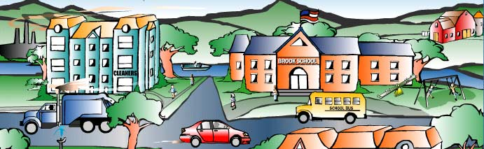
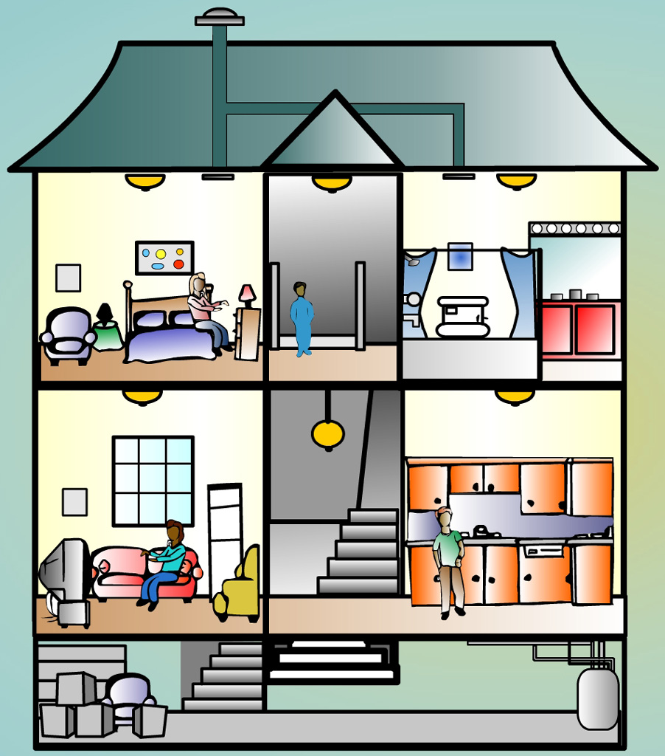 TOWN SCENE
HOME SCENE

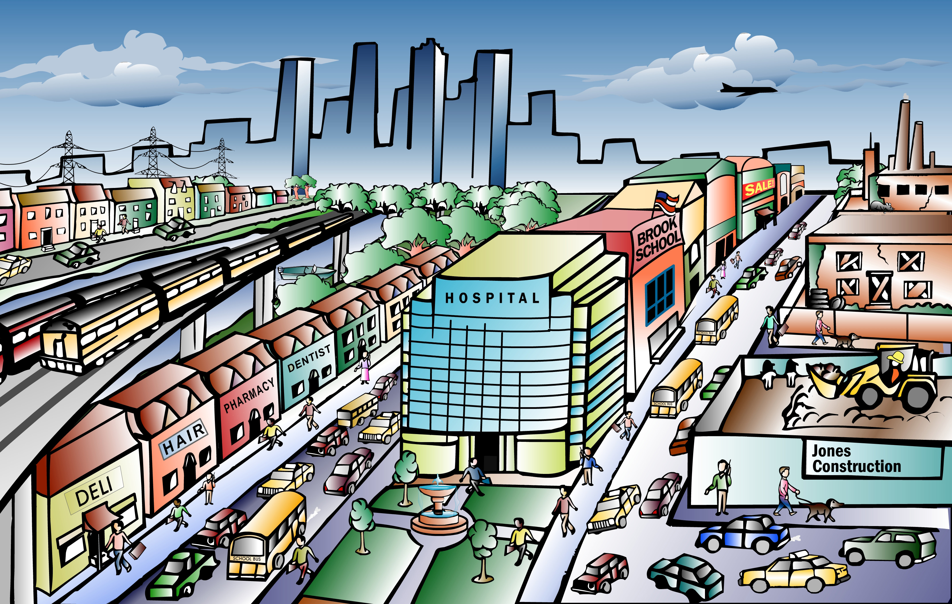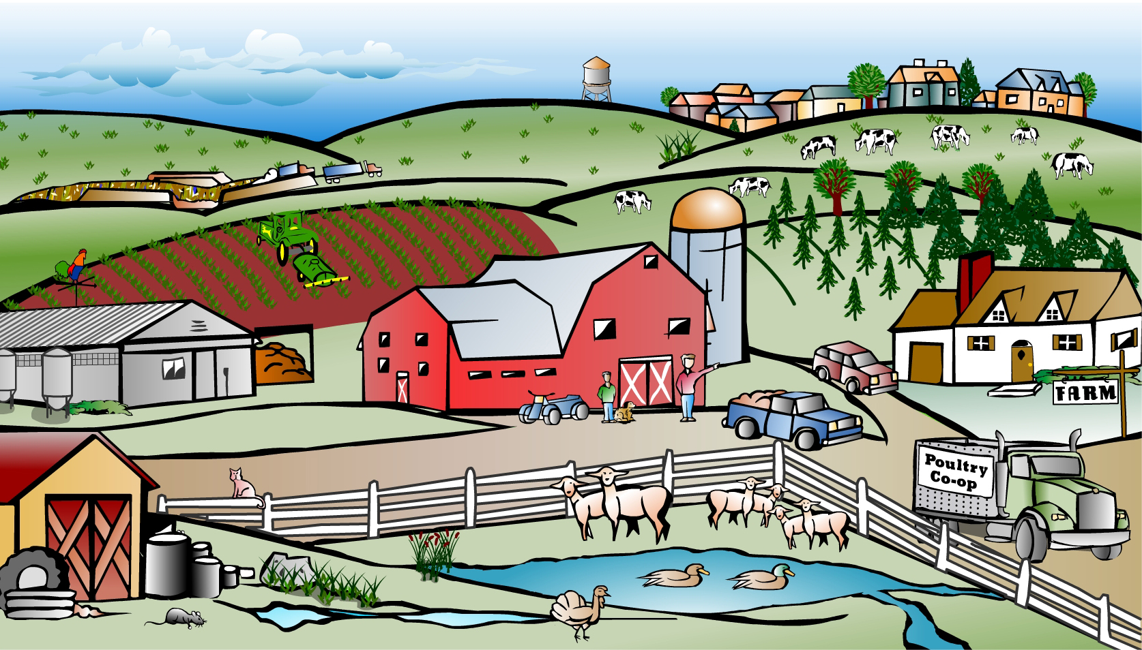
CITY SCENE FARM SCENE

BRAINSTORM

Write the name of your Tox Town Scene _________________________

Potential Sources of Hazard | Potential Hazard from the Source

10

12

ACTIVITY # 2

THINK/PAIR/SHARE

How does environmental health science differ from
how humans affect the environment (Ecology)?

Activity 3 and Extension Activity: Toxins and Toxicology

This activity will engage students as they as they explore the issue of “toxins” and develop the basic toxicology concept of “The dose makes the poison”.

- Show slides 39 and 40 to introduce basic definitions related to toxicology.

- Use slides 41 and 42 to introduce Activity #3 “Dihydrogen Monoxide” Article and have one student read it aloud while the others read along silently.

- Then, working with a partner, students are to answer the dihyrdogen monoxide questions on the Activity #3 Student Handout.

- You may have students report out their ideas to the class. During the discussion (you may use slides 43 and 44 as a reference to the article), students should be led to the conclusion that the chemical is actually water and that it can be harmful to an organism and thus should be considered a toxin. It may be important to point out to students that all of the statements are in fact true and are presented in a way to purposely lead them to believe that the chemical should be banned. This will emphasize the need to be a critical consumer of knowledge.

- To further the concept that any chemical can be a toxicant use slides 43 & 44 which refer to a true story in which “water intoxication” caused the death of a young man during a hazing event in college. This will lead to the basic toxicology principle of “The dose makes the poison” which is further developed on slides 45 & 46 as well as Activity #4.

- You may wish to do the Extension Activity: Chemical Categorization Activity if time permits.

ACTIVITY #3

DIHYRDOGEN MONOXIDE

Directions: Read along as someone reads this article out loud. Then, with a partner answer the questions on the question sheet. Be prepared to discuss with the class.

Dihydrogen Monoxide -The Invisible Killer

Dihydrogen monoxide is colorless, odorless, tasteless, and kills uncounted thousands of people every year. Most of these deaths are caused by accidental inhalation of DHMO, but the dangers of dihydrogen monoxide do not end there. Prolonged exposure to its solid form causes severe tissue damage. Symptoms of DHMO ingestion can include excessive sweating and urination, and possibly a bloated feeling, nausea, vomiting and body electrolyte imbalance. For those who have become dependent, DHMO withdrawal means certain death.

Dihydrogen monoxide:
- is also known as hydroxyl acid, and is the major component of acid rain.
- contributes to the "greenhouse effect."
- may cause severe burns.
- contributes to the erosion of our natural landscape.
- accelerates corrosion and rusting of many metals.
- may cause electrical failures and decreased effectiveness of automobile brakes.
- has been found in excised tumors of terminal cancer patients.
Continued →
Continue →
19
ACTIVITY #3 Continued

Contamination Is Reaching Epidemic Proportions!

Quantities of dihydrogen monoxide have been found in almost every stream, lake, and reservoir in America today. But the pollution is global, and the contaminant has even been found in Antarctic ice. DHMO has caused millions of dollars of property damage in the Midwest, and recently California.

Despite the danger, dihydrogen monoxide is often used:
- as an industrial solvent and coolant.
- in nuclear power plants.
- in the production of Styrofoam.
- as a fire retardant.
- in many forms of cruel animal research.
- in the distribution of pesticides. Even after washing, produce remains contaminated by this chemical.
- as an additive in certain "junk-foods" and other food products.

Companies dump waste DHMO into rivers and the ocean, and nothing can be done to stop them because this practice is still legal. The impact on wildlife is extreme, and we cannot afford to ignore it any longer!

The Horror Must Be Stopped!

The American government has refused to ban the production, distribution, or use of this damaging chemical due to its "importance to the economic health of this nation." In fact, the navy and other military organizations are conducting experiments with DHMO, and designing multi-billion dollar devices to control and utilize it during warfare situations. Hundreds of military research facilities receive tons of it through a highly sophisticated underground distribution network. Many store large quantities for later use.
20

ACTIVITY #3 STUDENT HANDOUT

Directions: After reading the article “Dihydrogen Monoxide”, answer the following questions with a partner. Be prepared to share your answers with the class.

1. Is dihydrogen monoxide a toxin?

2. Why or why not?

3. Do you believe that dihyrogen monoxide should be banned?
Place your self on the continuum below:

1 2 3 4 5
Strongly Disagree Disagree Neutral Agree Strongly Agree
No Restrictions
Ban in all situations
Optional EXTENSION to Activity #3

Chemical Categorization Activity

Purpose:
To uncover misconceptions that students harbor about chemicals and help move them away from viewing that chemicals, especially human-made chemicals, are always harmful to the environment and people and that naturally occurring substances are always safe for the environment and people.

Students will:
- understand that everything in the environment is made of chemicals (many students come with the idea that natural substances in the world around them are not made of chemicals.)
- recognize that the view of a chemical as “bad” or “good” relates to the perception of the potential for the chemical to do harm to a living organism.
- indicate that both human-made and natural substances can possess both safe and harmful attributes.

Directions:

- Provide 12 samples of things made of chemicals for each group of students—since everything in the environment is made of chemicals, any item will work. Some examples include sugar, aspartame, salt, water, soap detergent, window cleaner, vinegar, apple, leaf, rock, perfume, shampoo, vitamins, chemical stock bottles with things such as sodium hydrogen carbonate, acetic acid, sucrose, etc. Be cautious with items that may potentially dangerous or too difficult to provide for each group of students—you may hold these items up in the front of the class for the students to see or provide pictures of the items. It may be helpful to have the items stored in a box or other container to aid in the distribution and collection of the items.

2. Provide students with tent cards (can be made of index cards or other card stock that can be laminated to be saved and used for future classes) that say MADE OF CHEMICALS and NOT MADE OF CHEMICALS

- Have students work in groups of 4 (or 2) to discuss and place the items on their table into 2 the categories – MADE OF CHEMICALS or NOT MADE OF CHEMICALS. They should use the tent cards provided. One student in the group should record the items under the appropriate column on the form provided - Chemical Categorization Table. It may be helpful to suggest to the students that they may not come to consensus on all of the items but to write down their ideas for discussion with the class.

- Once students have placed each of the items into the 2 categories and the items have been written in the table, they are to then, place a green sticker on the items that are NATURALLY OCCURRING and a blue sticker on HUMAN-MADE (SYNTHETIC). If you do not want to use stickers, you can use different colored tape, Post-It paper or other pieces of paper to label the items. Have one student in the group (use a different recorder) use green and blue highlighters to identify the items on the list.

- At this time and throughout the rest of the activity, it may be helpful to ask students to reflect on their choices and see it they can see any patterns emerging.

6. Have students place a black sticker on the items that are BAD FOR THE ENVIRONMENT OR PEOPLE and a yellow smiley sticker on items that are GOOD FOR THE ENVIRONMENT OR PEOPLE. Have one student in the group use illustrations to identify the bad and good items (Be sure to have students include a key—such as a frown face for bad and a smiley face for good). Again other means can be used to label the items.

7. Finally, have students place a red sticker on any items that are TOXIC. Have one student in When students are done categorizing, they should discuss the follow-up questions with
the other members of the group. Answers should be recorded then shared with the class.

9. Once the students are done discussing, have them carefully remove the stickers and place
the items back in the box or container or other designated location.
ACTIVITY #3 EXTENSION
Student Handout
Chemical Categorization Activity

Directions:

1. Working in your group, place the items on your table into 2 categories—

MADE OF CHEMICALS or NOT MADE OF CHEMICALS.

Use the tent cards provided. Have one student in your group record the items under the appropriate column on the form provided (NEXT PAGE).

2. Then, place a green sticker on the items that are NATURALLY OCCURRING and a blue sticker on HUMAN-MADE (SYNTHETIC). Have one student in your group use green and blue highlighters to identify these items on your list.

3. Then, place a black sticker on the items that are BAD FOR THE ENVIRONMENT OR PEOPLE and a yellow smiley sticker on items that are GOOD FOR THE ENVIRONMENT OR PEOPLE. Have one student in your group use illustrations to identify the bad and good items (Be sure to include a key).

4. Finally, place a red sticker on any items that are TOXIC. Have one student in the
group place a red check next to these items on your list.

When you are done categorizing, discuss the following questions with your group members. Have one student record your group answers. Be ready to share with the class.

1. What criteria did you use to categorize an item as a Chemical?

2. What criteria did you use to categorize an item as Not a Chemical?

3. Identify any trends you see in the way your group categorized Natural vs.
Synthetic, Bad vs. Good, Toxic vs. Nontoxic as they relate to being made of
chemicals or not and to each other.
28

ACTIVITY #3 EXTENSION

CHEMICAL CATEGORIZATION TABLE

MADE OF CHEMICALS | NOT MADE OF CHEMICALS

Activity 4: Exposure and Dose

In this discovery activity students develop a concept of "dose" as it relates to concentration of a chemical as well as size of an organism.

- Use slides 46-52 to introduce the concepts of “exposure” and “dose.”

- At slide 53, have students work in groups to do Activity #4 which further develops the idea of “dose”, using a discovery lesson, described in Activity #4 Dose Exercises Student Handout.

- It is suggested that you provide “prepackaged” laboratory kits to minimize the need to distribute individual materials and supplies for this activity. Each kit should contain:
  - 3 equal sized clear containers, such as beakers, plastic cups, or test tubes.
  - Food coloring (“Mystery Chemical”) with dropper
  - Labels or marking pen
  - Water
  - 3 different sized containers, such as beakers, plastic cups, or test tubes
Place the items in plastic bins, boxes, etc. to make the distribution and
collection of materials and supplies faster and easier.

- You may wish to have students report out their answers from the Activity #4 Student Question Handout.

- Slides 54 & 55 summarize the concepts of the activity. Continue with slides 56-68 to explain and explore the concepts of “dose/response”, “toxic effects” and “individual susceptibility”.

ACTIVITY #4
Student Handout

DOSE EXERCISES

Directions: Perform the following 2 exercises with members of your group. Answer the questions that follow based on your observations and your understanding of dose.

Exercise #1

- Obtain 3 equal sized clear containers and label them #1, #2, and #3.
- Fill each container with equal amounts of water (1/2-2/3 full).
- To container #1, add 1 drop of “Mystery Chemical”.
- To container #2, add 4 drops of “Mystery Chemical”.
- To container #3, add 16 drops of “Mystery Chemical”.
6. Observe each of the containers.

Exercise #2

- Obtain 3 clear containers of different sizes and label them A (smallest container), B, and C (largest container).
- Fill each container with water (1/2-2/3 full). Each container should hold an obviously different amount of water.
- Place 2 drops of “Mystery Chemical” in each of the containers.
- Observe each of the containers.

Answer the questions on the following page. Be ready to share with the class.
31
ACTIVITY #4
Student Handout, continued

Questions:

1. In Exercise #1, what is the variable?

What is the control?

2. In Exercise #1, describe the relative concentrations of chemical in each of the
containers.

3. In Exercise #2, what is the variable?

What is the control?

4. In Exercise #2, describe the relative concentrations of chemical in each of the
containers.

5. What concept, regarding dose, is being illustrated in Exercise #1?

Give a real life example of this concept:

6. What concept, regarding dose, is being illustrated in Exercise #2?

Give a real life example of this concept:

7. Paracelsus (1493-1541), a Swiss physician stated:
"All substances are poisons; there is none that is not a poison. The right
dose differentiates a poison and a remedy."

What did he mean?

8. What does the phrase "the dose makes the poison" mean?

ACTIVITY #4 DOSE QUESTIONS

For Teachers - Sample Answers

Questions:

1. In Exercise #1, what is the variable? Number of drops of “Mystery Chemical

What is the control? Size of container

2. In Exercise #1, describe the relative concentrations of chemical in each of the
containers: Container #1 contains the lowest concentration , Container #2
contains the next highest concentration while container #3 contains the
highest concentration.

3. In Exercise #2, what is the variable? Size of the container

What is the control? Number of drops of “Mystery Chemical”

4. Exercise #2, describe the relative concentrations of chemical in each of the
containers: Container A (smallest size) contains the highest concentration,
Container B (medium size) the next highest concentration while Container C
(largest size) contains the lowest concentration.

5. What concept, regarding dose, is being illustrated in Exercise#1? The more
chemical there is the more concentrated the dose.

Give a real life example of this concept: If a person takes too much medicine
they may “overdose”

6. What concept, regarding dose, is being illustrated in Exercise #2? The
smaller the organism, the greater the dose.

Give a real life example of this concept: Children must receive smaller amounts of

medicine than adults to prevent “overdose.”

7. Paracelsus (1493-1541), a Swiss physician stated
"All substances are poisons; there is none that is not a poison. The right
dose differentiates a poison and a remedy."

What did he mean? Any chemical can be a toxin, even harmless and/or
helpful chemicals have the potential to do harm if the dose is high enough.

8. What does the phrase “The Dose Makes the Poison” mean? See answer #7

Activity 5: Risks and Benefits

The purpose of this activity is to wrap up the introductory lesson and bridge into another activity that focuses on an environmental health issue. The activity is designed to encourage students to think about certain issues and to generate a list of ideas by all members of the classroom. For strategies on how to do a "carousel" activity, please see Appendix D.

- Using slides 70 - 71, engage students in a preliminary understanding of the concept of “Risks and Benefits”.

- Cut butcher paper (or use poster paper) so that you have 6 different papers. On each paper, place an issue at the top of the page. Underneath, make two columns, one for risks and one for benefits (see samples below). You may select other environmental health hazards instead of the ones listed.

List of Issues:
  - Alcohol
  - Pesticides
  - Plastics and food usage
  - Cell phones
  - Food Preservatives
  - Medications

Sample Poster

Alcohol
Risks | Benefits

- Place each piece of paper on the wall in separate locations and have students form in groups at each station (approximately 3-4 students per station).

- Give students a marker and allow them 2-3 minutes (time may be varied depending upon individual situations) to generate as many ideas as possible at each station.

- After the time limit is up, have the students rotate in groups (clockwise) to the next station. Again, give them a time limit to answer the next question.

- Repeat this procedure until each group has had a chance to answer each question. Note: Tell students not to repeat items already on list. As they progress through the activity, it may be difficult for students to generate ideas since many may already be up there.

- After the activity is completed, transcribe all answers to a word document and give to students the following day. Use this to generate a class discussion, assign research projects, springboard into a more focused activity etc. etc.

- At the conclusion of Activity 5, administer the post-test.

Introduction to Environmental Health Sciences”
Alternative Assessment Options

The following is a list of suggestions and resources for culminating and extension activities:

1. Visit the University of Rochester website for “My Environment, My Health, My
Choice” curricular units
http://www2.envmed.rochester.edu/envmed/ehsc/outreach/index.html

2. Do toxic release inventory activity at What’s in My Backyard?
http://coep.pharmacy.arizona.edu/events/teacher_events/2001/backyard.pdf

3. Draw an editorial cartoon about an environmental health issue of interest. Include a
written summary of what the issue is, why it is important, and what are some ways to
address the issue. Submit the cartoon to a school or community newspaper.

4. Create a collage of environmental hazards or environmental health occupations.

5. Create a concept map that relates the following topics or concepts. You are not limited
to these terms:
exposure, dose, toxicant, toxicity, chemical, risks, environment, benefits, acute, chronic, hazard, exposure route, source, duration, frequency, dose/response, individual susceptibility, environmental health, body size, gender, age, genetics

6. Hazards in Your Community: Research an environmental health issue of interest to people in your community.
    - Make a list of possible environmental hazards in your community and research these hazards.
    - Discuss what you can do to protect yourself from the hazards.
    - Explain how you might be able to reduce or eliminate the hazards
    - Create a brochure, presentation, skit, or children’s book for elementary students to teach them about the hazards as well as ways to minimize their risks.

7. Critical Thinking Exercise - Research an environmental health topic that has become
an Internet “scarelore” or media myth such as Deodorant Causes Breast Cancer,
Febreze is Dangerous to Pets, etc. Write an essay that addresses:
- what is (are) the hazard(s) claimed
- what is the evidence (or lack thereof) for these claims
- some possible motivations for those making the claims
- conclusions from the scientific community in regard to the issue
- your own conclusions based on your research.

8. Household Product Toxicity Inventory Activity - Answer the following questions
- Name one product that can be found in your home that might be considered to be highly or moderately toxic. Bring in a picture and/or labelof the product (DO NOT remove the label from a product container that still contains the product)
- Specifically identify how you know the product’s toxicity level. What did you use to determine the level of hazard?
- List 3 routes of exposure of a toxin. What would be the primary route of exposure of the toxin in the product that you have identified? Give an example of a hazard that would enter the body by each of the other 2 routes of exposure.
- Identify ways to avoid or minimize the chances of exposure while using the product that you have identified. Explain how the concept of “exposure” is different from the concept of “dose”.

9. Visit the website Tox Town http://toxtown.nlm.nih.gov/ to learn about hazards found in
every day life.

10. Visit the website of the National Institute of Environmental Health Sciences (NIEHS)
http://www.niehs.nih.gov/ and visit the links:
NIEHS Fact Sheets http://www.niehs.nih.gov/oc/factsheets/fsmenu.htm
NIEHS A to Z Topics http://www.niehs.nih.gov/external/faq/faq.htm
NIEHS Kids Page http://www.niehs.nih.gov/kids/

11. Visit the website of Environmental Health Perspectives for information on the latest
research and update on many EH issues
http://ehpnet1.niehs.nih.gov/docs/ehpsearch.html

12. Visit the website of the Environmental Protection Agency to research just about any
environmental topic with a human health link. http://www.epa.gov/students/

13. Take a Toxic Home Tour http://www.epa.gov/kidshometour/tour.htm#view

14. Visit the Toxicology Library at the National Library of Medicine’s homepage for
toxicology and environmental health links at the site
http://sis.nlm.nih.gov/Tox/ToxMain.html

15. Play PERIL (Project Earth Risk Identification Lifeline) an interactive computer game that
allows teens to test their knowledge of risk and risky behavior. To receive a free copy of
the PERIL CD-rom contact Lisa Nader, Ph.D., MSMR Vice President for Education, at
lnader@concentric.net

Resources

1. See " 'Tox In' the City - Introduction to Environmental Health Sciences Assessment Options"

2. NIEHS Fact Sheets http://www.niehs.nih.gov/oc/factsheets/fsmenu.htm

3. NIEHS A to Z Topics http://www.niehs.nih.gov/external/faq/faq.htm

4. NIEHS Kids Page http://www.niehs.nih.gov/kids/

5. Scorecard http://www.scorecard.org

6. Tox Town http://toxtown.nlm.nih.gov/

7. Environmental Health Perspectives http://ehpnet1.niehs.nih.gov/docs/ehpsearch.html

8. Environmental Health Corner http://www.nsc.org/ehc.htm

9. Toxicology Library http://sis.nlm.nih.gov/Tox/ToxMain.html

10. EPA for Students http://www.epa.gov/students/

11. Toxic Home Tour http://www.epa.gov/kidshometour/tour.htm#view

12. Superfund for Kids Pages http://www.epa.gov/superfund/kids/index.htm

13. Agency for Toxic Substances and Disease Registry http://www.atsdr.cdc.gov/

14. Environmental Health Perspectives http://www.ehponline.org/science-ed/lessons2006.html

15. Center For Disease Control http://www.cdc.gov/EXCITE/about.htm

New York State Learning Standards:

Standard 1
Students will use mathematical analysis, scientific inquiry and engineering design, as appropriate, to pose questions, seek answers, and develop solutions.

Major Understandings
- 1.1b Learning about the historical development of scientific concepts or about individuals who have contributed to scientific knowledge provides a better understanding of scientific inquiry and the relationship between science and society.
- 1.1c Science provides knowledge, but values are also essential to making effective and ethical decisions about the application of scientific knowledge.
- 1.2b Inquiry involves making judgments about the reliability of the source and relevance of information.
- 3.4b Claims should be questioned if the data are based on samples that are very small, biased, or inadequately controlled or if the conclusions are based on the faulty, incomplete, or misleading use of numbers.

Standard 4
Students will understand and apply scientific concepts, principles, and theories pertaining to the physical setting and living environment and recognize the historical development of ideas in science.

Major Understandings
- 1.2d If there is a disruption in any human system, there may be a corresponding imbalance in homeostasis.
- 4.1h In humans, the embryonic development of essential organs occurs in early stages of pregnancy. The embryo may encounter risks from faults in its genes and from its mother's exposure to environmental factors such as inadequate diet, use of alcohol/drugs/tobacco, other toxins, or infections throughout her pregnancy.
- 5.2a Homeostasis in an organism is constantly threatened. Failure to respond effectively can result in disease or death.
- 5.2h Disease may also be caused by inheritance, toxic substances, poor nutrition, organ malfunction, and some personal behavior. Some effects show up right away; others may not show up for many years. Societies must decide on proposals which involve the introduction of new technologies. Individuals need to make decisions which will assess risks, costs, benefits, and trade-offs.

Appendix A

Understanding Science Cartoons

Developed by Gary Carlin. Edited and Revised by Bart Bookman:
B. Bookman and L. Maitland©The NYS Biology-Chemistry Mentor Network, DDE Title II, FLCC, 2002

Science cartoons have been finding their way onto many Regents exams. More importantly cartoons can be used to help students develop and demonstrate meaning of what they have learned.

Reading, writing, and understanding science cartoons is a very complex process that requires students to have appropriate scientific background and the ability to make analogies with both written and visual material. For many of our students, it is essential that they have a model they can follow when they try to see the humor in science-based cartoons.

There are 10 basic questions that can be used with any science cartoon.
- Identify the characters and their position in the frame.
- Identify the other objects/organisms in the frame.
- Describe the actual action of the characters.
- Relate the cartoon situation to a real life, human situation.
- Read the cartoon caption/dialogue.
- Based on the caption/dialogue, determine other objects.
- Explain caption/dialogue using the cartoon frame.
- Is there a pun(s) in the caption/dialogue?
- Explain the cartoon using the real-life, human situation.
- Explain why the cartoon is “humorous.”

Cartoons can also be used as motivators to jump-start lessons or as summarizers to check for understanding at the end of the session. Project one using the overhead and ask students, “How does this relate to a biology concept?” Alternatively, give students a copy of the cartoon without its caption and ask them to write an appropriate one. Cartoons by Gary Larson and Sidney Harris provide an especially rich source of material for motivators and summarizers.

Let’s examine few cartoons and see how these apply.
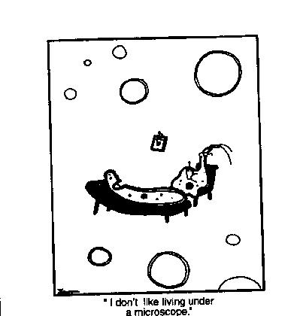

1. Identify the characters and their position in the frame.
- A possible paramecium(Protist) on the couch – single cell, nucleus, cilia, long shape
- A possible di-flagellate(Protist) on the chair – single cell, nucleus, flagella at one end

2. Identify the other objects or organisms in the frame.
- Small picture hanging on a nail on the wall
- Small single line circles
- Larger double line circles

3. Describe the actual action of the characters.
- Paramecium is laying down on the couch and is talking
- Protist in chair is writing on a pad.

4. Relate the cartoon situation to a real-life human situation.
- A psychiatrist taking notes while listening to a patient’s problem

5. Read the cartoon caption/dialogue.
- “I don’t like living under a microscope.”

6. Based on the caption/dialogue, determine other objects
- Small picture may be medical school diploma
- Small and large circles may be small and large air bubbles on a slide
7. Explain caption/dialogue using the cartoon frame.
- Paramecium is telling other Protist that he/she does not like living under a microscope (on a slide with a cover slip)

8. Explain caption/dialogue using the cartoon frame.
- Not applicable

9. Explain the cartoon using the real-life, human situation.
- People feel that their every move is being watched
- This creates a lot of stress
- They go to a psychiatrist to help them deal with the stress

10.Explain why the cartoon is “humorous.”
- Even a paramecium living under a microscope can be stressed by being watched. The stress has caused them to see a protist-psychiatrist.

Let’s try another. This one was on a Regents exam.

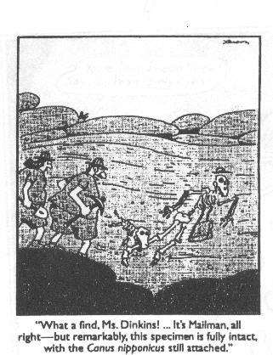

1. Identify the characters and their position in the frame.
- A male archeologist standing on a rock
- A female archeologist standing on a rock

2. Identify other objects/organisms in the frame.
- A skeleton of a human with a hat and a bag
- A skeleton of a small animal (dog?) with its mouth around the leg of the human

3. Describe the actual action of characters.
- Archeologists are observing fossils

4. Relate the action of the characters to a real-life human situation.
- Archeologists may find fossils in the wall of a rock

5. Read the caption/dialogue
- “What a find, Ms. Dinkins! … It’s a mailman, all right – but remarkably, this specimen if fully intact, with the Canus nipponicus still attached.”

6. Based on the caption/dialogue, determine other objects.
- Not necessary in this cartoon

7. Explain the caption/dialogue using the cartoon frame.
- The archeologists have found a human skeleton (a mailman with his bag and hat) and a small animal (a dog)
- The dog is attached to the leg of the human
- They are surprised to find the two sets of complete fossils for both organisms
8. Is there a pun(s) in the caption/dialogue?
- The species name of the dog, nipponicus, comes from the word “nip” which means a bite. The fossilized dog is biting the fossilized mailman’s leg
- The dog is still attached to the mailman’s leg. This is unusual since fossils usually break apart over time.

9. Explain the cartoon using real-life human situations.
- Mailmen are bitten by dogs.

10. Explain why the cartoon is “humorous.”
- The idea that there were prehistoric mailmen and they were also bitten by dogs
- The fact that there would be fossil evidence to support the negative relationship between mailmen and dogs.

Try doing this one.
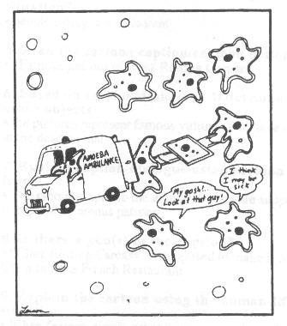

1. Identify the characters and their position in the frame.
- 1 amoeba driving an ambulance
- 2 amoeba holding a stretcher
- 1 square-shaped amoeba on the stretcher
- 3 amoeba above the stretcher
- 2 amoeba below the stretcher

2. Identify other objects/organisms in the frame.
- Small circles and double rings

3. Describe the actual action of characters.
- 2 amoeba putting a square-shaped amoeba into an ambulance
- 2 amoeba below the ambulance are talking to each other

4. Relate the action of the characters to a real-life human situation.
- A person is hurt and is being put into an ambulance

5. Read the caption/dialogue
- “My gosh! … Look at that guy!” “I think he may be sick.”

6. Based on the caption/dialogue, determine other objects.
- Small circles are air bubbles on a slide

7. Explain the caption/dialogue using the cartoon frame.
- The normal, irregular shaped amoeba are watching the not-normal, square shaped amoeba being put in the ambulance and are commenting on how bad the situation is.

8. Is there a pun(s) in the caption/dialogue?
- Not applicable.

9. Explain the cartoon using real-life human situations.
- People gather around ambulances to see what is happening.
- People comment on how it looks.
- Some people become ill at the sight of injured people.

10. Explain why the cartoon is “humorous.”
- Amoeba are generally irregular in shape, so be to perfectly square is quite abnormal.
- Perfect square-shape is the result of a bad accident. Or perhaps the amoeba was “squished’ between a slide and a cover slip.

Here are five more cartoons – see if you can make sense of them while using the model.

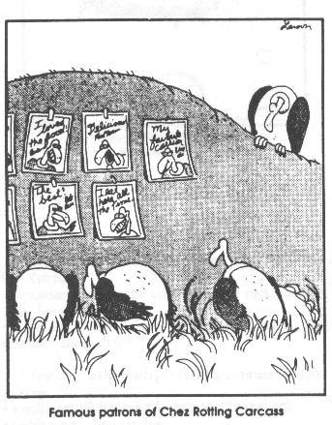
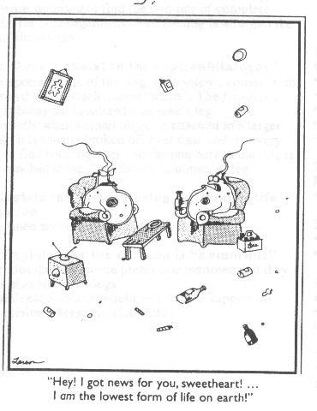

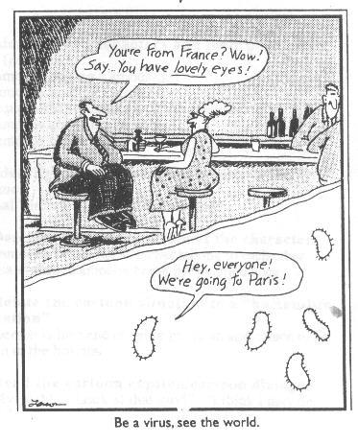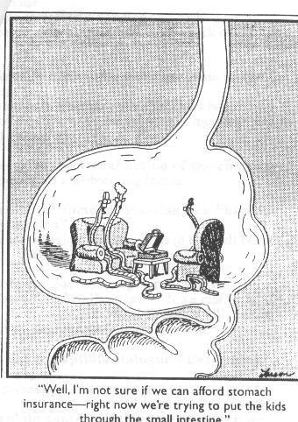
B. Bookman and L. Maitland©The NYS Biology-Chemistry Mentor Network, DDE Title II, FLCC, 2002

Appendix B

BRAINSTORMING

HOW TO BRAINSTORM
- Group members can call out ideas spontaneously, or the team leader can ask each member, in turn, for one of his/her ideas. In the latter case, members may pass if they don't have an idea at that time. Understand that introverts and extroverts react to brainstorming quite differently.
- The scribe records all ideas verbatim; no editing or summarizing without permission.
- Develop trust in each other.

BRAINSTORMING RULES
- This is not a time for discussion. It is a time to generate ideas quickly. Discussion will follow brainstorming.
- Do not evaluate (Do not make comments like “That is a very good idea,” or “That suggestion was just plain stupid.”) All ideas are potentially good.
- Encourage a wide range of ideas: from obvious to subtle, to out of the box or off the wall. No idea is ridiculous.
- Ideas may be built on the ideas of others.
- Each idea presented belongs to the group, not the person who said it.
- Strive for quantity. Narrow down later.

Appendix C

Think – Pair - Share and Think – Pair - Share/Square

©The NYS Biology-Chemistry Mentor Network, DDE Title II, FLCC, 2001
L. Maitland, S. Latourelle, B. Bookman, J. Valenti

According to many teachers, the simplest cooperative learning structure/strategy is “Think-Pair-Share.” While both Spencer Kagan who originated this term and Jack Hassard (1996) call this cooperative learning strategy “Think-Pair-Share,” you may know it as “Turn To Your Neighbor” (Lundgren, 1994) or “Turn-To-Your-Partner” (Johnson, Johnson, Holubec, 1991).

“Think-Pair-Share” requires each student to think about and respond to a question, discuss answers in pairs, then share their own or a partner’s answer with the whole class or another group. Variations include writing answers and reading the other’s answer(s), or discussing answers and constructing an answer that incorporates the best of each of the partners’ answers. Each student of the pair may be given a predetermined amount of time for sharing his/her response.

After a pair of students has shared responses, that pair pairs with another set of partners to form a square, “Think-Pair-Share-Square.” Students share their answers with teammates rather than with the class. As above, several variations can be used to help students construct learning. The whole group may decide that an answer they construct from all of the individual answers is superior to any of the original responses. Squares may share answers with the whole class or not.

“Think-Pair-Share” and “Think-Pair-Share/Square” are effective instructional strategies that can be useful during any stage of a lesson, but are most frequently used during the first few minutes (anticipatory set/motivation) or last few minutes (closure/summary/application).
Kagan (1998) suggests use of these structures/strategies for developing thinking skills, promoting communication skills and encouraging information sharing. He considers these tools that access verbal/linguistic, interpersonal and intrapersonal intelligences.

References Cited
Hassard, Jack (1996). Using cooperative learning to enhance your science instruction (Grades 6-12). Bellevue, WA: Bureau of Education and Research.
Johnson, David W., Roger T. Johnson and Edythe Johnson Holubec (1991). Revised cooperation in the classroom. Edina, MN: Interaction Book Company.
Kagan, Spencer (1989). Cooperative learning resources for teachers. San Juan Capistrano, CA: Resources for Teachers.
Kagan, Spencer (1998). Dr. Spencer Kagan’s new cooperative learning smart card. San Clemente: Kagan Cooperative Learning.
Lundgren, Linda (1994). Cooperative learning in the science classroom. New York: Glencoe-McGraw-Hill.

Appendix D

Carousel Brainstorm: A Cooperative/Collaborative Tool For

Generating and Processing Ideas

Written by Joyce G. Valenti, 1997. Updated by Michael J. Dupre’ and Joyce G. Valenti, 2002

Description:
The carousel brainstorm is a strategy used to get everyone involved in the generation of ideas. It provides an opportunity to make sure that everyone is aware of all the ideas that are generated because it relies on small group brainstorming rather than on one, large –group process that often leaves some people disengaged. These small groups rotate through a number of stations generating ideas or answering questions at each station.
A carousel works best when several ideas (or perhaps categories of ideas) are being managed at once.

Teacher Notes:
- The teacher determines the number of stations within the carousel. Each station focuses on one specific topic/idea/concept/question.
- There is no magical formula. Students are encouraged to help with the focus headings/statements for each station. The number depends on how the teaching/learning strategy (Carousel Brainstorming) is to be used with the instruction.
- When four or less stations are needed for the carousel brainstorming activity, it is highly recommended that duplicate or triplicate carousels are formed. All such carousels should contain identical stations. Assign equal numbers of students to each of the stations.
- Carousel Brainstorming is easily adaptable for teacher workshops, large classes, and department meetings.

Carousel Brainstorming General Procedure:
- Arrange students in groups of two to four. Assign each group to start at a specific station.
- Groups brainstorm at their station, writing responses to questions/topics at each station using a selected magic marker or ink color
- Groups are given two to five minutes to work at each station on their responses. The amount of time at each station depends on the objective(s) of the Carousel Brainstorming.
- When time is up, the groups rotate to the next station to work on a new set of responses, taking their selected marker/in color with them. In each round, students add responses to the existing list and make notes or suggestions on others’ responses. Students might also record their responses without looking at responses from previous groups.
- The carousel continues to turn until each group has had time to work at each station.
- Groups end by returning to their original station.

Depending on the teaching and learning objectives for the lesson using the carousel, the process may stop at this point. However, it is recommended that the idea generation steps listed above be followed by a reflective/processing component as described below.

The groups could be asked to create a variety of reflective summaries specific to the responses on their carousel. For example, student teams might be asked to
  - categorize/summarize
  - provide reasons or rationale for
  - produce a drawing from one idea
  - act out one idea
  - report out main or common concepts

An adaptation of the carousel is for each group to leave one member behind as they move on to the next station. This member can explain or clarify responses where it is necessary. A different person can be left behind each time. This assures continuity, yet allows all group members to get to most of the station.

