

Cancer Education Project

Thalidomide: A Cancer Treatment

Overview:

This activity was designed to be incorporated into instruction on the effects of environmental factors on human development. Students visit six different stations to learn about the use of thalidomide, a known teratogen that is used to treat some types of cancer. They answer the questions in the student handout. The activity could be completed in 60 minutes.

Teacher instructions:

Each student will need one copy of the student handouts (case study and station instructions) for this activity. Begin this activity by reading the first page of the student handout (“A Case Study: Thalidomide”) aloud in class. Allow 10 minutes for teams to work together to discuss the facts of this case study and to list questions that they have about the case. Then, ask students to follow the instructions on the student handout and answer all questions.

Provide computer access for each team or provide print handouts from the websites to each team. If students have access to 6 classroom computers, this activity can be done as a directed “web quest.” If students do not have access to classroom computers, the teacher can print the relevant resources needed for each station. Put the print handouts in sheet protectors so that they do not get mixed up with students’ handouts. Put the print handouts into 6 folders or notebooks clearly labeled with each station number.

If time permits, ask teams to revisit the questions that they had about the case. Discuss the answers to questions that were not answered by doing the web quest.

Station 1: Thalidomide and Birth Defects
Prepare three copies of the following four documents. It is suggested that you put these in sheet protectors so that they do not get mixed up with students’ handouts. In addition to these print resources, students who have access to a computer might be directed to the Visible Embyo web site at: http://www.visembryo.com/baby/index.html

The Effects of Thalidomide on Human Embryological Development

When a pregnant woman takes thalidomide 34-50 days (4.5 to 7 weeks) after the beginning of her last menstrual period, there is a risk that her child will be born with severe birth defects. Thalidomide may cause quite different malformations in different children. The type of thalidomide malformation depends on when the thalidomide was taken by the mother. Thalidomide does not produce malformations if taken before the 34th day after the last menstruation and usually no malformation occurs if it is taken only after the 50th day.

If thalidomide is taken throughout the sensitive period, the consequence may be severe defects of ears, arms and legs and of internal organs. Examples of these malformations include: extremely short or missing arms and legs, missing ears (both outside and inside), heart defects, missing or small eyes, paralysis of the face, kidney abnormalities, and mental retardation.

There are no studies on pregnancy outcome in women who only used thalidomide prior to conception. There are also no reports linking thalidomide use and infertility. The risk for fetal damage if the drug is taken after the first trimester is unknown.

Birth Defects

Each year many children are born with birth defects. Birth defects may affect body structures causing minor to major structural malformations. They may also affect brain function--ranging from mild behavioral changes which affect learning and social adjustment to severe mental retardation.

Some birth defects are not preventable. They are due to defective genes inherited from parents or unavoidable problems in the uterine environment during pregnancy. Other birth defects may be preventable because they are due to the mother's exposure to environmental factors. Inadequate diet, alcohol, drugs, tobacco, medications, and infections are some of the environmental factors that can harm a developing fetus. These environmental factors may interfere with the normal growth and differentiation of the organs. Because most of the organs of an embryo are developed during the first three months of pregnancy, exposure during the first trimester usually produces more severe fetal abnormalities. A fetus may also be at risk even during later stages of pregnancy.

The fetal period is a time of growth, differentiation, and maturation. Numerous developmental steps are involved and there are many possibilities for disruption of the process. Normal development requires precisely organized structural changes, physiological changes, and maturational changes. Anything that can cross the placenta has the potential for altering the normal developmental sequence.

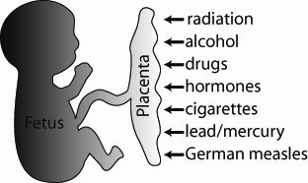

Table 1. Human Embryonic Development

Critical Periods of Human Development
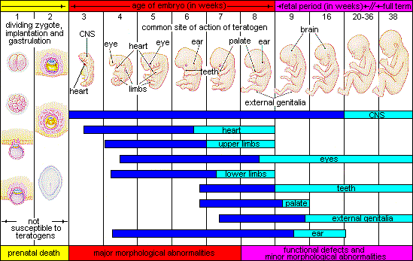
Image Source: http://embryology.med.unsw.edu.au/Medicine/images/hcriticaldev.gif

Table 2: Menstrual Cycle

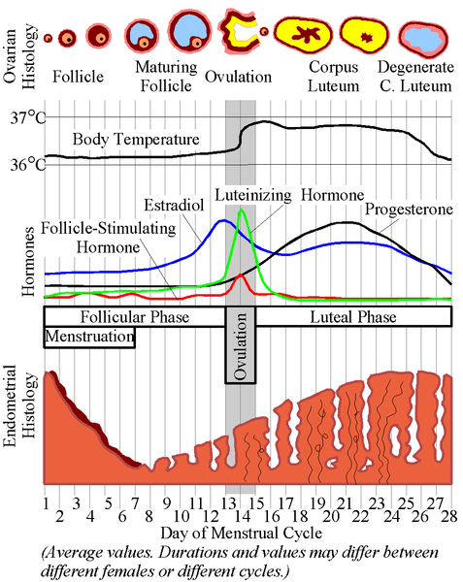

Image source:
http://upload.wikimedia.org/wikipedia/commons/thumb/f/f0/MenstrualCycle.png/477px-MenstrualCycle.png

Station 2: Angiogenesis Inhibitors in the Treatment of Cancer
Provide computer access to http://www.cancer.gov/cancertopics/factsheet/Therapy/angiogenesis-inhibitors
and http://www.pbs.org/wgbh/nova/cancer/faq.html#n01 OR prepare three printed copies of the documents found at these sites.

Station 3: Information on different types of teratogens
Provide computer access to http://teratology.org/jfs/Main.html OR prepare three printed copies of the six documents found by clicking on each of the topics on this site.

Station 4: The Risks and Benefits of Taking Thalidomide
Provide computer access to http://www.marchofdimes.com/professionals/681_1172.asp OR prepare three printed copies of the document found at this site.

Station 5: The FDA Position on Thalidomide Use
Provide computer access to http://www.cancer.gov/clinicaltrials/learning/approval-process-for-cancer-drugs/ then follow the drug information link on the right to get specific information on thalidomide at http://www.cancer.gov/cancertopics/druginfo/thalidomide OR prepare three printed copies of the documents found by clicking on these two sites.

Station 6: What Patients Should Know About Clinical Trials
Provide computer access to http://www.cancer.gov/clinicaltrials/understanding/what-is-a-clinical-trial OR prepare three printed copies of the document found at this site.


A Case Study:
THALIDOMIDE!

Sharon was horrified. Why would a doctor use thalidomine to treat her daughter Kathy’s multiple myeloma? Maybe the doctor is too young to remember what thalidomide did to babies. There had to be other things that could be used to treat her 23 year old daughter’s cancer.

Kathy knew that her mother was worried. She reassured Sharon that the FDA
(U. S. Food and Drug Administration) had approved thalidomide as a cancer treatment. Kathy also explained that she was participating in a Phase III clinical trial. Phase I and II trials for thalidomide treatment had been very promising. Kathy talked about thalidomide being a new kind of biological therapy, an angiogenesis inhibitor.

For Sharon, images of the babies born with flipper-like arms or legs that she had seen flashed into her head. Sharon knew Kathy was likely to regard anything she said as motherly interference. She had to make sure that Kathy understood the risks associated with thalidomide.

Brainstorm with your team members:

- What do you know about this case study?

- What questions do you have about this case study?

Station 1: Thalidomide and Birth Defects

Perhaps this thalidomide was not as bad as Sharon remembered. Before she panicked and got Kathy upset, she should find out whether thalidomide really did cause birth defects. The first documents she read were NOT at all encouraging!

- Read the information at this station and highlight the weeks (on Table 1) during which thalidomide is likely to affect the developing embryo. Note: This is trickier than it first seems. Look at both Table 1 and Table 2 before you do this.

Table 1. Human Embryonic Development

Critical Periods of Human Development
Image Source: http://embryology.med.unsw.edu.au/Medicine/images/hcriticaldev.gif

- List six organs in the embryo that are forming during the weeks when thalidomide affects embryological development?

Station 2: Angiogenesis Inhibitors in the Treatment of Cancer

Kathy had said that scientists thought that thalidomide was an angiogenesis inhibitor. Sharon wondered what that meant. Look at these sites to help Sharon answer these questions.
http://www.cancer.gov/cancertopics/factsheet/Therapy/angiogenesis-inhibitors
http://www.pbs.org/wgbh/nova/cancer/faq.html#n01

- What is angiogenesis?

- Why might angiogenesis be important in normal embryonic development?

- Why might angiogenesis promote the growth of cancer?

- What is an angiogenesis inhibitor?

- Why might an angiogenesis inhibitor interfere with the normal embryonic development process?

- Why might angiogenesis inhibitors interfere with the growth of cancer cells?

Station 3: Information on different types of teratogens

As part of her research, Sharon discovered a web site that had information about thalidomide as a teratogen. It also had information about other kinds of teratogens. Take a look at this site. http://teratology.org/jfs/Main.html

- What is the difference between a teratogen and a carcinogen?

- Below is a list of major categories of teratogens. For each of these categories, list one example of a teratogen and briefly describe how it affects the embryo.
  - Industrial
  - Metabolic/disease
  - Recreational
  - Pharmaceutical
  - Agricultural
  - Natural

Station 4: The Risks and Benefits of Taking Thalidomide

Sharon realized that there was a website she should visit. She knew the March of Dimes is a non-profit organization that focuses on preventing birth defects. Their site might be one that encourages women of child-bearing age not to participate in the thalidomide clinical trials. Sharon discovered that the March of Dimes site wasn’t opposed to the use of thalidomide as a cancer treatment. Instead, it listed the risks and benefits and discussed ways to reduce the risk to embryos.

Look at the information at this site to help you answer these questions: http://www.marchofdimes.com/professionals/681_1172.asp .

- What are the benefits of thalidomide use?

- What are the risks of thalidomide use?

- What “trade-offs” or “compromises” could people use to balance the risks and benefits of thalidomide use?

Station 5: The FDA Position on Thalidomide Use

Sharon still couldn’t believe that thalidomide had FDA approval for treating cancer patients—particularly for a young woman! She logged onto the web site:
http://www.cancer.gov/clinicaltrials/learning/approval-process-for-cancer-drugs/
She then followed the drug information link on the right to get specific information on thalidomide at the web site: http://www.cancer.gov/cancertopics/druginfo/thalidomide

- What is the FDA?

- Imagine you are a FDA official who must decide whether or not thalidomide can be placed on the market for use by cancer patients. What decision would YOU make? Support your position.

- Why might other people oppose your decision? What reasons might they have for their position?

- What actions has the FDA taken to reduce the risks associated with thalidomide?

Station 6: What Patients Should Know About Clinical Trials

Sharon decided that Phase III clinical trials sounded risky. Why should Kathy be involved in some experiment to test this drug? Wouldn’t it be better to just get the standard, not the experimental treatment?

She looked for information on clinical trials at:
http://www.cancer.gov/clinicaltrials/understanding/what-is-a-clinical-trial

- What is a clinical treatment trial?

- Why should Kathy find it reassuring that she was participating in Phase III, not Phase I or Phase II clinical trials?

- What questions should Kathy ask about the clinical trials before she signs an informed consent form for participation in the thalidomide clinical trials?

Optional: If You Would Like to Know More About Pregnancy and Cancer

Thalidomide is not the only medication that can harm a developing embryo. Women of child-bearing age who develop cancer may face difficult decisions that balance their health with their ability to have healthy children.

For more information on pregnancy and cancer, you might want to visit these web sites:
- http://www2.mdanderson.org/depts/oncolog/articles/04/1-jan/1-04-1.html
- http://www.plwc.org/portal/site/PLWC/menuitem.034b98abc65a8f566343cc10ee37a01d/?vgnextoid=83d7ea97a56d9010VgnVCM100000f2730ad1RCRD
- http://www2.mdanderson.org/app/pe/index.cfm?pagename=opendoc&docid=2124

