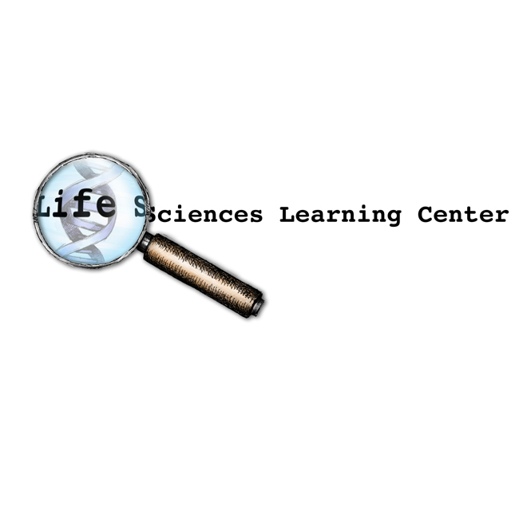

Stem Cell Biology

Overview:
This collection of activities is designed to introduce students to the basic biology of stem cells and stem cell research.

Summary of Activities:
Teachers may opt to implement all or some of these activities. Approximately 6 forty minute class periods are required to complete all of the activities.

Activity title  (Estimated time required) | Students will… | Purpose
Public Opinion Survey on Stem Cell Research  (20 minutes + homework) | - Complete a survey on their opinion and knowledge about stem cells.  - Survey another student and an adult. | Engage, assess prior knowledge
Analyzing Stem Cell Survey Data  (40 minutes) | - Analyze the results of the class survey  - Discuss and identify key knowledge, questions and concerns about stem cells. | Analyze and discuss survey data to develop awareness of different perspectives
Stem Cell Basics  (40 minutes) | - View slide show -“Stem Cell Basics”  - The following four activities may be integrated into the slide show presentation. | Background knowledge about stem cells and stem cell research
Culturing Stem Cells  (40 minutes) | - Culture stem cells from plants | Apply sterile technique to cell culture
Three Ways to Make a Pluripotent Stem Cell Line  (40 minutes) | - Use models and graphics to illustrate how in vitro fertilization, therapeutic cloning, and genetic reprogramming can be used to make a pluripotent stem cell line. | Apply knowledge of in vitro fertilization, therapeutic cloning, and genetic reprogramming.
Genes and Stem Cell Differentiation  (40 minutes or homework) | - Analyze simulated microarray data to investigate the role of gene expression in differentiation. | Model differentiation involing changes in gene expression.
Controlling Stem Cell Differentiation  (20 minutes + homework) | - Simulate treating embryonic and tissue specific (adult) stem cells with growth factors that lead to differentiation pathways. | Model how chemical factors and cell history influence gene expression.
Treating A Broken Heart  (40 minutes) | - Read a scenario about a stem cell therapy clinical trial. Consider what patients should know before they agree to participate. | Consider the risks and benefits of stem cell therapy and clinical trials.
A Revolutionary Breakthrough  (40 minutes) | - Develop information products about induced pluripotent stem cell technology | Illustrate gene transfer to reprogram differentiated cells.
Stem Cell Follow-Up Survey  (20 minutes) | - Complete the follow-up survey and reflect on how the lessons may have affected their knowledge and opinions. | Reflection, closure, and assessment.
Correlation with New York State Learning Standards:

Standard 1
1.1c Science provides knowledge, but values are also essential in making effective and ethical decisions about the application of scientific knowledge.
1.2a Inquiry involves asking questions and locating, interpreting, and processing information from a variety of sources.
1.2b Inquiry involves making judgments about the reliability of the source and relevance of information.
1.3b All scientific explanations are tentative and subject to change or improvement. Each new bit of evidence can create more questions than it answers.
3.1a Interpretation of data leads to the development of additional hypotheses, the formulation of generalizations, or explanations of natural phenomena.
3.4b Claims should be questioned if the data are based on samples that are very small, biased or inadequately controlled.
3.4c Claims should be questioned if fact and opinion are intermingled, if adequate evidence is not cited, or if the conclusions do not follow logically from the evidence given.

Standard 4
1.2e The cells of the body are of different kinds and are grouped in ways that enhance how they function together.
1.2f Cells have particular structures that perform specific jobs. These structures perform the actual work of the cell.
2.1k The many body cells in an individual can be very different from one another, even though they are all descended from a single cell and thus have essentially the same genetic instructions. This is because different parts of these instructions are used in different types of cells, and are influenced by the cell’s environment and past history.
4.1d The zygote may divide by mitosis and differentiate to form the specialized cells, tissues, and organs of multicellular organisms.
5.2 Biological research generates knowledge used to design ways of diagnosing, preventing, treating, controlling, or curing diseases.
7a Societies must decide on proposals which involve the introduction of new technologies. Individuals need to make decisions which will assess risks, costs, benefits, and trade-offs.

Laboratory Skills
- Organizes data through the use of data tables and graphs
- States an appropriate hypothesis
- Differentiates between independent and dependent variables
- Identifies the control group and/or controlled variables
- Collects, organizes, and analyzes data
- Analyzes results from observations/expressed data
- Formulates an appropriate conclusion or generalization from the results of an experiment
- Recognizes assumptions and limitations of an experiment

Selected Internet Resources for Teachers and Students:

The following web sites provide useful background information on stem cells

Stem Cell Basics

http://stemcells.nih.gov/info/basics/

This web site from the National Institutes of Health covers basic information including:
- What are the unique properties of all stem cells?
- What are the similarities and differences between embryonic and tissue specific (adult) stem cells?
- What are the potential uses of human stem cells and the obstacles that must be overcome before these potential uses will be realized?

Understanding Stem Cells

http://dels.nas.edu/bls/stemcells/booklet.shtml

This educational primer from the National Academies provides basic knowledge to facilitate thinking about and understanding the scientific and ethical issues surrounding stem cells. Free download or order free hard copies.

Stem Cells in The Spotlight
http://learn.genetics.utah.edu/units/stemcells/

A fantastic collection of classroom resources, lessons, animations, and classroom activities from the University of Utah’s Genetics Science Learning Center.

North West Association for Biomedical Research: Stem Cell Curriculum -
http://www.nwabr.org/education/stemcell.html
This stem cell curriculum unit includes a variety of classroom activities that focus on the biology and the ethical issues associated with stem cell.

NOVA Stem cells
http://www.pbs.org/wgbh/nova/sciencenow/3209/04.html
Online video, poll, and print resources to accompany the video.

International Society for Stem Cell Research -http://www.isscr.org/public/index.htm
Great resources for the general public including a media library.

Potent Biology: Stem Cells, Cloning, and Regeneration –
http://www.hhmi.org/biointeractive/stemcells/index.html
Lecture series from the Howard Hughes Medical Institute with extensive, advanced information on current stem cell research.

Stem Cell Research
http://www.abpischools.org.uk/res/coResourceImport/resources/poster-series/stemcell/index.cfm
Stem cell poster with related information and simple student activities

ExploreStemCells
http://www.explorestemcells.co.uk/
ExploreStemCells (for beginners) contains over 70 articles written by experts who continually update and add new content.

Stem Cell Research 101
http://www.kumc.edu/stemcell/intro.html
Accessible graphics and text written for the general public. Includes a slide show presentation.

Stem Cell Resources
http://www.stemcellresources.org/
An incredibly comprehensive website with abundant science education resources on stem cells. Sections to explore include: About, Cell Talk, For Educators, Multimedia, SRC Library, Who’s Who, Policy and Law, Events.

The following videos and animations may be used to illustrate stem cell biology.

Stem Cells: Building and Maintaining the Body
http://www.cdb.riken.jp/en/05_development/0505_stemcells04.html
Animations to illustrate:
- The characteristics of stem cells
- Embryonic stem cells
- Tissue specific (adult) stem cells
- Stem cell culture and control of differentiation

Stem Cells Explained
http://www.umich.edu/news/stemcells/C_030206.html
Animations to illustrate:
- Stem cells defined
- Embryonic stem cells
- Cell specialization
- Adult stem cells
- Nuclear transfer
- Drug testing

Human Embryonic Stem Cells:
http://www.sumanasinc.com/webcontent/animations/content/stemcells_scnt.html
Animations to illustrate:
- Culturing embryonic stem cells
- Stem cell differentiation
- Nuclear transplantation
- Use of stem cells in drug testing

Human Embryonic Stem Cells Tutorial
http://www.sumanasinc.com/webcontent/animations/content/stemcells_diabetes.html
Animations to illustrate:
- Embryonic stem cells
- Differentiation
- Glucose regulation, type 1 diabetes, and using stem cells to treat diabetes.

How Embryonic Stem Cell Lines are Made
http://www.dnalc.org/stemcells.html
An animation to illustrate how cells are removed from the inner cell mass and cultured. Would make a good introduction to culturing stem cells activity.

Stem Cells: Seeds of Hope
http://www.teachersdomain.org/resources/tdc02/sci/life/cell/stemcellvid/assets/tdc02_vid_stemcellvid/tdc02_vid_stemcellvid_56_mov.html
This video focuses on the potential for stem cell treatments and would be an excellent introduction to activity on clinical trials for stem cell treatments. The language used is very easy to understand.

Stem Cells Explained
http://www.umich.edu/stemcell/
Tutorial to illustrate stem cell biology.
http://www.lifesciences.umich.edu/research/featured/basics.html
This is video provides information on stem cell research and shows people whose lives might be changed by stem cell research.

NOVA ScienceNOW Stem Cells
http://www.pbs.org/wgbh/nova/sciencenow/3209/04.html
15 minute video segment on stem cell biology. Also provides excellent accompanying resources including:
- An interactive poll that explores the arguments for and against stem cell research.
- A slide show that illustrates how scientists create embryonic stem cells.
- Other sections include: An Alternative to Cloning, The Politics of Stem Cells, Related Science News, and Ask the Expert.

Nova ScienceNOW Stem Cell Update
http://www.pbs.org/wgbh/nova/sciencenow/3302/06.html
8 minute video segment on a new way to create embryonic stem cells. Excellent resources including Science News story on new way to make stem cells from skin cells

Making Sense of Stem Cells
http://www.isscr.org/public/MakingSenseOfStemCells.htm
Explains the basic concepts of stem cell research including:
- Cloning and nuclear transfer
- Human embryonic stem cells – where do they come from and how can they be used?
- Adult stem cell therapy

A Stem Cell Story
http://www.eurostemcell.org/films/a-stem-cell-story/English
This is a lively and interesting video introduction to stem cells. Be sure to explore the other resources available at this site.

Stem Cell Interactive Laboratory
http://www.childrenshospital.org/research/_stemcell/
Illustrates how coaxing agents can be used to control stem cell differentiation. An excellent activity that correlates with the Controlling Stem Cell Differentiation laboratory simulation.
This project was generously funded by Science Education Partnership Award R25RR023285 from the National Center for Research Resources. The content is solely the responsibility of the authors and does not necessarily represent the official views of the National Center for Research Resources or the National Institutes of Health.
Public Opinion Survey on Stem Cell Research

Summary:
Students complete a public opinion survey on stem cell research. They ask another student and an adult to complete the same survey.

Objectives:
- Students will consider their prior knowledge, questions, and concerns about stem cells and stem cell research.
- Students will develop curiosity about stem cell research and about the different perspectives that others may have on this topic.

Preparing for class:
- Consider beginning class by showing just the first few minutes of the video, Stem Cell Gold Rush, KQED Quest at http://www.kqed.org/quest/television/stem-cell-gold-rush. Show just the part of the video where people on the street explain what they know about stem cells. Stop at the point that shows an electrophoresis gel. You could show the remainder of the 10 minute video after students have completed the Stem Cell Basics slide show in the next activity. Hint: You may need to hit the pause button to allow the video to load completely if your computer has a low buffering capacity.
- Each student will need 1 copy of the half-page memo from Hank Jones. (Optional)
- Each student will need 3 copies of the Public Opinion Survey on Stem Cell Research.

In the classroom:
- Show the first few minutes of the Stem Cell Gold Rush, KQED Quest at http://www.kqed.org/quest/television/stem-cell-gold-rush. Stop at the point that shows an electrophoresis gel.
- Hand out the memo from Hank Jones. (Optional)
- Hand out one copy of the public opinion survey.
- Explain that different people may have very different knowledge, questions, and opinions about stem cell research. You would like to understand what they know and think about stem cells and stem cell research.
- Allow 10-15 minutes for students to work individually to complete the survey. To ensure confidentiality, they should NOT put their names on the survey.
- Collect the surveys.
- Hand out 2 additional copies of the public opinion surveys.
- Explain that having others complete the public opinion survey will help them understand what other people think about stem cell research.
- Tell students that their homework assignment is to have this survey completed by two other people: another student (not in your classes) and a parent or other adult. To ensure confidentiality, the names of the survey participants should NOT appear on the surveys. Students should indicate at the top of the survey whether the survey was completed by an adult or by another student.
- Explain that you will collect the adult and student surveys from each student at the beginning of class tomorrow.
- Read the surveys completed by the students in your classes to become aware of students’ prior knowledge, questions, and concerns.
- Follow this activity with the Analyzing Stem Cell Survey Data activity or provide an alternative opportunity for students to share the results of these surveys.

From: Hank Jones, Campaign Manager for Senator Brown
To: Campaign Public Relations Team

Senator Brown needs to discuss his position on the stem cell research issue at the political debate next week.

Please conduct and analyze a public opinion survey to identify:
- What the public knows about stem cells and stem cell research.
- What concerns or questions the public has about stem cell research.

From: Hank Jones, Campaign Manager for Senator Brown
To: Campaign Public Relations Team

Senator Brown needs to discuss his position on the stem cell research issue at the political debate next week.

Please conduct and analyze a public opinion survey to identify:
- What the public knows about stem cells and stem cell research.
- What concerns or questions the public has about stem cell research.

Survey completed by (check 1): ____ Student ____ Adult

Public Opinion Survey on Stem Cell Research

- Have you heard or read about stem cells? ____ Yes _____ No

- List 3 or 4 things you think you know about stem cells.
_______________________________________________________________________________________________________________________________________________________________________________________________________________________________________________________________________________________________________________________________________________________________________________________________________________________________________________________________________________________________________________________________

- Do you think scientists should be able to do research on stem cells?
___ Yes ___ Maybe ___No ____No Opinion

- Explain your position.
_____________________________________________________________________________________________________________________________________________________________________________________________________________________________________________________________________________________________________________________________________________________________________________

- What concerns or questions do you have about stem cells?
_______________________________________________________________________________________________________________________________________________________________________________________________________________________________________________________________________________________________________________________________________________________________________________________________________________________________________________________________________________________________________________________________
Analyzing Stem Cell Survey Data

Summary:
Students work in teams to analyze the class data from the public opinion survey. They also discuss and summarize information related to the public’s knowledge, concerns, and questions about stem cell research.

Objectives:
Students will…
- Create a graph and data table to summarize the data from the public opinion survey.
- Draw conclusions based on the survey data.
- Discuss and summarize the kinds of knowledge, questions, and concerns that people have about stem cells and stem cell research.
- Recognize that other people may have different perspectives on stem cells and stem cell research.

Preparing for class:
- Review the surveys completed by students during the previous activity

Yes Maybe No No
Opinion
- Prepare a class poster with the axes for a bar graph (as shown to the right).
- Each student will need:
  - 1 copy of Analyzing Stem Cell Survey Data for each student.
  - At least 2 yellow and 1 blue 3”X3” Post-It™ notes per student.
- Each team of 3 or 4 students will need a marker and one sheet of poster paper.

In the classroom:
- Remind students that they are to indicate (at the top of the surveys) whether the survey was completed by an adult or by another student.
- Collect one student survey from each student in the class.
- Collect one adult survey from each student in the class.
- Shuffle these surveys with the surveys completed by students in the class.
- Distribute surveys randomly. Give each student 2 student surveys and 1 adult survey.
- Distribute 2 yellow and 1 blue Post-It™ notes to each student.
- Read (and possibly model) these instructions for the students:
  - For each student survey, write “yes”, “maybe”, “no” or “no opinion” on a YELLOW Post-It™ note to indicate each student’s response to question 3.
  - Place these yellow Post-It™ notes in the appropriate location on the poster to create four bars on the class bar graph (as shown in the diagram above).
  - For each adult survey, write “yes”, “maybe”, “no” or “no opinion” on a BLUE Post-It™ note to indicate each adult’s response to question 3.
  - Place these blue Post-It™ notes on the poster next to the yellow ones, to create four NEW bars on the class bar graph.
- Distribute 1 copy of Analyzing Stem Cell Survey Data to each student.
- Ask students to work in teams of three or four students to complete the Analyzing Stem Cell Survey Data activity.
- As the teams work, distribute 1 marker and 1 sheet of poster paper to each team of students.
- At the end of class, post the class data poster and each team’s poster in the classroom. Save or display until all stem cell activities have been completed.

Analyzing Stem Cell Survey Data

Senator Brown would like you to analyze and report on the results of the public opinion survey that you conducted.

- Use the class bar graph to determine the:
- Total number of students surveyed _______
- Total number of adults surveyed _______
- Combined number of students and adults surveyed _______

- Use the information from the class bar graph to complete the last three columns of the following data table. Note: To do this you will need to convert the number of survey respondents into percentages.

Do you think that scientists should be able to do stem cell research? | Class Survey Data
 | %  Students | %  Adults | %  Combined
Yes
Maybe
No
No Opinion

- State two conclusions that you can draw based on the information in the bar graph and data table.
- ____________________________________________________________________________________________________________________________________________
- ____________________________________________________________________________________________________________________________________________

- Work with your team to read and discuss the information, questions, and concerns that people provided on their surveys. Make a poster that lists:
- 4 important or interesting things that people think they know about stem cells and stem cell research.
- 4 important or interesting concerns or questions that people have about stem cells and stem cell research.
Be certain to put your team members’ names at the bottom of the poster.
Stem Cell Basics

Summary:
Students view and “make notes on” an interactive slide show on the biology of stem cells and stem cell research. Several options for hands-on activities to illustrate concepts in the slide show are provided.

Objectives:
Students will…
- Describe 3 characteristics of stem cells
- Distinguish between pluripotent and multipotent stem cells.
- Compare embryonic and tissue specific (adult) stem cells (source, functions, and potentials)
- Distinguish between in vitro fertilization, therapeutic cloning, and genetic reprogramming.
- Explain the role of a cells genes, environment, and past history in cell differentiation
- Identify potential applications for stem cell research
- Identify risks associated with the use of stem cells for treating diseases
- Relate this information to the statements, questions, and concerns from the Public Opinion Survey activity.

Preparing for class:
- Preview the Stem Cell Basics slide show and Making Notes handout. See separate file titled Stem Cell Basics Slide Show.

NOTE: To open the Stem Cell Basics slide show, you will need to have Adobe FLASH Player installed on your computer.
To download FLASH player, go to http://www.adobe.com/shockwave/download/download.cgi?P1_Prod_Version=ShockwaveFlash
Once FLASH Player is installed on your computer:
    - Click on the “Stem Cells” file.
    - Click on “Select program from list”
    - Select “Open with Internet Explorer”
    - Click on beige bar at the top to “Allow Blocked Content”
    - Click to allow blocked content.

- Refer to the teacher resources listed below for additional background information.
- Each student will need:
- 1 copy of Stem Cell Basics—Making Notes
- 1 copy of Reflecting on Stem Cell Basics
- 1 file card (3” x 5”)
- Consider using one or more of the following activities during, or at the end of, the slide show presentation:
      - Culturing Stem Cells
      - Three Ways to Make an Embryonic Stem Cell Line
      - Controlling Stem Cell Differentiation
      - Genes and Stem Cell Differentiation

Note: If you do not have access to a computer projector, you can print stem cell fact sheets downloaded from the Internet for your students. Students can use the information in the fact sheets to complete the Making Notes. Some examples of fact sheets you could use are:
Stem Cell Facts: The next frontier? http://isscr.org/PUBLIC/ISSCR08_PubEdBroch.pdf
Stem Cell 101 http://www.kumc.edu/stemcell/mature.html (Print the introduction, and the sections on mature stem cells, and early stem cells.)

In the classroom:
- Distribute 1 copy of Stem Cells - Making Notes or Stem Cell Review Sheet to each student.
- Ask students to work individually to complete the Stem Cell Basics - Making Notes sheet during the slide show presentation.
- Use the Stem Cell Basics slide show to present information on stem cell biology.
- Consider integrating related hands-on activities into this slide show presentation.
- Pause after slide 11 if you are doing the Culturing Stem Cells activity
- Pause after slide 15 if you are doing the Three Ways to Make a Pluripotent Cell Line activity
- Pause after slide 19 if you are doing the Genes and Stem Cell Differentiation activity
- Pause after slide 21 if you are doing the Controlling Stem Cell Differentiation activity
- At the end of the slide show, distribute 1 file card to each student. Students should work individually to follow the “Ticket to Leave” instructions at the end of Making Notes.
- (optional) Show the remainder of the video Stem Cell Gold Rush, KQED Quest http://www.kqed.org/quest/television/stem-cell-gold-rush to review and add to what students learned.
- Distribute 1 copy of Reflecting on Stem Cell Basics to each student.
- Ask students to work with their team to complete the Reflecting on Stem Cell Basics activity.
Stem Cell Basics – Making Notes

Notes | Your drawings, questions, or reactions
1. Most cells are differentiated. What does that mean?
Differentiated cells have specialized structures and functions.

2. Compare these two types of cells.

Differentiated
Cells
Specialized structures and functions.
Undifferentiated
Cells
Lack specialized structures and functions.

Stem cell

Place the word stem cell in the appropriate column.

3. List three characteristics of stem cells  a.  Are undifferentiated  …………………………………………………  b.  Can divide by mitosis to self-renew  ………………………………………………..  c.  Can differentiate into specialized cells | Illustrate each characteristic of stem cells  …………………………………………………  ………………………………………………...

4. Compare pluripotent and multipotent stem cells

Pluripotent Stem Cells

Can differentiate into all cell types in the body
Multipotent
Stem Cells

Can only differentiate into some of the cells in the body

5. Two basic types of stem cells
- Tissue specific (adult)

- Embryonic

6. Four places tissue specific (adult) stem cells could be found
- Skin, muscle, brain, heart, bone marrow, and many other types of tissues

7. Why do you have tissue specific (adult) stem cells in your body?

To build tissues and serve as the body’s repair system.

Two processes carried out by the tissue specific (adult) stem cells in your body
- Mitosis

- Differentiation

8. Why are tissue specific (adult) stem cells considered multipotent?

Because they can only differentiate into a limited number of cell types.

9. Where are embryonic stem cells found? Be specific.

In the inner mass cells of a blastocyst.

10. How big is a blastocyst?

The size of the eye on a dime.

11. How are cells from a blastocyst cultured to make an embryonic stem cell line?

They are transferred to a culture dish that contains a culture medium.

12. How is in vitro fertilization (IVF) used to make an embryonic stem cell line?

A donated egg and donated sperm are combined in a culture dish and form a zygote. The zygote divides to form a blastocyst. Inner mass cells are transferred from the blastocyst to a culture dish.

13. How is nuclear transplantation (therapeutic cloning) used to make an embryonic stem cell line?
The nucleus is removed from an egg. A nucleus from a skin cell is transferred into the egg. The egg then divides to form a blastocyst. Inner mass cells are transferred from the blastocyst to a culture dish.

Why might making stem cells that are genetically identical to a patient’s cells be important?
They would not be rejected if they are transplanted into a patient.

    - How is genetic reprogramming used to make induced pluripotent stem cells that are like embryonic stem cells?

Viruses are used to add specific genes to a skin cell.

15. Why are embryonic stem cells considered pluripotent?

They can differentiate into all cell types.

16. One reason why scientists think that it is important to do research using stem cells that are…
- Made by in vitro fertilization
Easy to grow and pluripotent

- Made by nuclear transplantation
Not rejected by patient and pluripotent

- Induced pluripotent stem cells
Not rejected by patient and pluripotent

  - Tissue specific stem cells
Not rejected by patient and demonstrated success for treating some diseases.

17. Two processes needed to change embryonic stem cells into all of the cells in an adult body

Mitosis and differentiation

18. In your own words, define differentiation.

The development of specialized cell structures and functions.

19. All of your body cells contain the same genes (DNA). Explain why skin cells and muscle cells are different even though they contain the same genes.

Because different genes are turned on (or off) in different cells.

Two substances that are produced when a gene is turned on:
- RNA

- protein

20. What is the name for signal substances that cause stem cells to differentiate?

Growth factors

Explain how the different signal substances caused the stem cell to become a skin cell or a muscle cell.

They attach to receptors on the surface of the cells and send messages to the cell to turn different genes on and off.

Explain what is meant by this sentence. “Cell differentiation is influenced by the cell’s environment.”

Different growth factors in the cell’s environment can determine how a cell differentiates.

21. Explain what is meant by this sentence. “Cell differentiation is influenced by a cells past history.”

Once a cell goes down a “branch” it become limited in the type of cells it can form.
21. Looking at a muscle cell’s past history, do you think you could get a muscle cell to turn into a blood cell? Explain.

Student answers will vary. New research has made it possible to “reverse” the differentiation process and turn differentiated cells into other types of cells.

22. If scientists could learn how to control the differentiation of stem cells, they might use this to…

Student answers will vary.

23. Human stem cells have been used to…

Treat leukemia or replace abnormal blood cells.

24. Human stem cells might be used to…

Treat cardiovascular disease or repair damaged heart muscle cells.

25. Human stem cells might be used to…

Repair spinal cord injuries

- Human stem cells might be used to...

Treat diabetes

27. Human stem cells could also be used for…. (list 3 other things)
  - Study human development
  - Model human diseases
  - Develop new drugs
28. What risks do you think might be associated with stem cell therapy?

Student answers will vary.

29. Two potential risks associated with stem cell therapy.
- Cells may become tumor-like

- Cells may be rejected or other complications

One example of a possible complication.

Student answers will vary

30. What ethical and legal questions do you think might be associated with stem cell research and stem cell therapy?

Student answers will vary.

31. Three examples of ethical or legal questions associated with stem cell research and stem cell therapy.
- When does human life begin?
- Who owns stem cells?
- Rights of blastocyst versus patient?
- Who decides of blastocysts can be used for research?

Ticket to leave

On one side of a file card, write your name and two questions that you have about stem cells, stem cell research or stem cell therapy?

One the other side of the file card, indicate which you think should be used for stem cell research and stem cell therapy - embryonic stem cells, tissue specific (adult) stem cells, or both. Explain your answer.

Ticket to leave

On one side of a file card, write your name and two questions that you have about stem cells, stem cell research or stem cell therapy?

One the other side of the file card, indicate which you think should be used for stem cell research and stem cell therapy - embryonic stem cells, tissue specific (adult) stem cells, or both. Explain your answer.

Reflecting On the Stem Cell Basics

After viewing the Stem Cell Basics slide show, revisit your team’s poster.

- For each of the “know” statements on your poster:
- Put a “yes” in front of the statements that are true.
- Put a “no” in front of the statements that are false.
- If you are unsure whether a statement is true or false, put a “?”.
- For each of the four “questions or concerns” on your poster, use a different color of marker to write an answer or response.

Reflecting On the Stem Cell Basics

After viewing the Stem Cell Basics slide show, revisit your team’s poster.

- For each of the “know” statements on your poster:
- Put a “yes” in front of the statements that are true.
- Put a “no” in front of the statements that are false.
- If you are unsure whether a statement is true or false, put a “?”.
- For each of the four “questions or concerns” on your poster, use a different color of marker to write an answer or response.

Culturing Stem Cells

Summary:
Students culture plant stem cells and discuss sterile techniques.

Objectives:
Students will
- Discuss sterile techniques and culture conditions essential for culturing plant stem cells.
- Design and conduct a simple controlled experiment to determine which part of cauliflower contains stem cells.

Preparing for class (do these preparations up to 2 weeks before)
- Prepare culture plates (one per student team). These instructions prepare enough culture plates for 10 teams of students. Hint: make a few extras!
- Pour 260mL distilled water into a 500mL Erlenmeyer flask
- Add a stir bar
- Seal the flask lightly with aluminum foil (so that the foil extends at least 2 inches down from the lip of the flask
- Bring the water to a boil on a hotplate
- Boil the water for 10 minutes
- Take the water off the hotplate, allow to cool (until it stops bubbling is fine)
- Add 10g Murashige and Skoog Media
- Return flask to hotplate and boil for 10 minutes with stirring (Watch this carefully so that it doesn’t boil over)
- Allow the media to cool (until you can comfortably handle the flask, about 10 minutes) and add 0.5mL of PPM (a fungicide).
- Pour about 20-25 mL of media into Petri plates (100 mm X 15 mm). Immediately put lids on the Petri plates. Note, you will need five cups for each class.
- Allow to solidify (overnight is fine)
- If you are not using them immediately these culture plates may be placed in the refrigerator for up to 2 weeks.
- Prepare 1500 mL sterilized water.
- Put tap or distilled water in one or more Erlenmeyer flasks.
- Seal the flask(s) lightly with aluminum foil.
- Boil for at least 10 minutes.
- Prepare 700 mL of 10% bleach solution
- Mix 70 ml unscented household bleach with 630 ml distilled or tap water
- Prepare sterile work surfaces (one per student team)
- Fold aluminum foil as shown in the diagram—in thirds one way then in thirds the other way with the shiny side on the outside. Bake in 325 degree oven for 30 minutes.

Preparing for class (do these preparations no more than 1 day before class)
- Prepare sterile cauliflower pieces (one per team)
  - Cut cauliflower into cherry-sized piece of cauliflower per student team. Small pieces work best but they should each have a noticeable stem and curd portion.
  - Place all the pieces of cauliflower into a beaker with 10% bleach. Make sure all the pieces are submerged in the 10% bleach solution (you may need to place a weight on top to submerge them).
  - Soak the cauliflower in the bleach solution for 10 minutes.
  - Pour the bleach solution off the cauliflower (use your gloved hands to hold the cauliflower pieces in the beaker).
  - Pour 500mL cooled sterilized water into the beaker (stir the pieces with the sterile forceps).
  - Pour the water off.
  - Repeat steps 5-6 two more times
  - Cover the beaker with foil (face the “Sterile” side of the foil towards the inside of the cauliflower, ie, the side that is wrapped on the inside of the roll) and store in the fridge for no more than 1 night.
  - When distributing to student teams, handle with sterile forceps (soak in 10% bleach and rinse with sterilized water)
2. Prepare sterile scissors and forceps (one each per team) by soaking them in a beaker of rubbing alcohol.

In the classroom:
- Distribute 1 copy of Culturing Stem Cells to each student
- Show students what materials they will be given.
- Students read the introduction and fill in the “Do” and “Don’t” boxes at the bottom.
- Students share and discuss their lists of do/don’t with the class. Encourage students to add to their do/don’t lists.
- Students write an explanation of how they will set up their controlled experiment and predict what results they expect if their hypothesis is correct.
- Students set up their experiment.
- Results and conclusions can be completed approximately 1-2 weeks later.
Lab Prep “Quick Guide” for Culturing Stem Cells Activity

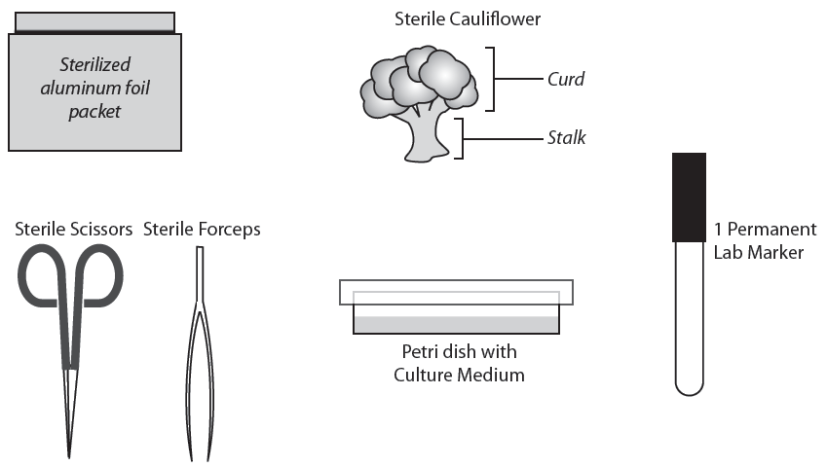

Culturing Stem Cells

For safety and cost reasons, we cannot use real human or animal tissues as a source of stem cells. But plants have stem cells that can be cultured successfully if you use the appropriate sterile techniques and culture conditions. So we’ll be using a cauliflower plant as a source of stem cells. You will try to grow the plant stem cells on a gelatin-like culture medium that contains nutrients which the stem cells need to survive.

Your task is to determine what parts of a piece of cauliflower (the “curd” or the stalk) could be a used as a source of stem cells for growing on a culture medium. A culture medium is a liquid or gelatinous substance containing nutrients which cells need to survive.

Question: In what part of a cauliflower are the stem cells located—the “curd” or the stalk?
Your hypothesis:
__________________________________________________________________________________________________________________________________________________

If you were given the following materials, what procedure would you use to test your hypothesis?

Bacteria and molds can also grow on the culture medium. Before you begin, talk with your partner about what you should do to keep the equipment and plant parts as sterile (free of mold and bacteria) as possible. Make a list of the things that you should be careful to do and not do to keep the plant parts sterile.

Do
____________________________________________________________________Student answers will vary. ____________________________________________________________________________________________________________________________________________________________________________________________________________________________________
Do NOT
____________________________________________________________________Student answers will vary. _______________________________________________________________________________________________________________________________________________________________________________________________________________________________________

Hint: You will need to cut the large piece of cauliflower into smaller “pea-sized” pieces of cauliflower for your experiment.

Plan your experiment:

- Explain how you will set up a controlled experiment to test your hypothesis.
_________________________________________________________________________Student answers will vary. Check to be sure they have a control for their experiment. ____________________________________________________________________________________________________________________________________________________________________________________________________________________________________________________________________________________________________

- Predict what results you would expect from your experiment if your hypothesis was correct.
Student answers will vary. Students should predict that the plant part(s) that they indicated in their hypothesis should divide to form new cells. ___________________________________________________________________________________________________________________________________________________________________________________________________________________________
- Ask your teacher to:
- Check your experiment plan and your predictions.
- Provide the materials needed to conduct your experiment.

Conduct your experiment:
- Set up your experiment. Be sure to put your team members’ names on the bottom of the plate.

- Results: (Visible growth may take 1-2 weeks, depending on light and temperature conditions)
_________________________________________________________________________Students may observe no growth, growth, or mold/bacteria contamination. __________________________________________________________________________________________________________________________________________________

- Conclusions:
_________________________________________________________________________Students answers will vary based on the results that they observed. ____________________________________________________________________________________________________________________________________________________________________________________________________________________________________________________________________________________________________

Three Ways to Make a Pluripotent Stem Cell Line
Summary:
Students model and describe how the processes of in vitro fertilization and therapeutic cloning (nuclear transplantation) can be used to create a pluripotent stem cell line.

Objectives:
Students will…
- Model and explain how in vitro fertilization could be used to produce a blastocyst and a pluripotent stem cell line.
- Model and explain how therapeutic cloning (nuclear transplantation) could be used to produce a blastocyst and a pluripotent stem cell line.
- Model and explain how genetic reprogramming can be used to create a pluripotent stem cell line.

Preparing for class:
- Each student will need 1 copy of Three Ways to Make a Pluripotent Stem Cell Line
- Each team of students will need an activity kit containing:
- Two condiment cups that each contain a yellow bead. Label the cups “Egg Cell.” The beads should be small enough to fit into a large bore straw.
- One blue bead with a small piece of wire/twist tie attached to represent the sperm flagellum.
- Two condiment cups that each containing a green bead. Label the cups “Skin Cell.” The beads should be small enough to fit into a large bore straw. Optional: Punch a hole in the lid that is large enough to fit a jumbo straw.
- A microtube containing 4 very small beads. Label ““Virus with 4 Master Genes.”
- One wide bore straw to simulate a pipet used to transfer nuclei (beads).
- A 100 mm. diameter plastic Petri plate (top or bottom) labeled “Culture Dish.”
- A “Development Diagram Sheet” with a series of diagrams illustrating how the zygote develops into a blastocyst and how inner cell mass is transferred into a culture dish to create an embryonic cell line. Consider cutting and laminating the diagram cards so they can be recycled.
- A pair of scissors (if the teacher has not already cut out the diagram cards)

In the classroom:
- Explain that embryonic stem cells are isolated from a blastocyst produced through in vitro fertilization or therapeutic cloning. They will model how both of these processes can be used to create an embryonic stem cell line.
- Distribute one copy of Three Ways to Make a Pluripotent Stem Cell Line to each student.
- Distribute an activity kit to each team of students.
- When students call you over to check their work, ask them to explain their models and their graphic sequences.
Development Diagram Sheet (Cut along dotted lines)

Three Ways to Make a Pluripotent Stem Cell Line

1. In Vitro Fertilization (IVF)
In vitro is a Latin term, meaning “in the glass”. In vitro refers to growing cells in laboratory containers (i.e. test tubes or culture dishes) instead of in a living organism.
In vitro fertilization (IVF) offers infertile couples a chance to have a child who is biologically related to them. With IVF, a method of assisted reproduction, a man's sperm and the woman's egg are combined in a laboratory dish (“in vitro”), where fertilization occurs. Two to four of the resulting embryos are then transferred to the woman's uterus (womb) to implant and develop naturally. Extra (“left-over”) embryos may be stored for future use or may be donated and cultured for use in embryonic stem cell research.
After many mitotic divisions in a laboratory dish, this single cell forms a blastocyst (an early stage embryo with about 100 cells) with DNA from both of the parents. Embryonic stem cells can be isolated by transferring cells from the inner cell mass of the blastocyst to another laboratory culture dish.
- Model the process by which in vitro fertilization forms a zygote. Use the culture dish, the sperm cell model, one of the egg cell models.

- Cut along the dotted lines on the Development Diagram Sheet to make a set of diagram cards.

- Arrange the diagram cards in the correct sequence to illustrate how the zygote develops into a blastocyst that is a source of embryonic stem cells used to create an embryonic stem cell line.

- Call your teacher over to check your work.

- In your own words, explain how in vitro fertilization is used to produce a blastocyst and an embryonic stem cell line.
Egg cells and sperm cells are placed in a culture dish. They combine to form a zygote. The zygote divides to form a blastocyst. Inner mass cells of the blastocyst are transferred to another culture dish.
2. Therapeutic Cloning
(also called Somatic Cell Nuclear Transplantation)
In therapeutic cloning an egg is placed in a laboratory dish and the egg’s nucleus is removed. At the same time, the nucleus of a somatic cell (a body cell other than a sperm or egg cell), which contains the organism's DNA is removed and the rest of the cell discarded. The nucleus of the somatic cell is then inserted into the enucleated egg cell. The egg containing the new nucleus is stimulated with a shock so that it begins to divide.
After many mitotic divisions in a laboratory dish, this single cell forms a blastocyst (an early stage embryo with about 100 cells) with almost identical DNA to the original organism. Embryonic stem cells can be isolated by transferring cells from the inner cell mass of the blastocyst to another laboratory culture dish.
- Model the process of therapeutic cloning (nuclear transplantation) to form a cell that begins the development process. Use the culture dish, egg cell model, straw (to transfer the nucleus) and skin cell model.

- Arrange the diagram cards in the correct sequence to illustrate how the new cell develops into a blastocyst that is a source of embryonic stem cells used to create an embryonic stem cell line.

- Call your teacher over to check your work.

- In your own words, explain how in therapeutic cloning is used to produce a blastocyst and an embryonic stem cell line.
The nucleus is removed from an egg cell. Another nucleus is transferred from a skin cell into the egg cell. The resulting cell divides to form a blastocyst. Inner mass cells of the blastocyst are transferred to another culture dish.

- State one similarity between a blastocyst created by in vitro fertilization and a blastocyst created by therapeutic cloning.
They both have inner mass cells that can be used to make an embryonic stem cell line.
- State one difference between a blastocyst created by in vitro fertilization and a blastocyst created by therapeutic cloning (nuclear transplantation).
The nucleus of the bastocyst produced by in vitro fertilization is not identical to either the egg cell or the sperm cell nuclei. The nucleus of the blastocyst cells produced by therapeutic cloning (nuclear transplantation) is identical to the nucleus of the skin cell.

3. Gene Transfer Reprograms

Differentiated Cells into Embryonic Stem Cells
Scientists report that they have turned human skin cells into what appear to be embryonic stem cells without having to make or destroy an embryo. Until now, the only way to get human embryonic stem cells was to pluck them from a human embryo, destroying the embryo in the process.
In this new technique for making embryonic stem cells, the scientists used viruses to transfer master regulator genes into skin cells. These master regulator genes turn other genes on or off, reprogramming the skin cells into undifferentiated cells. The reprogrammed skin cells, called induced pluripotent stem cells (IPSCs) appear to behave very much like human embryonic stem cells. They can be cultured and should be able to differentiate into any of the 220 cell types of the human body.
The new method could be used to create genetically matched cells which would not be rejected by the immune system if used as replacement tissues for patients. Even more important, scientists say, is that genetically matched cells from patients would enable them to study complex diseases, like Alzheimer’s, in the laboratory. For example, researchers could make stem cells from a person with a disease like Alzheimer’s and turn the stem cells into nerve cells in a Petri dish. Then they might learn what goes wrong in the brain and how to prevent or treat the disease.
Creating IPSCs includes potentially risky steps, like using viruses to insert the genes into the cells’ chromosomes. These viruses slip genes into chromosomes at random, sometimes causing mutations that can make normal cells turn into cancers. And one of the genes used to make IPSCs is a cancer gene. In addition, IPSCs may yet prove to have subtle differences from embryonic stem cells that come directly from human embryos.
Researchers are now trying to create IPSCs by adding chemicals or using harmless viruses to get the genes into cells.
Modified from: http://www.nytimes.com/2007/11/21/science/21stem.html?_r=2&bl=&ei=5087&en=7857a1f63763a21e&ex=1195707600&oref=slogin&pagewanted=&oref=slogin

- What is an “induced pluripotent stem cell” (IPSC)?
Skin cells that have been reprogrammed into undifferentiated cells. Induced pluripotent stem cells (IPSCs) appear to behave very much like human embryonic stem cells. They can be cultured and should be able to differentiate into any of the 220 cell types of the human body.

- Describe the process the scientists used to create “induced pluripotent stem cells.”
Scientists used viruses to transfer master regulator genes into skin cells. These master regulator genes turn other genes on or off, reprogramming the skin cells into undifferentiated cells.

- Use the models of a skin cell and a virus in kit to illustrate how a skin cell could be reprogrammed to make an embryonic stem cell.

- Call your teacher over to check your work.

- Explain two benefits associated with this stem cell research.
It reduces ethical concerns because no embryos are destroyed.
It produces pluripotent stem cells that are not rejected when they are transplanted.

- Explain two limitations associated with this stem cell research.
Viruses insert genes into chromosomes at random, sometimes causing mutations that can make normal cells turn into cancers. One of the genes used to make IPSCs is a cancer gene. IPSCs may have subtle differences from embryonic stem cells that come directly from human embryos.

Genes and Stem Cell Differentiation

Summary:
Students use simulated microarrays that illustrate that differentiation is a result of turning on and turning off different genes. Students also read an article that explains how scientists have manipulated genes to change differentiated cells into cells that are similar to embryonic stem cells.

Objectives:
Students will…
- Define “gene expression.”
- Explain that differentiation results with specific environmental factors turn on or turn off the expression of specific patterns of genes.
- Compare the genes that are expressed or silenced in embryonic stem cells, ectoderm cells, mesoderm cells, and endoderm cells.
- Identify growth factors that could be used to “coax” embryonic stem cells into the three different cell types.

Preparing for class:
- Copy one set of 4 microarray color transparencies (gray, green, blue, and red) per team of 2-4 students. Cut along dotted lines to make a set of 4 microarrays - gray, red, blue, green.
- Make 1 copy of Genes and Stem Cell Differentiation per student.

In the classroom:
- Distribute 1 set of “microarrays” to each student team.
- Distribute 1 copy of Genes and Stem Cell Differentiation for each student.
- Read or explain the first page. Ask students to write (and then share) a definition for gene expression.
- Read or explain the information on microarray technology. Ask students to explain how they will tell if a gene is active.
- Ask students to work in teams of 2-4 students to complete the activity.
Teacher Note: For more advanced classes you may wish to discuss the fact that current research indicates that control of differentiation may involve regulation at multiple levels.
  - Transcriptional—the production of mRNA (illustrated in this activity)
  - Translational—the production of proteins
  - Post-translational—the activation or deactivation of proteins.

Embryonic Stem Cells Microarray

 | 1 | 2 | 3 | 4
A
B
C
D

Ectoderm Cells Microarray

 | 1 | 2 | 3 | 4
A
B
C
D

Mesoderm Cells Microarray

 | 1 | 2 | 3 | 4
A
B
C
D

Endoderm Cells Microarray

 | 1 | 2 | 3 | 4
A
B
C
D

Genes and Stem Cell Differentiation

Once stem cells have been isolated, scientists need to figure out how to get them to differentiate into needed kinds of specialized cells. Research has shown that differentiation results when growth factors (“coaxing agents”) cause specific genes to be expressed (turned on) and other genes to be silenced (turned off).

In this laboratory activity, you will:
- Simulate one type of research used determine which genes are turned on or off when embryonic cells differentiate into three types of cell lines—ectoderm, mesoderm, and endoderm.
- Use this information to select growth factors that could be used to turn on and turn off genes in embryonic stem cells to “coax” them to differentiate into different cell lines.

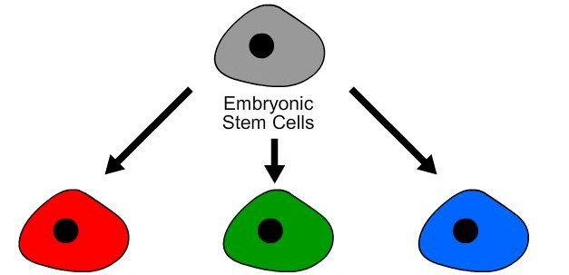

Mesoderm Cells  Becomes…  - Muscle  - Bone  - Blood | Endoderm Cells  Becomes lining of…  - Digestive system  - Lungs | Ectoderm Cells  Becomes…  - Skin  - Nervous system

First, scientists need to determine which genes in the embryonic stem cells are turned on and which genes are turned off as embryonic stem cells differentiate into ectoderm, mesoderm, or endoderm cells.

When a gene is expressed (turned on), it produces RNA that leads to production of a protein that results in specific cell structures or functions.

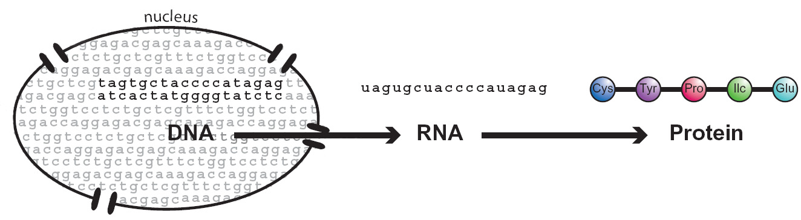
Cell Structure and Function

In your own words, explain the sequence of events that occur when a gene is expressed.
The DNA makes RNA. The RNA makes a protein. The protein makes cell structures or carries out cell functions.

Microarray technology can be used to compare which kinds of RNA produced when genes are expressed in different types of cells. A microarray is a slide that has spots of DNA from known genes. RNA samples from different types of cells are added to a microarray. The RNA will ONLY bind to complementary DNA (genes) on the microarray. If a gene is expressed (turned on) in a cell, it will make RNA that binds to the DNA on the microarray. The binding results in a colored spot on the microarray.

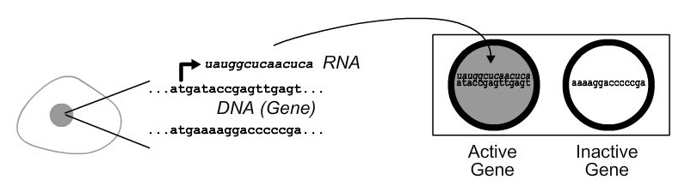
Active gene makes RNA
RNA binds to
this gene spot.

RNA cannot bind to
this gene spot.
.

Why does the RNA bind to one spot and not to the other spot?
The RNA only binds to DNA spots that have a complementary base code sequence.

How will you tell which genes are expressed by a cell?
Genes that are active make RNA that binds to spots on the microarray.
For this activity, you will use a set of four simulated microarrays representing four different types of cells.

- Obtain a gray embryonic (undifferentiated) stem cell microarray. Any coordinates (for example, 1-A) that are gray represent genes that are active (making RNA) in an embryonic stem cell.

- Obtain a red ectoderm microarray. The red spots represent genes that are active in ectoderm cells.

- Place the red microarray over the gray microarray, matching up the circles on the two slides.

- The red-gray spots on the overlapped microarray indicate genes that are active in both embryonic stem cells and ectoderm cells. These genes are NOT likely to cause the undifferentiated embryonic stem cells to differentiate into ectoderm cells.

- List the coordinates of the gray spots. These spots indicate genes that are only active in undifferentiated embryonic stem cells. __1D 2C 3B _____________________

- List the coordinates of the red spots. These spots indicate genes that are only active in ectoderm cells. ___1C 2D 3A _____________________________

- To coax embryonic stem cells to differentiate into ectoderm cells, scientists would want to:
- turn on genes _____1C 2D 3A ________
- turn off genes ______1D 2C 3B _____________

Next you need to identify which growth factors (“coaxing agents”) could be used to turn on and turn off the specific genes you identified in your microarray studies. The work of other researchers has previously identified the effect of various growth factors on gene expression. Data from their research is summarized in the data table below.

Growth Factor | Turns on genes | Turns off genes
GF A | 1C, 2D, and 3A | 1D 2C 3B
GF B | 3C, 3D, and 4A | 1D 3B 4D
GF C | 2A and 2D | 1A 4D
GF D | 1D 2C 3B | 1C, 2D, and 3A
GF E | 1A 4D | 3C, 3D, and 4A

- Which growth factor(s) would you select to “coax” embryonic stem cells to differentiate into ectoderm cells? ___GF A _______________________

- Obtain a gray undifferentiated embryonic stem cell microarray and a green mesoderm microarray. The green spots represent genes that are active in ectoderm cells.

- Place the green microarray over the gray microarray, matching up the circles on the two slides.

- The green-gray spots on the overlapped microarray indicate genes that are active in both embryonic stem cells and mesoderm cells. These genes are NOT likely to cause the undifferentiated embryonic stem cells to differentiate into ectoderm cells.

- List the coordinates of the gray spots. These spots indicate genes that are only active in undifferentiated embryonic stem cells. __1D 3B 4D _____________________

- List the coordinates of the green spots. These spots indicate genes that are only active in differentiated mesoderm cells. ___3C 3D 4A _____________________

- To coax embryonic stem cells to differentiate into mesoderm cells, scientists would want to:
- turn on genes _____3C 3D 4A ________
- turn off genes _____1D 3B 4D _______

- Use the growth factor chart on the previous page to select the growth factor you would use to “coax” embryonic stem cells to differentiate into mesoderm cells. Which growth factor would you use? __________GF C _____

- Obtain a gray undifferentiated embryonic stem cell microarray and a blue endoderm microarray. The blue spots represent genes that are active in endoderm cells.

- Place the blue microarray over the gray microarray, matching up the circles on the two slides.

- The blue-gray spots on the overlapped microarray indicate genes that are active in both embryonic stem cells and endoderm cells. These genes are NOT likely to cause the embryonic stem cells to differentiate into endoderm cells.

- List the coordinates of the gray spots. These spots indicate genes that are only active in undifferentiated embryonic stem cells. __1A 4D _____________________

- List the coordinates of the blue spots. These spots indicate genes that are only active in differentiated endoderm cells. ___2A 2D _____________________________

- To coax embryonic stem cells to differentiate into endoderm cells, scientists would want to:
- turn on genes _____2A 2D ________
- turn off genes ______1A 4D _____________

- Use the growth factor chart to determine which growth factor(s) could be used to “coax” embryonic stem cells to differentiate into endoderm cells? ___GF B ______

- Do you think you could change ectoderm cells into mesoderm cells? Explain how you would do this or explain why this might not be possible.
Student answers will vary. Accept NO or YES and any logical explanation. If they say yes, they might explain that they would want to turn the ectoderm cell back into an embryonic stem cell and then change the embryonic stem cell into a mesoderm cell. They might also put the microarray for an ectoderm cell on top of the microarray for a mesoderm cell and then select genes that should be turned on and off.
Controlling Stem Cell Differentiation

Summary:
Students use simulated growth factors, embryonic stem cells, and tissue specific (adult) stem cells to produce tissues that could be used to treat human diseases.

Objectives:
Students will…
- Follow a flow chart to simulate the use of growth factors and embryonic stem cells to create specialized cells that could be used to treat human diseases.
- Follow a flow chart to simulate the use of growth factors and tissue specific (adult) stem cells to create specialized cells that could be used to treat human diseases.
- Explain how the cell’s environment and past history influence differentiation.
- Explain why scientists think it is important to be able to do embryonic stem cell research.

Preparing for class:
- For each student, make 1 copy of Controlling Stem Cell Differentiation - A simulation.
- For each team of 2-4 students, prepare a lab activity kit that contains:
- 1 colored chart (Growth Factors Involved in Stem Cell Differentiation)
- 6 well microtiter strip or well plate
- 1 microtube containing 1.5 mL tap water. Label “ESC”
- 1 microtube containing 1 mL colorless household ammonia. Label “ANSC”
- 2 plastic droppers labeled “ESC” and “ANSC
- 1 set of six labeled thin stem droppers containing 0.5 - 1 mL of the following simulated growth factor solutions indicated in the table below.

Dropper Label | Fill droppers with 0.5-1.0 mL of the following solutions
GF A | Colorless household ammonia
GF B | Tap or distilled water
GF C | White distilled vinegar
GF 1 | Universal Indicator Solution
GF 2 | Food color solution (1 drop black food color + 100 mL water)
GF 3 | Bromothymol Indicator ( 0.1 g Bromothymol + 100 mL water)

In the classroom:
- Distribute to each student:
- 1 copy of Controlling Stem Cell Differentiation - A Simulation
- Goggles
- 1 lab activity kit containing a set of simulated growth factors, simulated stem cells, droppers, culture wells and colored chart (Growth Factors Involved in Stem Cell Differentiation).
- Read or explain the information in the first three paragraphs and the safety instructions.
- Ask students to use the materials provided to complete the lab activity.
- At the end of the activity, ask several students to share their answers to question 8 with the class. Place an emphasis on asking for different ways that students answered question 8 (Explain how this laboratory activity illustrates each of the following phrases: “the cell’s environment” AND “the cell’s past history”)

Growth Factors (GF) Involved in Stem Cell Differentiation (Add 1 DROP of the appropriate growth factors)
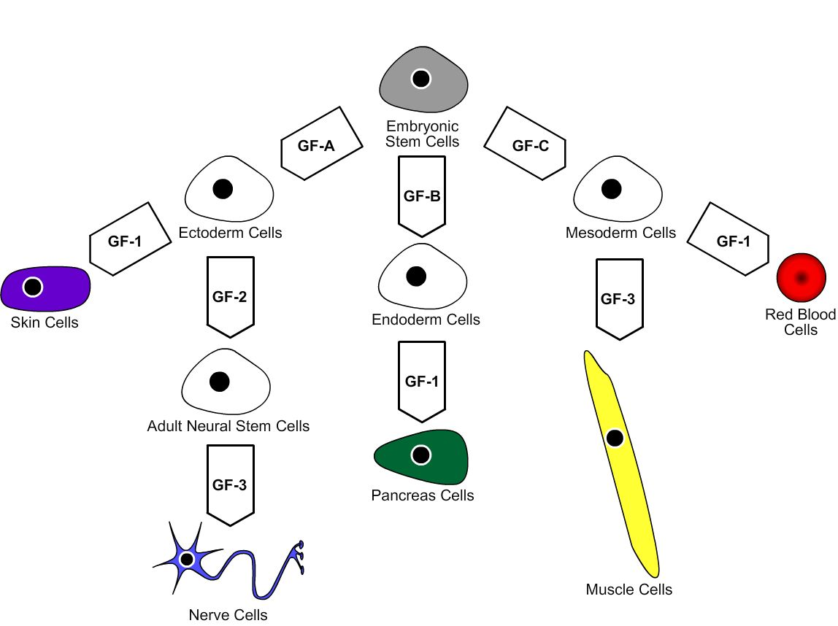

Controlling Stem Cell Differentiation - A Simulation

One of the challenges in stem cell research is developing techniques for coaxing stem cells into differentiating into specific kinds of cells. To coax stem cells into differentiating, scientists place them in environments that contain growth factors (“coaxing agents”). These growth factors include proteins and biochemicals that turn on, or turn off, the expression of specific genes that lead to differentiation.

This simulated laboratory activity gives you the chance to manipulate embryonic stem cell differentiation. You will begin with a "culture" of embryonic stem cells and tubes of growth factors (“coaxing agents”). By selecting a certain sequence of these factors you should be able to create differentiated cells that could be used to treat certain diseases.

Safety: You must wear safety goggles.

Note: if the droppers in your lab kit are sealed, use scissors to cut off the sealed end of the dropper stem.

- Use the “ESC” dropper to transfer 4 drops of the embryonic stem cell culture (ESC) from the microtube into each of five of the culture wells on the well strip.

- Use the information on the Growth Factors and Stem Cell Differentiation flow chart to select appropriate growth factors (GF) that you should add to coax the embryonic stem cells into each of the types of cells listed in column 1. Note: Use 1 drop of the appropriate growth factor. Read the colors immediately.

- Write “Yes” in column 2 if you are able to create that type of differentiated cell from embryonic stems cells.

Column 1 |  | Column 2
Differentiated Cell  Types | Potentially Used  to Treat | Able to Create from Embryonic Stem Cells
Skin cells  (purple) | Burn injuries | Yes
Nerve cells  (blue) | Spinal cord or brain injury | Yes
Pancreas cells  (blue-green) | Diabetes | Yes
Muscle cells  (yellow) | Heart damage | Yes
Blood cell  (red) | Sickle cell anemia | Yes

Imagine you are a scientist who has access to a culture of tissue specific (adult) neural stem cells. You would like to use these cells to treat brain injury.

- Use the “ANSC” dropper to transfer 4 drops of the adult neural stem cell culture (ANSC) from the microtube into the remaining well on the well strip.

- Use the information on the flow chart to select appropriate growth factors (GF) that you think you could add to coax the tissue specific (adult) neural stem cells into cells that could be used to treat brain injury.

- Can you change a tissue specific (adult neural) stem cell into a cell that could be used to treat brain injury? Yes__ Explain how. ____By adding GF-3_______

- Do you think that you could add growth factors to adult neural stem cells and turn them into differentiated blood cells? Why or why not?
Students may answer Yes or No. Their explanation should correlate logically.

- Explain why scientists think it is important to be able to do research using embryonic stem cells.
Student answers may vary. But most common answer will be that you can change them into many different kinds of cells to treat many different diseases.

Quote from a biology textbook:
“During differentiation, different parts of a cell’s genetic instructions are used in different types of cells, and are influenced by the cell’s environment and the cell’s past history.”

Quote from article Cell Decisions:
(http://www.rochester.edu/pr/Review/V69N1/feature1.html)
“In thinking about stem cells, it’s helpful to imagine the process of cell differentiation as a tree. At the roots are embryonic stem cells, and at the end of each different branch are the differentiated cells of the body. As a stem cell proceeds along each developmental branch, it becomes more specialized and loses its potential to produce different types of cells. A stem cell can move forward and produce the cell types ahead of it on the branch, but scientists generally believe that cells normally can’t move backward and produce the cells behind them or the cells on a different branch.”

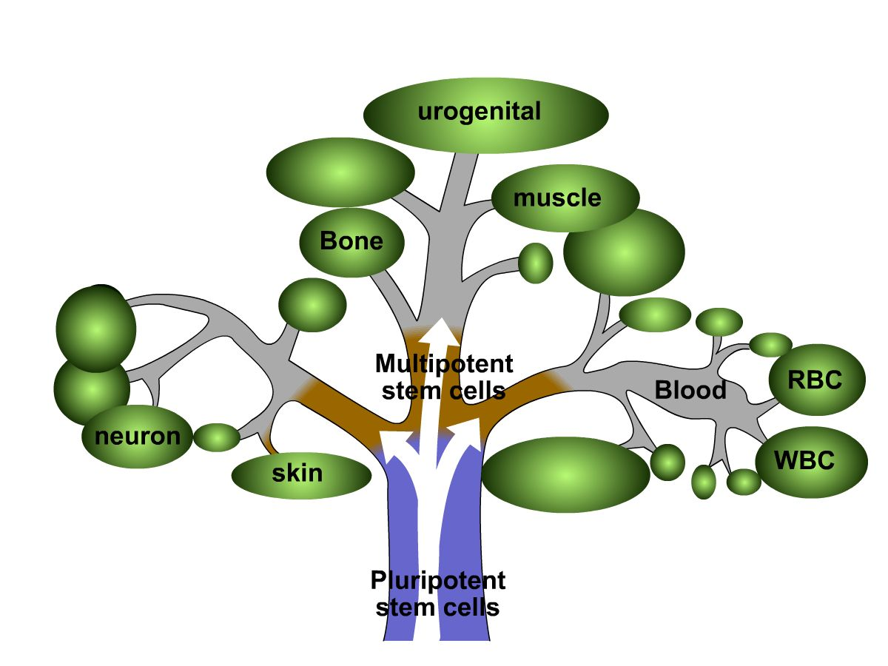
- In your own words, explain what is meant by each of the following sentences:

- Cell differentiation is determined by the cell’s environment.”
Substances like growth factors or contact with other cells can influence how a cell differentiates.
  - Cell differentiation is determine by the cell’s past history”
When a cell becomes specialized it loses its potential to produce different types of cells. A stem cell can move forward and produce the cell types ahead of it on the branch, but scientists generally believe that cells normally can’t move backward and produce the cells behind them or the cells on a different branch.”
Treating a broken heart

Summary:
Students read a scenario about a heart attack patient who has been asked to participate in a clinical trial to test a new stem cell treatment. They discuss what people should understand before they participate in a clinical trial for an experimental stem cell therapy.

Objectives:
Students will
- Read a scenario about a clinical trial to test a new stem cell therapy
- List what they know and would want to know about the scenario

Preparing for class:
Make one copy of each of the following handouts per student:
- Treating a Broken Heart scenario
- (optional) A folder or envelop containing to following handouts:
  - Stem Cells: Treating a Broken Heart article
  - Volunteering for a Clinical Trial brochure
  - Simulated Informed Consent Form

In the classroom:
- (optional) Consider showing the video “Stem Cells: Seeds of Hope” to introduce the concept of stem cell therapy. (http://www.teachersdomain.org/resources/tdc02/sci/life/cell/stemcellvid/assets/tdc02_vid_stemcellvid/tdc02_vid_stemcellvid_56_mov.html
- Distribute Treating a Broken Heart to each student. Ask them to work individually to read the scenario and answer the questions.
- Students should work in teams of 3-5 students to make a poster that lists what they know and what questions the family should ask the doctor.
- Ask students to share ONE of their questions with the class and identify a specific type of resource (person or information source) that they could use to find the answer to their question.
- (optional) Provide the folder/envelope of handouts and ask students to read to find the answers to their questions.
- (optional) Ask students which of their poster questions have not been answered by what they read. Discuss how they might find the answers to these questions.

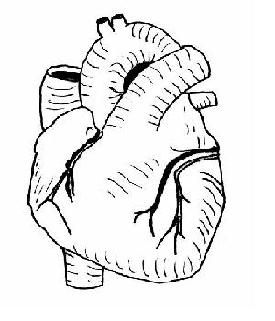
Treating a Broken Heart

Your 40 year-old mother has just had a heart attack. Her doctor says that she is lucky because the hospital is conducting the first clinical trial (experiment using human subjects) to test the safety and effectiveness of CardioStem. CardioStem is a new stem cell therapy for heart attack patients that researchers hope will repair damaged heart muscle. Patients who participate in this clinical trial will receive either an injection of CardioStem or an injection of a placebo.

Your mother has a week to decide whether she will sign the informed consent form to agree to be a participant in this clinical trial. She has asked you to help her decide what she should do.

- What do you know?

Student answers will vary.

- What questions could your family ask to help your mother make this decision?

Student answers will vary.

- Do you think that your mother should sign the informed consent form for the CardioStem treatment? Explain why or why not.

Student answers will vary.

- What other information sources (people or print materials) might your family consider consulting before making a final decision? BE SPECIFIC!

Student answers will vary.

What is a Clinical Trial?
A clinical trial is the term for any test or study of an investigational drug, device, or other medical treatment in human subjects. Some clinical trials may test already approved (on the market) medications or devices.

Researchers are constantly looking for better or new ways for treating illness and disease. Clinical trials are designed to determine whether the investigational drug, device or treatments are safe and effective for people to use. Clinical trials attempt to show that the investigational treatment is better than, as good as, or not better than the standard treatments available.

Why do people volunteer?
There are several reasons why people volunteer for clinical trials but for most, it is the possibility to help themselves and to help others who may benefit from developing a new medication or treatment.

Who conducts clinical trials?
Clinical trials are sponsored by government agencies such as the National Institutes of Health (NIH), foundations such as the American Cancer Society and the Kidney Foundation, pharmaceutical companies, device manufacturers, research institutions, individual physicians, and other health organizations. The sponsor is responsible for designing a protocol, which is the study plan that the investigator follows. Only trained investigators (doctors, nurses and medical researchers) actually conduct the study.
1
How are volunteers protected?
Your study doctor and the research team are concerned about your health and safety. If you have any questions or think you are having a study related problem, you should contact them right away.

Federal regulations require that you be given complete information about the trial before you agree to participate. This is known as informed consent. You will be told:

- That the trial involves research
- The purpose of the research
- How long the trial is expected to take
- What will go on in the study and which parts are experimental
- Possible risks or discomforts
- Possible benefits
- Other alternatives that are available instead of the research treatment
- That the FDA and others may inspect the study records, but the records will be kept in a confidential manner
- Whether medical treatments may be available if you have side effects, what the treatments are, where you can get them and who will pay for them
- Who you can contact with questions about the trial, your rights as a research subject, and injuries related to the research
- That being in the trial is voluntary and that you can quit at any time without otherwise affecting your treatment or the services you receive

2
How are volunteers protected?
Before you can be in the trial, you must sign a consent form showing that you have been given this information and that you understand it. So make sure you understand all the information first and ask the person giving you the information to explain anything you do not understand.

Clinical trials, by law, must be approved and monitored by an institutional review board (IRB). The IRB checks to see that there is the least possible risk to volunteers and that the risks are reasonable in relation to any expected benefits. The IRB reviews the plan for volunteer selection for fairness and that informed consent is obtained correctly.

Who can participate?
Every clinical trial has guidelines about who is eligible. There are certain requirements about your health, medical condition, medications, age and other things.

What can I expect?
More than anything else, you have the right to expect complete information about the trial. You should not participate in a clinical trial unless all your questions have been answered in a way you can understand. You should also understand your commitment to the trial. You will need to follow the investigator’s instructions carefully.

3
What are the risks?
There may be side effects or adverse reactions to the medications or treatments. Because the treatments being studied are new, the doctors do not always know what the side effects will be. While it is possible that some side effects could be permanent or life threatening, most are temporary and can be treated or go away when the treatment is stopped.

Many studies require that neither the subject nor the doctor know whether the subject is receiving the experimental treatment, the standard treatment or a placebo (an inactive substance that looks like the drug being tested).

What are the benefits?
There may or not be a direct benefit to you if you volunteer for a clinical trial. Your health or your health condition may get better as a result of your participation, it may stay the same or it may even get worse. No one can completely predict the outcome of a clinical trial or how it might affect you. The study may result in information that will help others in the future.

4
What kinds of questions should I be asking?
Here are some questions to ask the doctor to help you decide if you want to take part in a clinical trial:

- What is the study trying to find out?
- Who is sponsoring the study?
- What kinds of tests and exams will I have to take while I am in the study? How much time do these take? What is involved in each test? Are these extra tests?
- How often does the study require me to go to the doctor or clinic?
- Will I be hospitalized? If so, how often and for how long?
- What are the costs to me? Will my health insurance pay for it?
- Will there be follow-up?
- What happens at the end of the study?
- What are my other treatment choices? How do they compare with the treatment being studied?
- What side effects can I expect from the treatment being tested? How do they compare with side effects of standard treatment? How long will they last?

Questions, concerns, or feedback about human research at the University of Rochester, can be directed to a Human Subjects Protection Specialist at the University of Rochester Research Subjects Review Board, Box 315, 601 Elmwood Ave., Rochester, NY 14642-8315; Telephone: 585/276-0005; for long distance, call toll free: 877/449-4441.

5

Volunteering for a Clinical Trial

Important information you need to know

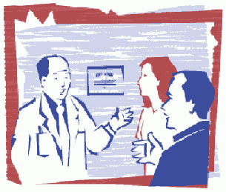

Stem Cells: Treating a Broken Heart

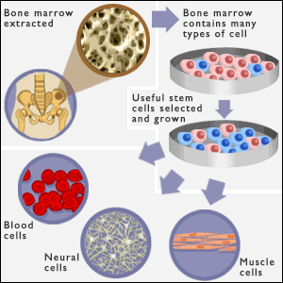
Source: http://news.bbc.co.uk/1/shared/spl/hi/pop_ups/03/health_stem_cell_guide/html/4.stm
More than half a million Americans each year have their first heart attack, a sudden blockage of an artery that deprives heart muscle of blood and oxygen. The resulting injury and scarring often contribute to a gradual loss of the heart’s pumping strength, a condition known as congestive heart failure.
University Medical Center researchers today announced the launch of a clinical trial that will examine whether transplanted stem cells can be safely used to treat damaged heart muscle in patients just after their first heart attack. As part of the fast emerging science of regenerative medicine, labs worldwide are attempting to replace damaged tissue with new cells, much in the same way as salamanders re-grow limbs.
“The potential to re-build damaged heart muscle by implanting stem cells that then become new muscle cells is one of the most exciting in cardiology,” said Alice Jones, M.D., assistant professor of Cardiology at the medical center and principal investigator for the current study. “This study will seek to ensure that stem cell therapy is safe in treating heart failure, a major cause of death in heart attack survivors.
This clinical trial involving heart attack patients will seek to demonstrate the safety, and roughly measure efficacy, of three intravenous doses of tissue specific (adult) human stem cells versus placebo in lessening damage to heart muscle within ten days of first heart attack. The treatment recently passed an early safety test and has been approved for study in more patients at higher doses. That process will get underway shortly in Rochester.
Forty-eight patients will participate in the trial. Male and female patients are eligible and must be between the ages of 21 and 85 and in good overall health, with the exception of a recent heart attack. Trial entry must occur within 10 days of first heart attack, and patients will be followed for two years afterward.
The trial is designed to evaluate safety of treatment with stem cells obtained from healthy, unrelated, adult donors (not from a fetus, embryo or animal). CardioStem, developed by StemCell Therapeutics, Inc., is not yet an approved or marketed therapy.
Researchers hope that the use of transplanted stem cells to replace lost heart muscle cells will do what current treatments cannot: prevent heart muscle loss after heart attack. Animal studies have shown that MSCs injected into heart muscle following a heart attack decreased the death of muscle cells and increased pumping strength.
This new study is a randomized, double-blind, placebo-controlled, Phase I clinical trial with patients randomized to receive either an injection of 0.5 million, 1.6 million or 5.0 million cultured adult mesenchymal stem cells (CardioStem) per kilogram of body weight, or placebo.
Along with the treatment or placebo, all patients will receive standard treatment, including techniques to maximize blood flow to damaged areas, pain relief, oxygen, anti-coagulants, beta-blockers, nitrates, ace-inhibitors and advice on reducing risk factors.
Experts believe that mesenchymal stem cells for many reasons have tremendous potential to become the basis for a powerful new treatment area in cardiology. For instance, research has shown that MSCs, like Blood Type O, are universally compatible, meaning they can be transplanted from person to person without fear of rejection by the recipient’s immune system.
Other approaches – like harvesting stem cells from the patients’ own tissue – can be expensive, time-consuming and limited in the numbers of cells produced. Stem cells donated by other humans (allogenic) make possible the storage of stem cell supplies ready for immediate use as heart attack patients arrive at hospitals.
From a small sample of bone marrow, researchers can grow billions of allogenic stem cells in cultures, controlled environments that mimic human tissue. Cultured MSCs are used already in the treatment of some cancers.
While previous studies injected cells directly into the heart, scientists hope that MSCs can be delivered to the heart by a standard injection in the arm. MSCs actually home in on the tissue damaged by heart attack. It has been shown that higher animals store MSCs in the bone marrow, and release them into the blood stream after injury, where they can rush to the site of damage to aid in wound repair the same way that white blood cells rush in to fight infection.
Several questions remain about whether MSC treatments will be effective for repairing damaged hearts. For example, implanted stem cells have been shown in some studies to only partly differentiate, with the end result lacking some of the characteristics of a mature heart muscle cell. Also, early studies also found that most implanted MSCs either re-enter the circulation or die rather than engraft to the heart muscle wall to form new muscle cells.

Modified from: http://www.urmc.rochester.edu/pr/news/story.cfm?id=1001

University Hospital Research Institute
Informed Consent Form

This Informed Consent Form is for men and women who have sought treatment at the University Hospital for a heart attack. We are inviting patients to participate in research to investigate CardioStem, a new treatment for heart attack patients.

The study described in this consent form is being conducted by Dr. Alice Jones, of the University Hospital Research Institute. The study is funded by the National Institutes of Health.

This Informed Consent Form has two parts:
- Part 1: Information Sheet – to share information about the research with you
- Part 2: Certificate of Consent – for signatures if you agree to take part

PART 1: Information Sheet

Introduction
I am Dr. Alice Jones, working for the University Hospital Research Institute. We are doing research on the use of CardioStem, a stem cell therapy to prevent congestive heart failure following a heart attack. I am going to give you information and invite you to be part of this research. You do not have to decide today whether or not you will participate in the research. Before you decide, you can talk to anyone you feel comfortable with about the research. There may be some words that you do not understand. Please ask me to stop as we go through the information and I will take time to explain. If you have questions later, you can ask them of me, the study doctor or the staff.

Purpose
The purpose of this research study is to investigate a new treatment for heart attack patients. The drugs that are currently used to treat heart attack patients do not always cause the patient to get better. For some patients, their heart disease may continue to worsen even with treatment. This may lead to congestive heart failure, a condition in which damaged heart muscle cannot pump blood enough blood to the body’s other organs. If administered within ten days of a first heart attack, CardioStem treatment has the potential to rebuild damaged heart muscle by implanting tissue specific (adult) stem cells that then become new heart muscle cells. Current treatments for heart attacks (perfusing oxygen, anticoagulants, beta blockers, nitrates, ace-inhibitors, and reduction of risk factors) have not proven as effective as we would like in reducing the incidence of congestive heart failure in patients who had a heart attack. CardioStem is a new treatment which may work better. The reason we are doing this research is to find out if CardioStem, is better than the standard treatment.

Type of research intervention
This research will involve three injections of CardioStem (mesenchymal stem cells) into the vein in your arm. These injections will be administered before you leave the hospital. The study will require four follow-up visits to the clinic where we will test your heart rhythm, ejection fraction, pulmonary function, and general health.

Participant Selection
We are inviting all adults with who have had a heart attack to participate in the research on the new treatment.

Voluntary Participation
Your participation in this research is entirely voluntary. It is your choice whether to participate or not. Whether you choose to participate or not, all the medical services you currently receive will continue and nothing will change. You may change your mind later and stop participating even if you agreed earlier.

Information on CardioStem
The treatment we are testing in this research is called CardioStem. CardioStem is made by isolating mesenchymal stem cells from bone marrow donated by adults. The injection of mesenchymal stem cells into veins has been tested and shown to be beneficial in treating mice with damaged heart muscle. Research done on human subjects has shown that transplanted mesenchymal stem cells do not induce an immune response or a graft-vs-host reaction. CardioStem has been used to treat other diseases during other clinical trials with no side-effects or adverse reactions. We now want to test CardioStem on people who have had a heart attack to see if this treatment is effective on decreasing the percentage of heart attack patients who develop congestive heart failure. This type of research is called a "Phase 2" trial.

CardioStem is made by StemCell Therapeutics, Inc. You should know that Phase I studies have shown that CardioStem, when given at the dosage we will be using in this clinical trial, was well tolerated by the study subjects. We do not anticipate and problems or risks as a result of CardioStem treatment.

Some participants in the research will not be given the treatment which we are testing. Instead, they will be only be given only the standard treatment typically given to all heart attack patients.

Procedures
Because we do not know if CardioStem treatment is better than the currently available treatments for heart attack patients, we need to compare the two. To do this, we will put clinical trial participants taking part in this research into two groups. The groups are selected by chance, as if by tossing a coin.

Participants in one group will be given CardioStem treatment along with the standard treatments given to all heart attack patients. Participants in the other group will be only be given the standard heart attack treatments. It is important that neither you nor we know whether you have been given CardioStem. This information will be in our files, but we will not look at these files until after the research is finished. This is the best way we have for testing without being biased—influenced by what we think or hope might happen.

We will then compare which of the two groups has the best results. The healthcare workers will be looking after you and the other participants very carefully during the study. If we are concerned about what the drug is doing, we will find out which treatment you are getting and make changes. If there is anything you are concerned about or that is bothering you about the research please talk to me or one of the other researchers

Participants in the group that will be given only the standard treatment will receive a dose of a placebo instead of doses of CardioStem. A placebo or inactive medicine looks like real medicine but it is not. A placebo has no effect on a person because it has no real medicine in it. Sometimes when we want to know whether a new medicine is good, we give some people the new medicine and some people the placebo. For the research to be good, it is important that you do not know whether you have been given the real treatment or the placebo. This is one of the best ways we have for knowing what the treatment we are testing really does.

You will receive the treatment of your condition according to national guidelines. This means that you will receive CardioStem through a vein in your arm (called an intravenous injection). To obtain baseline data on the extent of your heart damage, we will do an EKG, an MRI, a Pulmonary Function Test, and a general physical examination before you leave the hospital. The results of these tests will be used only for our research.

Description of the Process
During the research you will make five visits to our medical clinic—1 month, 3 months, 6 months, 12 months, and 24 months. During each visit we will do an EKG, an MRI, and a Pulmonary Function Test. We will also ask you a few questions about your general health and perform a general physical examination.

Duration
This research will take place over 2 years. During that time, it will be necessary for you to come to the clinic five times. Each clinic visit should be about four hours long. At the end of two years, the research will be finished.

Side Effects
As already mentioned, CardioStem treatment has been well-tolerated by patients during previous clinical trials. But there is always that possibility that it may also cause some short-term or long-term problems that we are not aware of. However, we will follow you closely and keep track of any unwanted effects or any problems. We may use some other medicines to decrease the symptoms of the side effects or reactions. If this is necessary we will discuss it together with you and you will always be consulted before we move to the next step

Risks
By participating in this research it is possible that you will be at greater risk than you would otherwise be. There is, for example, a risk that your disease will not get better and that the new treatment (CardioStem) when given in combination with standard treatments does not increase your chances of getting better when compared to the standard treatment only. There is also a risk that you will have some unwanted side effects or problems.

Discomforts
By participating in this research it is possible that you may experience some discomfort such as needle sticks from the injections or follow-up testing procedures.

Benefits
If you participate in this research, you will have the following benefits: any interim illnesses will be treated at no charge to you. There may not be any benefit for you but your participation is likely to help us find the answer to the research question. There may not be any benefit to the society at this stage of the research, but people are likely to benefit from this research in the future.

Incentives
We will give you $20 for each clinic visit to pay for your travel to the clinic. You will not be given any other money or gifts to take part in this research.

Research Related Injury
In the event that this research activity results in an injury, treatment will be available, including first aid, emergency treatment and follow-up care as needed. Care for such injuries will be billed in the ordinary manner, to you or your insurance company. The sponsor of the study has some funds available to pay for care for injuries resulting directly from being in this study. If you think that you have suffered a research related injury and that you may be eligible for reimbursement of some medical care costs, let the study physicians know right away.

Confidentiality
It is possible that if others in the community are aware that you are participating in this research, they may ask you questions. We will not be sharing the identity of those participating in the research with anyone. The information that we collect from this research project will be kept confidential. Information about you that will be collected during the research will not be identified by your name but by a number. Only the researchers will know what your number is and they will lock that information up with a lock and key. It will not be shared with or given to anyone except Dr. Jones and her research team, the National Institutes of Health (they are the research sponsors), and your own medical doctor.

Sharing the Results
The knowledge that we get from doing this research will be shared with you before it is made widely available to the public. Confidential information will not be shared. After the research is completed, we will publish the results in order that other interested people may learn from our research.

Right to Refuse or Withdraw
You do not have to take part in this research if you do not wish to do so and refusing to participate will not affect your medical treatment in any way. You will still have all the benefits that you would otherwise have at this clinic. You may stop participating in the research at any time that you wish without losing any of your rights as a patient here. Your treatment at this clinic will not be affected in any way.

Alternatives to Participating
If you do not wish to take part in the research, you will be provided with the established standard treatment available for Class IV lupus nephritis, which will be determined by your own medical doctor.

Who to Contact
If you have any questions you may ask them now or later, even after the study has started. If you wish to ask questions later, you may contact:
Dr. Alice Jones
University Hospital Research Institute
123 Institute Drive
Anytown, NY 12345
(555)123-4567
Alice_Jones@UHRI.org

This proposal has been reviewed and approved by the University Hospital Research Institute’s Institutional Review Board (IRB), which is a committee whose task it is to make sure that research participants are protected from harm. If you have any questions or concerns regarding the study and would like to talk to someone other than the researchers, you should contact: Mr. Robert Foster, University Hospital Research Institute, (555)123-5678 or Robert_Foster@URHI.org.

You will be given a copy of this form to keep for your records.
PART 2: Certificate of Consent

I have been invited to participate in research of a new drug to prevent congestive heart failure due to a heart attack. I understand that it will involve receiving three injection of CardioStem that contains mesenchymal stem cells isolated from donor bone marrow. I understand that participation in the study includes five visits to the clinic. I have been informed that there may be some risks to this procedure. I am aware that there may be no benefit to me personally and that I will not be compensated beyond travel expenses. I have been provided with the name of a researcher who can be easily contacted using the number and address I was given for that person.

I have read the information sheet about this research study, or it has been read to me. I have had the opportunity to ask questions about it and any questions that I have asked have been answered to my satisfaction. I consent voluntarily to participate in this research and understand that I have the right to withdraw form the research at any time without in any way affecting my medical care.

Print Name of Participant _____________________________________
Signature of Participant _______________________________________
Date (day/month/year) _______________________________________

Thumb print of Participant

I have witnesses the accurate reading of the consent form to the potential participant, and the individual has had the opportunity to ask questions. I confirm that the individual has given consent freely.

Print Name of Witness _______________________________________
Signature of Witness _________________________________________
Date (day/month/year) _______________________________________

I have accurately read or witnessed the accurate reading of the consent form to the potential participant, and the individual has had the opportunity to ask questions. I confirm that he individual has given consent freely.

Print Name of Researcher _____________________________________
Signature of Researcher _______________________________________
Date (day/month/year) _______________________________________

A copy of this Informed Consent Form has been provided to the participant _______ (initialed by the researcher/assistant).

A Revolutionary Breakthrough: Induced Pluripotent Stem Cells

Summary:
Students learn about a revolutionary scientific breakthrough that enables scientists to turn differentiated cells into pluripotent stems cells that are similar to embryonic stem cells.

Students will:
- Read current news articles about induced pluripotent stem cell technology that has revolutionized stem cell research.
- Work in teams to create a product that could be used to make information about induced pluripotent stem cells (IPSC) available to high school biology students.
- Review the work of other teams to peer review the information products that they created.

Before Class:
- Science Daily has a news articles that are relatively brief and easy for average students to read. Visit Science Daily (http://www.sciencedaily.com/) and type “induced pluripotent stem cells) into the search box. Select 4-8 articles for printing (one set of articles per student team).
- For each team of 2-4 students, print one copy of Stem Cell Researcher Letter and one copy of each article on induced pluripotent stem cells. Place these in an envelope or folder.
- Consider using internet search engines to locate and print additional current news articles on “induced pluripotent stem cells.”

During Class:
- Distribute one copy of folder/envelop containing the Stem Cell Researcher Letter and articles to each student.
- Read the letter aloud to the class.
- Explain that there are currently few lesson resources that teachers can use to make high school teachers aware of this revolutionary new technology.
- Explain that you would like them to work in teams of 2-4 students to create ONE information product that you could use with your future biology classes.
- List the possible types of products on the board or on the overhead. (See model transparency on the next page) You may opt to allow other types of products.
  - A one-page textbook section
  - A trifold brochure
  - A 5-10 slide PowerPoint slide show
  - A 2 minute video news broadcast
  - A poster
- Explain that you would like to share the information products that they create with your colleagues.
- Review the section of the researcher’s letter that describes the information that should be included in each product.
Induced Pluripotent Stem Cells
Information Products

Possible types of information products:
  - A one-page textbook section
  - A trifold brochure
  - A 5-10 slide PowerPoint slide show
  - A 2 minute video news broadcast
  - A poster

Information products should:
  - Explain how induced pluripotent stem cells can be produced by “reprogramming” differentiated cells.
  - Identify the advantages and limitations of induced pluripotent stem cells.
  - Identify current and potential future uses for induced pluripotent stem cells.
University Hospital Medical Center
Stem Cell Research Institute

Dear ________________________________,

My daughter has been telling me about the stem cell lessons that you are doing with her class. I am pleased that you have included lessons on stem cell biology that go beyond the brief section in her textbook. I am hoping that you will consider adding a lesson or two that make your students aware of exciting new research that is revolutionizing work in stem cell biology.

During the past few years, stem cell researchers have developed revolutionary techniques that allow them to reprogram differentiated cells and turn them into pluripotent cells. These pluripotent cells, called induced pluripotent stem cells (IPSCs) offer advantages that overcome the limitations of pluripotent stem cells produced from blastocysts or nuclear transplantation. IPSC technology has tremendous potential for a variety of applications for studying and possibly developing cures for human diseases.

I have included several news articles that you and your students might find interesting. Because IPSC research is advancing at an incredibly rapid pace, I would also encourage you and your students to use Internet search engines to follow the latest breakthroughs.

I am hoping that your students will willing to create information products (sample textbook pages, PowerPoint slides, tri-fold brochures, posters, or video segments) that could be used to make future biology students aware of induced pluripotent stem cell research. Ideally these information products would:
  - Explain how induced pluripotent stem cells can be produced by “reprogramming” differentiated cells.
  - Identify the advantages and limitations of induced pluripotent stem cells.
  - Identify current and potential future uses for induced pluripotent stem cells.

Sincerely yours,

Joseph Jones
Joseph Jones, Ph.D.
Department of Biomedical Genetics
Stem Cell Research Institute
University Hospital Medical Center

Stem Cell Follow-Up Survey

Summary:
Students complete a public opinion survey that is similar to the one they completed at the beginning of the stem cell unit. This activity encourages them to consider how the stem cell activities have impacted their opinions, knowledge, and questions about stem cell research and treatment.

Objectives:
- Students will reflect on their current knowledge, questions, and concerns about stem cells and stem cell research.
- Students will answer quiz questions to demonstrate their knowledge of stem cell biology.

Preparing for class:
- Make 1 copy of the Stem Cell Follow-Up Survey per student.
- Optional:
  - Make a new stem cell survey bar graph axes poster. Obtain 1 yellow Post-It™ note per student.
  - Make 1 copy of the Stem Cell Quiz for each student.

In the classroom:
- Distribute a copy of the Stem Cell Follow-Up Survey to each student.
- Ask students to work individually to complete the survey.
- If time permits, consider one or more of the following wrap-up activities:
- Ask students to share the answers to the questions with the class or with a small team of students.
- Make a new class bar graph that illustrates the results of the follow-up survey. Ask students what conclusions they can draw when they compare this previous class graph.
- Administer the Stem Cell Quiz.

Stem Cell Follow-Up Survey

- What are the two most important new things you learned about stem cells or stem cell research?
- __________________________________________________________________________________________________________________________________________________________________________________________________________________
- __________________________________________________________________________________________________________________________________________________________________________________________________________________

- What are two concerns or questions you still have about stem cells or stem cell research?
- __________________________________________________________________________________________________________________________________________________________________________________________________________________
- __________________________________________________________________________________________________________________________________________________________________________________________________________________

- Do you think scientists should be able to do stem cell research?
___ Yes ___ Maybe ___No ____No Opinion

- Explain your position.
___________________________________________________________________________________________________________________________________________________________________________________________________________________________

- Did you change your opinion as a result of class activities on stem cells? Explain why or why not.
___________________________________________________________________________________________________________________________________________________________________________________________________________________________

- If you were a scientist, what is one research question that you might want to ask about stem cells that might lead to disease prevention, treatment, or cure?

I want to know: ____________________________________________________________________________________________________________________________________________________________________________________________________________________________________________________________________________________________________

Because when I know the answer to this question, I might be able to: ____________________________________________________________________________________________________________________________________________________________________________________________________________________________________________________________________________________________________
(“Prevent, cure, or treat” diseases is NOT an acceptable answer to this question. You must explain how or why.)

