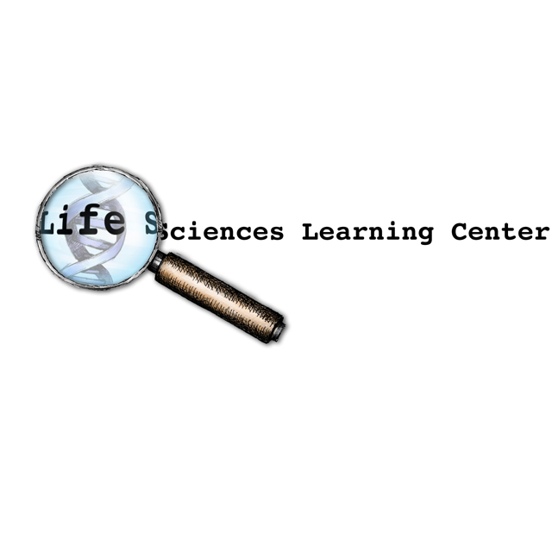

Cancer Education Project

Stem Cells and Cancer

Overview:

This series of activities is designed to introduce students to the theory that some cancers arise from cancer stem cells. This theory provides a possible explanation for why cancers reoccur after cancer treatment. It also provides insights that may lead to new types of chemotherapy drugs.

- Part 1: Stem Cells and Cancer PowerPoint (40 minutes)
Students view a PowerPoint presentation that introduces stem cell biology and shows ways that cancer stem cell research might lead to more effective cancer therapy treatments. Students answer questions as they view the PowerPoint. Then they create a cartoon strip to illustrate their understanding of cancer stem cells.

- Part 2: The Bad Seed: Rare stem cells appear to drive cancers (20 minutes)
Students read a brief article that introduces stem cell biology and explains how cancer stem cell research might lead to more effective cancer therapy treatments. Students answer questions based on this article. This activity may be done in class or for homework.

- Part 3: Plant Derivative Attacks the Roots of Leukemia (20 minutes)
Students read a brief article on the development of a potential chemotherapy agent that specifically targets cancer stem cells. Students answer questions based on this article. This activity may be done in class or for homework.

- Part 4: Clinical Trials: Parthocet (40 minutes)
Students answer questions about the design of a large-scale, randomized, double-blind clinical trial to determine if Parthocet (a fictitious chemotherapy drug) is safe and effective.

Teacher Instructions - Part 1
Stem Cells and Cancer PowerPoint Presentation

Students view a PowerPoint presentation that introduces stem cell biology and shows ways that cancer stem cell research might lead to more effective cancer therapy treatments.
- Review the PowerPoint presentation in the file titled “Stem Cells and Cancer”. Note that further information is provided in the notes section for each slide.
- Decide whether you will provide students with handout sheets printed to accompany the PowerPoint presentation.
- Provide each student with one copy of Stem Cells and Cancer questions to accompany the PowerPoint presentation.
- Provide paper and colored markers for students to use when creating their cartoon strip.
- Find additional teacher (or student) information on cancer stem cell research at:
- Stem Cells Seen Driving Tumors http://www.stronghealth.com/services/cancer/images/BostonGlobe-CJordon.pdf
- Cancer Killer: Radical researchers are onto a controversial idea for stopping cancer—go after stem cells
http://www.stronghealth.com/services/cancer/images/Forbes-CJordan.pdf
- The Rare Seed; Stem Cells Appear to Drive Cancers http://www.stronghealth.com/services/cancer/images/ScienceNews-CJordan.pdf
- How to Kill Cancer So It Doesn't Grow Back: Quest Seems as Elusive as Hercules's Second Labor
http://www.stronghealth.com/services/cancer/images/WashingtonPost-CJordan.pdf
- Stem Cells: The Real Culprits in Cancer? http://www.sciam.com/article.cfm?articleID=000B1BED-0C0A-1498-8C0A83414B7F0000&pageNumber=5&catID=2
Stem Cells and Cancer - Part 1
PowerPoint Presentation

At the end of the PowerPoint presentation, you should be able to answer the following questions.

- Describe two differences between normal stem cells and the other cells in your body?

- In what ways do normal stem cells contribute to maintaining homeostasis?

- Describe two differences between normal stem cells and cancer stem cell.

- How do scientists identify cancer stem cells?

- How might cancer stem cells originate?

- How might cancer stem cells can lead to the reoccurrence of tumors.

- Why are current radiation and chemotherapy treatments not always effective in preventing the reoccurrence of cancer?

- How might knowledge of cancer stem cells be applied to developing new cancer therapies?

- What questions might scientists ask to help them understand how to develop new cancer therapies that target cancer stem cells?

- A researcher discovered a drug that kills cancer stem cells, but not normal stem cells. Her fellow scientists congratulate her and tell her that she can now consider her job done. The researcher insists that more research is needed because it is important to discover HOW the drug kills cancer stem cells. Provide one reason why this additional research would be important.

- Use your creativity to illustrate what you learned about cancer stem cells. Draw a cartoon strip (series of frames) that includes information from your answers to either:
- Questions 3, 4 and 5, or
- Questions 6 and 7, or
- Questions 8 and 9.
Teacher Instructions - Part 2
The Bad Seed: Rare stem cells appear to drive cancers

In this homework or class activity, students read an article on cancer stem cell research and answer questions based on this article.
- Provide (for each student) one copy of Part 2: The Bad Seed - Rare stem cells appear to drive some cancers.
- Ask students to read the article and use the information to answer the five questions at the end of the article.

Stem Cells and Cancer - Part 2
The Bad Seed: Rare stem cells appear to drive some cancers

Directions: Read the article and analyze the diagrams. Use the information in the article and diagrams to answer the 5 questions at the end of the article.

While some brain tumors are treatable, many reoccur despite the best efforts of physicians. A neurosurgeon may carefully cut out every visible sign of a brain tumor, but new cancer cells may arise to take the original tumor's place. The cancer may survive toxic chemotherapy drugs and intense beams of radiation, two powerful weapons that kill rapidly dividing cells and suppress the growth of many tumors.

Why are many brain tumors and other cancers so difficult to treat? The answer may lie in a few. select tumor cells that have the capacity to divide repeatedly to form new cancerous tumors. These cells are known as “cancer stem cells” because they are similar, in some ways, to normal stem cells.

Normal stem cells are found in adult tissues as well as in the developing embryo. Stem cells are defined by their “pluripotency”— their ability to divide and give rise to cells that can go on to become many different kinds of cells. Stem cells divide unevenly; they divide to form another stem cell (self-renewal) and a cell called a “progenitor cell.” The progenitor cell cannot form another stem cell, but it can go on to divide a number of times and give rise to other kinds of cells that have different functions such as red blood cells or white blood cells (Fig 1). The process of forming different (specialized) kinds of cells is called “differentiation.” Adult stem cells are responsible for maintaining homeostasis by replacing damaged cells. For example, without blood stem cells, there would be no way of replacing damaged or dead blood cells.

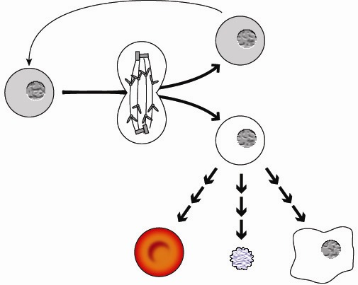
Progenitor Cell
Stem Cell
Stem Cell
Red Blood Cell
Platelet
White Blood Cell
Self Renewal
Cell division and differentiation
Figure 1. Blood forming stem cell in the bone marrow divides to form a new stem cell and a progenitor cell. A progenitor cell can then divide and differentiate to form specialized types of blood cells.

It is important for stem cell division to be tightly controlled. For example, if too much cell division by the stem cell occurs, the body can become overwhelmed with RBC’s. This leads to a condition known as polycythaemia in which very thick blood increases the danger of forming blood clots. However, if too little cell division occurs, the body does not have enough RBC’s to supply oxygen to all its cells.

For some kinds of cancer, researchers have harvested cancer cells from a tumor, separated them (Fig 2, A), and found that roughly one cancer cell in a million has the ability to regrow a tumor when transplanted into a new location (Fig 2, B). Researchers concluded that these rare cells could be considered cancer stem cells. Researchers are able to identify these cells by distinctive proteins on their cell surfaces, and are now racing to identify cancer stem cells in skin, lung, pancreatic, ovarian, prostate, and many other cancers.
Figure 2

Figure 2. Tumor cells that survive transplantation and form a new tumor are called cancer stem cells.

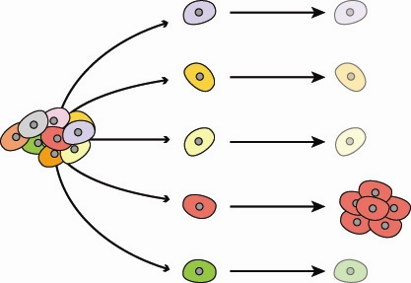
A
B

Cancer stem cells are like normal stem cells in that they can self-renew. However, cancer stem cells have lost many of the cell division controls under which normal stem cells operate. Because cancer stem cells do not control their cell division properly, they may give rise to tumors. In addition, the progeny of cancer stem cells do not differentiate properly. The progeny tend to be relatively “immature” or unspecialized and do not function as they should in carrying out normal body functions.

Treatment for cancer has typically involved targeting cells that divide rapidly, which is how most of the cells in a tumor behave (Fig 3, A). However, cancer stem cells do not divide rapidly, leading to a situation where most of a tumor, but not the cancer stem cells can be killed by chemotherapy or radiation. The cancer stem cell, still in the body, can survive and divide to create a whole new tumor (Fig 3, B).

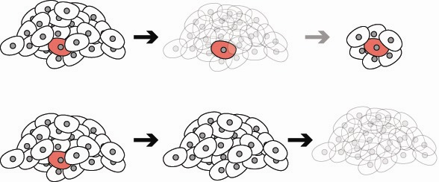
Original Tumor
Conventional Chemotherapy

Therapy that targets cancer stem cells

A
B
C
D

Figure 3. Conventional chemotherapy targets rapidly dividing cells and may leave cancer stem cells unaffected. More effective therapies may target cancer stem cells.

Scientists are now searching for molecules that can specifically target and kill cancer stem cells without harming normal stem cells or other body cells. The hope is that future research will lead to a new type of chemotherapy that kills the stem cells (Fig 3, C). In theory, this new chemotherapy should stop the tumor from growing and in combination with current chemotherapy, could completely eliminate the tumor (Fig 3, D).

Adapted from: “The Bad Seed: Rare Stem Cells Appear to Drive Cancers”, by John Travis. http://www.sciencenews.org/articles/20040320/bob8.asp
Questions

- What are two characteristics of normal stem cells that make them different from the other cells in your body? [2 credits]

- The statements in Table 1 describe some characteristics of cells. Complete the following chart by putting an X in the boxes if the statement is true for the type of cell indicated at the top of the column. [7 credits]

Table 1.
Characteristics of cells | Normal  Stem Cells | Cancer  Stem Cells
Divide only when new offspring cells are needed to maintain homeostasis.
Give rise to progenitor cells that divide
and differentiate to form specialized cells that carry out body functions.
Harmed by radiation and current chemotherapy drugs that kill rapidly dividing cells.
Grow to form a tumor if transplanted into a new location.
Can self-renew.

Divide unevenly to form a new stem cell and a progenitor cell.
Forms cells that are relatively “immature” (unspecialized).

- How do scientists determine whether a cell from cancerous tissue is a cancer stem cell? [1 credit]

- Some cancerous tumors may reoccur even after being treated with radiation or current chemotherapy. According to the article, how might this happen? [1 credit]

- Describe one method the scientists might use to apply their understanding of cancer stem cells to curing cancer. [1 credit]

Teacher Instructions - Part 3
Plant Derivative Attacks the Roots of Leukemia (20 minutes)

In this activity, students read a brief article on the development of a potential chemotherapy agent that specifically targets cancer stem cells. They answer questions based on this article. This activity may be done as homework or in class.
- Provide one copy of Part 3: Plant Derivative Attacks the Roots of Leukemia.
- Ask students to read the article and use the information to answer the five questions at the end of the article.

Stem Cells and Cancer - Part 3
Plant Derivative Attacks the Roots of Leukemia

Directions: Read the article and analyze the diagrams. Use the information in the article and diagrams to answer the 5 questions at the end of the article.
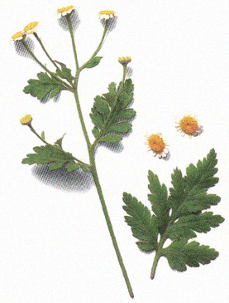

Leukemia is cancer of the white blood cell (leukocyte) forming tissues in the bone marrow, lymph nodes, and spleen. Patients with leukemia produce large numbers of ineffective white blood cells that are unable to defend the body against infection. In addition, leukemia also disrupts the bone marrow’s production of red blood cells and platelets.

Researchers have identified leukemia stem cells and have shown that current chemotherapy treatments are not effective in preventing the reoccurrence of leukemia caused by these cells.

A daisy-like plant known as Feverfew (Tanacetum parthenium), found in gardens across North America, is the source of parthenolide, a chemical that kills leukemia stem cells like no other single therapy. A research team led by Dr. Craig Jordan at the University of Rochester has shown that parthenolide selectively kills leukemia stem cells grown in cell cultures and laboratory animals. Parthenolide is the first single agent known to act on cancer at the stem-cell level. This finding is significant because current leukemia treatments do not kill mutant stem cells which can lead to leukemia reoccurrence.
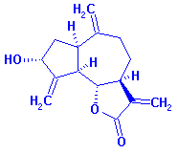
Research by the University of Rochester team has demonstrated that parthenolide selectively kills the leukemia cells while sparing normal stem cells. Scientists believe parthenolide might also make other cancer cells more sensitive to additional anti-tumor agents.

Before parthenolide or a parthenolide-like drug can be approved as a leukemia treatment, clinical trials must be conducted to ensure that the new drug is safe and effective for treating leukemia patients.

Feverfew has been used for centuries as an herbal remedy to reduce fevers and inflammation, to prevent migraine headaches, and to ease symptoms from arthritis. A person with leukemia, however, would not be able to take enough of the herbal remedy to halt the disease. “At this time, people should not take large amounts of Feverfew to treat leukemia or other cancers,” says Jordan. “We believe it is not possible to ingest enough feverfew to be of benefit for cancer therapy. It is likely that consuming large quantities of feverfew could be a health hazard.”

Modified from an article at http://www.urmc.rochester.edu/pr/news/story.cfm?id=731

Questions:

- What is leukemia? [1]

- Why are current chemotherapy treatments ineffective in preventing the reoccurrence of leukemia?[1]

- What is parthenolide?

- State two reasons why scientists think that parthenolide might be more effective in treating leukemia than current chemotherapy drugs. [2]

- Once a useable pharmaceutical compound is developed, what step must be taken before it is approved as a leukemia treatment? [1]

- State one reason why cancer patients should not take herbal remedy Feverfew products to treat their cancer. [1]
Teacher Instructions - Part 4
Clinical Trials: Parthocet (30 minutes)

In this class activity, students work in teams to answer questions that guide the design of a large-scale, randomized, double-blind clinical trial to determine if Parthocet (a new chemotherapy drug) is safe and effective. It is recommended that students work in teams, but for advanced classes, this activity could be assigned as individual homework.
- Provide one copy of Clinical Trials: Parthocet for each student.
- Group students in teams of 2-4 students.
- Ask two students to read aloud the first two paragraphs that provide essential background information.
- Ask students to work in teams to answer the questions in this activity.

Citation:

- The Clinical Trials: Parthocet activity was modified from Testing Ephedra: Using Epidemiologic Studies to Teach the Scientific Method by Flora Huang and Paul Stolley.
- The Young Epidemiology Scholars Program is supported by The Robert Wood Johnson Foundation and administered by the College Board.
http://www.collegeboard.com/yes/ft/iu/testing_ephedra.html

Stem Cells and Cancer - Part 4

Clinical Trials: Parthocet


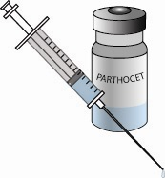
PARTHOCET
Standardized Derivative from
Tanacetum parthenium
325mg capsules –
60 capsules
A pharmaceutical company has used Feverfew (Tanacetum parthenium) to produce Parthocet, a parthenolide derivative. Parthocet has been shown to be effective in destroying cancer stem cells in cell culture and animal testing studies. The company would like to market Parthocet as a new chemotherapy agent for use by leukemia patients. Before drug manufacturers can obtain FDA approval for a new medication, they must conduct clinical trials to prove that the medication is both safe and effective.

You and your team members are research scientists seeking grant funding for a large-scale, randomized, double-blind, controlled, (phase III) clinical trial to determine whether Parthocet is safe and effective for the treatment of human leukemia patients. In planning for your grant application, you should consider the following questions:

- What are two research questions that your team should address in the clinical trials?

- What are the two hypotheses that your team will be testing? State these hypotheses as “if-then” statements.

- Briefly describe how you might test these hypotheses.

- What is the independent (experimental) variable in your experiment?

- What are the dependent variables in your experiment?

- What data do you plan on collecting from your experiment?

- A controlled study requires an experimental group and a control (comparison) group. How should the subjects (participants) in the experimental group and the subjects in the control group be treated differently?

- What similar characteristics should both the experimental group and the control group subjects have in common?

- Why is it important for the two groups to have these similar characteristics?

- What are some characteristics of subjects who should be excluded from participation in this clinical trial?

- How many subjects will you include in the control group and in the experimental group so that your experiment gives reliable results?
When designing a fair experiment, scientists try to avoid bias--sampling or testing error caused by systematically favoring some outcomes over others. To avoid bias, scientists often use both randomization and double-blinding. Randomization means that subjects are assigned randomly (by chance) to either the experimental or the control group. A blind study means that subject do not know whether they are in the experimental group or the control group. In addition, the researchers who are collecting data should not know in which group the subjects are placed. This creates what is known as a double blind study.
- Explain how you would randomize your experiment?

- Explain how you would make your experiment a blind study?

- Explain how you would make your experiment a double blind study?

- Because clinical trials involve human test subjects, there are ethical issues that a researcher must consider. Explain 2 or 3 important ethical issues that should be addressed when designing your experiment?

- Explain how you would design your experiment to address each of the issues that you listed in question 15.

- What data (measurable outcomes) do you plan to collect during your experiment?

- What results would you expect if your data supported your hypotheses?

- Explain what is meant by the phrase “large-scale, randomized, double-blind, controlled clinical trial.”

- Explain why it is important that this type of research be done before a chemotherapy drug is approved by the FDA (Federal Drug Administration).

