Survey completed by (check 1): ____ Student ____ Adult

Public Opinion Survey on Stem Cell Research

- Have you heard or read about stem cells? ____ Yes _____ No

- List 3 or 4 things you think you know about stem cells.
_______________________________________________________________________________________________________________________________________________________________________________________________________________________________________________________________________________________________________________________________________________________________________________________________________________________________________________________________________________________________________________________________

- Do you think scientists should be able to do research on stem cells?
___ Yes ___ Maybe ___No ____No Opinion

- Explain your position.
_____________________________________________________________________________________________________________________________________________________________________________________________________________________________________________________________________________________________________________________________________________________________________________

- What concerns or questions do you have about stem cells?
_______________________________________________________________________________________________________________________________________________________________________________________________________________________________________________________________________________________________________________________________________________________________________________________________________________________________________________________________________________________________________________________________
Analyzing Stem Cell Survey Data

Senator Brown would like you to analyze and report on the results of the public opinion survey that you conducted.

- Use the class bar graph to determine the:
- Total number of students surveyed _______
- Total number of adults surveyed _______
- Combined number of students and adults surveyed _______

- Use the information from the class bar graph to complete the last three columns of the following data table. Note: To do this you will need to convert the number of survey respondents into percentages.

Do you think that scientists should be able to do stem cell research? | Class Survey Data
 | %  Students | %  Adults | %  Combined
Yes
Maybe
No
No Opinion

- State two conclusions that you can draw based on the information in the bar graph and data table.
- ____________________________________________________________________________________________________________________________________________
- ____________________________________________________________________________________________________________________________________________

- Work with your team to read and discuss the information, questions, and concerns that people provided on their surveys. Make a poster that lists:
- 4 important or interesting things that people think they know about stem cells and stem cell research.
- 4 important or interesting concerns or questions that people have about stem cells and stem cell research.
Be certain to put your team members’ names at the bottom of the poster.
Stem Cell Basics – Making Notes

Notes | Your drawings, questions, or reactions
1. Most cells are differentiated. What does that mean?

2. Compare these two types of cells.

Differentiated
Cells

Undifferentiated
Cells

Place the word stem cell in the appropriate column.

3. List three characteristics of stem cells  a.  …………………………………………………  b.  ………………………………………………..  c. | Illustrate each characteristic of stem cells  …………………………………………………  ………………………………………………...

4. Compare pluripotent and multipotent stem cells

Pluripotent Stem Cells

Multipotent
Stem Cells

5. Two basic types of stem cells
- ________________________

- ________________________

6. Four places tissue specific (adult) stem cells could be found
- ________________________
- ________________________
- ________________________

- ________________________

7. Why do you have tissue specific (adult) stem cells in your body?

Two processes carried out by the tissue specific (adult) stem cells in your body
- ________________________

- ________________________

8. Why are tissue specific (adult) stem cells considered multipotent?

9. Where are embryonic stem cells found? Be specific.

10. How big is a blastocyst?

11. How are cells from a blastocyst cultured to make an embryonic stem cell line?

12. How is in vitro fertilization (IVF) used to make an embryonic stem cell line?

13. How is nuclear transplantation (therapeutic cloning) used to make an embryonic stem cell line?

Why might making stem cells that are genetically identical to a patient’s cells be important?

    - How is genetic reprogramming used to make induced pluripotent stem cells that are like embryonic stem cells?

15. Why are embryonic stem cells considered pluripotent?

16. One reason why scientists think that it is important to do research using stem cells that are…
- Made by in vitro fertilization _______________________________________________

- Made by nuclear transplantation ____________________________________________

- Induced pluripotent stem cells ______________________________________________

  - Tissue specific stem cells _________________________________________________

17. Two processes needed to change embryonic stem cells into all of the cells in an adult body
- ________________________

- ________________________

18. In your own words, define differentiation.

19. All of your body cells contain the same genes (DNA). Explain why skin cells and muscle cells are different even though they contain the same genes.

Two substances that are produced when a gene is turned on:
- ________________________

- ________________________

20. What is the name for signal substances that cause stem cells to differentiate?

__________________________

Explain how the different signal substances caused the stem cell to become a skin cell or a muscle cell.

Explain what is meant by this sentence. “Cell differentiation is influenced by the cell’s environment.”

21. Explain what is meant by this sentence. “Cell differentiation is influenced by a cells past history.”

21. Looking at a muscle cell’s past history, do you think you could get a muscle cell to turn into a blood cell? Explain.

22. If scientists could learn how to control the differentiation of stem cells, they might use this to…

23. Human stem cells have been used to…

24. Human stem cells might be used to…

25. Human stem cells might be used to…

- Human stem cells might be used to...

27. Human stem cells could also be used for…. (list 3 other things)
  - ______________________________
  - ______________________________
  - ______________________________
28. What risks do you think might be associated with stem cell therapy?

29. Two potential risks associated with stem cell therapy.
  - ______________________________
  - ______________________________

One example of a possible complication.

30. What ethical and legal questions do you think might be associated with stem cell research and stem cell therapy?

31. Three examples of ethical or legal questions associated with stem cell research and stem cell therapy.
  - ______________________________
______________________________
  - ______________________________
______________________________
  - ______________________________
______________________________

Ticket to leave

On one side of a file card, write your name and two questions that you have about stem cells, stem cell research or stem cell therapy?

One the other side of the file card, indicate which you think should be used for stem cell research and stem cell therapy - embryonic stem cells, tissue specific (adult) stem cells, or both. Explain your answer.

Reflecting On the Stem Cell Basics

After viewing the Stem Cell Basics slide show, revisit your team’s poster.

- For each of the “know” statements on your poster:
- Put a “yes” in front of the statements that are true.
- Put a “no” in front of the statements that are false.
- If you are unsure whether a statement is true or false, put a “?”.
- For each of the four “questions or concerns” on your poster, use a different color of marker to write an answer or response.

Culturing Stem Cells

For safety and cost reasons, we cannot use real human or animal tissues as a source of stem cells. But plants have stem cells that can be cultured successfully if you use the appropriate sterile techniques and culture conditions. So we’ll be using a cauliflower plant as a source of stem cells. You will try to grow the plant stem cells on a gelatin-like culture medium that contains nutrients which the stem cells need to survive.

Your task is to determine what parts of a piece of cauliflower (the “curd” or the stalk) could be a used as a source of stem cells for growing on a culture medium. A culture medium is a liquid or gelatinous substance containing nutrients which cells need to survive.

Question: In what part of a cauliflower are the stem cells located—the “curd” or the stalk?
Your hypothesis:
__________________________________________________________________________________________________________________________________________________

If you were given the following materials, what procedure would you use to test your hypothesis?

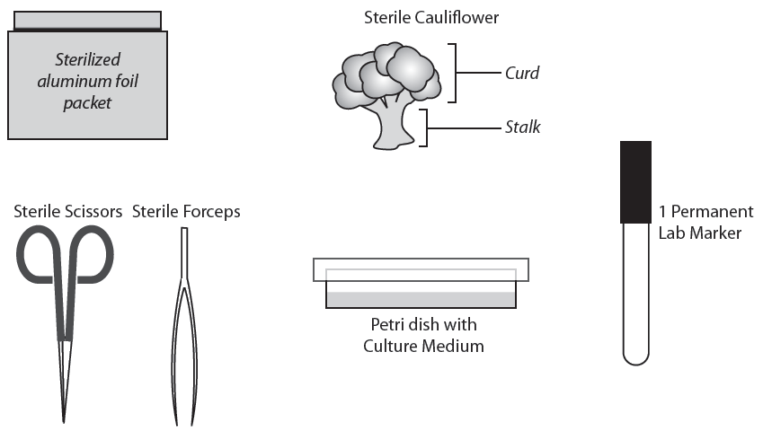

Bacteria and molds can also grow on the culture medium. Before you begin, talk with your partner about what you should do to keep the equipment and plant parts as sterile (free of mold and bacteria) as possible. Make a list of the things that you should be careful to do and not do to keep the plant parts sterile.

Do
____________________________________________________________________ _____________________________________________________________________________________________________________________________________________________________________________________________________________________________________________
Do NOT
____________________________________________________________________ _____________________________________________________________________________________________________________________________________________________________________________________________________________________________________________

Hint: You will need to cut the large piece of cauliflower into smaller “pea-sized” pieces of cauliflower for your experiment.

Plan your experiment:

- Explain how you will set up a controlled experiment to test your hypothesis.
_________________________________________________________________________ ____________________________________________________________________________________________________________________________________________________________________________________________________________________________________________________________________________________________________

- Predict what results you would expect from your experiment if your hypothesis was correct.
___________________________________________________________________________________________________________________________________________________________________________________________________________________________
- Ask your teacher to:
- Check your experiment plan and your predictions.
- Provide the materials needed to conduct your experiment.

Conduct your experiment:
- Set up your experiment. Be sure to put your team members’ names on the bottom of the plate.

- Results: (Visible growth may take 1-2 weeks, depending on light and temperature conditions)
_________________________________________________________________________ ___________________________________________________________________________________________________________________________________________________________________________________________________________________________

- Conclusions:
_________________________________________________________________________ _____________________________________________________________________________________________________________________________________________________________________________________________________________________________________________________________________________________________________________________________________________________________________________

Three Ways to Make a Pluripotent Stem Cell Line

1. In Vitro Fertilization (IVF)
In vitro is a Latin term, meaning “in the glass”. In vitro refers to growing cells in laboratory containers (i.e. test tubes or culture dishes) instead of in a living organism.
In vitro fertilization (IVF) offers infertile couples a chance to have a child who is biologically related to them. With IVF, a method of assisted reproduction, a man's sperm and the woman's egg are combined in a laboratory dish (“in vitro”), where fertilization occurs. Two to four of the resulting embryos are then transferred to the woman's uterus (womb) to implant and develop naturally. Extra (“left-over”) embryos may be stored for future use or may be donated and cultured for use in embryonic stem cell research.
After many mitotic divisions in a laboratory dish, this single cell forms a blastocyst (an early stage embryo with about 100 cells) with DNA from both of the parents. Embryonic stem cells can be isolated by transferring cells from the inner cell mass of the blastocyst to another laboratory culture dish.
- Model the process by which in vitro fertilization forms a zygote. Use the culture dish, the sperm cell model, one of the egg cell models.

- Cut along the dotted lines on the Development Diagram Sheet to make a set of diagram cards.

- Arrange the diagram cards in the correct sequence to illustrate how the zygote develops into a blastocyst that is a source of embryonic stem cells used to create an embryonic stem cell line.

- Call your teacher over to check your work.

- In your own words, explain how in vitro fertilization is used to produce a blastocyst and an embryonic stem cell line.
_________________________________________________________________________ ___________________________________________________________________________________________________________________________________________________________________________________________________________________________
2. Therapeutic Cloning
(also called Somatic Cell Nuclear Transplantation)
In therapeutic cloning an egg is placed in a laboratory dish and the egg’s nucleus is removed. At the same time, the nucleus of a somatic cell (a body cell other than a sperm or egg cell), which contains the organism's DNA is removed and the rest of the cell discarded. The nucleus of the somatic cell is then inserted into the enucleated egg cell. The egg containing the new nucleus is stimulated with a shock so that it begins to divide.
After many mitotic divisions in a laboratory dish, this single cell forms a blastocyst (an early stage embryo with about 100 cells) with almost identical DNA to the original organism. Embryonic stem cells can be isolated by transferring cells from the inner cell mass of the blastocyst to another laboratory culture dish.
- Model the process of therapeutic cloning (nuclear transplantation) to form a cell that begins the development process. Use the culture dish, egg cell model, straw (to transfer the nucleus) and skin cell model.

- Arrange the diagram cards in the correct sequence to illustrate how the new cell develops into a blastocyst that is a source of embryonic stem cells used to create an embryonic stem cell line.

- Call your teacher over to check your work.

- In your own words, explain how in therapeutic cloning is used to produce a blastocyst and an embryonic stem cell line.
_________________________________________________________________________ __________________________________________________________________________________________________________________________________________________

- State one similarity between a blastocyst created by in vitro fertilization and a blastocyst created by therapeutic cloning.
__________________________________________________________________________________________________________________________________________________
- State one difference between a blastocyst created by in vitro fertilization and a blastocyst created by therapeutic cloning (nuclear transplantation).
__________________________________________________________________________________________________________________________________________________

3. Gene Transfer Reprograms

Differentiated Cells into Embryonic Stem Cells
Scientists report that they have turned human skin cells into what appear to be embryonic stem cells without having to make or destroy an embryo. Until now, the only way to get human embryonic stem cells was to pluck them from a human embryo, destroying the embryo in the process.
In this new technique for making embryonic stem cells, the scientists used viruses to transfer master regulator genes into skin cells. These master regulator genes turn other genes on or off, reprogramming the skin cells into undifferentiated cells. The reprogrammed skin cells, called induced pluripotent stem cells (IPSCs) appear to behave very much like human embryonic stem cells. They can be cultured and should be able to differentiate into any of the 220 cell types of the human body.
The new method could be used to create genetically matched cells which would not be rejected by the immune system if used as replacement tissues for patients. Even more important, scientists say, is that genetically matched cells from patients would enable them to study complex diseases, like Alzheimer’s, in the laboratory. For example, researchers could make stem cells from a person with a disease like Alzheimer’s and turn the stem cells into nerve cells in a Petri dish. Then they might learn what goes wrong in the brain and how to prevent or treat the disease.
Creating IPSCs includes potentially risky steps, like using viruses to insert the genes into the cells’ chromosomes. These viruses slip genes into chromosomes at random, sometimes causing mutations that can make normal cells turn into cancers. And one of the genes used to make IPSCs is a cancer gene. In addition, IPSCs may yet prove to have subtle differences from embryonic stem cells that come directly from human embryos.
Researchers are now trying to create IPSCs by adding chemicals or using harmless viruses to get the genes into cells.
Modified from: http://www.nytimes.com/2007/11/21/science/21stem.html?_r=2&bl=&ei=5087&en=7857a1f63763a21e&ex=1195707600&oref=slogin&pagewanted=&oref=slogin

- What is an “induced pluripotent stem cell” (IPSC)?
__________________________________________________________________________________________________________________________________________________

- Describe the process the scientists used to create “induced pluripotent stem cells.”
__________________________________________________________________________________________________________________________________________________
_________________________________________________________________________
- Use the models of a skin cell and a virus in kit to illustrate how a skin cell could be reprogrammed to make an embryonic stem cell.

- Call your teacher over to check your work.

- Explain two benefits associated with this stem cell research.
____________________________________________________________________________________________________________________________________________________________________________________________________________________________________________________________________________________________________

- Explain two limitations associated with this stem cell research.
____________________________________________________________________________________________________________________________________________________________________________________________________________________________________________________________________________________________________

Genes and Stem Cell Differentiation

Once stem cells have been isolated, scientists need to figure out how to get them to differentiate into needed kinds of specialized cells. Research has shown that differentiation results when growth factors (“coaxing agents”) cause specific genes to be expressed (turned on) and other genes to be silenced (turned off).

In this laboratory activity, you will:
- Simulate one type of research used determine which genes are turned on or off when embryonic cells differentiate into three types of cell lines—ectoderm, mesoderm, and endoderm.
- Use this information to select growth factors that could be used to turn on and turn off genes in embryonic stem cells to “coax” them to differentiate into different cell lines.

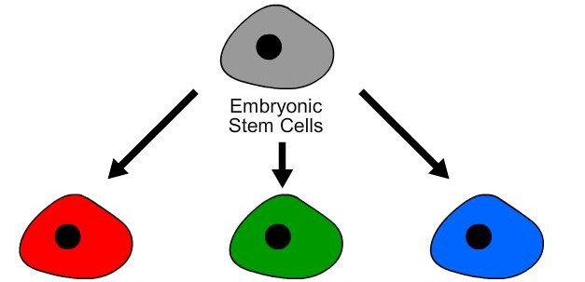

Mesoderm Cells  Becomes…  - Muscle  - Bone  - Blood | Endoderm Cells  Becomes lining of…  - Digestive system  - Lungs | Ectoderm Cells  Becomes…  - Skin  - Nervous system

First, scientists need to determine which genes in the embryonic stem cells are turned on and which genes are turned off as embryonic stem cells differentiate into ectoderm, mesoderm, or endoderm cells.

When a gene is expressed (turned on), it produces RNA that leads to production of a protein that results in specific cell structures or functions.

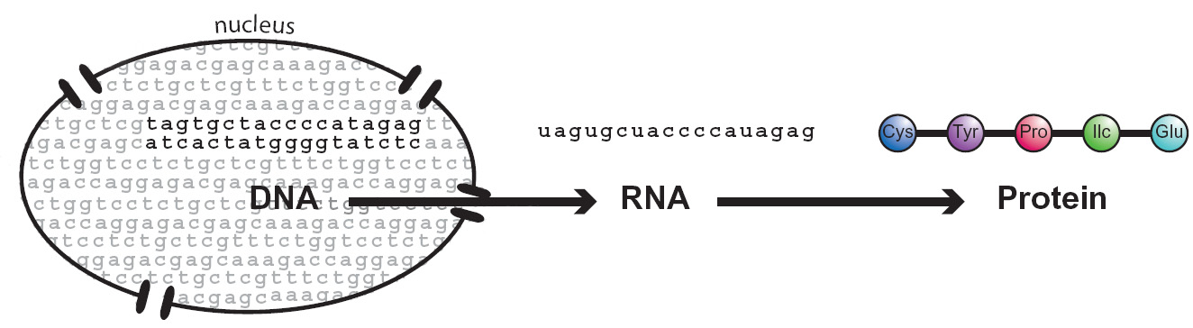
Cell Structure and Function

In your own words, explain the sequence of events that occur when a gene is expressed.
_________________________________________________________________________
_________________________________________________________________________

Microarray technology can be used to compare which kinds of RNA produced when genes are expressed in different types of cells. A microarray is a slide that has spots of DNA from known genes. RNA samples from different types of cells are added to a microarray. The RNA will ONLY bind to complementary DNA (genes) on the microarray. If a gene is expressed (turned on) in a cell, it will make RNA that binds to the DNA on the microarray. The binding results in a colored spot on the microarray.

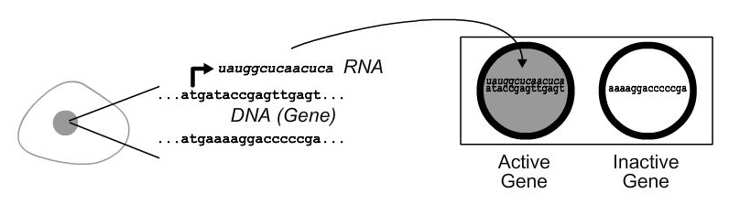
Active gene makes RNA
RNA binds to
this gene spot.

RNA cannot bind to
this gene spot.
.

Why does the RNA bind to one spot and not to the other spot?
_________________________________________________________________________

How will you tell which genes are expressed by a cell?
_________________________________________________________________________
For this activity, you will use a set of four simulated microarrays representing four different types of cells.

- Obtain a gray embryonic (undifferentiated) stem cell microarray. Any coordinates (for example, 1-A) that are gray represent genes that are active (making RNA) in an embryonic stem cell.

- Obtain a red ectoderm microarray. The red spots represent genes that are active in ectoderm cells.

- Place the red microarray over the gray microarray, matching up the circles on the two slides.

- The red-gray spots on the overlapped microarray indicate genes that are active in both embryonic stem cells and ectoderm cells. These genes are NOT likely to cause the undifferentiated embryonic stem cells to differentiate into ectoderm cells.

- List the coordinates of the gray spots. These spots indicate genes that are only active in undifferentiated embryonic stem cells. _______________________

- List the coordinates of the red spots. These spots indicate genes that are only active in ectoderm cells. _____________________________

- To coax embryonic stem cells to differentiate into ectoderm cells, scientists would want to:
- turn on genes ___________________
- turn off genes ___________________

Next you need to identify which growth factors (“coaxing agents”) could be used to turn on and turn off the specific genes you identified in your microarray studies. The work of other researchers has previously identified the effect of various growth factors on gene expression. Data from their research is summarized in the data table below.

Growth Factor | Turns on genes | Turns off genes
GF A | 1C, 2D, and 3A | 1D 2C 3B
GF B | 3C, 3D, and 4A | 1D 3B 4D
GF C | 2A and 2D | 1A 4D
GF D | 1D 2C 3B | 1C, 2D, and 3A
GF E | 1A 4D | 3C, 3D, and 4A

- Which growth factor(s) would you select to “coax” embryonic stem cells to differentiate into ectoderm cells? __________________________

- Obtain a gray undifferentiated embryonic stem cell microarray and a green mesoderm microarray. The green spots represent genes that are active in ectoderm cells.

- Place the green microarray over the gray microarray, matching up the circles on the two slides.

- The green-gray spots on the overlapped microarray indicate genes that are active in both embryonic stem cells and mesoderm cells. These genes are NOT likely to cause the undifferentiated embryonic stem cells to differentiate into ectoderm cells.

- List the coordinates of the gray spots. These spots indicate genes that are only active in undifferentiated embryonic stem cells. _______________________

- List the coordinates of the green spots. These spots indicate genes that are only active in differentiated mesoderm cells. ________________________

- To coax embryonic stem cells to differentiate into mesoderm cells, scientists would want to:
- turn on genes _____________
- turn off genes _____________

- Use the growth factor chart on the previous page to select the growth factor you would use to “coax” embryonic stem cells to differentiate into mesoderm cells. Which growth factor would you use? _______________

- Obtain a gray undifferentiated embryonic stem cell microarray and a blue endoderm microarray. The blue spots represent genes that are active in endoderm cells.

- Place the blue microarray over the gray microarray, matching up the circles on the two slides.

- The blue-gray spots on the overlapped microarray indicate genes that are active in both embryonic stem cells and endoderm cells. These genes are NOT likely to cause the embryonic stem cells to differentiate into endoderm cells.

- List the coordinates of the gray spots. These spots indicate genes that are only active in undifferentiated embryonic stem cells. _______________________

- List the coordinates of the blue spots. These spots indicate genes that are only active in differentiated endoderm cells. _________________________

- To coax embryonic stem cells to differentiate into endoderm cells, scientists would want to:
- turn on genes _____ _________
- turn off genes ______________

- Use the growth factor chart to determine which growth factor(s) could be used to “coax” embryonic stem cells to differentiate into endoderm cells? ________________

- Do you think you could change ectoderm cells into mesoderm cells? Explain how you would do this or explain why this might not be possible.
____________________________________________________________________________________________________________________________________________________________________________________________________________________________________________________________________________________________________

Controlling Stem Cell Differentiation - A Simulation

One of the challenges in stem cell research is developing techniques for coaxing stem cells into differentiating into specific kinds of cells. To coax stem cells into differentiating, scientists place them in environments that contain growth factors (“coaxing agents”). These growth factors include proteins and biochemicals that turn on, or turn off, the expression of specific genes that lead to differentiation.

This simulated laboratory activity gives you the chance to manipulate embryonic stem cell differentiation. You will begin with a "culture" of embryonic stem cells and tubes of growth factors (“coaxing agents”). By selecting a certain sequence of these factors you should be able to create differentiated cells that could be used to treat certain diseases.

Safety: You must wear safety goggles.

Note: if the droppers in your lab kit are sealed, use scissors to cut off the sealed end of the dropper stem.

- Use the “ESC” dropper to transfer 4 drops of the embryonic stem cell culture (ESC) from the microtube into each of five of the culture wells on the well strip.

- Use the information on the Growth Factors and Stem Cell Differentiation flow chart to select appropriate growth factors (GF) that you should add to coax the embryonic stem cells into each of the types of cells listed in column 1. Note: Use 1 drop of the appropriate growth factor. Read the colors immediately.

- Write “Yes” in column 2 if you are able to create that type of differentiated cell from embryonic stems cells.

Column 1 |  | Column 2
Differentiated Cell  Types | Potentially Used  to Treat | Able to Create from Embryonic Stem Cells
Skin cells  (purple) | Burn injuries
Nerve cells  (blue) | Spinal cord or brain injury
Pancreas cells  (blue-green) | Diabetes
Muscle cells  (yellow) | Heart damage
Blood cell  (red) | Sickle cell anemia

Imagine you are a scientist who has access to a culture of tissue specific (adult) neural stem cells. You would like to use these cells to treat brain injury.

- Use the “ANSC” dropper to transfer 4 drops of the adult neural stem cell culture (ANSC) from the microtube into the remaining well on the well strip.

- Use the information on the flow chart to select appropriate growth factors (GF) that you think you could add to coax the tissue specific (adult) neural stem cells into cells that could be used to treat brain injury.

- Can you change a tissue specific (adult neural) stem cell into a cell that could be used to treat brain injury? _________ Explain how. _________________________________

- Do you think that you could add growth factors to adult neural stem cells and turn them into differentiated blood cells? Why or why not?
__________________________________________________________________________________________________________________________________________________
_________________________________________________________________________

- Explain why scientists think it is important to be able to do research using embryonic stem cells.
__________________________________________________________________________________________________________________________________________________
_________________________________________________________________________

Quote from a biology textbook:
“During differentiation, different parts of a cell’s genetic instructions are used in different types of cells, and are influenced by the cell’s environment and the cell’s past history.”

Quote from article Cell Decisions:
(http://www.rochester.edu/pr/Review/V69N1/feature1.html)
“In thinking about stem cells, it’s helpful to imagine the process of cell differentiation as a tree. At the roots are embryonic stem cells, and at the end of each different branch are the differentiated cells of the body. As a stem cell proceeds along each developmental branch, it becomes more specialized and loses its potential to produce different types of cells. A stem cell can move forward and produce the cell types ahead of it on the branch, but scientists generally believe that cells normally can’t move backward and produce the cells behind them or the cells on a different branch.”

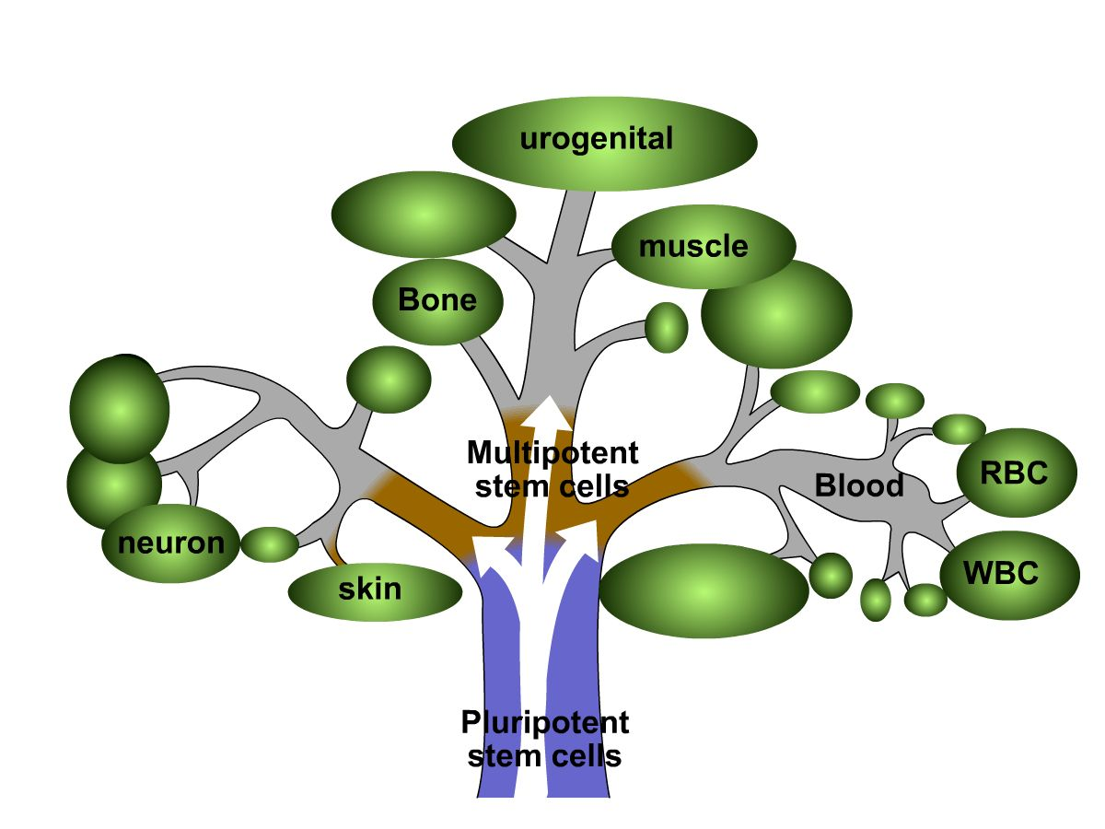
- In your own words, explain what is meant by each of the following sentences:

- Cell differentiation is determined by the cell’s environment.”
__________________________________________________________________________________________________________________________________________________________________________________________________________________
  - Cell differentiation is determine by the cell’s past history”
__________________________________________________________________________________________________________________________________________________________________________________________________________________
Growth Factors (GF) Involved in Stem Cell Differentiation (Add 1 DROP of the appropriate growth factors)
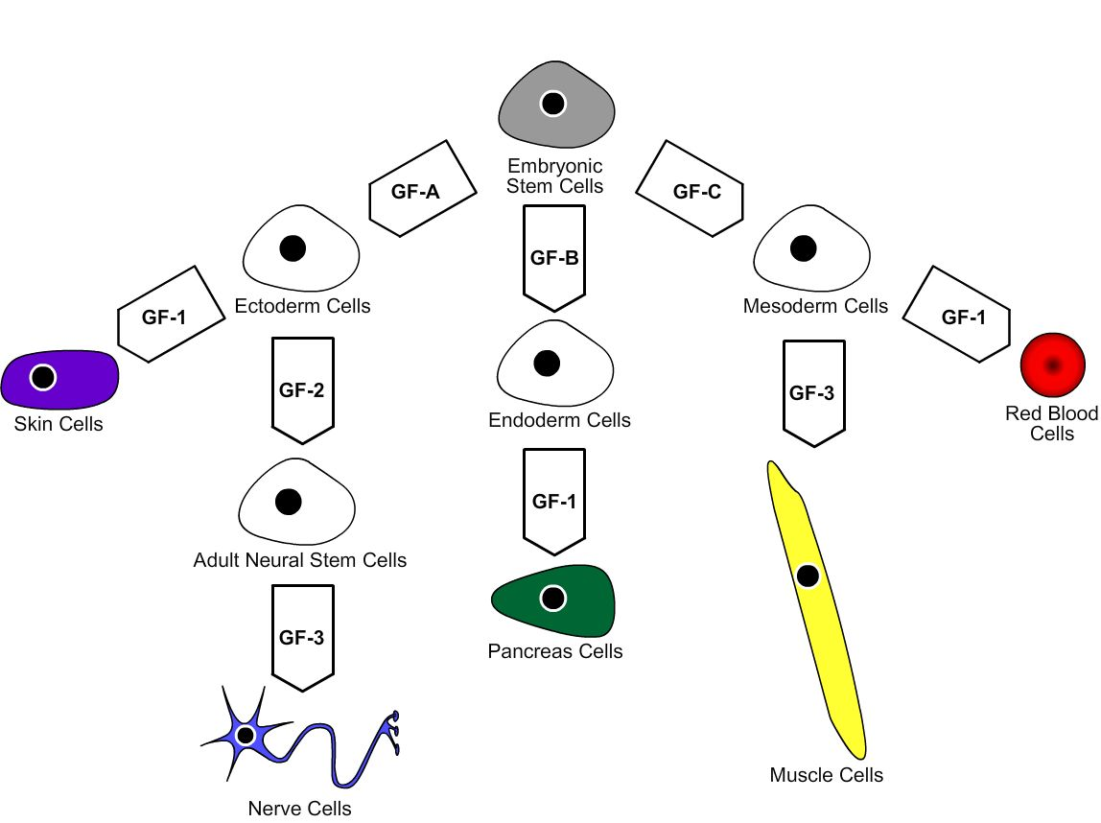

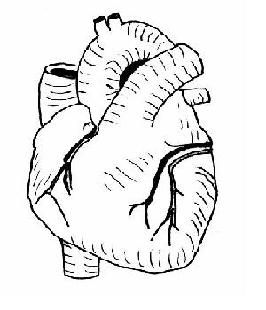
Treating a Broken Heart

Your 40 year-old mother has just had a heart attack. Her doctor says that she is lucky because the hospital is conducting the first clinical trial (experiment using human subjects) to test the safety and effectiveness of CardioStem. CardioStem is a new stem cell therapy for heart attack patients that researchers hope will repair damaged heart muscle. Patients who participate in this clinical trial will receive either an injection of CardioStem or an injection of a placebo.

Your mother has a week to decide whether she will sign the informed consent form to agree to be a participant in this clinical trial. She has asked you to help her decide what she should do.

- What do you know?

- What questions could your family ask to help your mother make this decision?

- Do you think that your mother should sign the informed consent form for the CardioStem treatment? Explain why or why not.

- What other information sources (people or print materials) might your family consider consulting before making a final decision? BE SPECIFIC!

What is a Clinical Trial?
A clinical trial is the term for any test or study of an investigational drug, device, or other medical treatment in human subjects. Some clinical trials may test already approved (on the market) medications or devices.

Researchers are constantly looking for better or new ways for treating illness and disease. Clinical trials are designed to determine whether the investigational drug, device or treatments are safe and effective for people to use. Clinical trials attempt to show that the investigational treatment is better than, as good as, or not better than the standard treatments available.

Why do people volunteer?
There are several reasons why people volunteer for clinical trials but for most, it is the possibility to help themselves and to help others who may benefit from developing a new medication or treatment.

Who conducts clinical trials?
Clinical trials are sponsored by government agencies such as the National Institutes of Health (NIH), foundations such as the American Cancer Society and the Kidney Foundation, pharmaceutical companies, device manufacturers, research institutions, individual physicians, and other health organizations. The sponsor is responsible for designing a protocol, which is the study plan that the investigator follows. Only trained investigators (doctors, nurses and medical researchers) actually conduct the study.
1
How are volunteers protected?
Your study doctor and the research team are concerned about your health and safety. If you have any questions or think you are having a study related problem, you should contact them right away.

Federal regulations require that you be given complete information about the trial before you agree to participate. This is known as informed consent. You will be told:

- That the trial involves research
- The purpose of the research
- How long the trial is expected to take
- What will go on in the study and which parts are experimental
- Possible risks or discomforts
- Possible benefits
- Other alternatives that are available instead of the research treatment
- That the FDA and others may inspect the study records, but the records will be kept in a confidential manner
- Whether medical treatments may be available if you have side effects, what the treatments are, where you can get them and who will pay for them
- Who you can contact with questions about the trial, your rights as a research subject, and injuries related to the research
- That being in the trial is voluntary and that you can quit at any time without otherwise affecting your treatment or the services you receive

2
How are volunteers protected?
Before you can be in the trial, you must sign a consent form showing that you have been given this information and that you understand it. So make sure you understand all the information first and ask the person giving you the information to explain anything you do not understand.

Clinical trials, by law, must be approved and monitored by an institutional review board (IRB). The IRB checks to see that there is the least possible risk to volunteers and that the risks are reasonable in relation to any expected benefits. The IRB reviews the plan for volunteer selection for fairness and that informed consent is obtained correctly.

Who can participate?
Every clinical trial has guidelines about who is eligible. There are certain requirements about your health, medical condition, medications, age and other things.

What can I expect?
More than anything else, you have the right to expect complete information about the trial. You should not participate in a clinical trial unless all your questions have been answered in a way you can understand. You should also understand your commitment to the trial. You will need to follow the investigator’s instructions carefully.

3
What are the risks?
There may be side effects or adverse reactions to the medications or treatments. Because the treatments being studied are new, the doctors do not always know what the side effects will be. While it is possible that some side effects could be permanent or life threatening, most are temporary and can be treated or go away when the treatment is stopped.

Many studies require that neither the subject nor the doctor know whether the subject is receiving the experimental treatment, the standard treatment or a placebo (an inactive substance that looks like the drug being tested).

What are the benefits?
There may or not be a direct benefit to you if you volunteer for a clinical trial. Your health or your health condition may get better as a result of your participation, it may stay the same or it may even get worse. No one can completely predict the outcome of a clinical trial or how it might affect you. The study may result in information that will help others in the future.

4
What kinds of questions should I be asking?
Here are some questions to ask the doctor to help you decide if you want to take part in a clinical trial:

- What is the study trying to find out?
- Who is sponsoring the study?
- What kinds of tests and exams will I have to take while I am in the study? How much time do these take? What is involved in each test? Are these extra tests?
- How often does the study require me to go to the doctor or clinic?
- Will I be hospitalized? If so, how often and for how long?
- What are the costs to me? Will my health insurance pay for it?
- Will there be follow-up?
- What happens at the end of the study?
- What are my other treatment choices? How do they compare with the treatment being studied?
- What side effects can I expect from the treatment being tested? How do they compare with side effects of standard treatment? How long will they last?

Questions, concerns, or feedback about human research at the University of Rochester, can be directed to a Human Subjects Protection Specialist at the University of Rochester Research Subjects Review Board, Box 315, 601 Elmwood Ave., Rochester, NY 14642-8315; Telephone: 585/276-0005; for long distance, call toll free: 877/449-4441.

5

Volunteering for a Clinical Trial

Important information you need to know

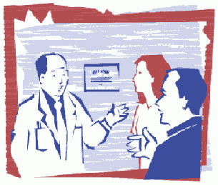

Stem Cells: Treating a Broken Heart

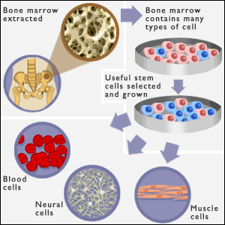
Source: http://news.bbc.co.uk/1/shared/spl/hi/pop_ups/03/health_stem_cell_guide/html/4.stm
More than half a million Americans each year have their first heart attack, a sudden blockage of an artery that deprives heart muscle of blood and oxygen. The resulting injury and scarring often contribute to a gradual loss of the heart’s pumping strength, a condition known as congestive heart failure.
University Medical Center researchers today announced the launch of a clinical trial that will examine whether transplanted stem cells can be safely used to treat damaged heart muscle in patients just after their first heart attack. As part of the fast emerging science of regenerative medicine, labs worldwide are attempting to replace damaged tissue with new cells, much in the same way as salamanders re-grow limbs.
“The potential to re-build damaged heart muscle by implanting stem cells that then become new muscle cells is one of the most exciting in cardiology,” said Alice Jones, M.D., assistant professor of Cardiology at the medical center and principal investigator for the current study. “This study will seek to ensure that stem cell therapy is safe in treating heart failure, a major cause of death in heart attack survivors.
This clinical trial involving heart attack patients will seek to demonstrate the safety, and roughly measure efficacy, of three intravenous doses of tissue specific (adult) human stem cells versus placebo in lessening damage to heart muscle within ten days of first heart attack. The treatment recently passed an early safety test and has been approved for study in more patients at higher doses. That process will get underway shortly in Rochester.
Forty-eight patients will participate in the trial. Male and female patients are eligible and must be between the ages of 21 and 85 and in good overall health, with the exception of a recent heart attack. Trial entry must occur within 10 days of first heart attack, and patients will be followed for two years afterward.
The trial is designed to evaluate safety of treatment with stem cells obtained from healthy, unrelated, adult donors (not from a fetus, embryo or animal). CardioStem, developed by StemCell Therapeutics, Inc., is not yet an approved or marketed therapy.
Researchers hope that the use of transplanted stem cells to replace lost heart muscle cells will do what current treatments cannot: prevent heart muscle loss after heart attack. Animal studies have shown that MSCs injected into heart muscle following a heart attack decreased the death of muscle cells and increased pumping strength.
This new study is a randomized, double-blind, placebo-controlled, Phase I clinical trial with patients randomized to receive either an injection of 0.5 million, 1.6 million or 5.0 million cultured adult mesenchymal stem cells (CardioStem) per kilogram of body weight, or placebo.
Along with the treatment or placebo, all patients will receive standard treatment, including techniques to maximize blood flow to damaged areas, pain relief, oxygen, anti-coagulants, beta-blockers, nitrates, ace-inhibitors and advice on reducing risk factors.
Experts believe that mesenchymal stem cells for many reasons have tremendous potential to become the basis for a powerful new treatment area in cardiology. For instance, research has shown that MSCs, like Blood Type O, are universally compatible, meaning they can be transplanted from person to person without fear of rejection by the recipient’s immune system.
Other approaches – like harvesting stem cells from the patients’ own tissue – can be expensive, time-consuming and limited in the numbers of cells produced. Stem cells donated by other humans (allogenic) make possible the storage of stem cell supplies ready for immediate use as heart attack patients arrive at hospitals.
From a small sample of bone marrow, researchers can grow billions of allogenic stem cells in cultures, controlled environments that mimic human tissue. Cultured MSCs are used already in the treatment of some cancers.
While previous studies injected cells directly into the heart, scientists hope that MSCs can be delivered to the heart by a standard injection in the arm. MSCs actually home in on the tissue damaged by heart attack. It has been shown that higher animals store MSCs in the bone marrow, and release them into the blood stream after injury, where they can rush to the site of damage to aid in wound repair the same way that white blood cells rush in to fight infection.
Several questions remain about whether MSC treatments will be effective for repairing damaged hearts. For example, implanted stem cells have been shown in some studies to only partly differentiate, with the end result lacking some of the characteristics of a mature heart muscle cell. Also, early studies also found that most implanted MSCs either re-enter the circulation or die rather than engraft to the heart muscle wall to form new muscle cells.

Modified from: http://www.urmc.rochester.edu/pr/news/story.cfm?id=1001

University Hospital Research Institute
Informed Consent Form

This Informed Consent Form is for men and women who have sought treatment at the University Hospital for a heart attack. We are inviting patients to participate in research to investigate CardioStem, a new treatment for heart attack patients.

The study described in this consent form is being conducted by Dr. Alice Jones, of the University Hospital Research Institute. The study is funded by the National Institutes of Health.

This Informed Consent Form has two parts:
- Part 1: Information Sheet – to share information about the research with you
- Part 2: Certificate of Consent – for signatures if you agree to take part

PART 1: Information Sheet

Introduction
I am Dr. Alice Jones, working for the University Hospital Research Institute. We are doing research on the use of CardioStem, a stem cell therapy to prevent congestive heart failure following a heart attack. I am going to give you information and invite you to be part of this research. You do not have to decide today whether or not you will participate in the research. Before you decide, you can talk to anyone you feel comfortable with about the research. There may be some words that you do not understand. Please ask me to stop as we go through the information and I will take time to explain. If you have questions later, you can ask them of me, the study doctor or the staff.

Purpose
The purpose of this research study is to investigate a new treatment for heart attack patients. The drugs that are currently used to treat heart attack patients do not always cause the patient to get better. For some patients, their heart disease may continue to worsen even with treatment. This may lead to congestive heart failure, a condition in which damaged heart muscle cannot pump blood enough blood to the body’s other organs. If administered within ten days of a first heart attack, CardioStem treatment has the potential to rebuild damaged heart muscle by implanting tissue specific (adult) stem cells that then become new heart muscle cells. Current treatments for heart attacks (perfusing oxygen, anticoagulants, beta blockers, nitrates, ace-inhibitors, and reduction of risk factors) have not proven as effective as we would like in reducing the incidence of congestive heart failure in patients who had a heart attack. CardioStem is a new treatment which may work better. The reason we are doing this research is to find out if CardioStem, is better than the standard treatment.

Type of research intervention
This research will involve three injections of CardioStem (mesenchymal stem cells) into the vein in your arm. These injections will be administered before you leave the hospital. The study will require four follow-up visits to the clinic where we will test your heart rhythm, ejection fraction, pulmonary function, and general health.

Participant Selection
We are inviting all adults with who have had a heart attack to participate in the research on the new treatment.

Voluntary Participation
Your participation in this research is entirely voluntary. It is your choice whether to participate or not. Whether you choose to participate or not, all the medical services you currently receive will continue and nothing will change. You may change your mind later and stop participating even if you agreed earlier.

Information on CardioStem
The treatment we are testing in this research is called CardioStem. CardioStem is made by isolating mesenchymal stem cells from bone marrow donated by adults. The injection of mesenchymal stem cells into veins has been tested and shown to be beneficial in treating mice with damaged heart muscle. Research done on human subjects has shown that transplanted mesenchymal stem cells do not induce an immune response or a graft-vs-host reaction. CardioStem has been used to treat other diseases during other clinical trials with no side-effects or adverse reactions. We now want to test CardioStem on people who have had a heart attack to see if this treatment is effective on decreasing the percentage of heart attack patients who develop congestive heart failure. This type of research is called a "Phase 2" trial.

CardioStem is made by StemCell Therapeutics, Inc. You should know that Phase I studies have shown that CardioStem, when given at the dosage we will be using in this clinical trial, was well tolerated by the study subjects. We do not anticipate and problems or risks as a result of CardioStem treatment.

Some participants in the research will not be given the treatment which we are testing. Instead, they will be only be given only the standard treatment typically given to all heart attack patients.

Procedures
Because we do not know if CardioStem treatment is better than the currently available treatments for heart attack patients, we need to compare the two. To do this, we will put clinical trial participants taking part in this research into two groups. The groups are selected by chance, as if by tossing a coin.

Participants in one group will be given CardioStem treatment along with the standard treatments given to all heart attack patients. Participants in the other group will be only be given the standard heart attack treatments. It is important that neither you nor we know whether you have been given CardioStem. This information will be in our files, but we will not look at these files until after the research is finished. This is the best way we have for testing without being biased—influenced by what we think or hope might happen.

We will then compare which of the two groups has the best results. The healthcare workers will be looking after you and the other participants very carefully during the study. If we are concerned about what the drug is doing, we will find out which treatment you are getting and make changes. If there is anything you are concerned about or that is bothering you about the research please talk to me or one of the other researchers

Participants in the group that will be given only the standard treatment will receive a dose of a placebo instead of doses of CardioStem. A placebo or inactive medicine looks like real medicine but it is not. A placebo has no effect on a person because it has no real medicine in it. Sometimes when we want to know whether a new medicine is good, we give some people the new medicine and some people the placebo. For the research to be good, it is important that you do not know whether you have been given the real treatment or the placebo. This is one of the best ways we have for knowing what the treatment we are testing really does.

You will receive the treatment of your condition according to national guidelines. This means that you will receive CardioStem through a vein in your arm (called an intravenous injection). To obtain baseline data on the extent of your heart damage, we will do an EKG, an MRI, a Pulmonary Function Test, and a general physical examination before you leave the hospital. The results of these tests will be used only for our research.

Description of the Process
During the research you will make five visits to our medical clinic—1 month, 3 months, 6 months, 12 months, and 24 months. During each visit we will do an EKG, an MRI, and a Pulmonary Function Test. We will also ask you a few questions about your general health and perform a general physical examination.

Duration
This research will take place over 2 years. During that time, it will be necessary for you to come to the clinic five times. Each clinic visit should be about four hours long. At the end of two years, the research will be finished.

Side Effects
As already mentioned, CardioStem treatment has been well-tolerated by patients during previous clinical trials. But there is always that possibility that it may also cause some short-term or long-term problems that we are not aware of. However, we will follow you closely and keep track of any unwanted effects or any problems. We may use some other medicines to decrease the symptoms of the side effects or reactions. If this is necessary we will discuss it together with you and you will always be consulted before we move to the next step

Risks
By participating in this research it is possible that you will be at greater risk than you would otherwise be. There is, for example, a risk that your disease will not get better and that the new treatment (CardioStem) when given in combination with standard treatments does not increase your chances of getting better when compared to the standard treatment only. There is also a risk that you will have some unwanted side effects or problems.

Discomforts
By participating in this research it is possible that you may experience some discomfort such as needle sticks from the injections or follow-up testing procedures.

Benefits
If you participate in this research, you will have the following benefits: any interim illnesses will be treated at no charge to you. There may not be any benefit for you but your participation is likely to help us find the answer to the research question. There may not be any benefit to the society at this stage of the research, but people are likely to benefit from this research in the future.

Incentives
We will give you $20 for each clinic visit to pay for your travel to the clinic. You will not be given any other money or gifts to take part in this research.

Research Related Injury
In the event that this research activity results in an injury, treatment will be available, including first aid, emergency treatment and follow-up care as needed. Care for such injuries will be billed in the ordinary manner, to you or your insurance company. The sponsor of the study has some funds available to pay for care for injuries resulting directly from being in this study. If you think that you have suffered a research related injury and that you may be eligible for reimbursement of some medical care costs, let the study physicians know right away.

Confidentiality
It is possible that if others in the community are aware that you are participating in this research, they may ask you questions. We will not be sharing the identity of those participating in the research with anyone. The information that we collect from this research project will be kept confidential. Information about you that will be collected during the research will not be identified by your name but by a number. Only the researchers will know what your number is and they will lock that information up with a lock and key. It will not be shared with or given to anyone except Dr. Jones and her research team, the National Institutes of Health (they are the research sponsors), and your own medical doctor.

Sharing the Results
The knowledge that we get from doing this research will be shared with you before it is made widely available to the public. Confidential information will not be shared. After the research is completed, we will publish the results in order that other interested people may learn from our research.

Right to Refuse or Withdraw
You do not have to take part in this research if you do not wish to do so and refusing to participate will not affect your medical treatment in any way. You will still have all the benefits that you would otherwise have at this clinic. You may stop participating in the research at any time that you wish without losing any of your rights as a patient here. Your treatment at this clinic will not be affected in any way.

Alternatives to Participating
If you do not wish to take part in the research, you will be provided with the established standard treatment available for Class IV lupus nephritis, which will be determined by your own medical doctor.

Who to Contact
If you have any questions you may ask them now or later, even after the study has started. If you wish to ask questions later, you may contact:
Dr. Alice Jones
University Hospital Research Institute
123 Institute Drive
Anytown, NY 12345
(555)123-4567
Alice_Jones@UHRI.org

This proposal has been reviewed and approved by the University Hospital Research Institute’s Institutional Review Board (IRB), which is a committee whose task it is to make sure that research participants are protected from harm. If you have any questions or concerns regarding the study and would like to talk to someone other than the researchers, you should contact: Mr. Robert Foster, University Hospital Research Institute, (555)123-5678 or Robert_Foster@URHI.org.

You will be given a copy of this form to keep for your records.
PART 2: Certificate of Consent

I have been invited to participate in research of a new drug to prevent congestive heart failure due to a heart attack. I understand that it will involve receiving three injection of CardioStem that contains mesenchymal stem cells isolated from donor bone marrow. I understand that participation in the study includes five visits to the clinic. I have been informed that there may be some risks to this procedure. I am aware that there may be no benefit to me personally and that I will not be compensated beyond travel expenses. I have been provided with the name of a researcher who can be easily contacted using the number and address I was given for that person.

I have read the information sheet about this research study, or it has been read to me. I have had the opportunity to ask questions about it and any questions that I have asked have been answered to my satisfaction. I consent voluntarily to participate in this research and understand that I have the right to withdraw form the research at any time without in any way affecting my medical care.

Print Name of Participant _____________________________________
Signature of Participant _______________________________________
Date (day/month/year) _______________________________________

Thumb print of Participant

I have witnesses the accurate reading of the consent form to the potential participant, and the individual has had the opportunity to ask questions. I confirm that the individual has given consent freely.

Print Name of Witness _______________________________________
Signature of Witness _________________________________________
Date (day/month/year) _______________________________________

I have accurately read or witnessed the accurate reading of the consent form to the potential participant, and the individual has had the opportunity to ask questions. I confirm that he individual has given consent freely.

Print Name of Researcher _____________________________________
Signature of Researcher _______________________________________
Date (day/month/year) _______________________________________

A copy of this Informed Consent Form has been provided to the participant _______ (initialed by the researcher/assistant).

University Hospital Medical Center
Stem Cell Research Institute

Dear ________________________________,

My daughter has been telling me about the stem cell lessons that you are doing with her class. I am pleased that you have included lessons on stem cell biology that go beyond the brief section in her textbook. I am hoping that you will consider adding a lesson or two that make your students aware of exciting new research that is revolutionizing work in stem cell biology.

During the past few years, stem cell researchers have developed revolutionary techniques that allow them to reprogram differentiated cells and turn them into pluripotent cells. These pluripotent cells, called induced pluripotent stem cells (IPSCs) offer advantages that overcome the limitations of pluripotent stem cells produced from blastocysts or nuclear transplantation. IPSC technology has tremendous potential for a variety of applications for studying and possibly developing cures for human diseases.

I have included several news articles that you and your students might find interesting. Because IPSC research is advancing at an incredibly rapid pace, I would also encourage you and your students to use Internet search engines to follow the latest breakthroughs.

I am hoping that your students will willing to create information products (sample textbook pages, PowerPoint slides, tri-fold brochures, posters, or video segments) that could be used to make future biology students aware of induced pluripotent stem cell research. Ideally these information products would:
  - Explain how induced pluripotent stem cells can be produced by “reprogramming” differentiated cells.
  - Identify the advantages and limitations of induced pluripotent stem cells.
  - Identify current and potential future uses for induced pluripotent stem cells.

Sincerely yours,

Joseph Jones
Joseph Jones, Ph.D.
Department of Biomedical Genetics
Stem Cell Research Institute
University Hospital Medical Center

Stem Cell Follow-Up Survey

- What are the two most important new things you learned about stem cells or stem cell research?
- __________________________________________________________________________________________________________________________________________________________________________________________________________________
- __________________________________________________________________________________________________________________________________________________________________________________________________________________

- What are two concerns or questions you still have about stem cells or stem cell research?
- __________________________________________________________________________________________________________________________________________________________________________________________________________________
- __________________________________________________________________________________________________________________________________________________________________________________________________________________

- Do you think scientists should be able to do stem cell research?
___ Yes ___ Maybe ___No ____No Opinion

- Explain your position.
___________________________________________________________________________________________________________________________________________________________________________________________________________________________

- Did you change your opinion as a result of class activities on stem cells? Explain why or why not.
___________________________________________________________________________________________________________________________________________________________________________________________________________________________

- If you were a scientist, what is one research question that you might want to ask about stem cells that might lead to disease prevention, treatment, or cure?

I want to know: ____________________________________________________________________________________________________________________________________________________________________________________________________________________________________________________________________________________________________

Because when I know the answer to this question, I might be able to: ____________________________________________________________________________________________________________________________________________________________________________________________________________________________________________________________________________________________________
(“Prevent, cure, or treat” diseases is NOT an acceptable answer to this question. You must explain how or why.)

