Family Secrets
A Problem-Based Learning Case

Part 5
Making Decisions

Family Secrets

Part 5
Making Decisions

Narrator: It had been a week since Jenny got her test results. She’d waited for Jeremy to call to tell her about his results. But he hadn’t called. Finally she couldn’t stand the suspense any longer, so she picked up the phone and called him.

Jeremy: Hi Jen, glad you called. When are you coming out here to visit me? The skiing here in Colorado is fantastic! I can get free lift tickets for you. That’s one of the benefits of this ski instructor’s job

Jenny: Jeremy, I know. I will make plans to visit you one of these days, but you know I didn’t call you about skiing. I want to know what happened with your HD testing. It seems like I am more uptight about it than you are.

Jeremy: Well, if you really want to know, my doctor told me that I do have the gene. He was so serious about the whole thing, but I told him I’m not going to worry about it right now.

Jenny: I am so sorry, Jeremy. No wonder you didn’t call. I can’t believe you’re taking the news so well. Now I wish I’d made those plane reservations so I could be out there with you.

Jeremy: Don’t get all freaked out on me now, Jen. It’s not the worst thing that could happen. I’ve always been good at taking what comes along, so I’ll just focus on appreciating life more—you know, having fun. Any way, all this skiing is good for me—keeps me fit and active.

Jenny: But aren’t you worried? I would be hysterical.

Jeremy: I can’t worry about what might happen in 10 or 20 or 30 years. By then scientists will probably have a cure for HD. Stem cell therapy, gene therapy, medicines……I know they are working on finding a treatment or a cure.

Jenny: Have you contacted the Huntington’s disease support group in your area?

Jeremy: Nope, I haven’t had time. Oh, by the way, I haven’t told Mom yet either. She left five messages on my answering machine asking about my test results. I am just waiting for a day in my schedule when I can be on the phone with her for a few hours before I call her. Hey, maybe you can tell her for me.”

Jenny: Uh, uh! No way Jeremy! You know I’d do almost anything for you, but not that. You better make time to call her. I know she’s really worried. She keeps asking Dad and me about your test results, and I don’t want to be the one to break the news.

Jeremy: OK, okay, I get your point. I’ll call her soon. By the way, how is Dad doing?

Jenny: He seems to have some good days and then some bad days. He’s happy that he still has his job, at least for now. But the last time I saw him he started complaining about how difficult living alone and caring for himself has become.

Jeremy: Hey, that doesn’t sound too good. When you talk to him, tell him that I’m thinking about him. Look Jen, I gotta go.

Jenny: Hey Jeremy! Wait! Are you still serious with your girlfriend, Liz? Have you told her that you have the HD gene?

Jeremy: Uh…. No and I really haven’t figured out how to tell her. I know that Liz loves kids and I’m not sure how she’ll react to all of this. I don’t know if she’ll want to stick around if she finds out.

Jenny: Yeah, I guess that’s something you need to think about. Hey Jeremy, you know it seems that we focused so much on deciding whether or not to get tested that we didn’t realize that getting the test results would just lead to more decisions.

Narrator: Imagine what ethical, legal, and social implications the members of the Lanahan family will face in the future. What might be the new, major decisions that Jenny, Jeremy, their father, their mother, and their family and friends will have to make?

Potential Ethical, Legal, and Social Implications for the Lanahans and Others

Name: Class:

What does your team think might be a major ethical, legal, or social implication that Jenny, Jeremy, their father, their mother, or family and friends might have in the future?

Jenny?

Jeremy?

Their father?

Their mother?

Their family and friends?

Family Secrets Part 5: Making Decisions

Quick Guide for Sample Lesson Sequence

Overview

PBL Part 5 | Class # | Check Off | Time | Strategy / Activity Name
More Decisions | 11 |  |  | Script Reading: Part 5
More Decisions | 11 |  |  | ELSI “Future” Posters
More Decisions | 11 |  |  | PBL Rubrics (post-PBL reflection)  #1: Problem Solving  #2: Team Processing
More Decisions | 11 |  |  | Optional: Poster Museum Walk
Optional  Alternative Assessments | 12+ |  | B | Genetic Assessment (Parts, A, B, and C)
Optional  Alternative Assessments | 12+ |  | C | Creating Your Own Ending
Optional  Alternative Assessments | 12+ |  | D | Researching “Hopes for the Future”
Optional  Alternative Assessments | 12+ |  | E | Understanding Another Genetic Condition
Optional  Alternative Assessments | 12+ |  | F | ELSI Speculation
Optional  Alternative Assessments | 12+ |  | G | Genetic Literacy Survey
Optional  Alternative Assessments | 12+ |  | H | Should It Be A Law?
Optional  Alternative Assessments | 12+ |  | I | Testing for “Good” Genes
 |  |  | J | Societal Concerns Arising from Genetic Testing and Genetic Engineering

You will need

For each student:
1 copy per student of
- Family Secrets Part 5 script
- PBL Rubrics #1 and #2 from Part 1
- Family Secrets Genetics Test (Part 5 Appendix B)

Per Team:
1 colored copy per team of the PBL Rubric #2: Teamwork and Team Processing (Part 5: Appendix A.)

Per Class:
3 highlighted copies of Part 5 script, one for each reader: Narrator, Jenny, Jeremy

Class 11

- Distribute copies of Family Secrets - Part 5 script to all students.
- Class reading of Family Secrets - Part 5 script by readers: Narrator, Jenny, Jeremy.
- ELSI poster activity: Teams complete the poster, speculating on ELSI issues that Lanahan family members might face in the future. Students hang posters for optional Museum Walk.
- Distribute formally completed (in Part 2) copies of the PBL Rubrics #1 and #2 to each student.
- Ask students to work individually to use the rubrics again to evaluate their own work (individual column) on each rubric. This is a “post-PBL” comparison reflection activity. Student may use a different colored pen or pencil for this “post-PBL” activity.
- Have students look at their first Rubric #1 ratings, and reflect on changes for their early PBL work.
- Distribute one colored copy of the PBL Rubric #2 Teamwork and Team Processing to each PBL team. Ask teams to reach consensus to complete the rubric to evaluate their team’s work.
- Have teams look at their first Rubric #2 ratings, and reflect on changes from their early PBL work as a team.
- Collect all rubrics.
- Optional: “Museum Walk” of ELSI posters.

Class 12+ options

If time permits, teachers may choose to offer one or more of the Alternative Assessment assignments (Part 5, Appendix B-J) to students, including the Genetics Assessment, Parts A, B, and C (Appendix B). The complexity and variety of the other assessment options are ideal as differentiated assessment tools within or among teams.

Family Secrets
Part 5 – Making Decisions
Detailed Instructional Guide

Overview

Jenny, Jeremy, and Dad now know the results of their genetic tests. They are now considering how this knowledge will affect their lives. Students read Part 5, do a short summary activity related to ELSI issues, and complete the post-PBL rubrics. Teachers may choose to extend the unit with a number of optional, alternative assessments.

Objectives

After completing Part 5 students should provide evidence that they have:
- Identified possible ethical, legal, and social implication issues that patients and family members may face in the future once the results of genetics tests are known.
- Reflected on the results of the “early-PBL” and “post-PBL” Rubrics #1 and #2 for themselves and their team.
- Optional: completed one or more alternative assessment assignments.

Coach’s Preparation

Before beginning Family Secrets Part 5, coaches should:
- Provide one copy of Family Secrets Part 5 script for each student.
- Make copies for each student of both PBL Rubrics #1 and #2.for and additional colored-paper copy of PBL Rubric #2 for each team. (Part 5: Appendix B.)
- Plan for summative assessment using a test and/or alternative assessment. See Part 5: Appendix B for Family Secrets Genetics Test and scoring guide.
- Have a supply of flip chart or 11”x 17” paper and markers ELSI poster activity.

Concepts for class discussion: background or supporting lessons

Students need to understand the concepts listed below. Lessons on these concepts may be completed as background information before Part 5 or during Part 5.
- Importance of research to understand mechanisms that link gene mutations to phenotype/symptoms of disorders
- Potential prevention, treatment, or cure for genetic diseases including, but not limited to reproductive technologies, medication, stem cell technology, and gene therapy
- Legal and societal issues that may impact families affected by HD such as laws, support for research, discrimination, insurance, financial burden, reproductive issues.

Possible ELSI Coaching Questions

Coaches should direct students to consider the impact of the results of genetic testing on families and the importance of supporting research in understanding genetic diseases with such questions as:
- What decisions and ELSI issues might Jenny, Jeremy, their father, their mother, and their family and friends need to face in the future?
- What future medical treatments or technologies might offer hope for a better future for people with Huntington’s disease?

Sample Lesson Sequence:

Part 5: Making Decisions – Class 11 + options

Estimated  Time  (min.) | Summary of Steps | Suggested Strategies
Class 11
2 | Introduction | - Coach explains that once people know the results of genetic tests, they may face additional, future ELSI issues.
3 | Read aloud  PBL Part 5 | - Coach distributes copies of Family Secrets - Part 5 script to students.  - Coach asks students to listen to Family Secrets - Part 5 script and imagine what future ELSI issues might Jenny, Jeremy, Dad, Mom, their family, and their friends may have to face.  - Students are asked listen and make notes of the potential alternative futures (issues, problems, and questions) the Lanahan family may face in the future.  - Three students read to the class: Narrator, Jenny, and Jeremy.
15 | ELSI Futures Posters | - Coach provides large sheets of paper (chart or 11x17) and markers for each team, and distributes the Potential Future ELSI Poster handout.  - Coach instructs PBL team recorders to copy the Potential Future ELSI question on the top of the poster and list the name of the Lanahan family and friends along the side.  - Coach reminds students that they might consider issues related to short-term and long-term consequences or other possible ELSI concerns.  - Teams brainstorm to make a list of ELSI issue of what they think might be faced by the Lanahan family in the future.  - Posters may be hung on the walls for sharing
20 | Reflection using PBL Rubrics #1 and #2. | - Coach distributes copies of the saved PBL Rubrics #1 and #2 from Part 2 to each student.  - Coach asks students to work individually to use the rubrics to re-evaluate their own work for both the Problem Solving and Team Processing Rubrics, and to rate themselves again, now at the end of the PBL process.  - Coach directs team to meet and come to consensus on Rubric #2 about their work as a team at the end of the PBL process, including answering the 3 reflection questions at the bottom of Rubric #2.  - If time permits, coach may lead a discussion about individual and/or team reflections comparing “early-PBL” and “post-PBL” rubrics, or about the whole PBL process as a learning tool.  - Coach collects individual and team rubrics.
Class 12+
Optional | Individual “Test” | - Coach administers Family Secrets Assessment. See Appendix B.
Optional | Assessment Alternatives | - Coach explains group or individual alternative assessment assignment(s) to students. See Appendices C-J for possibilities.

If time permits, consider using an additional class period to:
- Have students share the products of their alternative assessment with their classmates.
- Review other genes that have been identified on human chromosomes. “Pose the question: “Is the study of genetics only about things that kill or injure humans?”

Appendix A:

#1: PROBLEM SOLVING RUBRIC

Student: | 1  Limited | 2 Developing | 3  Proficient | 4  Advanced | 5  Exemplary | Self | Team
Identifies Relevant Facts (“What do we know?”) | Cannot identify facts, or mixes facts with opinions. |  | Identifies most relevant facts. |  | Helps distinguish facts from opinions/inferences.
Asks Relevant Questions (“What more do we want to know?”) | Asks no questions or ones unrelated to script. |  | Asks basic kinds of “who, what, where, when” questions. |  | Asks higher-level questions which reflect depth of thought.
Organizes Questions for Research | Is unable to organize questions into categories. |  | Organizes questions into appropriate categories. |  | Identifies questions that fit into multiple categories.
Selects Useful Information from Appropriate Sources | Cannot locate information to answer research questions. |  | Obtains relevant information from key sources provided. |  | Obtains reliable and wide-ranging information from sources beyond those provided.
Organizes and Presents Information Effectively | Does not organize information to clearly present answers to research question(s). |  | Organizes information to clearly present answers to research question(s) |  | Summarizes information from many sources; presentation is concise accurate, and insightful.
Identifies Major  Problem(s) and Stakeholders | Cannot state a major problem or identify important stakeholders. |  | Identifies major problem and major stakeholders. |  | Distinguishes between major & minor problems; identifies direct & indirect stakeholders.
Develops Multiple Solutions to Major Problem(s) | States only one (obvious) course of action to major problem. |  | Develops two or more solutions to the major problem(s) |  | Develops multiple solutions based on pros/cons and stakeholder perspectives.
Chooses a Course of Action and Supports Choice | Cannot select or support a course of action. |  | Selects and supports a course of action based on ethics or risks/benefits to one stakeholder |  | Selects a solution based both ethics and risks/benefits to multiple stakeholders

#2: PBL TEAMWORK AND TEAM PROCESSING RUBRIC

Team  Members: | 1  Limited | 2  Developing | 3  Proficient | 4  Advanced | 5  Exemplary | Self | Team
Distribute Tasks | Do not distribute tasks equally. |  | Distribute tasks equally. |  | Distribute tasks based on team members’ skills.
Collaborate  & Contribute Equitably | Let one or two team members do most of the work. |  | Ensure that all team members contribute fully. |  | Know and encourage each other’s strengths to do quality work.
Manage Conflict | Do not recognize or take action to reduce conflict |  | Resolve conflicts to continue to stay “on task.” |  | Identify and actively use “win-win” solutions to manage conflict.
Use Brainstorm  “Rules” | Do not use brainstorm “rules”; allow others to block the process. |  | Follow brainstorming “rules” and contribute ideas equally. |  | Develop new “rules” as needed to facilitate the brainstorming process.
Effectively Reflect on Teamwork | Do not contribute to discussions about their work as a team. |  | Use the results of this rubric to suggest ways to improve teamwork. |  | Regularly monitor and assess teamwork of individuals and group as a whole.
Build Consensus | Do not attempt consensus process. |  | Use consensus process to work effectively. |  | Seek out feedback and process this information to improve teamwork.
Manage Time | Do not monitor their progress or recognize time constraints. |  | Use time efficiently and complete all tasks on time. |  | Regularly monitor and assess progress to exceed task expectations.
Produce Quality Work | Show no, or limited, attention to making quality products. |  | Create high school products that meet expectations |  | Create products that resemble practicing professionals “in the field.”
Stay on Task | Are easily distracted or frequently go “off task.” |  | Use time in focused & productive ways. |  | Create work-plan agenda and monitor progress.
Come Prepared | Are not consistently prepared with needed materials. |  | Are consistently prepared with needed materials. |  | Take time daily to assure that materials are ready for next work session.
Maintain Positive Attitude | Exhibit negative behaviors; use “put down” expressions. |  | Exhibits positive attitudes/behaviors towards work and others. |  | Assist others in maintaining positive attitudes and behaviors.

PBL Problem Solving and Teamwork Reflection Questions:

1. Describe a specific example of something you learned from your PBL team (e.g., information or a problem solving or teamwork skill) that you probably would not have learned on your own.

2. Describe a specific example of something that your team members learned from you (e.g., information or a problem solving or teamwork skill) that they probably would not have learned without you on their team.

3. Suggest one specific, practical change the team could make that would improve the team’s learning, problem solving or teamwork skills.

Appendix B
Family Secrets Genetics Test

Part A

1. The symptoms of many genetic diseases happen because of a change in a gene’s base sequence. That change then:
- alters the function of the protein produced by that gene.
- breaks the weak bonds attaching genes to a chromosome.
- causes more frequent fertilizations by deformed gametes.
- modifies the gene frequency for that gene in the cell.

2. Which laboratory technique is most likely used to test for a change in the sequence of bases within a gene?
- microscopic analysis
- gel electrophoresis
- chromatography
- pH indicators

3. Listed below are 4 events that occur in cells as a result of a mutation.

A. | B. | C. | D.
Change in the DNA code | Change in the shape of a protein | Change in the amino acid sequence of a protein | Change in  cell metabolism

Which sequence of events most accurately represents the order in which these changes normally occur?
- A, C, B, D
- B, C, D, A
- C, D, A, B
- D, B, A, C

4. Polymerase Chain Reaction (PCR) is a laboratory technique used for replicating DNA molecules. During this PCR process, a DNA molecule serves as a template to:
- link amino acids to form a new protein.
- cut genes at specific DNA base sequences.
- alter genes for recombination.
- form a new, complementary strand of DNA.

5. Familial ALS, also known as Lou Gehrig’s disease, is a lethal, genetic disease caused by a gene mutation. The symptoms of this disease typically begin when affected individuals are in their late 50s. The percentage of the human population affected by familial ALS has remained relatively stable for many years. The most likely explanation for this stability is that:
- harmful mutations are not subject to natural selection.
- individuals with this disease do not have any mutations.
- the symptoms of the disease occur only in males.
- affected individuals reproduce before their symptoms appear.

6. Doctor’s now have the technology to perform genetic tests on developing embryos to determine if the embryos carry specific genes that cause inherited diseases. One of the main reasons that these genetic tests are not used extensively is that:
- it is not possible to obtain genetic material from embryos.
- gene testing causes changes in the genetic code.
- there are many ethical concerns about this technology.
- it is easier to clone embryos that are free from genetic defects.

7. When geneticists perform a test on a patient’s genetic material to determine whether it contains a gene for an inherited disease, they often include both a sample from the patient and a sample known as a “positive control”. The positive control sample would most likely contain:
- genes for other diseases caused by bacteria or viruses.
- antibodies that bond to the DNA that causes the genetic disease.
- enzymes that digest the protein produced by the gene.
- DNA from an individual who has the inherited disease.
8. The information in the graph below was obtained from research on individuals who have inherited the gene that causes Huntington’s disease (HD). Huntington’s disease is caused by an abnormal number of CAG repeats in the DNA base sequence of the huntingtin gene.
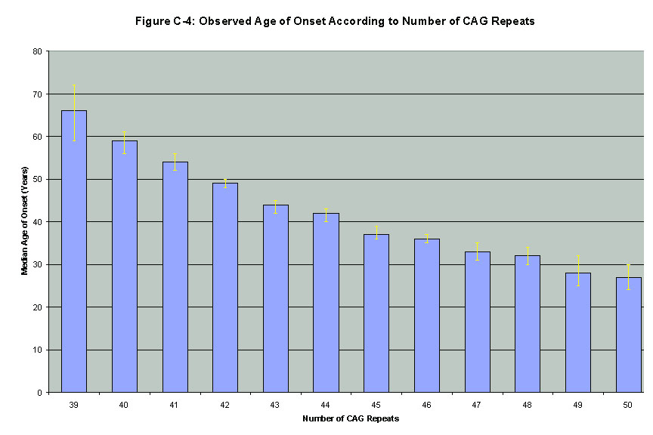
Number of CAG Repeats
Observed
Age of
Onset of
Symptoms

What is the best interpretation of the observed results?
- A large numbers of CAG repeats is associated with early onset of HD symptoms.
- As people get older, their number of CAG repeats increases significantly.
- The number CAG repeats predicts what symptoms an individual will have.
- Early onset of HD symptoms causes a small number of CAG repeats.

- Researchers conducted a survey to study the attitudes of the public towards the use of genetic engineering technology. The results in the chart below show the percentages of people who responded to questions about possible reasons to use genetic engineering technology to change a baby’s genetic characteristics.

Possible reasons to use genetic technology | Appropriate use of genetic technology | Don’t know | Taking genetic technology “too far”
for cosmetic purposes | 4% | 2% | 94%
to reduce the risk of serious genetic disease | 41% | 4% | 54%

Which of the following statements best explains the results of this survey?
- The use of medical advances to change a baby’s characteristics is not legal.
- Genetic engineering will have no effect on a baby’s characteristics.
- Decisions about using medical advances depend on people’s values.
- Most people support changing a baby’s genetic characteristics.

________________________________________________________________

Part B

Base your answers to questions 10 through 12 on the information below and on your knowledge of biology.

Huntington’s Disease Research: Hope for the future?

Huntington’s disease (HD) is a fatal neurological disorder. Symptoms of the disease include rapid, jerky involuntary movements, difficulty in speaking and swallowing, cognitive (mental) decline, and depression. These symptoms are caused by the destruction of cells within specific regions of the brain. As this destruction continues, symptoms appear in the late 40s, and the person dies within 8 to 25 years of the onset of the symptoms.
Huntington’s disease is caused by a mutation in gene that codes for the production of a protein called huntingtin. Researchers discovered that in the mutant HD gene, molecular ”triplets” of Cytosine, Adenine, and Guanine (CAG triplets) are more abundant than they are in the normal gene. In normal (unaffected) people, the CAG triplets repeat between 10 and 35 times. In HD (affected) people, the CAG triplets repeat between 40 and 100 times.
The CAG triplet codes for the amino acid glutamine. Therefore, the abnormal form of the huntingtin protein has a longer-than-normal repeating stretch of this amino acid. This longer glutamine stretch causes the protein to have a misfolded structure that, in turn, causes it to bind tightly to a specific protein (known as HAP-1) found in certain brain cells. This binding causes these brain cells, over time, to malfunction and be destroyed.
Scientists have developed a genetics test that can detect the mutation that causes HD. This genetic test can identify people who are at risk of developing the disease symptoms. Researchers are studying the structure and function of the lethal huntingtin gene in hopes of controlling and preventing HD. Scientists hope to find new therapies to prevent the harmful interactions between abnormal huntingtin and HAP-1. Currently, however, there is no cure or treatment for Huntington’s disease.

10. The normal huntingtin gene and the mutant huntingtin gene that causes Huntington’s differ in their:
1. amount of HAP-1
2. DNA base sequence
3. amino acid shape
4. amount of glutamine

11. The mutant gene most likely leads to the symptoms of Huntington’s disease because the HD gene codes for a protein that:
- occurs in sex cells but not in body cells
- has a different shape and function
- results in gametes that lack chromosomes
- is expressed in males but not in females.

12. As a test for the gene that causes Huntington’s disease, scientists would most likely:
- look for symptoms of mental decline and depression
- measure the concentration of glutamine in the blood and brain
- prevent interactions between HAP-1 and huntingtin protein
- identify the number of CAG triplets in the huntingtin gene

Base your answers to questions 13 through 15 on the information below and on your knowledge of biology.
The children in Family 1 and Family 2 have a family history of a genetic disease known as “familial hypercholesterolemia.” This genetic disease is caused by a gene mutation. Individuals with one defective gene have high blood cholesterol levels which puts them a risk of early heart disease. Genetic testing can be done to reveal whether children have inherited the defective gene for “familial hypercholesterolemia.”
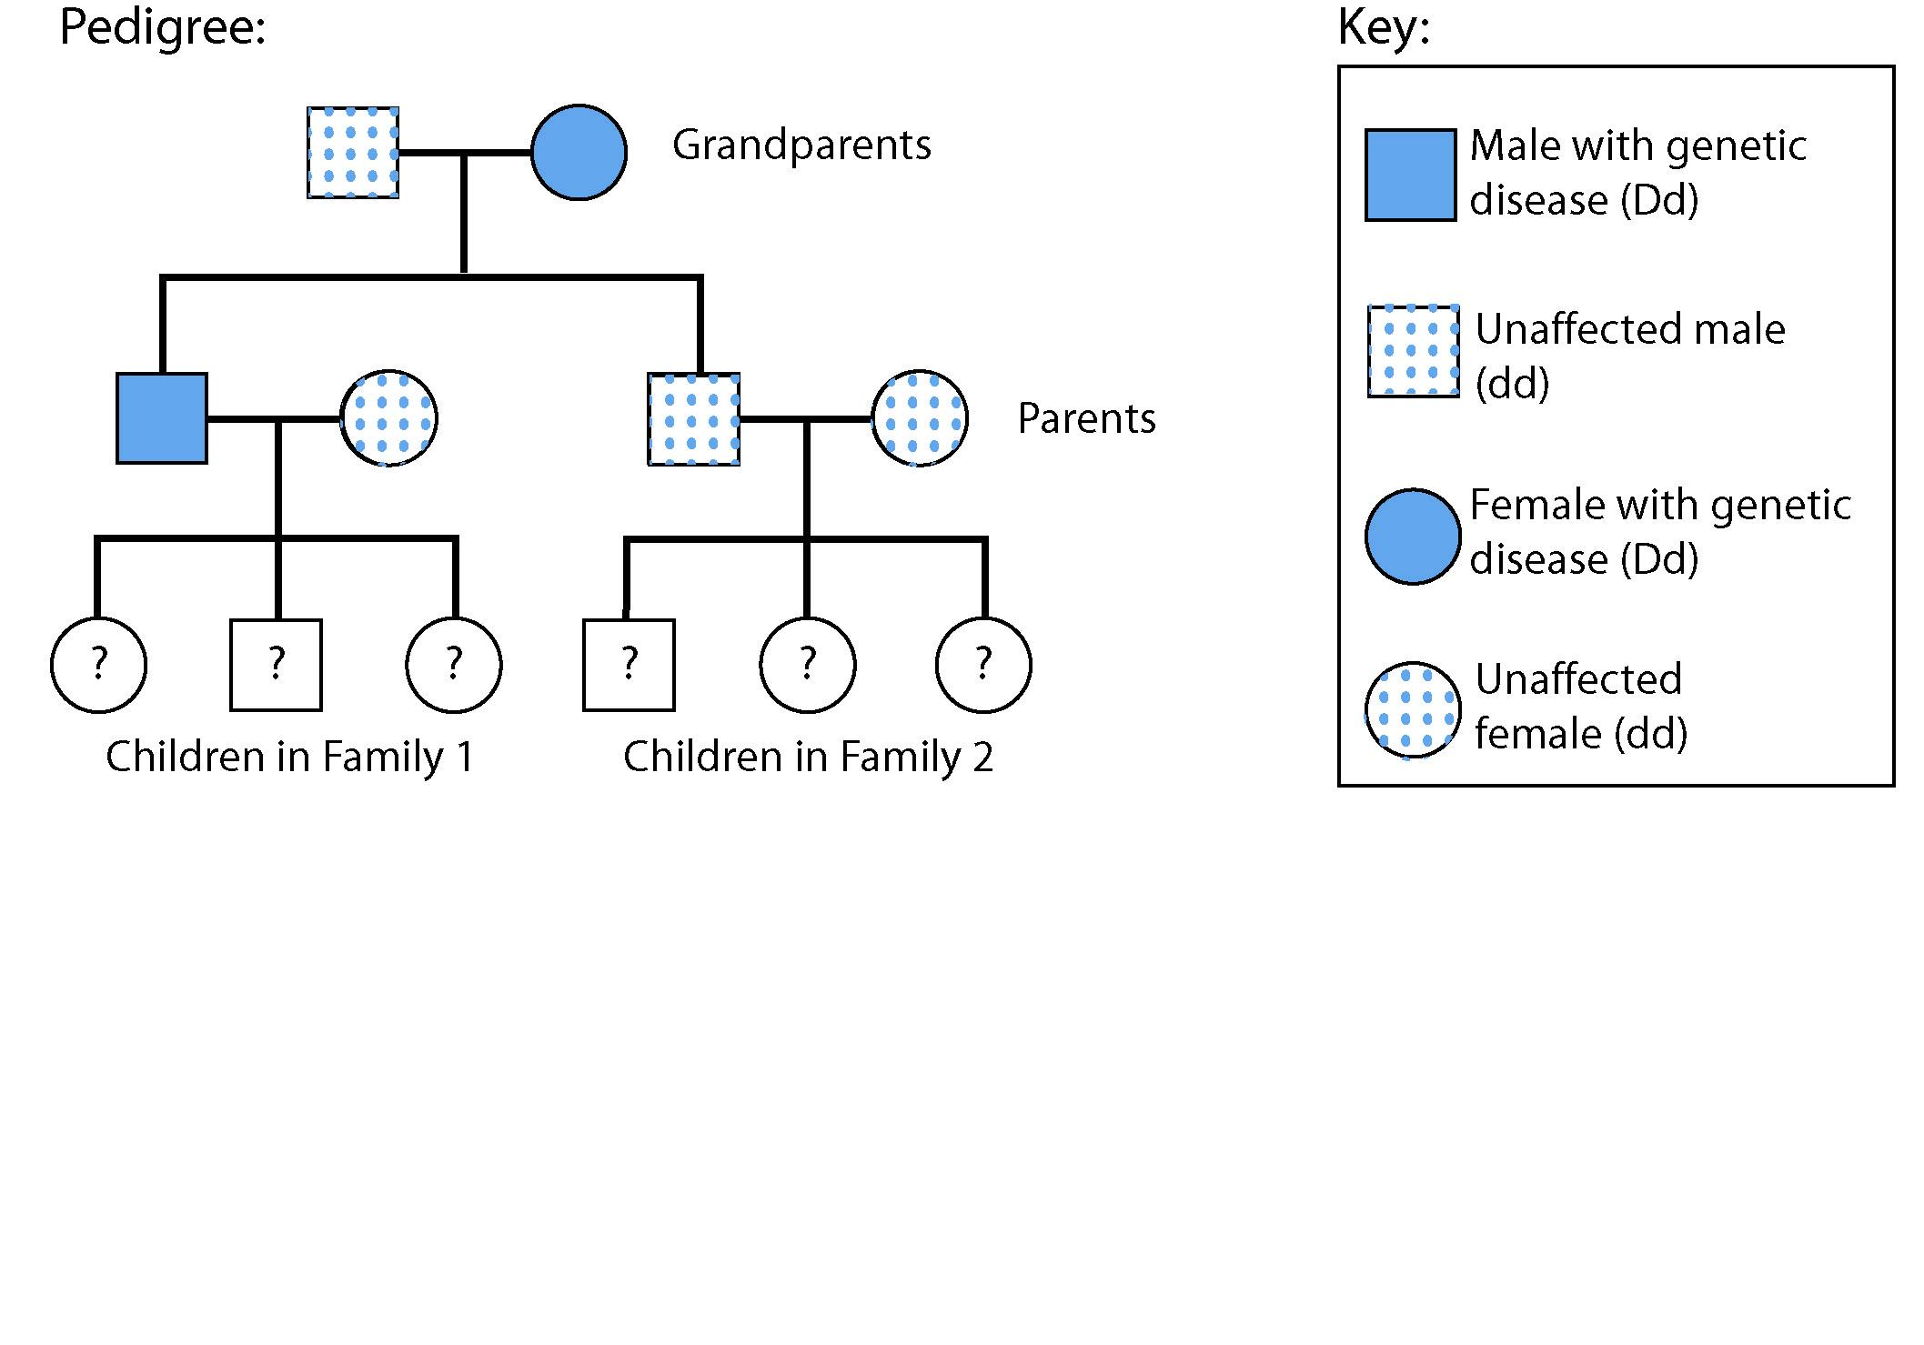
13. When people have a family history of a familial hypercholesterolemia, doctors usually suspect that the symptoms of the disease are caused by
- a defective base sequence in DNA
- increased exposure to viruses
- antigens produced by bacteria
- vaccinations that trigger an immune response

14. Which statement best describes the children’s risk of developing familial hypercholesterolemia?
- The children in both Family 1 and Family 2 are at a 25% risk because genes can “skip” generations.
- All of the children in Family 2 are at a 100% risk of inheriting the gene that causes the disease.
- Each child in Family 1 has a 50% chance of inheriting the gene that causes the disease.
- It is not possible to determine if the children in Family 2 are at risk.

15. Which genetic concept best explains the fact that two parents who have familial hypercholesterolemia can produce offspring who do NOT have the disease?
- Radiation and certain chemicals cause mutations.
- Meiosis and fertilization result in new gene combinations.
- Natural selection increases the frequency of beneficial genes.
- Cloning produces identical genetic copies.

Base your answers to questions 16 through 18 on the diagram below which shows the results of genetic testing for polycystic kidney disease.
At least one band in the D range occurs in individuals who will develop polycystic kidney disease.

Two bands in the normal d range occur in individuals who do not have the gene for polycystic kidney disease.

Polycystic Kidney Disease (PKD) is an inherited condition caused by a dominant gene mutation. An individual with one or two genes for this disease will typically develop symptoms at approximately age 50. These symptoms include cysts in kidneys, bloody urine, high blood pressure, and abdominal pain. 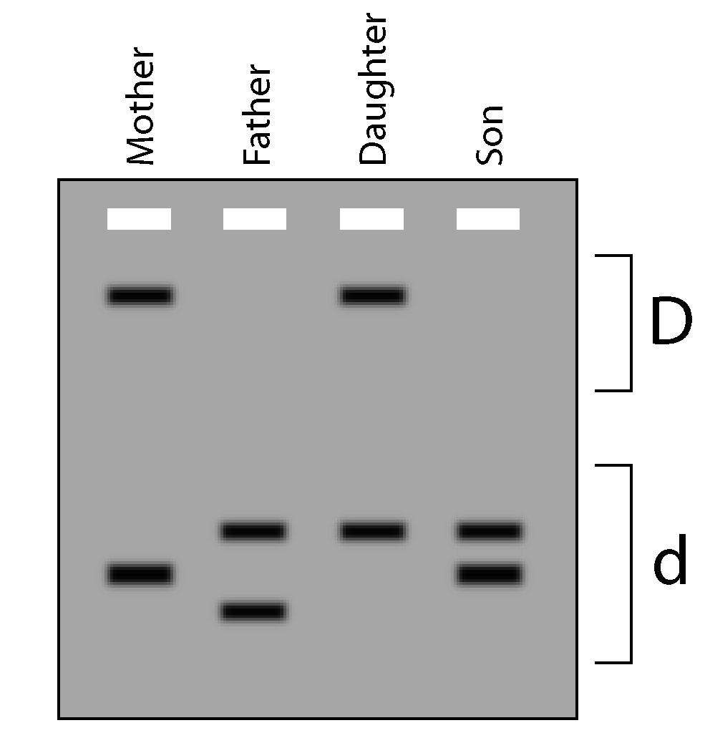

16. Which statement is supported by the information in the diagram?
- The mother may develop polycystic kidney disease
- The father has two disease causing genes
- The daughter will not develop polycystic kidney disease.
- The son received two normal genes from his father

17. The diagram illustrates the use of what laboratory technique?
- dichotomous keys
- chromatography
- gel electrophoresis
- pH indicators

18. The technique illustrated in the diagram is used to
- cut genetic material
- remove extra chromosomes
- replace defective genetic material
- separate fragments of DNA

Base your answers to questions 19 through 21 on the information below and on your knowledge of biology.

Sickle cell disease is caused by a recessive mutation in the gene that codes for hemoglobin, a protein found in red blood cells. Individuals with sickle cell disease have two defective genes. Symptoms of the disease typically include fatigue, joint pain, spleen damage, and high risk of infection. The diagram below illustrates the result of genetic testing performed on 3 family members suspected of having the gene that causes sickle cell disease.

4
1
2
3
5
1 = DNA from individual with sickle cell disease

2 = DNA from unaffected individual

3 = DNA from Mother

4 = DNA from Father

5 = DNA from Daughter
19. Why did the DNA from the father move farther through the gel than the DNA from the mother? [1 credit]

20. Explain why the DNA from the daughter produced two bands rather than one. [1 credit]

21. The mother has a sickle cell disease. Her daughter does not have sickle cell disease. Give a genetic reason why this is possible. [1 credit]

Part C

People who have a parent with a genetic disease can find out whether or not they have inherited the gene for that disease by having a genetic test. In order for to make an informed decision about genetic testing, they should understand that their decision may have both positive consequences (benefits) and negative consequences (risks).

22. State one positive consequence (benefit) that could result if you decided to be tested to determine if you had a gene for an inherited disease. [1 credit]

23. State one negative consequence (risk) that could result if you decided to be tested to determine if you had a gene for an inherited disease, AND explain why this consequence would be considered a “risk.” [2 credits]

Family Secrets Genetics Test
Scoring Guide

Part A

Question | Answer
1 | 1
2 | 2
3 | 1
4 | 3
5 | 4
6 | 3
7 | 4
8 | 1
9 | 3

Part B

Question | Answer
10 | 2
11 | 2
12 | 4
13 | 1
14 | 3
15 | 2
16 | 1
17 | 3
18 | 4

19. Explain why the DNA from the father moved farther through the gel than the DNA from the mom [1 credit]
The DNA from the father was smaller.

20. Explain why the DNA from the daughter produced two bands rather than one. [1 credit]
The daughter had two different genes. OR The daughter got one gene from each of her parents.

21. The mother has a genetic disease due to a mutation in this gene. Her daughter does not have this genetic disease. Explain how this is possible. [1 credit]
It takes two defective genes to result in the disease symptoms. OR The gene for the diseases is recessive. OR The daughter only had one mutant gene.

Part C

- State one positive consequence (benefit) that could result if you decided to be tested to determine if you had a gene for an inherited disease. [1 credit]

Allow one credit for examples such as the ones below, or for any other reasonable answer.

If I found that I did have gene, I could:
- Plan for future medical needs
- Take preventative actions to decrease gene transmission
- Make lifestyle changes to prolong life

If I found that I did not have gene, I could:
- Know for sure I didn’t have the gene
- Stop worrying: relief from anxiety; lower stress
- Know I could have children and not pass gene on

23. State one negative consequence (risk) that could result if you decided to be tested to determine if you had a gene for an inherited disease, AND explain why this consequence would be considered a “risk.” [2 credits]

Allow one credit for negative consequence examples such as the ones below, or for any other reasonable answer. Allow one credit for any reasonable explanation why the consequence chosen is a risk.

If I found that I did have the gene:
- Discrimination in current or future employment and/or ability to get insurance
- Others might want to know the results of the test
- Family members might be able to figure out their genetic status
- Psychological impact on self and others
- May affect personal relationships

If I found out that I did not have gene:
- Survivor’s guilt
- Wonder if tests were really accurate

Sample answer: One negative consequence is possible discrimination. It is a risk because I might loose employment (or medical insurance coverage.)

Sample answer: It is bad because my family members, who don’t want to know anything about this, will be able to know if they got the bad gene too.
Appendix C - Creating Your Own Ending

Write a script for a NEW part for Family Secrets.

This could be either:
- an alternate to the existing Part 5 (the same time).
- a Part 6 (one, five, ten, or 20 years in the future).

Appendix D – Researching “Hopes for the Future”

Report one type of current research that could lead to future treatments or cures for HD. Include a discussion of potential ethical, legal, and social issues associated with the research.
- Pre-implantation Genetic Diagnosis
- Gene Therapy
- Stem Cell Research
- Drug Therapy
- Other medical advances

Appendix E – Understanding Another Genetic Condition

Research another genetic condition and use the information that you gather to create a:
- a one scene dialog for a PBL
- a newsletter for patients and their families
- an educational pamphlet for patients or their families
- a PowerPoint for patients or for a genetics class
- a poster
Include information on the ethical, legal, and social implications of genetic research and genetic testing for this condition.

Consider using these two websites as a source of ideas for genetic diseases that could be researched: http://www.ygyh.org/index.htm and http://www.ornl.gov/sci/techresources/HumanGenome/posters/chromosome/index.shtml).

Appendix F – ELSI Speculation

Review other genes identified on one chromosome as a result of the Human Genome Project at this website: http://www.ornl.gov/sci/techresources/HumanGenome/posters/chromosome/index.shtml
Identify and discuss three additional ethical, legal, and social issues might arise from this knowledge.

Appendix G – Genetic Literacy Survey

What should all people understand about genetics and genetic testing? Construct and administer a survey to collect data on the genetic literacy of a target audience: teachers, parents, community members, or other students. Tabulate the results of the survey and present the report to an appropriate group.

Appendix H – Should it Be a Law?

Write a position statement to address the following question: Should there be a law that requires that all newborns be tested for every genetic disease for which tests are available? Support your position by discussing its ethical, legal, and social implications.

Appendix I – Testing for “Good” Genes

Do research to answer the following questions:
- Are there “good” genes?
- Are there tests that can be done to see if people have “good” genes?
- Would it be ethical to test for these “good” genes?
- Would it be ethical go use genetic engineering to introduce “good” genes into developing embryos?

Appendix J - Societal Concerns Arising from Genetic Testing and Genetic Technology

Select ONE of the categories of questions from the list below. Do further research to the answers to the questions in the category that you selected. Share what you learned from your research with your classmates in an interesting and informative way.

- Privacy and Confidentiality of genetic information
- Who owns and controls genetic information?
- Is genetic privacy different from medical privacy?

- Fairness in the use of genetic information by insurers, employers, courts, schools, adoption agencies, and the military, among others
- Who should have access to personal genetic information?
- How should personal genetic information be used?

- Psychological impact, stigmatization, and discrimination due to an individual’s genetic makeup
- How does personal genetic information affect self-identity and society’s perceptions?

- Reproductive issues, including adequate and informed consent and the use of genetic information in reproductive decision making
- How should health care professionals counsel patients about the risks and limitations of using genetic information in reproductive decision making?
- What are the larger societal issues raised by new reproductive technologies?

- Clinical issues regarding the education of doctors and other health-service providers, people with identified genetic conditions, and the general public
- How should healthcare professionals be prepared for the new genetics?
- How should the public be educated to make informed decisions?
- Clinical issues regarding the implementation of standards of quality control measures
- How will genetic tests be evaluated and regulated for accuracy, reliability, and usefulness?
- How does society balance current scientific limitations and social risk with long-term benefits?

- Fairness in access to advanced genomic technologies
- Who will benefit or be harmed from access to advanced genomic technologies?
- Will there be world-wide inequities in access to advanced genetic technologies?

- Uncertainties associated with gene tests for susceptibilities and complex conditions (e.g. heart disease, diabetes, and Alzheimer’s disease)
- Should gene tests be performed when no treatment is available or when interpretation is unsure?
- Should embryos or children be tested for susceptibility to adult-onset diseases?

- Conceptual and philosophical implications regarding human responsibility, free will vs. genetic determinism, and concepts of health and disease
- Do our genes determine our behavior, or can we control it?
- What is considered acceptable diversity?
- Where is the line drawn between medical treatment and enhancement?

- Commercialization of products including property rights (patents, copyrights, and trade secrets) and accessibility of data and materials
- Will patenting DNA sequences or genetic technology limit their accessibility and development into useful and affordable products?

