Family Secrets

Part 4
Testing for the HD Gene

Narrator: Jenny, Jeremy, and their father have decided to undergo genetic testing for Huntington’s disease. Today, our lab groups will act as gene testing laboratory technicians. We will use the gel electrophoresis laboratory procedure to analyze the results of the simulated DNA samples from Jenny, Jeremy, and Dad. We will determine if they have the mutated huntingtin gene that causes Huntington’s disease, and prepare reports of the analysis of our results.

Nurse: I see that each of you met with a genetic counselor and signed the required informed consent forms. Now I’m going to draw a blood sample from each of you. Jenny, I’ll take you first.

Jenny: When do we get the results?

Nurse: We don’t do the testing here at this facility. We send your blood to a genetics lab that specializes in HD testing. Your doctor will call you when he gets the report from the genetics lab.

Dad: The genetic counselor said a lab technician isolates the DNA from our blood cells and then tests the DNA to see if we have the gene for Huntington’s disease....But how do they tell if our DNA has the HD gene?

Jenny: I think the lab uses a process called PCR to make many copies of the huntingtin gene part of your DNA.

Dad: But how can they tell whether we have the mutated HD gene or the normal gene?

Jeremy: I know that the mutated gene has extra nucleotides (CAG repeats) so it is longer than the normal gene. But how do they tell if we have the longer gene?

Jenny: The lab use a process called gel electrophoresis to separate our gene copies based on size. They put each of our gene copies into a different well on an agarose gel that looks like a piece of Jell-O. Then they put the gel into a box filled with a liquid that carries electric current. When the current is turned it causes the gene copies will move out of the wells to certain places in the gel. How far the copies move depending on how big they are. The larger HD genes don’t move as far as the smaller normal genes.

Jeremy: So how do they tell if I have the mutated gene?

Jenny: They look to see where your DNA pieces end up on the gel. If you have the HD gene, some of your gene copies won’t move as far in the gel as normal pieces do. They’ll be closer to the wells on the gel than the normal genes.

Dad: Seems like there are lots of steps to this testing where something could go wrong. Will it tell for sure whether we have the gene?

* Note: This laboratory activity is a simulation of the gene testing process that uses dyes instead of actual DNA molecules. The activity illustrates how agarose gel electrophoresis is used to separate DNA fragments of different lengths to determine if individuals have a defective gene. Performing the gene testing procedures on DNA samples used in an actual medical test would be too expensive for most high school classrooms.

Genetic Testing Laboratory Procedure

____A. Prepare an agarose solution:

- Place 1.8 grams (1/2 teaspoon) of agarose and 75 ml of electrophoresis buffer into a flask or bottle.

- Follow your teacher’s instructions to heat the agarose solution until it has dissolved completely.

- Insert a thermometer into the agarose solution. Allow the solution to cool to 60ºC. While the agarose solution cools, continue with the following steps.

____B. Set up the electrophoresis apparatus:
(Note: These diagrams represent an example of electrophoresis equipment. Your electrophoresis equipment may look different, and you may need to follow different instructions for setting up the equipment.)

Side view Top view

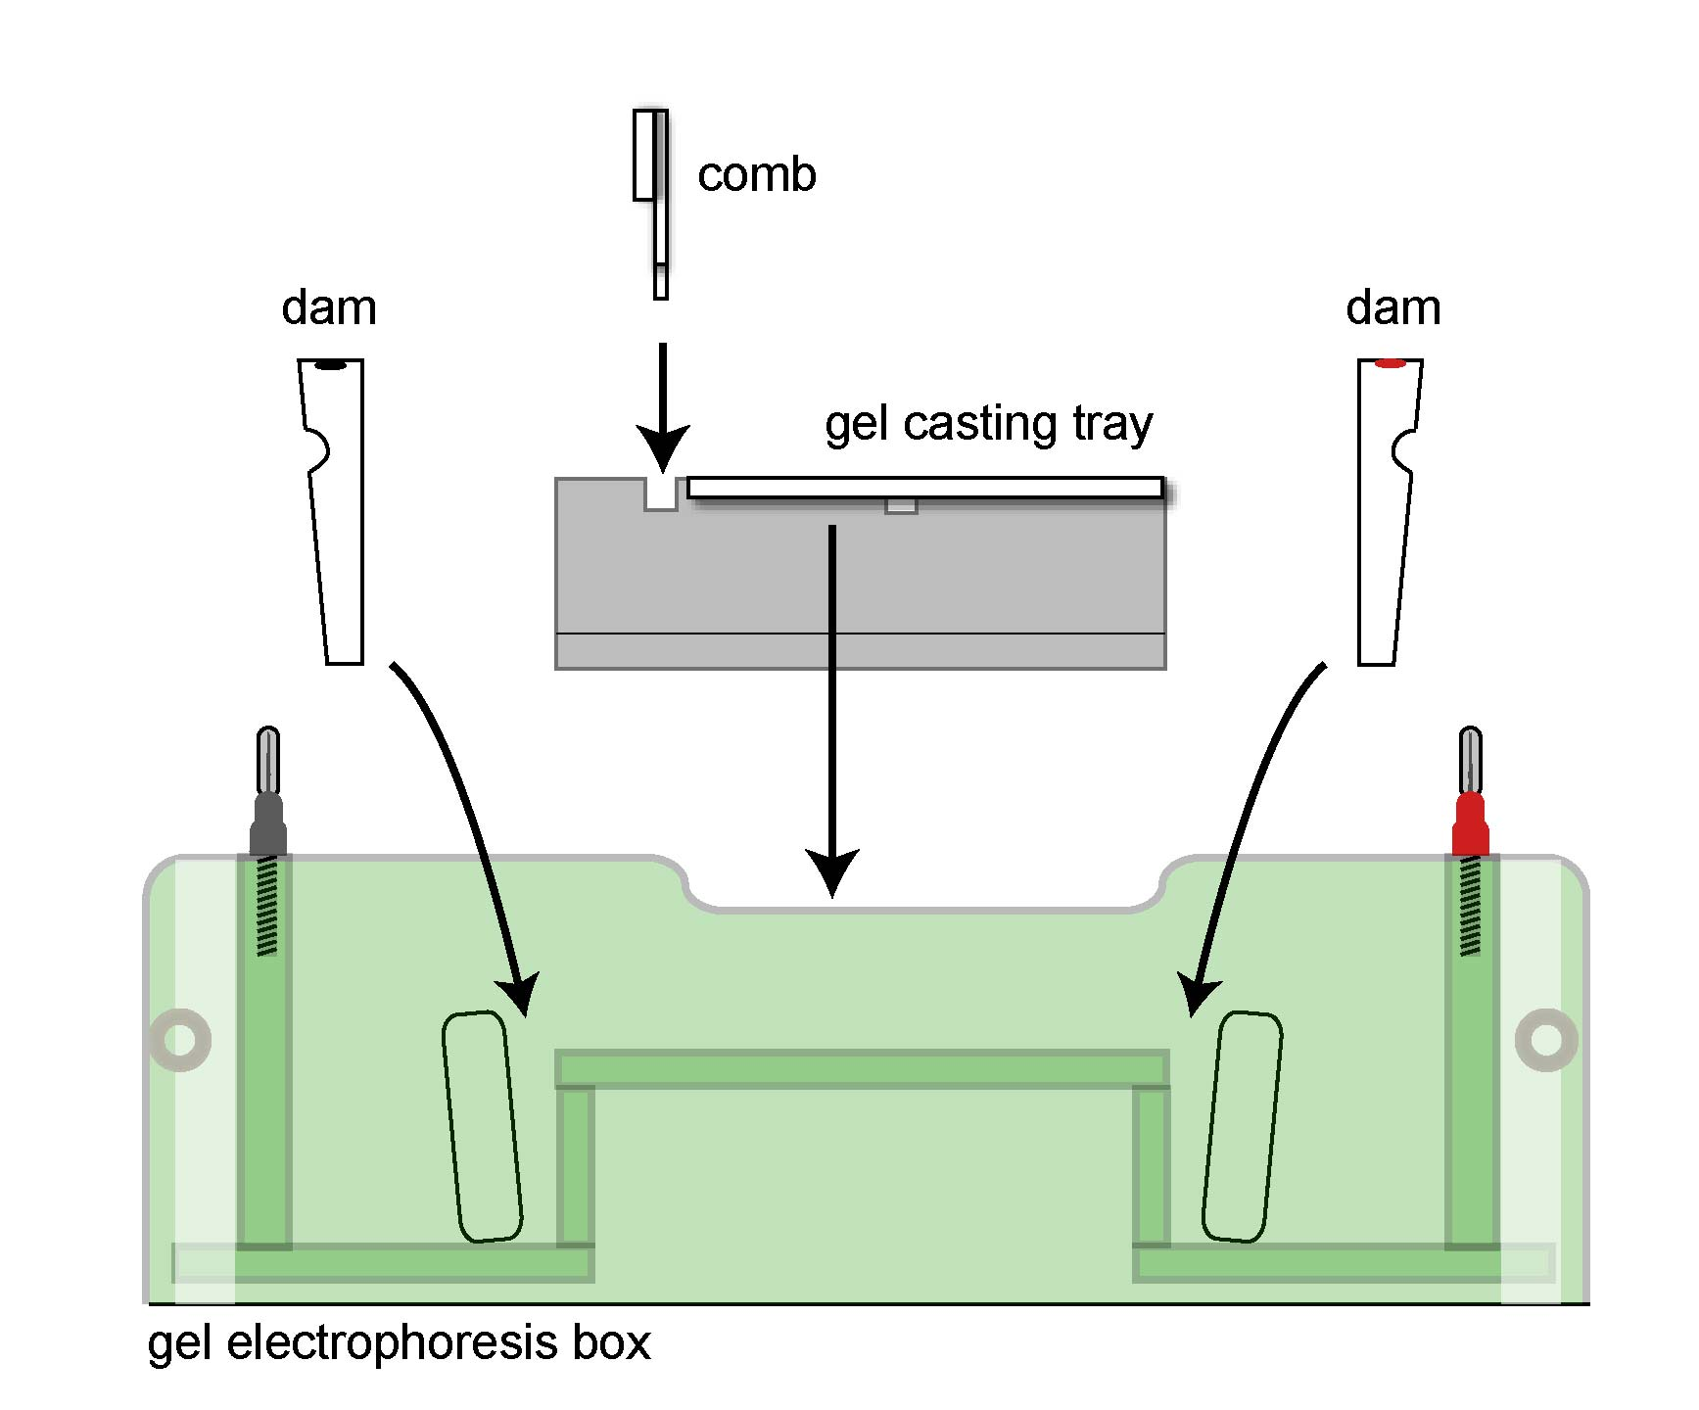

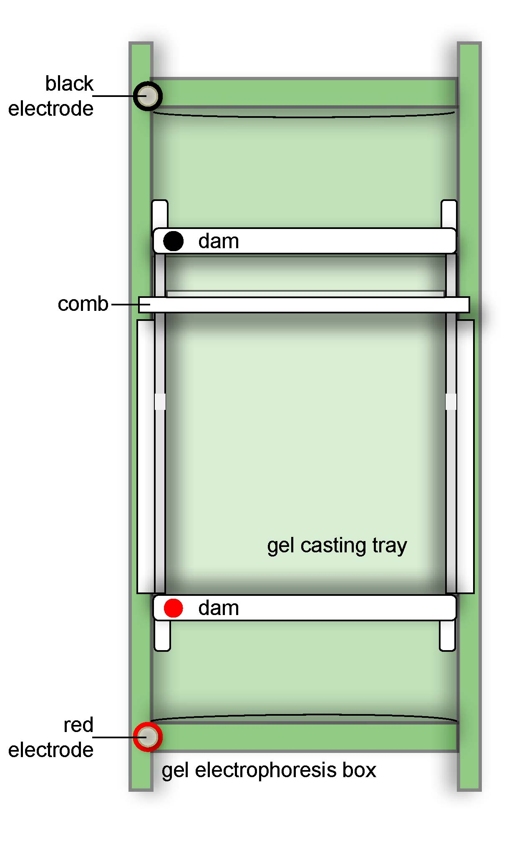

- Remove the gel box lid by pulling it up vertically.

- Place the gel casting tray on the raised platform in center of gel box. The tray can only fit properly in one direction.

- Place the white, wedge-shaped dams in the appropriate slots at either end of gel casting tray. The flat sides of the dams should face the gel casting tray. Be certain that the colored dots are on the same side as the matching color electrode.

- Place the comb in the slots located at the end of the gel casting tray closest to the black electrode.

____C. Pour the gel:

- When the agarose solution has cooled to 60ºC, pour it into the gel casting tray between the two dams. The agarose solution should come ½ to ¾ of the way up the teeth of the comb.

- Do not move or touch the gel while it cools and hardens. The gel should harden in 20 minutes.

D. Practice loading samples: (all students should do this)

- While the gel hardens, each member of the lab group should practice using a micropipettor to load samples of dye into the wells on the small practice gel.

- Use the sample in the orange tube labeled P. Follow the instructions on the Practice Gel Loading Instructions sheet.

____E. Remove the dams and comb:

- Once the gel has completely hardened, remove the wedge-shaped dams by lifting them vertically out of their slots.

- Store the dams in the spaces at the ends of the gel box. Match the colors on the gel box with the colors on the dams.

- Gently but firmly remove the comb from the gel by pulling up with one hand, while holding the gel casting tray in place with the other hand. Set the comb aside in the plastic bag that contains your team’s other supplies.
_____ F. Load the samples to be tested:

- Load the samples from the colored sample tubes (1 through 5) into the wells on the gel as shown below. To open the sample tube, hold the tube tightly and carefully push upward on the top tab.

- Make sure to use a fresh disposable pipette tip to load each sample.

- Take turns so that each member of your lab group has an opportunity to load samples into 2 or 3 wells.

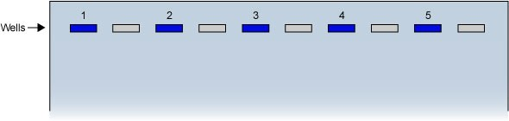

Key to samples:

Sample  Number | Sample
1 | Negative control from an unaffected individual
2 | Positive control from an individual with HD
3 | Sample from Jenny Lanahan
4 | Sample from Jeremy Lanahan
5 | Sample from James Lanahan (Dad)

___G. Add buffer:

- Position the gel box so that the electrode wires will reach the power supply.

- The gel box should not be moved once you have added buffer. If it is moved after the buffer is added, the samples may spill out of the wells.

- Pour approximately 350-400 ml of electrophoresis buffer into the chambers at the ends of the gel. Pour slowly so that you do not wash the samples out of the wells.

- Make sure that the buffer completely covers the surface of the gel to a depth of approximately 5 mm. Add more buffer if needed.

____H. Set up to run the gel:

- Place the lid on the gel box, making sure the black and red colors match.

- Plug electrode wires into the power source, making sure that the red and black colors match.
(Note: these diagrams represent an example of electrophoresis equipment. Your electrophoresis equipment may look different, and you may need to follow different instructions for setting up the equipment.)

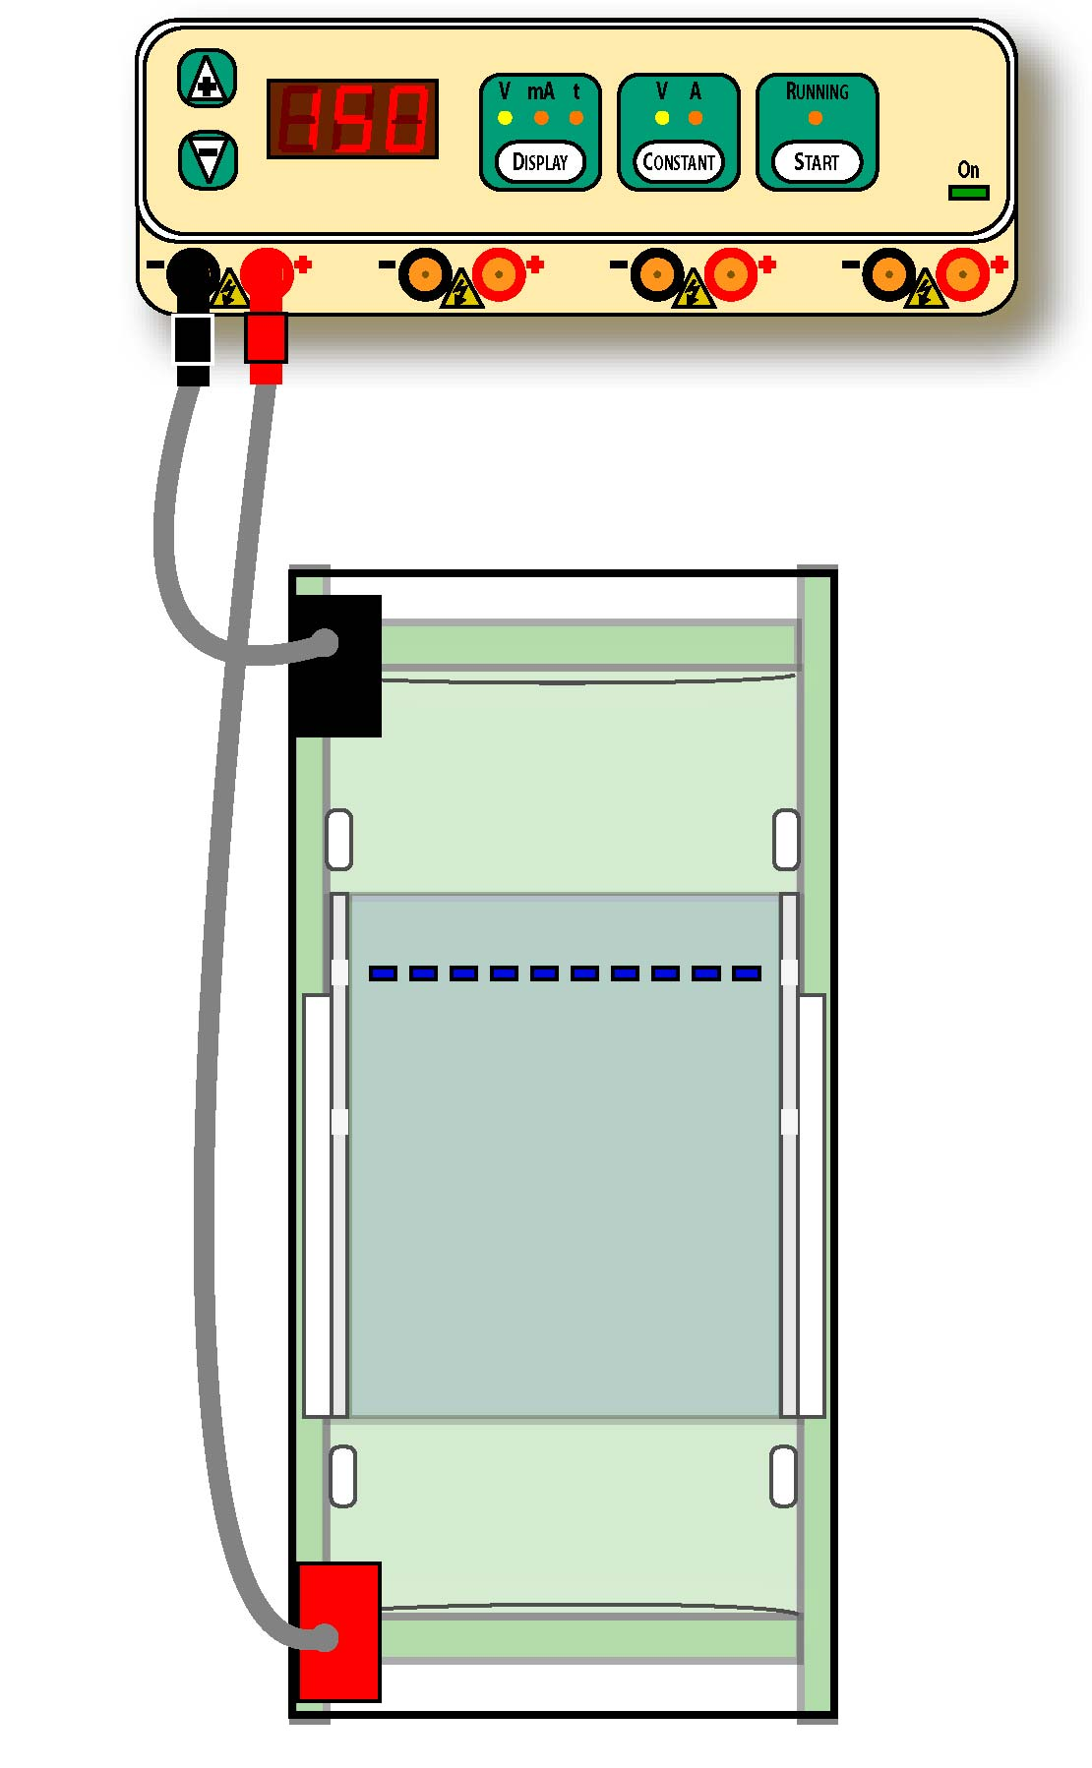

- When all teams sharing a power supply have completed the previous steps, have your teacher to check your work.

- Your teacher will then:
- Plug the power cord into the back of the power supply and into a wall socket.
- Turn on power switch in the back of the power supply.
- Use CONSTANT button to select “V” for constant voltage.
- Use the DISPLAY button to select “V” display for voltage
- Use the +/- controls to set the voltage at 150 Volts.
- Press the “Start” button to start the electrophoresis process.

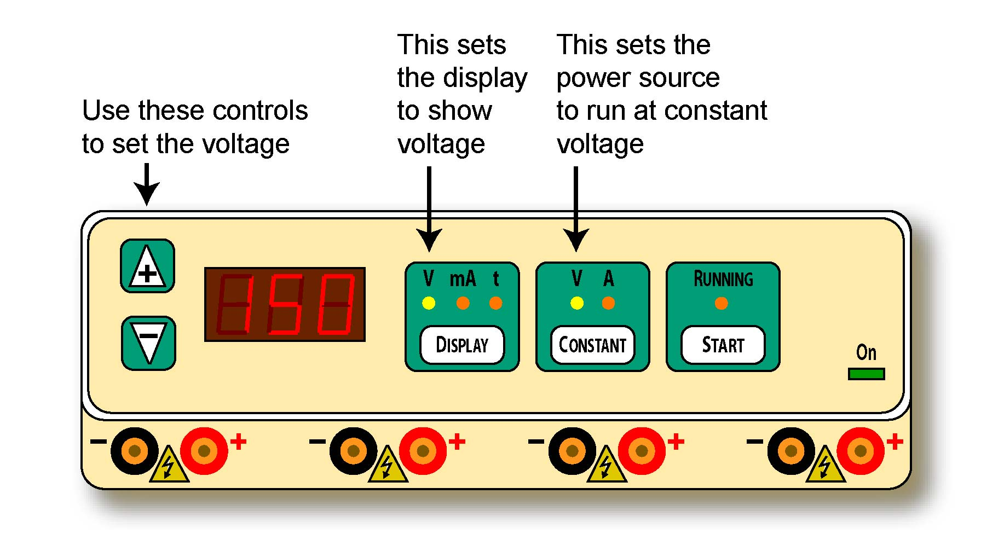

- Observe the ends of the gel box. You should be able to see the small bubbles forming on the wires in the chambers covered by buffer on the bottom of the gel box.

- After 5 minutes, you should be able to observe the colored samples moving through the gel.

_____ I. Observe the results:

- After approximately 10-15 minutes, when the bands have clearly separated, call your teacher. Your teacher will turn off the current.

- After your teacher has turned off the power supply, unplug the gel box from the power supply.

- Carefully remove the lid from the gel box. Lift the gel casting tray out of gel box. The gel is slippery, so keep the tray level and gently hold the gel to keep it from sliding out of the gel tray.

- Place the gel tray onto a light background surface (such as a piece of white paper).

- Record your results. Draw the position of the bands in each of the lanes of the gel using the diagram in the Genetic Testing Laboratory Report question #1.

____J. Clean and store the equipment:

- Place the gels into the recycling container provided by your teacher.

- Empty the electrophoresis buffer into the recycling container provided by your teacher.

- Rinse and dry the gel box, gel casting tray, and comb.

- Place the gel casting tray inside the gel box. Put the lid on the gel box.

Electrophoresis Analysis Report

Name _____________________________________ Class ________________

- Observe and draw the position of the bands in each of the lanes of your gel.

Lane
1 – Negative control
2 – Positive control
3 - Jenny
4 - Jeremy
5 – James (Dad)
1 – Negative control
2 – Positive control
3 - Jenny
4 - Jeremy
5 – James (Dad)
1
2
3
4
5
1
2
3
4
5

- Each person inherits one copy of the huntingtin gene from each parent. Explain why the negative control sample (from an unaffected individual) only produced one band.
____________________________________________________________________________________________________________________________
______________________________________________________________

- Explain why the positive control sample (from an individual affected by Huntington’s disease) produced two bands.
____________________________________________________________________________________________________________________________
______________________________________________________________

- Which band in the positive control lane (the one closest to the well or the one farthest from the well) represents the DNA from an abnormal huntingtin gene with CAG repeats? Explain your answer.
____________________________________________________________________________________________________________________________
______________________________________________________________

- Does Jenny have a gene for Huntington’s disease? Support your answer using the results of the gel electrophoresis.
____________________________________________________________________________________________________________________________
______________________________________________________________

- Does Jeremy have a gene for Huntington’s disease? Support your answer using the results of the gel electrophoresis.
____________________________________________________________________________________________________________________________
______________________________________________________________

- Does James (their father) have a gene for Huntington’s disease? Support your answer using the results of the gel electrophoresis.
____________________________________________________________________________________________________________________________
______________________________________________________________

- State two ways to improve the accuracy and/or reliability of these gene tests.
____________________________________________________________________________________________________________________________
______________________________________________________________

- Complete the gene testing report for James Lanahan (their father) on the next page.

Who should have access to James Lanahan’s gene testing report? Support your answer with ethical principles and values. ____________________________________________________________________________________________________________________________
______________________________________________________________

Technician’s Gene Testing Report
James Lanahan

Lab technicians (group members):
________________________________ ____________________________
________________________________ ______________________________

Patient’s name: ____James Lanahan_______Date of Test: _____________

Description of testing procedure:
________________________________________________________________________________________________________________________________________________________________________________________________________________________________________________________________________________________________________________________________
________________________________________________________________________________________________________________________________________________________________________________________________

Test Results:
________________________________________________________________________________________________________________________________
________________________________________________________________________________________________________________________________

Analysis/interpretation of test Results:
________________________________________________________________________________________________________________________________________________________________________________________________________________________________________________________________
________________________________________________________________

Signature: ___________________________________ Date: _______________
Practice Gel Loading Instructions

Note: these diagrams represent an example of a pipette. Your pipette may look different, and you may need to follow different instructions for using it to load your gel.

Put a clean, plastic tip firmly on the narrow end of the pipette. Follow the instructions below to load the orange dye samples into the wells on the practice gel. Use a new tip each time you switch to a new sample.

