Name: ___________________________ Date: __________________

Genetic Testing: Family Secrets

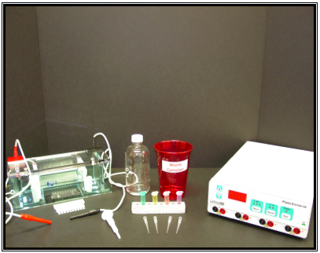
Lab Materials

1x
T
B
E

Gel Box

Power Supply

DNA

Micropipettor
PipetTips
i
p

Note: These diagrams represent an example of electrophoresis equipment. Your electrophoresis equipment may look different, and you may need to follow different instructions for setting up the equipment.
Set Up Your Equipment

- At your lab desk, you will find the gel electrophoresis box (also called a “gel box”). Put your gel box together as shown below.

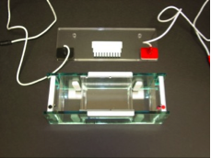

Remove the dams (red and black dot) from the gel box

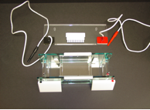

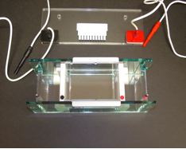

Place the dams (red and black dot) inside the gel box with the flat side in
- Pour 75ml of agar into your gel box. Place the comb into the gel box as shown below. The comb will only fit one way.

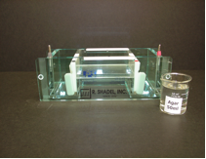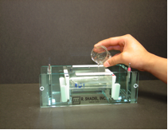
Agar
Gel Box

Pour
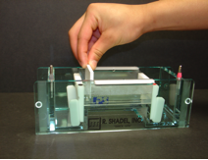
Place comb in Slot

Pouring Agar and Placing Comb in Slot in Gel

You will need to let your agar solidify. This will take about 20-30 minutes.

- After 20-30 minutes, remove the comb by pulling it directly up as shown below. Remove the white dams (black and red dot) at either end of the gel box.

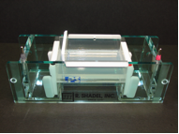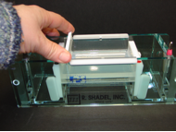

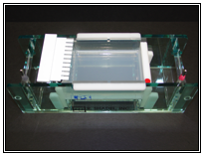
The removal of the comb

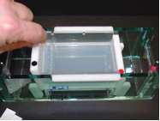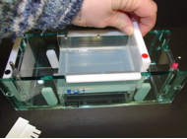
The removal of the dams

- Pour 300ml of 1X TBE buffer over the gel. Cover both sides and the gel with the buffer.

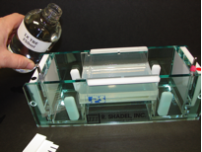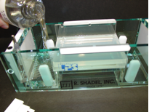
Pouring in buffer solution which allows the current to run across the gel and separate the DNA.

- Use the micropipettor to load each of your five samples of DNA into the wells at the end of the gel. See step 6 for instructions for which samples to load into the wells. (Note: You may also load your DNA samples into the gel before pouring the buffer over the gel)

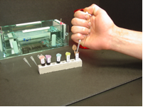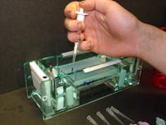
6. Follow the diagram and the chart below to load the DNA samples in this order. You need to make sure that you load them in the correct order so that you know which sample is in each well.

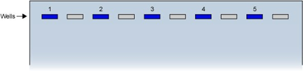

Sample  Number | Sample
1 | Negative control from an unaffected individual
2 | Positive control from an individual with HD
3 | Sample from Jenny Lanahan
4 | Sample from Jeremy Lanahan
5 | Sample from James Lanahan (Dad)

- Cover your gel box with the black electrode on the black end and the red electrode on the red end. Plug the ends of the electrodes into the correct area on your power supply (battery). Four gel boxes can plug into one power supply.

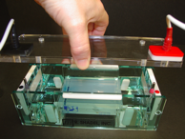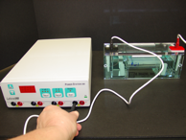

Covering the Gel Box and Plugging Electrodes into the Power Supply

8. Your teacher will set the voltage on your power supply and start the electricity to your gel box. You will have to wait approximately 30 minutes for your DNA gel electrophoresis results.

