Family Secrets
A Problem-Based Learning Case

Part 4
Testing for the HD Gene

Family Secrets

Part 4
Testing for the HD Gene

Narrator: Jenny, Jeremy, and their father have decided to undergo genetic testing for Huntington’s disease. Today, our lab groups will act as gene testing laboratory technicians. We will use the gel electrophoresis laboratory procedure to analyze the results of the simulated DNA samples from Jenny, Jeremy, and Dad. We will determine if they have the mutated huntingtin gene that causes Huntington’s disease, and prepare reports of the analysis of our results.

Nurse: I see that each of you met with a genetic counselor and signed the required informed consent forms. Now I’m going to draw a blood sample from each of you. Jenny, I’ll take you first.

Jenny: When do we get the results?

Nurse: We don’t do the testing here at this facility. We send your blood to a genetics lab that specializes in HD testing. Your doctor will call you when he gets the report from the genetics lab.

Dad: The genetic counselor said a lab technician isolates the DNA from our blood cells and then tests the DNA to see if we have the gene for Huntington’s disease....But how do they tell if our DNA has the HD gene?

Jenny: I think the lab uses a process called PCR to make many copies of the huntingtin gene part of your DNA.

Dad: But how can they tell whether we have the mutated HD gene or the normal gene?

Jeremy: I know that the mutated gene has extra nucleotides (CAG repeats) so it is longer than the normal gene. But how do they tell if we have the longer gene?

Jenny: The lab use a process called gel electrophoresis to separate our gene copies based on size. They put each of our gene copies into a different well on an agarose gel that looks like a piece of Jell-O. Then they put the gel into a box filled with a liquid that carries electric current. When the current is turned on it causes the gene copies to move out of the wells to certain places in the gel. How far the copies move depends on how big they are. The larger HD genes don’t move as far as the smaller normal genes.

Jeremy: So how do they tell if I have the mutated gene?

Jenny: They look to see where your DNA pieces end up on the gel. If you have the HD gene, some of your gene copies won’t move as far in the gel as normal pieces do. They’ll be closer to the wells on the gel than the normal genes.

Dad: Seems like there are lots of steps to this testing where something could go wrong. Will it tell for sure whether we have the gene?

* Note: This laboratory activity is a simulation of the gene testing process that uses dyes instead of actual DNA molecules. The activity illustrates how agarose gel electrophoresis is used to separate DNA fragments of different lengths to determine if individuals have a defective gene. Performing the gene testing procedures on DNA samples used in an actual medical test would be too expensive for most high school classrooms.

Genetic Testing Laboratory Procedure

____A. Prepare an agarose solution:

- Place 1.8 grams (1/2 teaspoon) of agarose and 75 ml of electrophoresis buffer into a flask or bottle.

- Follow your teacher’s instructions to heat the agarose solution until it has dissolved completely.

- Insert a thermometer into the agarose solution. Allow the solution to cool to 60ºC. While the agarose solution cools, continue with the following steps.

____B. Set up the electrophoresis apparatus:
(Note: These diagrams represent an example of electrophoresis equipment. Your electrophoresis equipment may look different, and you may need to follow different instructions for setting up the equipment.)

Side view Top view

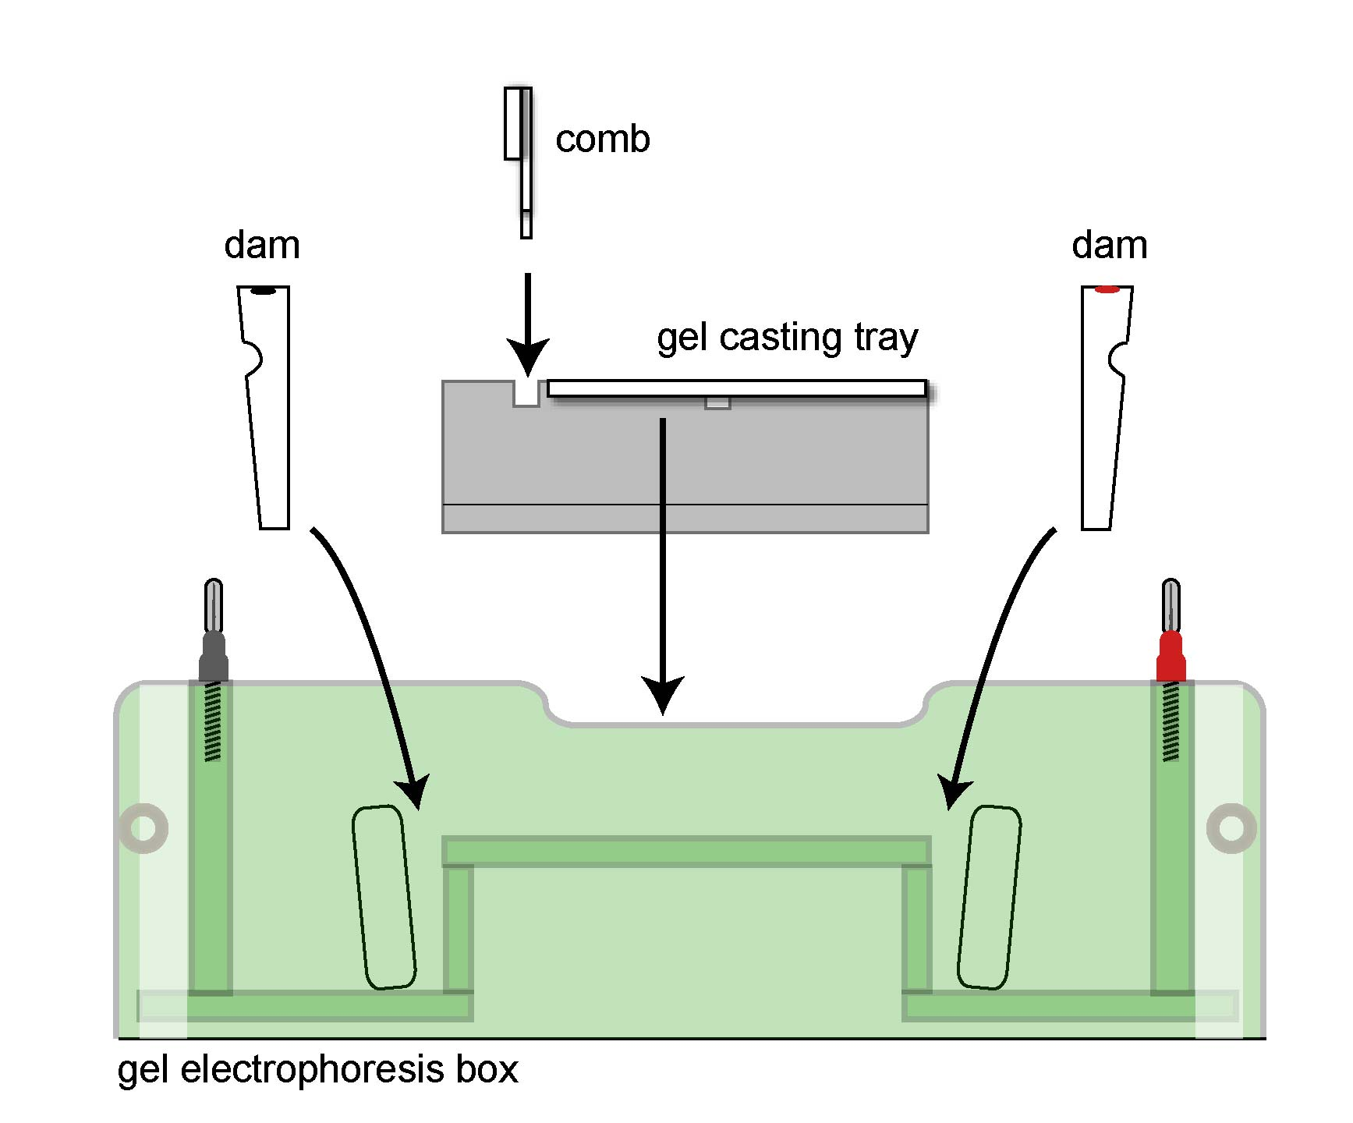

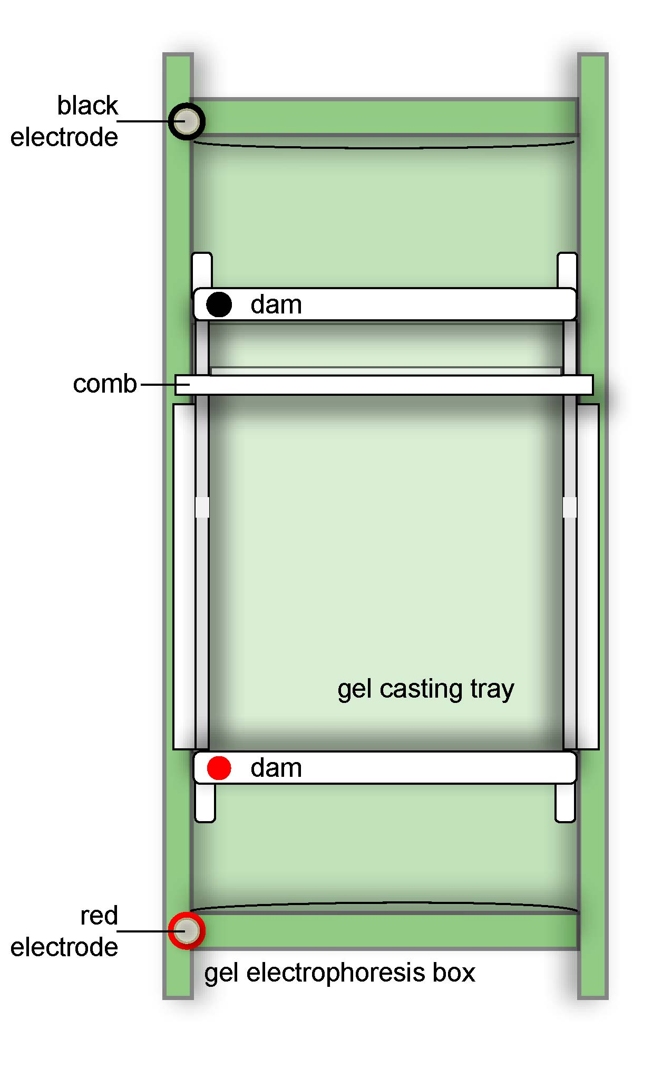

- Remove the gel box lid by pulling it up vertically.

- Place the gel casting tray on the raised platform in center of gel box. The tray can only fit properly in one direction.

- Place the white, wedge-shaped dams in the appropriate slots at either end of gel casting tray. The flat sides of the dams should face the gel casting tray. Be certain that the colored dots are on the same side as the matching color electrode.

- Place the comb in the slots located at the end of the gel casting tray closest to the black electrode.

____C. Pour the gel:

- When the agarose solution has cooled to 60ºC, pour it into the gel casting tray between the two dams. The agarose solution should come ½ to ¾ of the way up the teeth of the comb.

- Do not move or touch the gel while it cools and hardens. The gel should harden in 20 minutes.

____ D. Practice loading samples: (all students should do this)

- While the gel hardens, each member of the lab group should practice using a micropipettor to load samples of dye into the wells on the small practice gel.

- Use the sample in the orange tube labeled P. Follow the instructions on the Practice Gel Loading Instructions sheet.

____ E. Remove the dams and comb:

- Once the gel has completely hardened, remove the wedge-shaped dams by lifting them vertically out of their slots.

- Store the dams in the spaces at the ends of the gel box. Match the colors on the gel box with the colors on the dams.

- Gently but firmly remove the comb from the gel by pulling up with one hand, while holding the gel casting tray in place with the other hand. Set the comb aside in the plastic bag that contains your team’s other supplies.
____ F. Load the samples to be tested:

- Load the samples from the colored sample tubes (1 through 5) into the wells on the gel as shown below. To open the sample tube, hold the tube tightly and carefully push upward on the top tab.

- Make sure to use a fresh disposable pipette tip to load each sample.

- Take turns so that each member of your lab group has an opportunity to load samples into 2 or 3 wells.

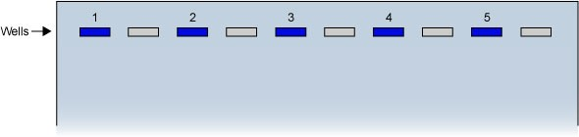

Key to samples:

Sample  Number | Sample
1 | Negative control from an unaffected individual
2 | Positive control from an individual with HD
3 | Sample from Jenny Lanahan
4 | Sample from Jeremy Lanahan
5 | Sample from James Lanahan (Dad)

____ G. Add buffer:

- Position the gel box so that the electrode wires will reach the power supply.

- The gel box should not be moved once you have added buffer. If it is moved after the buffer is added, the samples may spill out of the wells.

- Pour approximately 350-400 ml of electrophoresis buffer into the chambers at the ends of the gel. Pour slowly so that you do not wash the samples out of the wells.

- Make sure that the buffer completely covers the surface of the gel to a depth of approximately 5 mm. Add more buffer if needed.

____ H. Set up to run the gel:

- Place the lid on the gel box, making sure the black and red colors match.

- Plug electrode wires into the power source, making sure that the red and black colors match.
(Note: these diagrams represent an example of electrophoresis equipment. Your electrophoresis equipment may look different, and you may need to follow different instructions for setting up the equipment.)

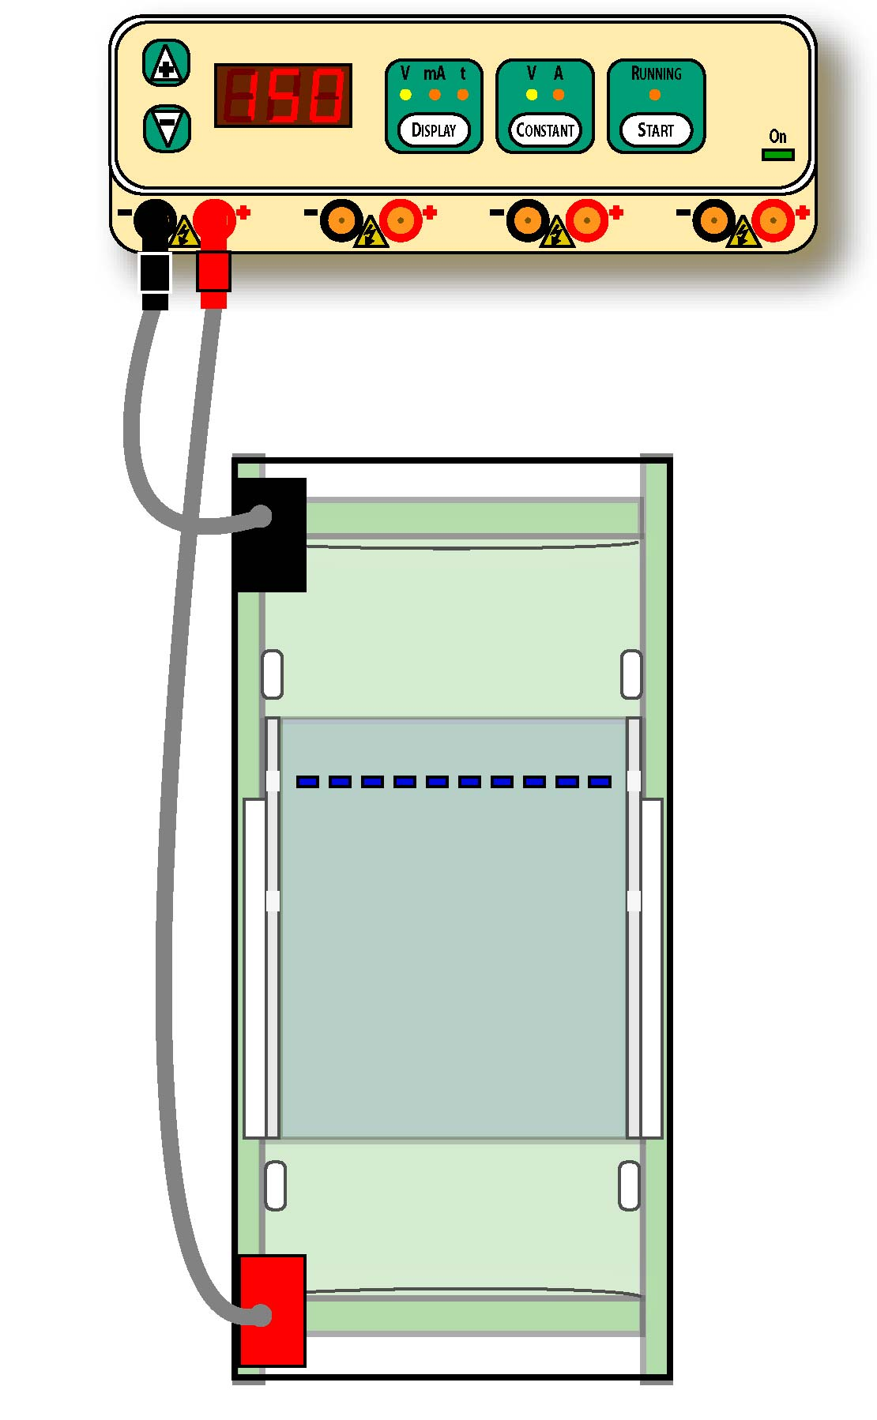

- When all teams sharing a power supply have completed the previous steps, have your teacher to check your work.

- Your teacher will then:
- Plug the power cord into the back of the power supply and into a wall socket.
- Turn on power switch in the back of the power supply.
- Use CONSTANT button to select “V” for constant voltage.
- Use the DISPLAY button to select “V” display for voltage
- Use the +/- controls to set the voltage at 150 Volts.
- Press the “Start” button to start the electrophoresis process.

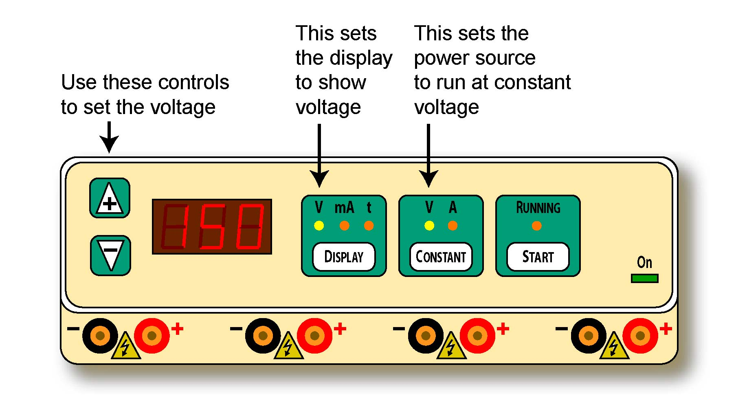

- Observe the ends of the gel box. You should be able to see the small bubbles forming on the wires in the chambers covered by buffer on the bottom of the gel box.

- After 5 minutes, you should be able to observe the colored samples moving through the gel.

_____ I. Observe the results:

- After approximately 10-15 minutes, when the bands have clearly separated, call your teacher. Your teacher will turn off the current.

- After your teacher has turned off the power supply, unplug the gel box from the power supply.

- Carefully remove the lid from the gel box. Lift the gel casting tray out of gel box. The gel is slippery, so keep the tray level and gently hold the gel to keep it from sliding out of the gel tray.

- Place the gel tray onto a light background surface (such as a piece of white paper).

- Record your results. Draw the position of the bands in each of the lanes of the gel using the diagram in the Genetic Testing Laboratory Report question #1.

____ J. Clean and store the equipment:

- Place the gels into the recycling container provided by your teacher.

- Empty the electrophoresis buffer into the recycling container provided by your teacher.

- Rinse and dry the gel box, gel casting tray, and comb.

- Place the gel casting tray inside the gel box. Put the lid on the gel box.

Electrophoresis Analysis Report

Name _____________________________________ Class ________________

- Observe and draw the position of the bands in each of the lanes of your gel.

Lane
1 – Negative control
2 – Positive control
3 - Jenny
4 - Jeremy
5 – James (Dad)
1 – Negative control
2 – Positive control
3 - Jenny
4 - Jeremy
5 – James (Dad)
1
2
3
4
5
1
2
3
4
5

- Each person inherits one copy of the huntingtin gene from each parent. Explain why the negative control sample (from an unaffected individual) only produced one band.
____________________________________________________________________________________________________________________________
______________________________________________________________

- Explain why the positive control sample (from an individual affected by Huntington’s disease) produced two bands.
____________________________________________________________________________________________________________________________
______________________________________________________________

- Which band in the positive control lane (the one closest to the well or the one farthest from the well) represents the DNA from an abnormal huntingtin gene with CAG repeats? Explain your answer.
____________________________________________________________________________________________________________________________
______________________________________________________________

- Does Jenny have a gene for Huntington’s disease? Support your answer using the results of the gel electrophoresis.
____________________________________________________________________________________________________________________________
______________________________________________________________

- Does Jeremy have a gene for Huntington’s disease? Support your answer using the results of the gel electrophoresis.
____________________________________________________________________________________________________________________________
______________________________________________________________

- Does James (their father) have a gene for Huntington’s disease? Support your answer using the results of the gel electrophoresis.
____________________________________________________________________________________________________________________________
______________________________________________________________

- State two ways to improve the accuracy and/or reliability of these gene tests.
____________________________________________________________________________________________________________________________
______________________________________________________________

- Complete the gene testing report for James Lanahan (their father) on the next page.

10. Who should have access to James Lanahan’s gene testing report? Support your answer with ethical principles and values. ____________________________________________________________________________________________________________________________
______________________________________________________________

Technician’s Gene Testing Report
James Lanahan

Lab technicians (group members):
________________________________ ____________________________
________________________________ ______________________________

Patient’s name: ____James Lanahan_______Date of Test: _____________

Description of testing procedure:
________________________________________________________________________________________________________________________________________________________________________________________________________________________________________________________________________________________________________________________________
________________________________________________________________________________________________________________________________________________________________________________________________

Test Results:
________________________________________________________________________________________________________________________________
________________________________________________________________________________________________________________________________

Analysis/interpretation of test Results:
________________________________________________________________________________________________________________________________________________________________________________________________________________________________________________________________
________________________________________________________________

Signature: ___________________________________ Date: _______________
Practice Gel Loading Instructions

Note: these diagrams represent an example of a pipette. Your pipette may look different, and you may need to follow different instructions for using it to load your gel.

Put a clean, plastic tip firmly on the narrow end of the pipette. Follow the instructions below to load the orange dye samples into the wells on the practice gel. Use a new tip each time you switch to a new sample.

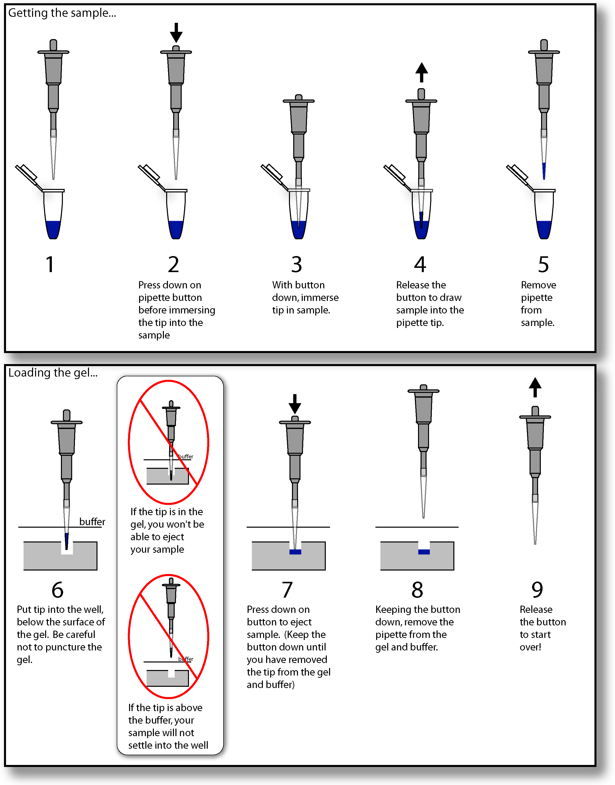

Family Secrets Part 4: Testing for the HD Gene

Quick Guide for Sample Lesson Sequence

Overview

PBL Part 4 | Class # | Check Off | Time | Strategy / Activity Name
Testing for the HD Gene | Pre-  Lab  “prep” |  |  | Prepare quantities of buffer  Run off hand-outs  Assemble non-“blue box” lab supplies  Dispense dyes for each station  Prepare gel box station “baggies”  Prepare practice gel loading supplies  Arrange for computer use for virtual lab
Testing for the HD Gene | 8  Steps A-E  Gel  Set-up |  |  | Narrator’s introduction reading
Testing for the HD Gene | 8  Steps A-E  Gel  Set-up |  |  | Gel box assignments
Testing for the HD Gene | 8  Steps A-E  Gel  Set-up |  |  | A = Agarose preparation
Testing for the HD Gene | 8  Steps A-E  Gel  Set-up |  |  | B = Electrophoresis apparatus set-up
Testing for the HD Gene | 8  Steps A-E  Gel  Set-up |  |  | C = Gel pour (and time to set up)
Testing for the HD Gene | 8  Steps A-E  Gel  Set-up |  |  | D = Practice loading dyes
Testing for the HD Gene | 8  Steps A-E  Gel  Set-up |  |  | E = Dams & comb removal
Testing for the HD Gene | 8  Steps A-E  Gel  Set-up |  |  | Gel storage (if not doing lass 9 right away)
Testing for the HD Gene | 8  Steps A-E  Gel  Set-up |  |  | Clean-up
Testing for the HD Gene | 8  Steps A-E  Gel  Set-up | Note: This class time may be eliminated if teacher pours (pre-casts) the gels.

Testing for the HD Gene | 9  Steps  F-G  Gel load and run |  |  | Gel replacement from storage
Testing for the HD Gene | 9  Steps  F-G  Gel load and run |  |  | F = Load Samples (dry load option)
Testing for the HD Gene | 9  Steps  F-G  Gel load and run |  |  | G = Add buffer
Testing for the HD Gene | 9  Steps  F-G  Gel load and run |  |  | H = Set up and “run” gel
Testing for the HD Gene | 9  Steps  F-G  Gel load and run |  |  | Part 4 script reading
Testing for the HD Gene | 9  Steps  F-G  Gel load and run |  |  | I = Observe (and record) results: Electrophoresis Analysis Report diagram
Testing for the HD Gene | 9  Steps  F-G  Gel load and run |  |  | J = Clean up
Testing for the HD Gene | 10  Report  writing |  |  | Electrophoresis Analysis Report completion
Testing for the HD Gene | 10  Report  writing |  |  | Technician’s Gene Testing Report completion
Testing for the HD Gene | 10  Report  writing | Note: This class time may be eliminated if reports are assigned for homework

Quick Pre-lab list
- Prepare 4 liters of electrophoresis buffer (Part 4: Appendix B)
- Dispense dyes
- Prepare practice gels (Part 4: Appendix B)
- Alternative: Prepare agarose or pre-cast 8 gels per class (Part 4: Appendix B)
- Arrange for Virtual Laboratory to be seen by students prior to gel setups or during gel “run”

See Part 4: Appendix A - Supplies and Equipment for a detailed list of needed supplies and equipment.

See Part 4: Appendix B - Setting Up the Lab for a more detailed description of laboratory preparations.

Some short cuts

To save classroom time (and increase teacher preparation time), some teachers have used the following short cuts:
- Prepare pre-melted agarose (see first three bullets below and dispense in eight small bottles or beakers) and have students begin with Step A 3.
2. Prepare pre-cast the gels (see complete procedure below) and have students insert the gels into the gel trays and then begin with Step F.

You will also need

Plastic bags and permanent markers if students will pour gels in one day and load/run them on another day.

For Each Student:
1 copy per student of:
- Family Secrets Part 4: Testing for the HD Gene script
- Genetic Testing Laboratory Procedure. See alternative in Per Team
- Electrophoresis Analysis Report
- Technician’s Gene Testing Report: James Lanahan

Per Team:
  - Alternative: 1 color copy per team of the Genetic Testing Laboratory Procedure placed in sheet protectors and put in a notebook (1 notebook per lab team).
  - 1 colored copy per team of Technician’s Gene Testing Report: James Lanahan

Per Class:
- Optional: Family Secrets Virtual Laboratory Part 4 computer access

Class 8
- Narrator reads introduction at the top of the script
- Coach assigns student to read and complete steps A-E of the Genetic Testing Laboratory Procedure
- Students complete agarose melting, apparatus set-up, and gel pouring
- Coach distributes practice gel loading supplies
- Students take turns practice loading dyes into practice wells (dry load method).
- Students follow procedure for storing gels in baggies for overnight storage, if not continuing to Class 9 immediately.

Class 9
- If gels were stored, distribute gels to students and have them slide the gels back into the gel tray with the wells placed closest to the black electrode.
- Instruct students to complete the remaining parts of the procedure (F through J). Remind them that each student should have an opportunity to load some of the samples into wells.
- Check to make sure buffer completely covers the gel before you turn on the power.
- Turn off and unplug power supplies when dye bands have clearly separated and before students open gel boxes. Hint: if gel box lid is “steamy”, view the gel from the side.
- While the gel is running (approximately 10-15 minutes) have the class listen as selected students read the rest of the script of Family Secrets Part 4: Testing for the HD Gene
- Distribute Electrophoresis Analysis Report
- Students should be able to complete the laboratory procedure by the end of class.

It is critical that students record their agarose gel data (Part I, step 32) before the end of class. They should draw the positions of the bands in each of the lanes of the gel using the question # 1 diagram at the top of the electrophoresis Analysis Report. If the gels sit for several hours, the dye in the bands will diffuse out of the gel, making the gel data unreadable.

Class 10

- Teams work together (or students individually) to complete the Electrophoresis Analysis Report.
- Each student should place her/his own completed copy of this lab report in her/his folder.
- Distribute one white copy (per student) and one colored copy (per team) of the Technician’s Gene Testing Report : James Lanahan to each team.
- Students work in teams and come to consensus on the answers to the Technician’s Gene Testing Report: James Lanahan. A new recorder should complete a colored team copy with the names of all of the team members at the top.
- Students work in lab teams and come to consensus on the answers to the Technician’s Gene Testing Report: James Lanahan. Other students should complete a similar copy to place in their folder.
- Colored copies of the Technician’s Gene Testing Report: James Lanahan from each team should be collected and graded.

Family Secrets
Part 4 – Testing for the HD Gene
Detailed Instructional Guide

Overview

Students are introduced to the genetic testing laboratory procedures. They use gel electrophoresis to analyze simulated DNA samples from Jenny, Jeremy, and James Lanahan. They analyze the test results and prepare laboratory reports.

Objectives

After completing Part 4, students should provide evidence that they have:
- Followed the laboratory procedure that simulates the gene testing process.
- Interpreted the test results by completing an individual lab report
- Prepared a team report for the genetic counselor based on the laboratory results

Coach’s Preparation

The preparation for Part 4 will depend on the coach’s experience with running gel electrophoresis labs with classes and on the coach’s decision on whether to pre-cast the gels or to have students do the entire laboratory procedure.

Note: To save classroom time (and increase teacher preparation time), some teachers have used the following “short-cuts”:
- Prepare pre-melted agarose and have students begin with Step A-3.
- Prepare pre-cast the gels and have students insert the gels into the gel trays and then begin with Step F.

Coaches should:
- Assign student lab groups (which may be different from the PBL teams) so that there are groups of students working with each gel box.
- Make 1 copy of Family Secrets - Part 4: Testing for the HD Gene script for each student.
- Prepare 8 copies of Practice Gel Loading Instructions and laminate or put in sheet protectors.
- Obtain necessary laboratory supplies and equipment. See Part 4: Appendix A - Supplies and Equipment.
- Make sure you know how to use your electrophoresis equipment – gel boxes, power supplies, and micropipettors.
- Follow the instructions for setting up the lab. See Part 4: Appendix B - Setting Up the Lab.
- Remind students about laboratory safety procedures related to use of heat, electricity, and chemicals before beginning this lab.
- Review MSDS sheets for the chemicals used in this lab.
- Review the suggestions for how to handle potential problems encountered when conducting the lab. See Part 4: Appendix C - Potential Problems and Solutions.
- Review the answers to the Electrophoresis Analysis Report. See Part 4: Appendix D - Sample Answers for Electrophoresis Analysis Report.
- Review the answers to the Technician’s Gene Testing Report: James Lanahan. See Part 4: Appendix E - Sample Answers for Technician’s Gene Testing Report: James Lanahan.

Concepts for class discussion: background or supporting lessons

For this laboratory activity, students need to understand the concepts listed below. Lessons on these concepts may be completed as background before Part 4 or may be provided as supporting lessons during Part 4.
- Gene testing processes - PCR and gel electrophoresis.
- Evaluating the accuracy, reliability, and limitations of medical tests.

Coaches should consider relating this lab to other molecular genetics topics in their curriculum.
- Other types of gene testing processes - RFLP analysis, protein/enzyme/metabolite assays, and DNA sequencing.
- Other DNA analysis applications related to genetics, evolution, ecology, disease, and forensics.
- Newborn, prenatal, and pre-implantation gene testing.
- Reproductive options for people who carry a gene for inherited disorders.
- Comparing risk analysis for single gene disorders with complex disorders such as cancer, heart disease, diabetes, and behavioral disorders

Sample Lesson Sequence:

Part 4: Testing for the HD Gene - Classes 8-10

Estimated  Time  (min.) | Summary of Steps | Suggested Strategies
Class 8
10 | Introduction | - Coach distributes copies of Family Secrets - Part 4: Testing for the HD Gene script and Genetic Testing Laboratory Procedure to all students.  - Narrator reads Narrator introduction of Family Secrets - Part 4 script
30 | Organize and supervise lab work  Prepare gels  Storing gels (if not used immediately)  Reading rest of script | - Coach should assign students to work in groups so that all eight gel boxes are used.  - Coach tells students that they will work in their lab groups to carefully read and carry out the steps in Genetic Testing Laboratory Procedure.  - Coach recommends that students divide the work so that all students have an opportunity for hands-on participation. This may be done by while one student completes each part; others should assist by reading the instructions aloud and checking to be certain the procedure is being followed correctly.  - Coach encourages lab groups to ask for assistance, if needed.  - Coach provides instructions for how the agarose is to be heated in either a microwave or hot-water bath. Coach assists and monitors the heating of the agarose solution. Note: to save time coaches may wish to have the agarose prepared and heated before class begins.  - Students should be able to complete the procedure through part E by the end of one class (40-minute) period.  - If the students will not continue lab the same day, coaches should distribute plastic “zipper” sandwich bags to each group. Students put their names on the sandwich bag. They gently slide the gels off the gel casting tray into the bags. Add about 1 tablespoon of electrophoresis buffer to the bags to prevent the gels from drying out.  - Bags with the gels should be refrigerated until the next class.  - If time permit, complete reading the rest of the Part 4 script

Estimated  Time  (min.) | Summary of Steps | Suggested Strategies

Class 9
10  30 | Continue lab work  Loading wells with dyes  Gel run  Script reading  Drawing band positions | - If gels were stored, distribute gels to students and have them slide the gels back into the gel tray with the wells placed closest to the black electrode.  - Coach asks students to complete the remaining parts of the procedure (F through J).  - Coach makes it clear that each student in a lab group should have an opportunity to load some of the samples into wells.  - Safety note: Coach should be responsible for plugging in the power supply and for making certain that it is properly set for running the gel.  - Coach uses the time when gel is running (approximately 10-15 minutes) to read the rest of the script or review how gel electrophoresis separates the normal and mutant DNA fragments. An alternative would be to have students complete the “Description of testing procedure” on the Technician’s Gene Testing Report: James Lanahan.  - Students should be able to complete the procedure through part J by the end of class.  - It is critical that students record their data before the end of class (part I, step 32). They need to draw the positions of the bands in each of the lanes of the gel using the question # 1 diagram in the Electrophoresis Analysis Report . If the gels sit for several hours, the dye in the bands will diffuse out of the gel, making the gel data unreadable.  - Students begin Electrophoresis Analysis Report
Optional Homework or Optional additional class |  | - Students use the Family Secrets Virtual Laboratory. The password for Gel Electrophoresis; Family Secrets is “gelsix” and the password for Data Analysis: Family Secrets is “gelseven.”

Estimated  Time  (min.) | Summary of Steps |  | Suggested Strategies
Class 10
40 |  | Completing Laboratory Reports  Individual (white) and Team (colored) Reports | - Coach distributes one colored copy of the Electrophoresis Analysis Report and one colored copy of the Technician’s Gene Testing Report: James Lanahan to each team.  - Students work in lab groups and come to consensus on the answers to the Electrophoresis Analysis Report. A recorder should complete a colored group copy with the names of all of the group members at the top.  - Each student places their individual copy of the lab report in their folder.  - Students work in lab groups and come to consensus on the answers to the Technician’s Gene Testing Report: James Lanahan. A new recorder should complete the colored group copy with the names of all of the group members at the top. Other students should complete an individual copy that is placed in their folder.  - Coach collects (and later grades) the colored group copies of Electrophoresis Analysis Report and the Technician’s Gene Testing Report: James Lanahan from each team.  - Coach assists students as they work. Some teachers provide a word bank for students to use in the Technician’s Report: Polymerase Chain Reaction (PCR), Gel Electrophoresis, DNA sample, Huntingtin Gene, Agarose Gel, Buffer, Electrical Current, Wells, DNA bands, Pipet, Wells.

Appendix A – Supplies and Equipment Needed
(Note: this list is for a class with 8 lab groups)
- Gel boxes with casting trays and combs
- 8 Micropipettors (each well will need 10 uL of sample) – 1 per student group
- Pipet tips - will need approximately 90 tips for each class (8 groups)
- 8 microtube racks
- 6 microtubes of dye samples per group (positive control, negative control, Jenny, Jeremy, Dad, and orange practice loading dye)
- Agarose - will need approximately 15 grams per class (8 gels)
- Electrophoresis buffer (50X TAE)
- Safety goggles - one per student
- Metric balance and weighing paper (or teacher can distribute pre-measured amounts of agarose).
- Microwave oven or hot water bath(s) or hot plates for heating agarose solution
- 8 Flasks or bottles (250 mL) for mixing and heating agarose solution
- Tongs, hot pads, gloves for handling containers of heated agarose solution
- 8 Thermometers (Celsius)
- 8 copies of Practice Gel Loading Instructions (laminate or put in sheet protectors)
- Distilled water (approximately 4 liters per class)
- 8 graduated cylinders (100 mL or 300 mL)
- 8 beakers (500 mL) for water baths if heating agarose solution on a hot plate
- 1 bucket or container labeled “Recycling Container for Buffer and Gels ONLY”
- Paper towels
- Wall outlets for plugging in power supplies
- Large container for mixing and dispensing electrophoresis buffer
- 8 Plastic “zipper” sandwich bags for storing gels if they must be stored between lab periods
- 8 Permanent markers for writing on plastic sandwich bags
- Plastic wrap to cover top of bottle or flask when heating agarose solution to prevent evaporation
Optional supplies:
- Extension cords if power supplies cannot be placed near wall outlets
- 8 Plastic cups filled with 400 mL of electrophoresis buffer for each group - avoids waiting lines for buffer solution
Appendix B - Setting Up the Lab

Prepare 4 liters of electrophoresis buffer:
- Mix 80 mL of 50X TAE Buffer with 3920 mL of distilled water.
- Dispense in container or in 8 plastic cups/beakers. Label container or cups “Electrophoresis Buffer—Poison—Not for Human Consumption”
- Extra buffer may be stored for up to 6 months if refrigerated. Used buffer may also be recycled to use in two or three classes.

Recipes for Family Secrets simulated DNA samples:

- Recipe for “Jenny” and for negative control samples
70 ml Water
0.2 g Amido Black dye
30 ml Glycerol

- Recipe for “Jeremy”, “Dad”, and positive control samples
70 ml Water
0.2 g Amido Black dye
0.25 g Xylene Cyanol dye
30 ml Glycerol

Purchasing information for dyes:

Amido Black Dye: Amresco Inc. Catalog# 0603
30175 Solon Industrial Parkway
PO Box 39098
Solon, Ohio 44139-1199
Phone: 440-349-1182
www.amresco-inc.com

Xylene Cyanol: Sigma-Aldrich Catalog # X4126
PO Box 952968
St. Louis, MO 63195
Phone: 1-800-325-3010
www.sigmaaldrich.com

Family Secrets premixed simulated DNA samples (Jenny, Jeremy, Dad, Positive Control, Negative Control) and electrophoresis equipment can be purchased from:
Laboratory Product Sales Inc.
1665 Buffalo Road
Rochester, NY 14624
Phone: 800-388-0166
See this webpage for ordering information: http://www.lpsinc.com/Catalog3.asp?ChapterID=344&dropdown=False

Dispense dyes into labeled microtubes:
- Label microtube with the corresponding numbers (1, 2, 3, 4, 5, 6) using a permanent marker.
- Use a graduated plastic pipet to dispense approximately 0.1 mL of the appropriate dye sample into each of the tubes. Follow the directions in chart below.

Number on Tube | Sample
1 | Negative control from unaffected individual
2 | Positive control from individual with HD
3 | Sample from Jenny Lanahan
4 | Sample from Jeremy Lanahan
5 | Sample from James Lanahan (Dad)
P | Orange dye for practice loading

- Distribute microtubes - one of each microtube per student group. Each student group will have a total of 6 different tubes.

Preparing practice gels:

Practice loading gels may be made up to 1 month before the lab.
- Set up with 2 combs, if possible (Put combs in BOTH the end and the middle slots of the gel casting tray).
- Prepare 350 mL of 1X TAE buffer by mixing 7 mL of 50X TAE with 343 mL water.
- Add 9 grams (2 ½ teaspoons) of agarose powder.
- Heat in hot water bath or microwave until agarose has completely dissolved.
- Cool to 60 º C.
- Pour agarose solution to a depth of ½ to ¾ of the way up the comb teeth.
- Allow to cool for at least 20 minutes.
- Remove combs.
- Cut gels in half crosswise so that each half has wells.
- Store in plastic bag or container and place in the refrigerator.
- Dispense to students in small plastic plates or in Petri plates.

NOTE: These practice gels (and the gels made by students during lab classes) should be recycled for future lab classes. Soak them overnight in fresh or recycled buffer to remove the dyes, place in plastic container, and refrigerate.

Set up 8 student workstations:

Each workstation should have the following supplies and equipment:
- One pair of safety goggles per student
- 1 Gel box containing a gel tray and a comb and two dams
- 1 Micropipetter
- 1 Bag containing at least 11 pipette tips
- 1 Microtube rack with the 6 dye samples
- 1 Thermometer
- 1 Graduated cylinder (100 mL)
- Paper towel
- Bottle or flask (250 mL) for preparing agarose solution
- 1 Set of gloves/hotpads/tong for handling heated solution
- 1 Hot plate and 1 500 mL beaker (if students are heating their own agarose solution)
- 1 Beaker or cup for electrophoresis buffer
- 1 Copy of Practice Gel Loading Instructions
- 1 Practice gel
- 1 Plastic sandwich bag if gels are to be stored.
- 1 permanent marker for labeling bags containing gels

Set up at other work areas:
- Large container of “Electrophoresis Buffer” (4 liters per class approximately) OR put 450 mL of electrophoresis buffer into 8 labeled containers (cups or beakers) set at student workstations
- Container labeled “Recycling Container for Buffer and Gels ONLY”
- Two power supplies set up near electrical outlets

Backup materials:

In case of problems, you may find it helpful to have prepared:
- Several extra gels that could be used if students’ gels break or are not properly prepared.
- Several extra sets of microtubes filled with dye samples.
Appendix C - Potential Problems and Solutions

Lab preparation:

Problem | Solution
Not enough time for lab | Pre-weigh agarose, pre-pour gels, and store gels wrapped in plastic wrap in refrigerator. Go over protocol with students before lab
Hints to avoid problems
Run through procedure yourself to make sure your set-up works, and how long it takes

- Prepare an agarose solution:

Problem | Solution
Agarose boils over | Use larger container, heat for less time
Running low on agarose | Use less agarose - gel will work, but gel will break easier
Hints to avoid problems
Test your method for melting agarose prior to use in lab

- Set up the electrophoresis apparatus:

Problem | Solution
Gel dams are missing or damaged | Gel tray ends can be sealed by taping ends to form gel. Tape must be removed prior to electrophoresis.
Hints to avoid problems
Store gel box with dams and combs inside and lid on

- Pour the gel:

Problem | Solution
Gel leaks out of tray | Add a bit of melted agarose to pre-seal the edges of the tray. A small amount of leakage isn’t a problem
Agarose is lumpy and not pouring well | Agarose is too cool and starting to solidify- try reheating
Hints to avoid problems
Have both partners check set up before pouring the gel
Try not to move the gel tray once the gel is poured
- Practice loading samples:

Problem | Solution
Hard to remove dye from used practice gel | Soak gel in buffer
Practice gels are broken | Remelt and pour new gels
Hints to avoid problems
Make sure students put dye in wells and don’t poke holes in gel

E. Remove the dams and comb:

Problem | Solution
Dam is stuck | Wiggle dam back and forth, try other dam first. Squirt dam with buffer to loosen it.
Gel rips when removing comb | Remove comb more slowly, squirt the comb with buffer to loosen it a bit
Hints to avoid problems
Keep agarose gel from sloshing up the sides of the comb when pouring the gel

F. Load the samples to be tested:

Problem | Solution
Sample is leaking out the bottom of the gel  Sample is floating up and out of the well. | Well may have a hole - use a different well.  Adding glycerol to sample will make it more dense and stay in well better  Make sure buffer is added to chambers at either end of gel tray, not directly on gel.
Hints to avoid problems
Pipet slowly and carefully
Do not poke tip down through well

G. Add buffer:

Problem | Solution
Do not have enough buffer to cover the gel | If you run out of buffer, salt water can be used or you can dilute existing buffer with water (50:50)
Wells are sticking up out of buffer | Add more buffer
Hints to avoid problems
Avoid moving the gel box once buffer is added

H. Set up to run the gel:

Problem | Solution
Lid won’t close | Make sure comb is removed and lid is aligned properly
No signs of current | Remember to press the START button  Check that wires aren’t broken
Hints to avoid problems
Check that bubbles are coming from wires in each end chamber and that dyes are moving through the gel

I. Observe the results:

Problem | Solution
Can’t see two different bands on positive control sample | Allow gel to run longer
Had bands but now can’t see them | Bands will diffuse over time
Hints to avoid problems
Read gels immediately after running. You can’t store the gels because bands will diffuse

J. Clean and store equipment:

Problem | Solution
Lid is dirty | Lid can be rinsed
No time to dry gel box | Invert box to air dry
Hints to avoid problems
Do not scrub wires - breaking wires will make gel box not work

Lab cleanup by teacher:

Problem | Solution
No time to make more buffer | Buffer can be reused several times for running the gel. Don’t reuse buffer to make agarose gels, if possible
Hints to avoid problems
Have the students do as much of the cleanup as possible
Check equipment, lab stations prior to student dismissal if possible

Appendix D - Sample Answers for Electrophoresis Analysis Report

- Observe and draw the position of the bands in each of the lanes of your gel.

Lane
1 – Negative control
2 – Positive control
3 - Jenny
4 - Jeremy
5 – James (Dad)
1 – Negative control
2 – Positive control
3 - Jenny
4 - Jeremy
5 – James (Dad)
1
2
3
4
5
1
2
3
4
5

- Each person inherits one copy of the huntingtin gene from each parent. Explain why the negative control sample (from an unaffected individual) only produced one band.

Because the unaffected individual inherited a normal allele from each parent and the normal alleles are both relatively the same size

- Explain why the positive control sample (from an individual affected by Huntington’s disease) produced two bands.

Because an affected individual has one long mutant allele and one shorter normal allele which each move different distances on the gel.

- Which band in the positive control lane (the one closest to the well or the one farthest from the well) represents the DNA from an abnormal huntingtin gene with CAG repeats? Explain your answer.

The band closest to the well represents the abnormal gene. The abnormal Huntingtin gene has extra CAG repeats and is longer than the normal gene. Longer DNA fragments move more slowly through the gel so would be closer to the well.

- Does Jenny have a gene for Huntington’s disease? Support your answer using the results of the gel electrophoresis.
Jenny does not have the gene for Huntington’s disease. Her results show only one band. This means that she inherited normal alleles from both of her parents. Alternate: Her bands look like the negative control.
- Does Jeremy have a gene for Huntington’s disease? Support your answer using the results of the gel electrophoresis.
Jeremy has the gene for Huntington’s disease. His results show two bands. This means that he inherited one normal allele from his mother and one abnormal allele from his father. Alternate: His bands look like the positive control.
- Does James (their father) have a gene for Huntington’s disease? Support your answer using the results of the gel electrophoresis.
Dad has the gene for Huntington’s disease. His results show two bands. This means that he inherited one normal allele from his father and one abnormal allele from his mother (Grandma). Alternate: His bands look like the positive control.

- State two ways to improve the accuracy and/or reliability of these gene tests?

- Repeat the tests more than once.
- Be certain that the procedures for collecting blood, PCR, and/or gel electrophoresis are followed exactly.
- Include both positive and negative controls.

- Complete the gene testing report for James Lanahan (their father) on the next page.

- Who should have access to James Lanahan’s gene testing report? Support your answer with ethical principles and values.
Answers will vary. But student responses should indicate an understanding of a patient’s right to know his/her test results and of the need for appropriate privacy of genetic information.

Appendix E: Sample Answers for Technician’s Gene Testing Report

Technician’s Gene Testing Report
James Lanahan

Lab technicians (group members):
________________________________ ____________________________
________________________________ ______________________________

Patient’s name: ____James Lanahan_______Date of Test: _____________

Description of testing procedure:

Answers will vary but should include the following concepts:
- DNA isolated from blood sample
- PCR used to make multiple copies of huntingtin genes
- Gel electrophoresis used to separate DNA fragments on the basis of size

Test Results:

Two bands—one normal short band (farthest from well) and one mutant longer band (closest to well).

Analysis/interpretation of test Results:

The banding pattern indicates that the patient has one normal allele and one abnormal allele for the huntingtin gene/protein.
The patient has a gene that leads to Huntington’s disease.
The test results cannot accurately predict the age at which symptoms may appear but longer HD alleles are associated with earlier symptom onset. The patient has a 50% chance of passing the mutant allele to each offspring.

Signature: ___________________________________ Date: _______________

