

Cancer Education Project

Metastasis and Homeostasis

Overview:

This activity was designed to help students understand how metastasis (the spread of cancer cells) disrupts organ function and interferes with the maintenance of homeostasis. Students use their textbook and other resources to do research on the normal structure and function of different organ types. They read about how metastasis disrupts homeostasis. They use information from their research to explain:
- the organ’s normal structure and function(s)
- how the organ interacts with other organs to maintain homeostasis
- how cancer could metastasize to the organ
- how a tumor in the organ disrupts its function(s)
- how disruption of the organ’s function(s) interferes with the maintenance of homeostasis
- how metastasis could be prevented

List of organs* that are common potential sites for metastasis:
- Liver
- Brain
- Lung
- Lymph nodes
- Bone
- Kidney
- Adrenal glands
- * Other organs may be substituted to correlate with your curriculum

Class 1 (40 minutes):

Students learn about metastasis and why it is dangerous. They then do research to learn how secondary tumors in an assigned organ interfere with homeostasis.
- Students read Why is Metastasis Dangerous? for homework or in class.
- Teacher assigns selected organs to six teams of students.
- Students read the Mini-Med School assignment.
- Teacher provides access to these web resources or provides 1 print copy of each article to teams.
http://www.cancer.gov/PDF/FactSheet/fs6_20.pdf
http://www.answers.com/topic/metastasis
http://health.discovery.com/encyclopedias/illnesses.html?article=2549
- Teacher encourages students to use their textbook and web resources to do research for this assignment for homework.

Class 2 (40 minutes):

Student teams use textbooks and web resources to create their PowerPoint presentation.

Class 3 (40 minutes):
- Student teams present their Mini-Med School PowerPoints to their classmates.
- If feasible, teachers may arrange for a more authentic audience of community members.

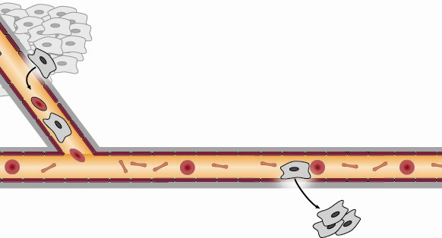
1
2
3
4
Why is Metastasis Dangerous?

When cells break away from a cancerous tumor (1), they can travel to other areas of the body through the bloodstream (2). The cancer cells can leave the bloodstream at a new location. (3). Most of these cells die, but occasionally they begin to grow a secondary tumor (4).The spread of a cancer from a primary tumor to a new part of the body is called metastasis.

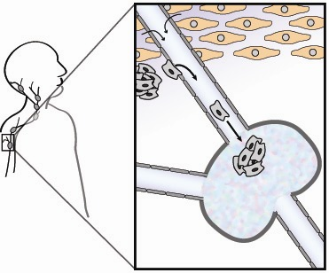
Another way cancer cells can travel to new locations in the body is through the lymphatic vessels. Lymphatic vessels run throughout the body (much like blood vessels). Lymphatic vessels normally drain fluid from between cells (A) and return it to the bloodstream. The fluid, called lymph, is filtered through organs known as lymph nodes. Cancer cells can enter a lymph vessel (B), become trapped in lymph nodes and form secondary tumors (C).
A
B
C
Lymph Node
Cancer Cells
Normal Cells
Intracellular fluid

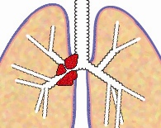
As secondary tumors grow, they crowd out and compete with normal tissues and organs. Their uncontrolled growth interferes with the tissue’s or organ’s ability to perform functions that are essential for maintaining homeostasis in the body.
Lung Cancer
Metastatic cancer is cancer that has spread from the part of the body where it started (called the primary cancer site) to other parts of the body (called secondary cancer sites). Common sites for metastasis are the brain, lungs, liver, lymph nodes, bone, skin, kidneys and adrenal glands. Metastatic cancer is responsible for 90% of cancer deaths.

Additional information on metastasis:
- http://www.cancer.gov/PDF/FactSheet/fs6_20.pdf
- http://www.answers.com/topic/metastasis
- http://health.discovery.com/encyclopedias/illnesses.html?article=2549

Metastasis and Homeostasis
Mini-Med School

Your medical team has been invited to present a five-minute talk at the “Mini-Med School”, a community outreach program for teenagers and adults. The topic for the program is “Why is Metastasis Dangerous?”

Each participating team should develop a PowerPoint presentation to explain how the spread of cancer to ______(name of organ)___________ might interfere with a cancer patient’s ability to maintain homeostasis.

Your PowerPoint presentation should explain:
- The normal structure and function of the _(organ)_.
- How a healthy _(organ)_contributes to maintaining homeostasis.
- Why the _(organ)_ is susceptible to metastasis that forms a secondary tumor.
- How a secondary tumor might disrupt the function of the _(organ)_.
- Why a secondary tumor retains the characteristics of a tumor in the primary site.
- Sseveral symptoms that might be associated with a secondary tumor in the _(organ)_.
- How disruption of the _(organ)_ might affect other organs or systems and lead to an inability to maintain homeostasis.
- What actions could be taken to prevent metastasis that leads to secondary tumors of the _(organ)_.

Because this information is very important to the community, your team should plan carefully to help community members understand and remember how metastasizing cancer cells could affect their health. You are encouraged to use creativity and graphics to get your message across in an interesting manner.

Your team is scheduled to present your talk at ____on____________.
Time Day, Date

