Laboratory Activities

to Accompany “Killing Killer Rain” Unit

Modified from the work of Beth Guzzetta
Allendale Columbia School
Rochester, NY

for

My Environment, My Health, My Choices

An environmental health curriculum development project

Sponsored by the University of Rochester
Department of Environmental Medicine, and
Environmental Health Sciences Center

Funded by the National Institute of Environmental Health Sciences (grant R25 ES10717)

These science activities were designed to accompany the interdisciplinary environmental health curriculum project called “Killing Killer Rain.” In social studies classes students investigate the impact of acid rain on economics, politics, the environment, and human health in New York State and Canada. In the science classes, students’ develop an understanding of acids, buffers, and pH through a series of laboratory activities.

Goals:
For students to develop an understanding of:
- Acids, bases, buffers, and pH measurement
- The impact of acid rain on living organisms

Overview:

Lab 1: How do scientists measure how acidic or basic a solution is?
Students are introduced to the pH scale as a way of expressing the “strength” of acids and bases. They use two indicators to test the pH of common household substances.
- Handout #1: How do scientists measure how acidic or basic a solution is?
- Teacher’s Guide for Handout #1.

Lab 2: Why is a small change in pH a serious a problem?
Students measure the amount of water that must be added to 10 mL of mildly acid solution to change it’s pH to 7. Class discussion develops the understanding that a change of one number on the pH scale means a ten-fold change in the hydrogen ion concentration.
- Handout #2: Why is a small change in pH a serious a problem?
- Teacher’s Guide for Handout #2.

Lab 3: Why are some lakes and ponds more affected by acid rain?
Students discover the natural buffering action of some types of rocks by comparing the pH change that occurs when equal amounts of acid is added to model “lakes”, containing limestone, granite, sand, or clay. They graph the results and then discuss how natural buffers reduce the effect of acid rain in some lakes and ponds.
- Handout #3 Why are some lakes and ponds more affected by acid rain?
- Teacher’s Guide for Handout #3.

Lab 4: How does acid rain affect living organisms? Students observe how sulfur dioxide in the air affects plant and animal specimens. They generate sulfur dioxide in a closed container which contains living Daphnia, small pieces of purple cabbage and spinach leaves. This leads into a discussion about how acid rain affects living organisms.
- Handout #4 How does acid rain affect living organisms?
- Teacher’s Guide for Handout #4.

Teacher’s Guide for Lab 1
How Do Scientist Measure How Acidic and Basic a Solution Is?

Objectives: Students should
- Develop an understanding of acids, bases, and the pH scale
- Develop an understanding of the use of purple cabbage indicator and pH paper to measure the pH of various solutions.

Time required:
Ten minutes of class time to introduce the topic. One 40-minute class period for the laboratory activity. Homework time to answer the questions at the end of the activity.

Materials required for each student:
- Safety goggles
- Vial of pH paper
- Dropping bottle of cabbage juice indicator (See below *)
- Dropping bottles or droppers containing pH solutions (pH 1-12). Purchase buffer solutions (1-12) from a science supply company.
- Dropping bottles or droppers containing water, vinegar, 7-UP, and dish detergent
- Various other liquids (household products or foods) to be tested—at least 4 acids and 4 bases
- Colored pencils
- Paper towel
- Handout #1A: How do scientists measure how acidic or basic a solution is?
- Handout #1B: Spot Plate Template (insert into a plastic sheet protector)
- Sheet protector to cover spot plate templates

* To prepare cabbage juice indicator:
  - Chop one head of purple cabbage into small pieces.
  - Place in pan and add enough water to barely cover the cabbage.
  - Bring to a boil and boil for three minutes.
  - Allow to cool to room temperature.
  - Filter through cheesecloth or fabric.
  - Refrigerate and use within a week. May be frozen for longer storage.

Pre-Lab Activity:
  - Distribute one copy of Handout #1: How do scientists measure how acidic or basic a solution is? to each student.
  - Briefly discuss the pH scale and pH measurement.
  - Ask students to use the information on the first page of the lab to answer questions one through 12 on the first two pages of the lab.

Activities:
- Check homework and discuss any questions students have.
- Ask students to put the “Spot plate” pages at the end of their lab packet inside a sheet protector.
- Inform students that they MUST wear safety goggles for this lab.
- Ask students to complete Parts 1 through 4 of this lab.
- If they finish early, they should begin the homework questions at the end of the lab.

Teacher’s Guide for Lab 2
Why is a small change in pH a serious problem?

Objectives: Students should
- Develop an understanding that a change in one pH unit represents a tenfold change in hydrogen ion concentration.
- Be able to explain why a small change in the pH of a lake is a serious problem.

Time Required: One 40 minute period

Materials needed for each group of students:
- Large plastic cup
- Simulated water from lake affected by acid rain (100 mL water + 10 mL white vinegar)
- Bottle of distilled water (you may substitute tap water)
- 10 mL graduated cylinder
- 100 mL graduated cylinder
- Strip of register tape or crepe paper (3 meters long)
- Meter stick
- 5 small plastic condiment cups per team
- 10 drops of blue food coloring per team (dispense in dropping bottle or dropper)
- Permanent marking pen
- Cup of water
- Dropping pipette

Activities:
  - Distribute copies of Handout #2 to each student.
  - Distribute materials to each student group.
  - Ask students to follow instructions in Handout #2.
  - End class by asking students to explain why a small change in pH is a serious problem.

Teacher’s Guide for Lab 3
Why are some lakes are more affected by acid rain?

Objectives: Students should
- Explain what a buffer is.
- Graph the effects of adding “acid rain” to model lakes.
- Identify which lake substratum is the least and the most effective in buffering the effects of acid rain.
- Explain why some lakes are more (or less) affected by acid rain.

Time Required: One 40 minute period

Materials needed for each group of students:
- 4 large plastic cups
- 4 vials of pH paper
- 4 dropping bottles with white vinegar labeled “Acid”
- 4 tablespoon measuring spoons
- 4 stirring sticks or plastic spoons
- Cup of limestone gravel
- Cup of granite gravel
- Cup of sand
- Cup of clay
- 100 mL graduated cylinder

Activities:
- Distribute one copy of Handout #3 for each student.
- Distribute laboratory materials to each group.
- Ask students to follow the instructions in Handout #3.
- End class by asking students to explain what kinds of lakes would be more affected by acid rain?

Teacher’s Guide for Lab 4
How does acid rain affect living organisms?

Objectives:
Students should observe and describe the short term and long term effects of sulfur dioxide on plants and animals.

Time Required: One 40 minute period + 15 minutes on next day.

Materials:
- Safety goggles
- Three large (100 cm) Petri plates
- Vial of pH paper
- Permanent marking pens
- Access to class supply of:
  - Cup containing small pieces of red cabbage (1 cm X 1 cm)
  - Cup containing small pieces of spinach leaves (1 cm X 1 cm)
  - Cup of water with plastic dropper
  - Cup containing Daphnia culture with large bore dropper for dispensing
- 2 M Sulfuric acid (See note below)
- 0.5 M sodium sulfite (Na2SO3) (See note below)

IMPORTANT NOTE: The TEACHER (not students) should dispense the drops pf sulfuric acid and sodium sulfite into the Petri plates during step 3 in the lab activity!

Activities:
- Distribute copies of Handout #4 to each student.
- Make materials available to students
- Ask students to follow the instructions in Handout #4
- Be ready to help students dispense Daphnia into Petri plates during step 2.
- Be ready to dispense sulfur dioxide producing chemicals into Petri plates during step 3.
- Discard “short term” plates. Carefully collect “control” and “long term” plates at the end of class. Distribute again at the beginning of the following class. Handle carefully so that the fluids in each area of the plate do not run together!
- If you wish, students can replace the lids on the “control” and “long term” plates and informally observe them over a period of several weeks.

Handout # 1
Acids, Bases, Indicators, and pH

Pre-lab:

The pH scale is a measure of the acidity or alkalinity of a solution.

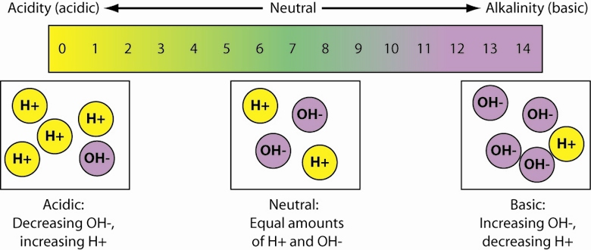

Acids have a pH of less than 7.

Alkalines or bases have a pH of greater than 7.

Neutral solutions have a pH of 7.

Indicators are chemicals that change color when they are mixed with solutions of different pH. There are many kinds of indicators.

pH testing kits are made from indicators and are sold to people who want to monitor the pH of their swimming pool water, aquarium water, or garden soil. Doctors use pH testing kits to monitor the pH of blood or urine.

- A substance with a pH of 5 would be a(n) _____________________.

- A substance with a pH of 8 would be a(n)_____________________ .

- A neutral solution would have a pH of ______________.

- Chemicals that change color when they are mixed with solutions of different pH are called __________________________________.

- A solution in which the hydrogen ion and hydroxide ion concentration are equal is said to be ______________

- A solution with a pH greater than 7 is ______________________ or ______________________

- A solution with a pH less than 7 is ___________________________.

- What is a pH Testing Kit? __________________________________________
________________________________________________________________

- What is pH paper? _______________________________________________
________________________________________________________________

10. Why might scientists use pH paper or pH testing kits to study acid rain problems?
__________________________________________________________________________________________________________________________________

11. What would happen to the pH of a lake if acid rain accumulated in it? ________________________________________________________________

12. Some people have suggested that adding basic or alkaline substances (such as lime) to a lake may help reduce the effects of acid rain. Explain how this might work.
__________________________________________________________________________________________________________________________________

During Your Lab Class, you will use purple cabbage juice as a pH indicator. To do this, you need to know what color results when cabbage juice is mixed with solutions with different pH values. To do this you will create a pH Color Chart by mixing cabbage juice (an indicator) with solutions with know pH values. Once you’ve made your chart, you will use it to determine the pH of several unknown solutions.

Laboratory Procedure:

Part 1: Make a pH Color Chart using cabbage juice as an indicator.
- Use the 12 well spot plate portion of your “spot plate.” Do NOT take it out of the plastic sheet protector.
- Place two drops of the appropriate pH solution (1 through 12) in each of the numbered wells. For example, place two drops of pH 1 solution in well 1.
- Add two drops of purple cabbage solution to each well.
- Use colored pencils to color the indicator chart at the top of the next page to show the colors in each of the wells on your “spot plate”.

Color Chart for a Cabbage Juice pH Testing Kit
 | pH of solution
 | 1 | 2 | 3 | 4 | 5 | 6 | 7 | 8 | 9 | 10 | 11 | 12
Color of Purple Cabbage Indicator

Part 2: Use your Color Chart for a Cabbage Juice pH Testing Kit to determine the approximate pH of each of the 4 solutions provided.
- Use the “Spot Plate for Part 2. ”
- Place two drops of each of the solutions you are testing in the appropriate wells on your “spot plate”.
- Add one drop of the cabbage juice indicator solution to each well.
- Use your color chart to determine the pH of each of the solutions. Note: You may express this as a range of numbers, like 3-5, if appropriate.
Tap water has a pH above _______ and below ________.
Vinegar has a pH above _______ and below _______.
Dish detergent has a pH above _______ and below _______.
7-UP has a pH above _______ and below_______.
Which substance that you tested is the most acidic? ________________
Which substance that you tested is the most basic? _________________

Part 3: pH paper contains a mixture of different indicators. Use pH paper to determine the pH of each of the solutions that you tested in Part 2.
- Use the ”Spot Plate for Part 3.”
- Put two drops of the solution you are testing in the appropriate wells on the spot plate.
- Tear one pH paper strip into 4 evenly sized pieces.
- Drop pH paper pieces into each of the solutions you are testing.
- Refer to the color chart on the pH paper vial to determine the pH of each of the solutions.
Tap water has a pH of ___________
Vinegar has a pH of ___________
Dish detergent has a pH of ___________
7-UP has a pH pH of ___________
Which is more accurate for testing the pH of a solution—pH paper or cabbage juice? Explain why.________________________________________________________

Part 4: Observe the solutions at the demonstration table. Select four that you think are acidic.
- List the solutions you selected in the chart below.
- Use the Spot Plate for Part 4. Test the solutions with pH paper.
- Use this information to complete the chart.

Names of 4 Solutions I think are acidic | pH of the solution | Is it acidic? Yes or No

Homework:

Base your answers to the questions 1-3 on the diagram below:

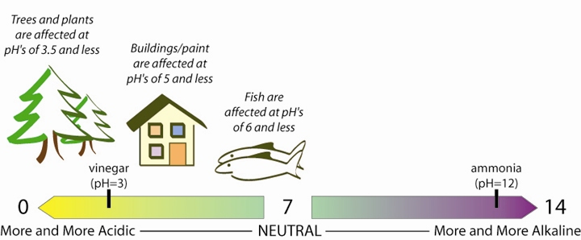

1. Acid rain has a pH of ___________ (less than 7 or more than 7).

2. According to the information in the diagram, which type of organism (fish or trees) is most sensitive to acid rain? __________________________________

3. Would adding ammonia to a lake make it more acidic or more basic? _______

The chart below shows the range of pH values at which plants will grow in gray. Base your answers to questions 4-6 on the information in the chart below:

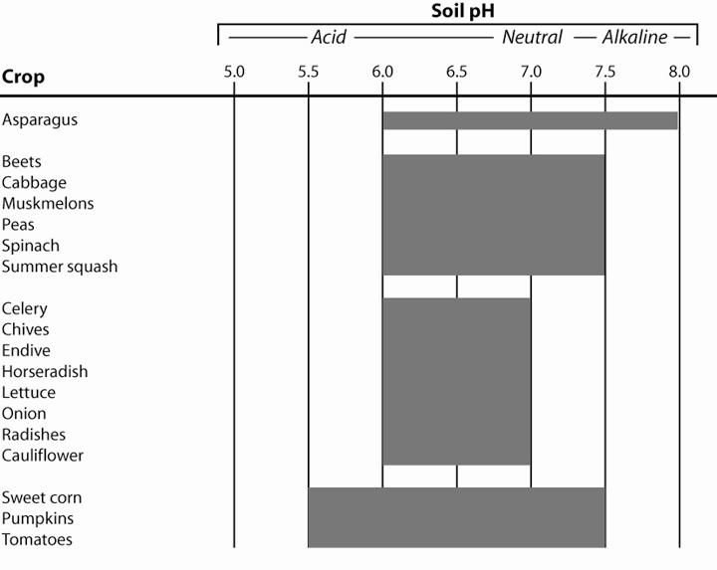

4. Which plant would grow best in alkaline (basic) soil?

5. What pH range would permit growth of all of the listed types of garden plants? A pH between _______ and _______

- Which plant would be best adapted to survive in an ecosystem that was affected by acid rain? ________________________________

- The diagram below shows the effect of pH on plant root growth. At which pH does the best plant growth occur? __________________

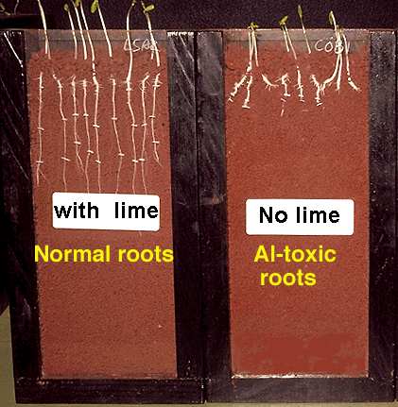
Plant growth in soil with pH 5
Plant growth in soil with pH 6
- Do you think that acidic liquids can affect materials that they come in contact with? Explain why you think that and how you think they can affect them

Handout # 1B
Spot Plate (insert into a plastic sheet protector)

Spot Plate for Part 1 (mixing cabbage juice with pH solutions)

pH 1
pH 2
pH 3
pH 4
pH 5
pH 6
pH 7
pH 8
pH 9
pH 10
pH 11
pH 12

Spot Plate for Part 2
tap water
7-Up
Dish detergent
Cabbage Juice

vinegar

Spot Plate for Part 3
tap water
7-Up
Dish detergent
pH paper

vinegar

Spot Plate for Part 4

pH paper

Solutions You Think Are Acids (label each arrow)

Handout # 2

Why is a small change in pH a serious a problem?

One student suggests that you could “fix” a lake with a low pH by adding pure water to the lake. Let’s see if that is practical.
- Take a large plastic cup. Add 10 mL of water from a lake affected by acid rain to it. Measure and record the pH of the lake water. ___________________
- Predict approximately how much distilled water (in mL) you would need to add to change the pH of the water from the lake to a pH of 6? _____________ mL Explain how you arrived at this prediction.

- Try adding the predicted amount of water to the lake water. Measure and record the pH of the lake water.

- Try this again.
- Predict approximately how much more distilled water (in mL) you would need to add to change the pH of the water in your lake to a pH of 6? _____________ mL Explain how you arrived at this prediction.

- Try adding the additional amount of water to the lake water. Measure and record the pH of the lake water. ____________
- Do you think it is practical to “fix” a lake with a low pH by adding pure water to the lake? Why or why not?

The abbreviated pH scale that you are accustomed to seeing is a common way to represent the concept of pH, but does not convey an important concept about pH.

To help you understand why it takes so much water to change the pH of an acid solution to neutral, it is important to understand that the pH scale is a logarithmic scale. This means that every change in number on the scale represents a multiplication of 10. As the pH of a solution decreases by one pH unit, that represents a tenfold increase in the concentration of hydrogen ions (H⁺). For example, lemon juice with a pH of 2 is 10 times more acidic than soda with a pH of 3.

To help you visualize what this means and to understand why it takes so much water to change the pH of an acid solution to neutral, you will create a paper model that is a more accurate representation of the pH scale.
- Unroll the strip of receipt tape and find its approximate midpoint. Label the midpoint pH 7 – neutral.
- Measure 10 millimeters to the right of the pH 7 point and label that point pH 8.
- Measure 10 millimeters to the left of the pH 7 point and label that point pH 6.
- Measure 100 millimeters to the right of the pH point and label that point pH 9.
- Measure 100 millimeters to the left of pH 7 and label that point pH 5.
- How far to the right from the pH 7 point should you measure to represent pH 10? Mark and label this point on your receipt tape.
- How far to the left from the pH 7 point would you measure to represent pH 4? Mark and label this point on your receipt tape.
- How far to the right from the pH 7 point should you measure to represent:
pH 11? ___________millimeters
pH 12? ___________millimeters
pH 13? ___________millimeters
pH 14? ___________millimeters
- How far to the left from the pH 7 point should you measure to represent:
pH 3? ____________millimeters
pH 2? ____________millimeters
pH 1? ____________millimeters
pH 0? ____________millimeters

There is another way to visualize this. Let’s imagine that a dye solution has a pH of 3 and that the blue color represents the hydrogen ions in that solution. Let’s see what happens when you add water to this dye.
- Label 5 small plastic cups: 3, 4, 5, 6 and 7.
- Put 10 drops of dye into a cup 3. This represents the pH 3.
- Transfer 1 drop of the dye into cup 4 and then add 9 drops of water. This represents a pH 4 solution.
- Transfer 1 drop from cup 4 into cup 5 and then add 9 drops of water. This represents a pH 5 solution.
- Transfer 1 drop from cup 5 into cup 6 and then add 9 drops of water. This represents a pH 6 solution.
- Transfer 1 drop from cup 6 into cup 7 and then add 9 drops of water. This represents a pH 7 solution.
- Which cup do you think represents the strongest acid, cup 7 or cup 3? Explain your answer.

Homework:
- How much more acidic is a solution with a pH of 2 than a solution with a pH of 6?
- How many times more basic is a solution with a pH of 12 than a solution with a pH of 9?
- How many times more acidic is a solution with a pH of 3 than a solution with a pH of 8?
- How many times more basic is a solution with a pH of 11 than a solution with a pH of 5?
- How long of a piece of paper would you need to draw a complete pH scale (using centimeters)?
- How would you explain why you would need to add a huge amount of water to change the pH of a lake from pH 5 to pH 7.
- Why do you think a change in a body of water's pH level of even one pH unit could be deadly for the organisms that live in the water?
Handout # 3
Buffers and Acid Rain

The effect of acid rain on the environment may be reduced through natural buffers. Buffers are chemicals that act to keep the pH of a solution relatively constant. You will work in a team of four to determine which type of lake substratum (bottom material) is best for buffering the effects of acid rain. Assign a different substratum material to each member of your team: granite, limestone, sand, or clay.

Each team member should prepare a model “lake”:
- What lake substratum material that YOU are testing? ___________________
- Add 50 mL of tap water to a small cup. Add 1 tablespoon of assigned substratum material to “lake.”
- Stir for 30 seconds to mix the substratum material with the “lake” water. Allow 60 seconds for this to settle to the bottom of the “lake”.
- Use a 1 cm long strip of pH paper to test the initial pH of the “lake.” Record your results in the table below.

Now simulate acid rain by adding drops of acid to the model “lake.”
- Add one drop of acid to the lake. Stir for 30 seconds. Measure and record the pH of the water.
- Add four more drops of acid to the lake. Stir for 30 seconds. Measure and record the pH of the water.
- Add five more drops of acid to the lake. Stir for 30 seconds. Measure and record the pH of the water.
- Add 10 more drops of acid to the lake. Stir for 30 seconds. Measure and record the pH of the water.

Share data with other students in your group and complete the data table on the next page.

Drops of Acid  Added to Model “Lake” | pH of Model “Lake”
Drops of Acid  Added to Model “Lake” | Granite  substratum | Limestone  substratum | Sand  substratum | Clay  substratum
0
(initial)
1
5
10
20

On the next page, prepare a single graph that summarizes the results of your group’s data. You should have a total of 4 lines on your graph—one for each type of substratum. Be certain to include a legend (key) to show what the lines on your graph mean.

Graph: The Effect of Adding “Acid Rain” on the pH of Model Lakes with Different Substrata

Resulting pH
of
Model “Lake”

Drops of Acid Added to Model “Lake”

Legend: Lake Substratum
Granite - Sand -
Limestone - Clay -

Questions:

- What is a buffer?

- Which “lake” substratum was best at buffering the effects of acid rain? Support your answer.

- Which “lake” substratum was worst at buffering the effects of acid rain? Support your answer.
Handout #4
How does acid rain affect living organisms?

Sulfur dioxide is a gas released by coal burning power plants. When it combines with moisture in the atmosphere, it produces sulfuric acid that leads to acid rain. In this lab, you will create a model to show how sulfur dioxide (SO₂) affects a model environment containing living plants and animals. You will observe the short term effects and long term effects of sulfur dioxide on the organisms in the model environment.

Procedure:
- Obtain 3 large Petri plates. Remove the lids (large halves). Label these “Control,” “Short Term,” and “Long Term.” Label all three with your group’s name.
- Refer to the diagram below to place water, spinach, Daphnia, and cabbage on the bottom (smaller half) of all three of the Petri plates in the proper locations. You may ask your teacher to help you “capture” the Daphnia (water fleas).

2 Drops of Water
2 Drops of Water +
1or 2 Daphnia
1 Piece of Purple cabbage Leaf + 1 Drop of Water
1 Piece of Spinach Leaf +
1 Drop of Water

- Ask your teacher to place sulfur dioxide producing chemicals to the center of two of your Petri plates. Immediately place the “short term” and the “long term” lids on all these Petri plates. Place the “control” lid on the Petri plate that does not have sulfur dioxide producing chemicals.
- Allow 10 minutes for the sulfur dioxide to affect the contents of the model environment. While you wait read the following paragraph and answer the questions.

The effect of sulfur dioxide and sulfuric acid on human health has been well studied. Toxicologists have done in vitro studies of animal tissues exposed to sulfur pollutants in experiments similar the one you are doing today. Toxicologists have also done in vivo studies on the effects of inhaled sulfur pollutants on animals and human volunteers. Their opinion is that the concentration of sulfur pollutants currently encountered in the industrialized cities is too low to cause changes in the lung function of healthy adults. They have, however, noted that chronic exposure of more susceptible population groups should be viewed with great concern.

- Discuss with your lab group what each of the following words or phrases might mean. In your own words, explain what each means.

- Toxicologist

- In vitro studies

- In vivo studies

- Concentration

- Chronic exposure

- Susceptible population groups

- Based on this reading, do you think that people who live in an area affected by acid rain should be worried about going outside on rainy days? Why or why not?

- Remove the lid from the “control” Petri plate and from the “short term” Petri plate.

- Use pH paper to test the pH of the water drops in both plates. Record your results in the data table on the next page.

- Observe and compare the spinach and cabbage leaves in both plates. Record your observations in the data table below.

- Observe and compare the Daphnia in both plates. Record your observations in the data table below.

- Put the lid back on the “control” Petri plate and save it for future observation. Discard the “short term” Petri plate.

 | Control | Short Term | Long Term
pH of water drop
Observation of spinach leaf
Observation of cabbage leaf
Observation of Daphnia

- What was the purpose of the control Petri plate?

- Based on your observations, describe the short-term effects of sulfur pollution on living organisms?

- Organisms that are very sensitive to changes in their environment may be used to determine if there are harmful changes in an environment. Which organism that you studied would make the best biological indicator of sulfur dioxide pollution? Explain your answer.

- Your teacher will collect your “control” and the “long term” Petri plate at the end of class.

- After 24 hours, compare the contents of the “control” and “long term” Petri plates. Complete the data table on the previous page to record your observations.

- Based on your observations, describe the long term effects of sulfur pollution on living organisms?

- What do you predict might happen if the living organisms had chronic exposure to sulfur pollution—a week, a month, a year?

- Based on this experiment, do you think that humans should be concerned about their exposure to acid rain in a rainstorm or a lake? Why or why not.

- Based on this experiment, do you think that breathing in sulfur dioxide might harm your lungs? Why or why not.

