Apples

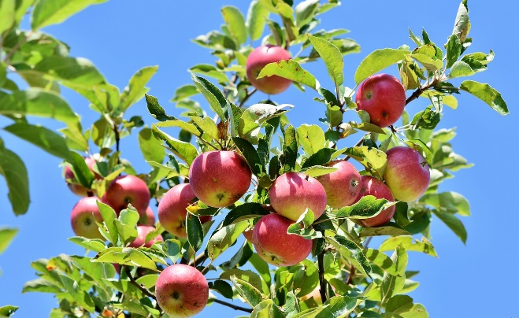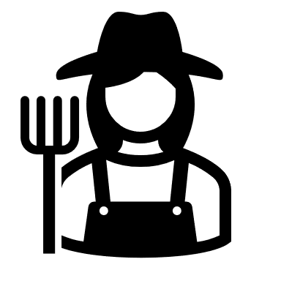

Hay (Alfalfa)

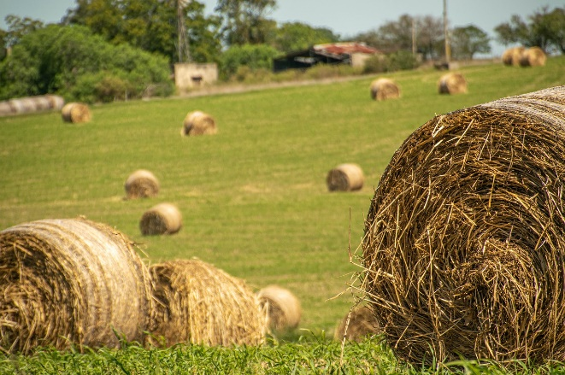

Cabbage

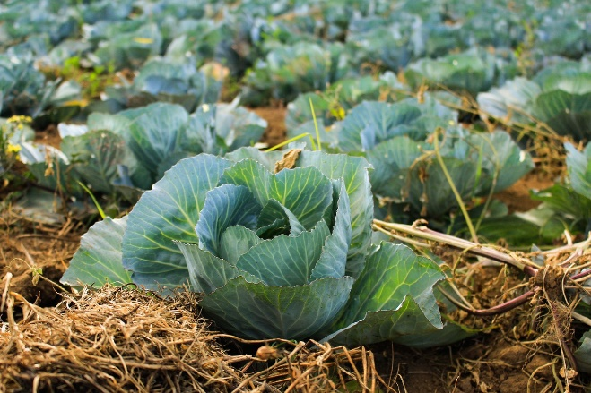

Potatoes

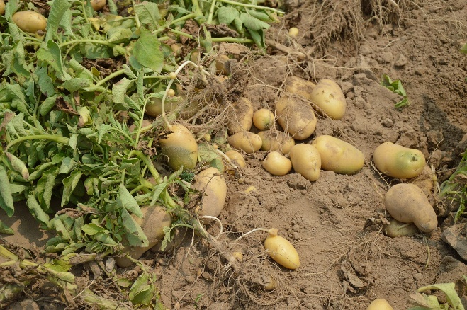

Sweet Corn

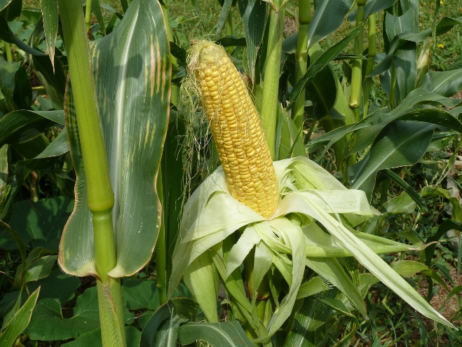

Flowers (Floriculture)

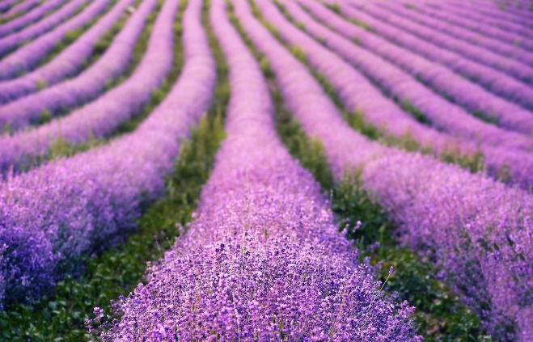

**Honey bees** are the most common pollinator for apples.

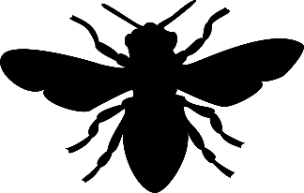

**Alfalfa leafcutting bees** are the most common pollinator for alfalfa.



Cabbage is a **leaf**. Plants can make leaves without pollination. Pollination by **bees** is needed to make seeds.

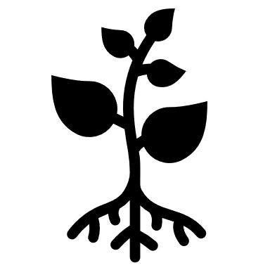

Potatoes are a **root**. Plants can make roots without pollination. Potatoes are grown from pieces of other potatoes, not seeds!



Sweet corn is pollinated by the **wind**.



Plants can make **flowers** without pollination. **Bees**, **butterflies**, **moths**, **birds**, **bats**, **beetles**, **wasps** and **flies** all pollinate flowers. Pollination is needed to make **seeds**.



Milk

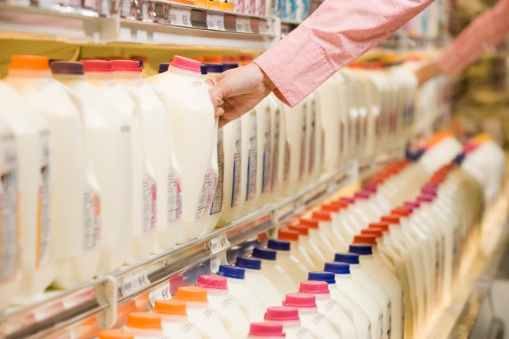

Cattle

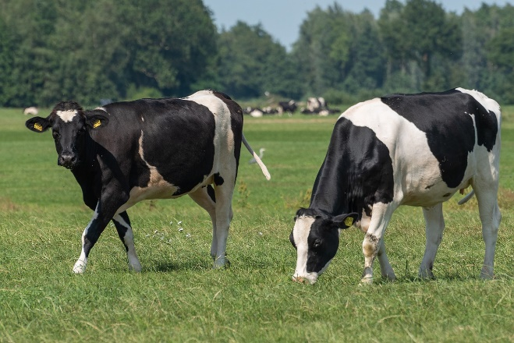

Corn (for grain)

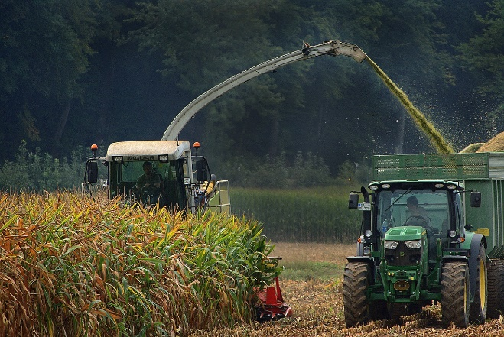

Tomatoes

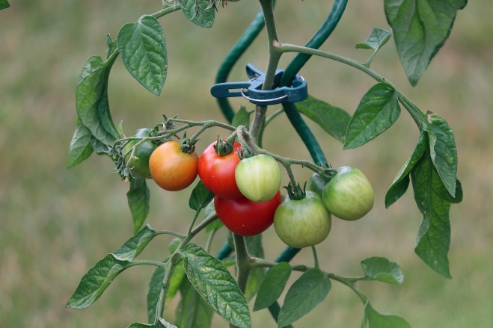

Milk comes from cattle, which eat alfalfa pollinated by **alfalfa** **leafcutting bees**.



Cattle eat hay (alfalfa), which is pollinated by **alfalfa leafcutting bees**.

Tomatoes are pollinated by **bumble bees**.



Corn is pollinated by the **wind**.

