AIDSVax Inc.
Department of Vaccine Research
1979 Cure Drive
Rochester, NY 14620

Dear Research Technician,

We are excited to collaborate with your organization in developing an AIDS vaccine. I am sending you 4 possible DNA vaccines that you could use in your vaccine trials. I’m not sure which combinations of the three HIV genes are in each one. You will have to check this.

Along with the HIV DNA, I have included some data collected from preliminary animal studies. We injected mice with each of the three HIV genes alone: the gag gene codes for HIV structural proteins; the env gene codes for the virus envelope proteins; and the pol gene codes for viral enzymes.

Sincerely,

Clarke Kent, Ph.D
Director
Center for Vaccine Research
University of Rochester

Part 1: Gel Electrophoresis

You have been given 4 potential AIDS vaccines (V1, V2, V3, V4). These are DNA vaccines that contain different parts of the HIV genome, which is shown below.

The DNA vaccines have already been cut with a restriction enzyme. The restriction enzyme cut sites are shown below. The entire HIV genome is cut into three pieces (gag, pol and env).

HIV Genome:

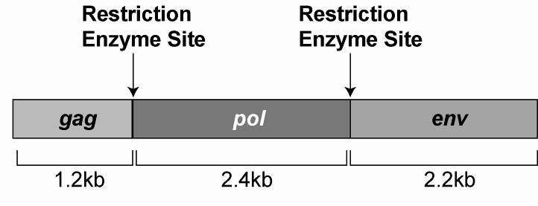

You will need to identify which of the 4 DNA vaccines have parts of the HIV genome that you might be interested in using in an AIDS vaccine clinical trial. For example, you will not want to use a vaccine that contains all three genes (why not?)

You will use agarose gel electrophoresis to determine which parts of the HIV genome are in each of the 4 DNA vaccines.

Load 10μL of each of the pre-cut DNA vaccines into the wells of an agarose gel and run the gel for about 15 minutes at 120 Volts

V1
V2
V3
V4

Part 1: Observations/Conclusions

Draw what you see on your gel:

V1
V2
V3
V4
Wells

What does each band represent on the gel?
Part 1: Studies in mouse models

Amount of antibodies
Teacher Note: Students should recognize that immunizingnjecting mice with the pol gene does not stimulate the production of antibodies, and is therefore not a good candidate for a vaccine when given on its own
DNA injected into mice

Figure 1. Comparison of antibody titers collected from 10 mice injected with different DNA HIV vaccines encoding pol, env, gag, or control DNA. Serum from each animal was collected 8 weeks after injection. Each filled circle represents one mouse.

Amount of cytotoxic T-cell Activity
DNA injected into mice

Figure 2. Cytotoxic T cell activity from 10 mice injected with different DNA HIV vaccines encoding pol, env, gag, or control DNA. Immune cells from each animal were collected 8 weeks after injection.

Use the information from your gel and the animal studies to answer the following questions:
Vaccine Name | What genes are in this vaccine? | Would you use this in a human trial? | If no, why not?
V1

V2

V3

V4

Part 2: Testing for an Immune Response using ELISA
(Enzyme Linked ImmunoSorbant Assay)

Which vaccine results in the best immune response, V2 or V4?

You have tested V2 and V4 vaccines by injecting volunteer patients with V2 or V4 vaccine, or with a placebo.

14 people were injected with V2
14 people were injected with V4
6 people were injected with placebo

Several months later, you collect serum from these patients. You will test their serum samples to see if these patients have made antibodies against the proteins that are coded for by the DNA vaccine. This is done using an Enzyme Linked ImmunoSorbant Assay, or ELISA.

ELISA:

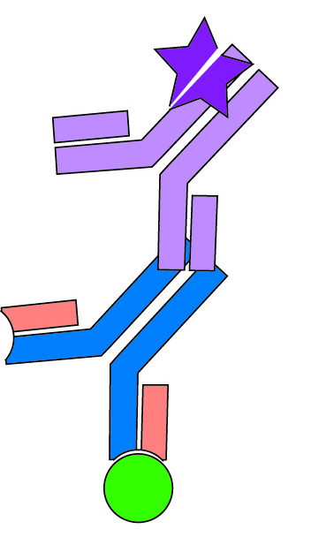
Solid substrate – Made of plastic or specially treated paper, this holds the protein in place.
pol protein
Labeled Antibody – this antibody binds to human antibodies and is labeled with a tag
Developing Solution- Contains molecules that activate the tag on the Secondary Antibody so that it can be seen.

Serum antibodies – If the patient has antibodies against pol protein, the antibodies will bind to the protein and solid substrate.

Part 2: Clinical Trial: Individual ELISA Data

PROCEDURE
- Label three absorbent squares using a pencil. One for each HIV protein (As shown below)

env
gag
pol

- Place one labeled absorbent square in each of the three small plastic trays
Place one square in each tray

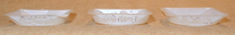

- Use a transfer pipette to:
  - drop 1 drop of env proteins onto the square labeled “env”
  - drop 1 drop of gag proteins onto the square labeled “gag”
  - drop 1 drop of pol proteins onto the square labeled “pol”

- Let the squares dry for 1 minute

- Use a transfer pipette to put 0.5mL of your patient serum onto each square
- Let soak for 5 seconds
- Pour off the excess serum
- Transfer 0.5mL of labeled antibodies on the square
- Let soak for 5 seconds
- Transfer 0.5mL of water onto each square to quickly rinse the card
- Pour off the water
- Drop 1 drop of Developing Solution onto each square
- Record your results

Patient #
env
gag
pol

Patient was given vaccine

Part 2: Clinical Trial Group Data
Patient # | Vaccine given | pol antibodies? | env antibodies? | gag antibodies?
1 | V2
2 | V2
3 | V2
4 | V2
5 | V2
6 | V2
7 | V2
8 | V2
9 | V2
10 | V2
11 | V2
12 | V2
13 | V2
14 | V2
15 | V4
16 | V4
17 | V4
18 | V4
19 | V4
20 | V4
21 | V4
22 | V4
23 | V4
24 | V4
25 | V4
26 | V4
27 | V4
28 | V4
29 | Placebo
30 | Placebo
31 | Placebo
32 | Placebo
33 | Placebo
34 | Placebo

- What antibodies did you expect a person injected with V2 would have?

- What antibodies did you expect a person injected with V4 would have?

- What antibodies did you expect a person injected with Placebo would have?

- Which vaccine do you think works the best? Why?

