Activity 5:

Nano Risk?
____________________________________________________

Core Concept:
- Nanoparticles are small enough to enter and be circulated to many parts of the body.
- Little is known about the potential harmful effects of nanoparticles on human health.
- Different kinds of nanoparticles may have different toxicity levels.

Class time required:
Two 40 minute class periods

Teacher Provides:
- A copy of student handout “Nano Risk?” and the article “Nanotoxicology Research” for each student. The “Nanotoxicology Research” article may be laminated for reuse with additional classes.
- Note: For advanced classes, consider using the following research report instead of the “Nanotoxicology Research” reading. Consider asking different teams of students to read and report on different pages of this article:
Nanotoxicology: An Emerging Discipline Evolving from Studies of Ultrafine Particles by Gunter Oberdorster, Eva Oberdorster, and Jan Oberdorster Environmental Health Perspectives, Volume 113, Number 7, July 2005 http://ehis.niehs.nih.gov/members/2005/7339/7339.html
- Two different colors of highlighter for each team of 3-5 students.
- Optional: access to texts to use for identifying structures and functions of human systems.

For Part 3, each team of two students will need:
- A fine point permanent marker
- One 8-well test strip. You can also use 1-ounce condiment cups or well plates but you will need to show students how the illustrations in the lab are different from what they will be using in your class. The test strips can be ordered from VWR, catalog number 62402-961 (https://www.vwrsp.com/catalog/product/index.cgi?catalog_number=62402-963&inE=1&highlight=62402-963).
- Small plastic droppers labeled:
- Indicator  - Cultured Cells | - PS 1 ug/mL  - PS 10 ug/mL  - PS 50 ug/mL  - PS 100 ug/mL | - CeO 1 ug/mL  - CeO 10 ug/mL  - CeO 50 ug/mL  - CeO 100 ug/mL
- 16 plastic toothpicks
- One set of small tubes of indicator, cultured cells, and nanoparticles. Use the information found in the data table below:

Label on Tube | Contents of Tube
Indicator | At least 2 mL of 0.04% bromothymol blue (WARDS 944 V 7004 for 100 ml)
Cultured Cells | At least 2 mL of distilled water
PS 1 ug/mL | At least 1 mL of pH 9 buffer or 1/20 dilution of household ammonia
PS 10 ug/mL | At least 1 mL of pH 9 buffer or 1/20 dilution of household ammonia
PS 50 ug/mL | At least 1 mL of pH 5 buffer or white vinegar
PS 100 ug/mL | At least 1 mL of pH 5 buffer or white vinegar
CeO 1 ug/mL | At least 1 mL of pH 9 buffer or 1/20 dilution of household ammonia
CeO 10 ug/mL | At least 1 mL of pH 9 buffer or 1/20 dilution of household ammonia
CeO 50 ug/mL | At least 1 mL of pH 9 buffer or 1/20 dilution of household ammonia
CeO 100 ug/mL | At least 1 mL of pH 9 buffer or 1/20 dilution of household ammonia

Suggested Class Procedure:
- Distribute copies of the student handout entitled “Nano Risk?”
- Read the information at the top of the first page. Ask students to complete Part 1 for homework.
During class
- Explain to students that they will be doing two activities that will help them understand how scientists study the health effects of nanoparticles.
- Organize students in teams of 3-5 students. Distribute two different colored highlighters to each team.
- Students complete Part 1. Encourage them to use textbooks as a source of information about the various body organs and systems.
- Ask several students to share their answers to develop the concept that many systems and functions might be affected by nanoparticles. Encourage them to explain their reasoning.
- Distribute the article entitled “Nanotoxicology Research” to each student.
- Students work in teams to read the article to complete Part 2. They should read the article aloud and use the information to put X’s in the first column to indicate systems referred to in the article.
- Ask several teams to share their answers to each of the questions. Encourage them to explain their reasoning.
- Explain that in Activity 2, students learned that size and surface area are important when considering potential risks from nanoparticles. BUT, size is not all that matters when considering the potential for harmful health effects. Nanoparticles may have different chemical compositions and/or different shapes. In Part 3 they will do an experiment that uses nanoparticles that are the same size and same shape but have different chemical compositions.
- For Part 3, students should work in teams of two students. Distribute lab materials to teams of two students.
- Part 4 may be done for homework or during class.

This project was generously funded by Science Education Partnership Award R25RR023285 from the National Center for Research Resources. The content is solely the responsibility of the authors and does not necessarily represent the official views of the National Center for Research Resources or the National Institutes of Health.
Nanotoxicology Research

The rapidly developing field of nanotechnology is likely to become a source for human and environmental exposure to nanosized particles. The same properties that make nanoparticles so attractive for use in consumer products, industrial processes, and nanomedicine could also make them harmful when nanoparticles interact with cells in living organisms.

Nanotoxicology is the science of the effects of nanosized materials on living organisms. Nanotoxicologists are scientists who do research to determine which nanoparticles are potentially toxic (harmful) to cells and organisms. Nanotoxicologists are just beginning to investigate the effects of nanoparticles on human health.

The biological actions of nanoparticles are different from larger particles of the same chemical composition. When inhaled, nanoparticles are efficiently deposited in all regions of the respiratory tract. Nanoparticles can move out of the respiratory tract and into other parts of the body, using different pathways and mechanisms. Nanoparticles in the nose can travel to the brain through the nerves involved in smell. Ingested nanoparticles move into the blood, but most ingested nanoparticles are excreted via feces. Nanoparticles may also enter the body if they penetrate the outer layers of the skin, particularly skin damaged by cuts or burns. Some nanoparticles that are used in medicines are injected directly into the bloodstream.

Once in blood and lymph, nanoparticles can be distributed throughout the organism, and they may be taken up by many parts of the body such as the liver, the spleen, the bone marrow, the heart, the brain, and other organs. Because nanoparticles are so tiny, they can evade immune system defense mechanisms that typically remove foreign materials from the body.

The diagram below illustrates the known pathways for nanoparticles. Future research is needed to determine additional pathways and the rates of nanoparticle exposure, uptake, and movement throughout the body.
Exposure
Uptake
Removal
Air, water, clothes,
Air
Food and
water
Movement through organism
Skin
Respiratory tract

Digestive tract

Brain, nerves
Blood and Lymph
Bone marrow
Kidney
Spleen
Heart
Liver
Urine
Feces

The use of nanotechnology products is likely to increase dramatically over the next decade. Both the societal benefits and potential risks of nanotechnology should be evaluated and clearly communicated to the general public. But before the public can effectively weigh the benefits and risks of nanomaterials, additional scientific information is needed on the hazards (toxicity) of nanoparticles and the levels of exposure to nanoparticles.

Large risks result when the nanoparticles are highly toxic (very hazardous) and people are likely to be exposed to high levels of these nanoparticles. The risks are smaller when nanoparticles are less toxic (less hazardous) or when people not likely to be exposed to high levels of these nanoparticles.

Risk High | Risk Moderate | Risk Low
High toxicity (very hazardous)  High exposure levels | Low toxicity  OR  Low exposure | Low toxicity (less hazardous)  Low exposure levels

The research on the potential harmful health effects of nanoparticles is difficult for three main reasons:
- Nanoparticles are difficult to see. They are so tiny that they cannot be seen with a light microscope. Even with special types of microscopes, nanoparticles are very difficult to find because they are about the size of many of the organelles and large molecules inside of cells.
- There are many different types of nanoparticles. They may be made of different sizes, shapes, surface areas, electrical charges, and chemical compositions.
- There are many different cell or organ functions that might be disrupted by nanoparticles. For example, there is evidence that some nanoparticles can lead to inflammation, cell damage, loss of enzyme function, and failure of receptor binding.

A better understanding of the potential toxic effects of nanoparticles will best be achieved through the work of multidisciplinary teams of researchers in the fields of toxicology, chemistry, physics, earth science, material science, medicine, and molecular biology.

Nano Risk?
____________________________________________________

Sunscreens, cosmetics, the air you breathe, foods, and clothing are just a few of the things that you are exposed to that contain nanoparticles. As the use of nanotechnology increases, your exposure to nanoparticles may become greater. Should you be worried about the effects of nanoparticles on your health?

Part 1: Develop some hypotheses

- Hypothesize! Where might nanoparticles enter the body? Use a marker to color the parts of the body on the diagram below where you think nanoparticles might enter the body. Hint: Think about the different nanoproducts that are sold and the different sources of nanoparticle pollution.

- Hypothesize! Where might nanoparticles go once they are inside the body? Use a different colored marker to color the parts of the diagram where nanoparticles might go once they are inside the body.

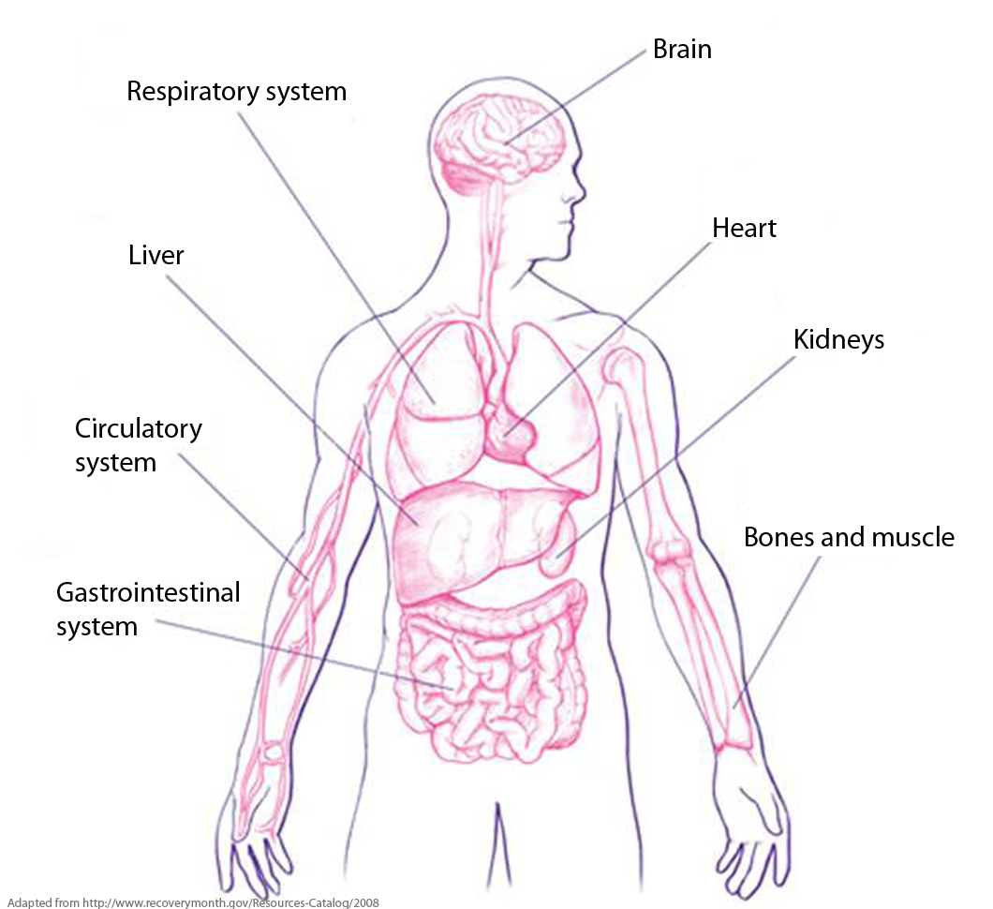
Nanoparticles may enter the nose, mouth, and skin. They may be transported to most parts of the body.
- Hypothesize! What systems of the body do you think might be affected by nanoparticles? In the first column of the chart below, put check mark ( ) in front of the systems you think might be affected by nanoparticles. Then, complete the chart by:
- Writing a brief description of the function of each body system
- Listing one symptom that might be observed if nanoparticles disrupted the normal function of each body system

Check Mark  | Body System | Brief description of the function of the system | Possible symptom caused by nanoparticles
X | Circulatory System | Transport Materials | Student answers will vary.
X | Digestive System | Digests and absorbs food | Share and discuss answers.
X | Nervous System | Controls body
 | Muscular System | Contracts to move the body
X | Skeletal System | Supports the body
X | Respiratory System | Takes in oxygen and gets rid of carbon dioxide
 | Endocrine System | Produces hormones to regulate body
X | Immune System | Defends against disease
 | Reproductive System | Produces offspring
X | Lymphatic System | Collects and filters lymph
X | Urinary System | Gets rid of wastes

Part 2: What does the research say?

- Read the article, “Nanotoxicology Research.” As you read, you should compare what the researchers have found with your hypotheses in Part 2. Put an “X” in the first column if the information in the “Nanotoxicology Research” article indicates that a body system if affected by nanoparticles. Student answers may vary. Should be discussed.

- What is a nanotoxicologist?

Nanotoxicologists are scientists who do research to determine which nanoparticles are potentially toxic (harmful or hazardous).

- What is meant by the term “multidisciplinary team”?

Scientists from many different subject areas.

- Do you think that further research might find that nanoparticles affect other systems in the body, in addition to the ones mentioned in the article? Explain why or why not.

Student answers will vary but most students will explain that nanoparticles can move into the circulatory system, so this suggests that other systems might be affected. But, currently, there is no evidence for this.

- Do you think that there is enough scientific evidence to support banning the production and use of all consumer products that contain nanoparticles? Explain why or why not.

Student answers will vary. They should recognize that more research is needed to understand the health effects of nanoparticles.

Part 3: Does chemical composition matter?

There are many different kinds of nanoparticles! Nanoparticles can be made of different chemicals. To compare the toxicity of nanoparticles made of different chemicals, scientists can expose cells to different concentrations of each type of nanoparticle.

In this activity, you will conduct simulated tests to compare the toxicity of two kinds of nanoparticles on cells.
[----------------] = 50 nanometers
- The two kinds of nanoparticles that you will use for this experiment are made of different chemicals—polystyrene and cerium oxide.
Polystyrene
Nanoparticle
Cerium Oxide
Nanoparticle
- These nanoparticles are the same size and the same shape.

- Obtain a well strip with 8 wells. Use a permanent marker to label the
wells 1 – 8.
1
2
3
4
5
6
7
8

- Obtain the tube of “Cultured Cells” to use for your tests. Use the “Cultured Cells” dropper to place 3 drops of cultured cells in each of the eight wells (cups) on the well strip.
Be certain to keep the small tab on the strip on the left when you work.
1
2
3
4
5
6
7
8
Cultured Cells

- Obtain four tubes of different concentrations of polystyrene (PS) nanoparticles. Hint: Organize these tubes and droppers in the order shown below.
PS
1 ug/mL
PS
10 ug/mL
PS
50 ug/mL
PS
100 ug/mL

- Use the appropriately labeled droppers to place 2 drops of the different polystyrene (PS) concentrations into wells 1 - 4 on the well strip as shown in the diagram below.
PS
1 ug/mLLL
PS
10 ug/mL
PS
50 ug/mL
PS
100 ug/mL

1
2
3
4
5
6
7
8

- Obtain four tubes of different concentrations of cerium oxide (CeO) nanoparticles. Hint: Organize these tubes and droppers in the order shown below.
CeO
1 ug/mL
CeO
10 ug/mL
CeO
50 ug/mL
CeO
100 ug/mL

- Use the appropriately labeled droppers to place 2 drops of the different cerium oxide (CeO) concentrations into wells 5 - 8 on the well strip as shown in the diagram below.
CeO
1 ug/mL
CeO
10 ug/mL
CeO
50 ug/mL
CeO
100 ug/mL

1
2
3
4
5
6
7
8

- Use a different clean toothpick to stir the cultured cells with the nanoparticles in each of the wells.

- Use the appropriately labeled dropper to add 2 drops of the color-changing “Indicator” to each of the wells.

1
2
3
4
5
6
7
8
Indicator

- Use a different clean toothpick to mix the contents of each well.

- Record the color of the contents of each of the wells in the data table below. Hint: It is easier to determine the colors, if you hold the well strip up to the light.

Type of Nanoparticles | Concentration of Nanoparticles
Type of Nanoparticles | 1 ug/mL | 10 ug/mL | 50 ug/mL | 100 ug/mL
Polystyrene | BLUE | BLUE | YELLOW | YELLOW
Cerium Oxide | BLUE | BLUE | BLUE | BLUE

- Based on the results of your experiment, which type of nanoparticle, polystyrene (PS) or cerium oxide (CeO), is most toxic? Support your answer with evidence from the data table.
Key for Color Change
- Blue = Healthy Cells
- Green = Unhealthy Cells
- Yellow = Dead Cells

Polystyrene nanoparticles were toxic and cerium oxide nanoparticles were not toxic at the concentrations tested. Polystyrene particles caused green/yellow color or unhealthy/dead cells at low nanoparticle concentrations.

- Notice that the tests for effects of polystyrene did not result in a green color that indicates unhealthy cells. Explain how you might design an experiment to determine (more precisely) the lowest concentration of polystyrene (PS) nanoparticles that is harmful to the cells—causes them to become unhealthy.

Student answers will vary but should include increasing the number of different concentrations of polystyrene nanoparticles—particularly concentrations between 10 and 50 ug/mL.

Part 4: Does shape matter?

Nanoparticles can have different shapes. To compare the toxicity of nanoparticles with different shapes, scientists exposed cells to carbon nanoparticles that have two different shapes.
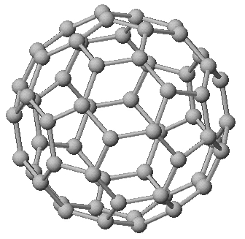
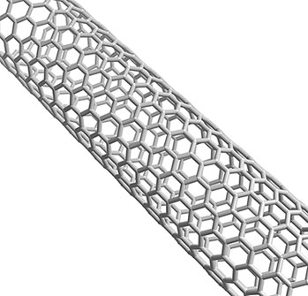

Carbon
Buckey Ball
Carbon
Nanotube

The data collected by the scientists is represented below.
KEY:
Black = dead
Gray = not healthy
White = healthy

1 ug/mL

10 ug/mL

Carbon Nanotubes
Carbon Buckey Balls
50 ug/mL

100 ug/mL

1 ug/mL

10 ug/mL

50 ug/mL

100 ug/mL

- Which carbon nanoparticle shape is most toxic—Buckey balls or carbon nanotubes? Support your answer with information from the data represented above.

Carbon nanotubes. They cause unhealthy cells a concentration between 1 and 10 ug. Buckey balls do not have a harmful affect at those concentrations.

- Based on the data, does the shape of a nanoparticle affect its toxicity? Support your answer with information from the data represented above.

Yes, the carbon nanotubes and the Buckey balls had different toxicities.

