Nano Risk?
____________________________________________________

Sunscreens, cosmetics, the air you breathe, foods, and clothing are just a few of the things that you are exposed to that contain nanoparticles. As the use of nanotechnology increases, your exposure to nanoparticles may become greater. Should you be worried about the effects of nanoparticles on your health?

Part 1: Develop some hypotheses

- Hypothesize! Where might nanoparticles enter the body? Use a marker to color the parts of the body on the diagram below where you think nanoparticles might enter the body. Hint: Think about the different nanoproducts that are sold and the different sources of nanoparticle pollution.

- Hypothesize! Where might nanoparticles go once they are inside the body? Use a different colored marker to color the parts of the diagram where nanoparticles might go once they are inside the body.

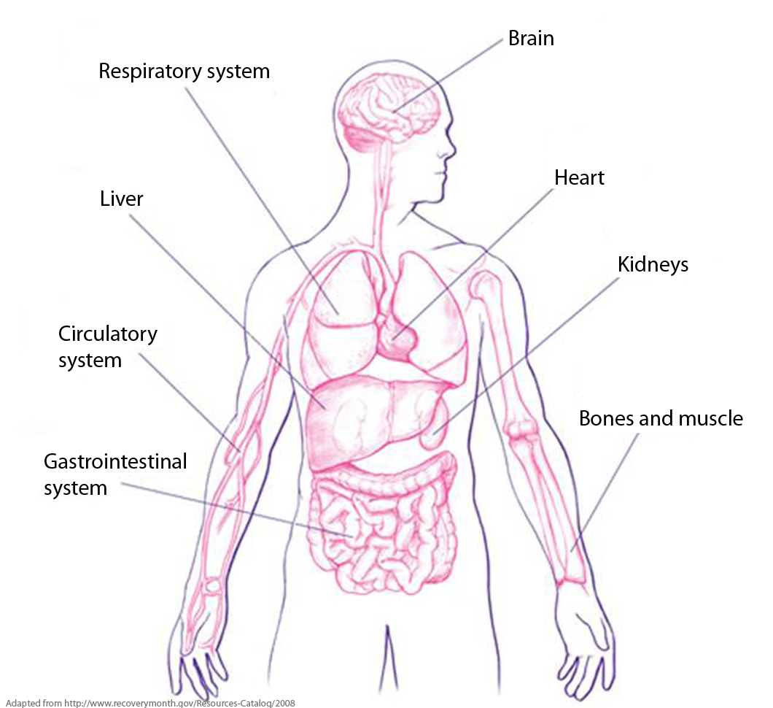
- Hypothesize! What systems of the body do you think might be affected by nanoparticles? In the first column of the chart below, put check mark ( ) in front of the systems you think might be affected by nanoparticles. Then, complete the chart by:
- Writing a brief description of the function of each body system
- Listing one symptom that might be observed if nanoparticles disrupted the normal function of each body system

Check Mark  | Body System | Brief description of the function of the system | Possible symptom caused by nanoparticles
 | Circulatory System
 | Digestive System
 | Nervous System
 | Muscular System
 | Skeletal System
 | Respiratory System
 | Endocrine System
 | Immune System
 | Reproductive System
 | Lymphatic System
 | Urinary System

Part 2: What does the research say?

- Read the article, “Nanotoxicology Research.” As you read, you should compare what the researchers have found with your hypotheses in Part 2. Put an “X” in the first column if the information in the “Nanotoxicology Research” article indicates that a body system if affected by nanoparticles.

- What is a nanotoxicologist?
_________________________________________________________________________
_________________________________________________________________________

- What is meant by the term “multidisciplinary team”?
_________________________________________________________________________
_________________________________________________________________________

- Do you think that further research might find that nanoparticles affect other systems in the body, in addition to the ones mentioned in the article? Explain why or why not.
_________________________________________________________________________
_________________________________________________________________________
_________________________________________________________________________

- Do you think that there is enough scientific evidence to support banning the production and use of all consumer products that contain nanoparticles? Explain why or why not.
_________________________________________________________________________
_________________________________________________________________________
_________________________________________________________________________

Part 3: Does chemical composition matter?

There are many different kinds of nanoparticles! Nanoparticles can be made of different chemicals. To compare the toxicity of nanoparticles made of different chemicals, scientists can expose cells to different concentrations of each type of nanoparticle.

In this activity, you will conduct simulated tests to compare the toxicity of two kinds of nanoparticles on cells.
[----------------] = 50 nanometers
- The two kinds of nanoparticles that you will use for this experiment are made of different chemicals—polystyrene and cerium oxide.
Polystyrene
Nanoparticle
Cerium Oxide
Nanoparticle
- These nanoparticles are the same size and the same shape.

- Obtain a well strip with 8 wells. Use a permanent marker to label the
wells 1 – 8.
1
2
3
4
5
6
7
8

- Obtain the tube of “Cultured Cells” to use for your tests. Use the “Cultured Cells” dropper to place 3 drops of cultured cells in each of the eight wells (cups) on the well strip.
Be certain to keep the small tab on the strip on the left when you work.
1
2
3
4
5
6
7
8
Cultured Cells

- Obtain four tubes of different concentrations of polystyrene (PS) nanoparticles. Hint: Organize these tubes and droppers in the order shown below.
PS
1 ug/mL
PS
10 ug/mL
PS
50 ug/mL
PS
100 ug/mL

- Use the appropriately labeled droppers to place 2 drops of the different polystyrene (PS) concentrations into wells 1 - 4 on the well strip as shown in the diagram below.
PS
1 ug/mLLL
PS
10 ug/mL
PS
50 ug/mL
PS
100 ug/mL

1
2
3
4
5
6
7
8

- Obtain four tubes of different concentrations of cerium oxide (CeO) nanoparticles. Hint: Organize these tubes and droppers in the order shown below.
CeO
1 ug/mL
CeO
10 ug/mL
CeO
50 ug/mL
CeO
100 ug/mL

- Use the appropriately labeled droppers to place 2 drops of the different cerium oxide (CeO) concentrations into wells 5 - 8 on the well strip as shown in the diagram below.
CeO
1 ug/mL
CeO
10 ug/mL
CeO
50 ug/mL
CeO
100 ug/mL

1
2
3
4
5
6
7
8

- Use a different clean toothpick to stir the cultured cells with the nanoparticles in each of the wells.

- Use the appropriately labeled dropper to add 2 drops of the color-changing “Indicator” to each of the wells.

1
2
3
4
5
6
7
8
Indicator

- Use a different clean toothpick to mix the contents of each well.

- Record the color of the contents of each of the wells in the data table below. Hint: It is easier to determine the colors, if you hold the well strip up to the light.

Type of Nanoparticles | Concentration of Nanoparticles
Type of Nanoparticles | 1 ug/mL | 10 ug/mL | 50 ug/mL | 100 ug/mL
Polystyrene
Cerium Oxide

- Based on the results of your experiment, which type of nanoparticle, polystyrene (PS) or cerium oxide (CeO), is most toxic? Support your answer with evidence from the data table.
Key for Color Change
- Blue = Healthy Cells
- Green = Unhealthy Cells
- Yellow = Dead Cells

_________________________________________________________________________
_________________________________________________________________________
_________________________________________________________________________

- Notice that the tests for effects of polystyrene did not result in a green color that indicates unhealthy cells. Explain how you might design an experiment to determine (more precisely) the lowest concentration of polystyrene (PS) nanoparticles that is harmful to the cells—causes them to become unhealthy.
_________________________________________________________________________
_________________________________________________________________________
_________________________________________________________________________

Part 4: Does shape matter?

Nanoparticles can have different shapes. To compare the toxicity of nanoparticles with different shapes, scientists exposed cells to carbon nanoparticles that have two different shapes.
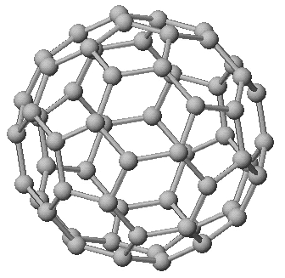
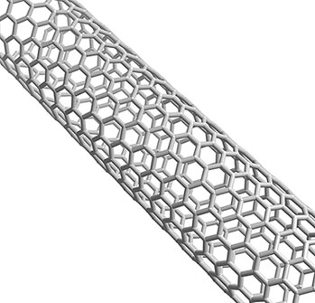

Carbon
Buckey Ball
Carbon
Nanotube

The data collected by the scientists is represented below.
KEY:
Black = dead
Gray = not healthy
White = healthy

1 ug/mL

10 ug/mL

Carbon Nanotubes
Carbon Buckey Balls
50 ug/mL

100 ug/mL

1 ug/mL

10 ug/mL

50 ug/mL

100 ug/mL

- Which carbon nanoparticle shape is most toxic—Buckey balls or carbon nanotubes? Support your answer with information from the data represented above.
_________________________________________________________________________
_________________________________________________________________________
_________________________________________________________________________

- Based on the data, does the shape of a nanoparticle affect its toxicity? Support your answer with information from the data represented above.
_________________________________________________________________________
_________________________________________________________________________
_________________________________________________________________________

