Activity 4:

Nano Benefits
____________________________________________________

Key Concept:
Nanotechnology has been used to create many products that are smaller, lighter, and more effective than products made from larger materials.

Class time required:
Approximately 20 minutes of class time to introduce the activity. At least 30 minutes for students to do computer research—this may be continued at home. At least 30 minutes to make posters—this may be continued at home. Class time should be provided for students to present their posters to their classmates.

Teacher Provides:
- A copy of student handout “Nano Benefits” (4 pages) for each student or for each team of students.
- Access to computers with Internet and to printers (color if possible).
- Blank paper for making posters—card stock is ideal but regular printer paper will do.
- Tape
- Scissors
- Glue

Suggested Class Procedure:
- Distribute copies of “Nano Benefits” to each student or each team of students.
- Read the first page. Direct students’ attention to the poster template and the scoring guide.
- Direct students’ attention to the category assignment list. There are 11 categories on this list.
- Assign categories to individual students or teams. Students should record the number and the title of their assigned category on their handout. Consider:
  - Random assignment: Students draw a numbered slip of paper with the number of their assigned category on it.
  - Selective assignment: Assign easier topics to less able students and more challenging topics to advanced students.
- Students may work individually or in teams. If students are working in teams, ask students to move to work in a team with other students who drew the same number.
- Allow at least 30 minutes for students to work individually or in teams to visit the websites suggested in the student instructions to obtain information about products related to their assigned category. Stress the importance of recording the source of information (URL) for each product. IMPORTANT: Some of your students may need assistance with exploring the websites. Allow at least some class time so that you can provide initial support and assistance as students begin exploring the websites.
- Allow at least 30 minutes for students to work individually or in teams create their poster pages. Ideally students could do this using word processing software, but accept hand written posters if you cannot provide computer access for this.
- Arrange for students to hang their posters in the classroom or in another area of the school. Allow time for students to do a “gallery walk” in which they view their classmates’ posters and add a “Post It” notes with one thing they found interesting on each poster. Or use the “Peer Review of Nano Benefits Posters” form is included for teachers who would like to have their students peer review the posters.

Sample Posters
Photo courtesy of Rosalie Zonder, Our Lady Mercy School
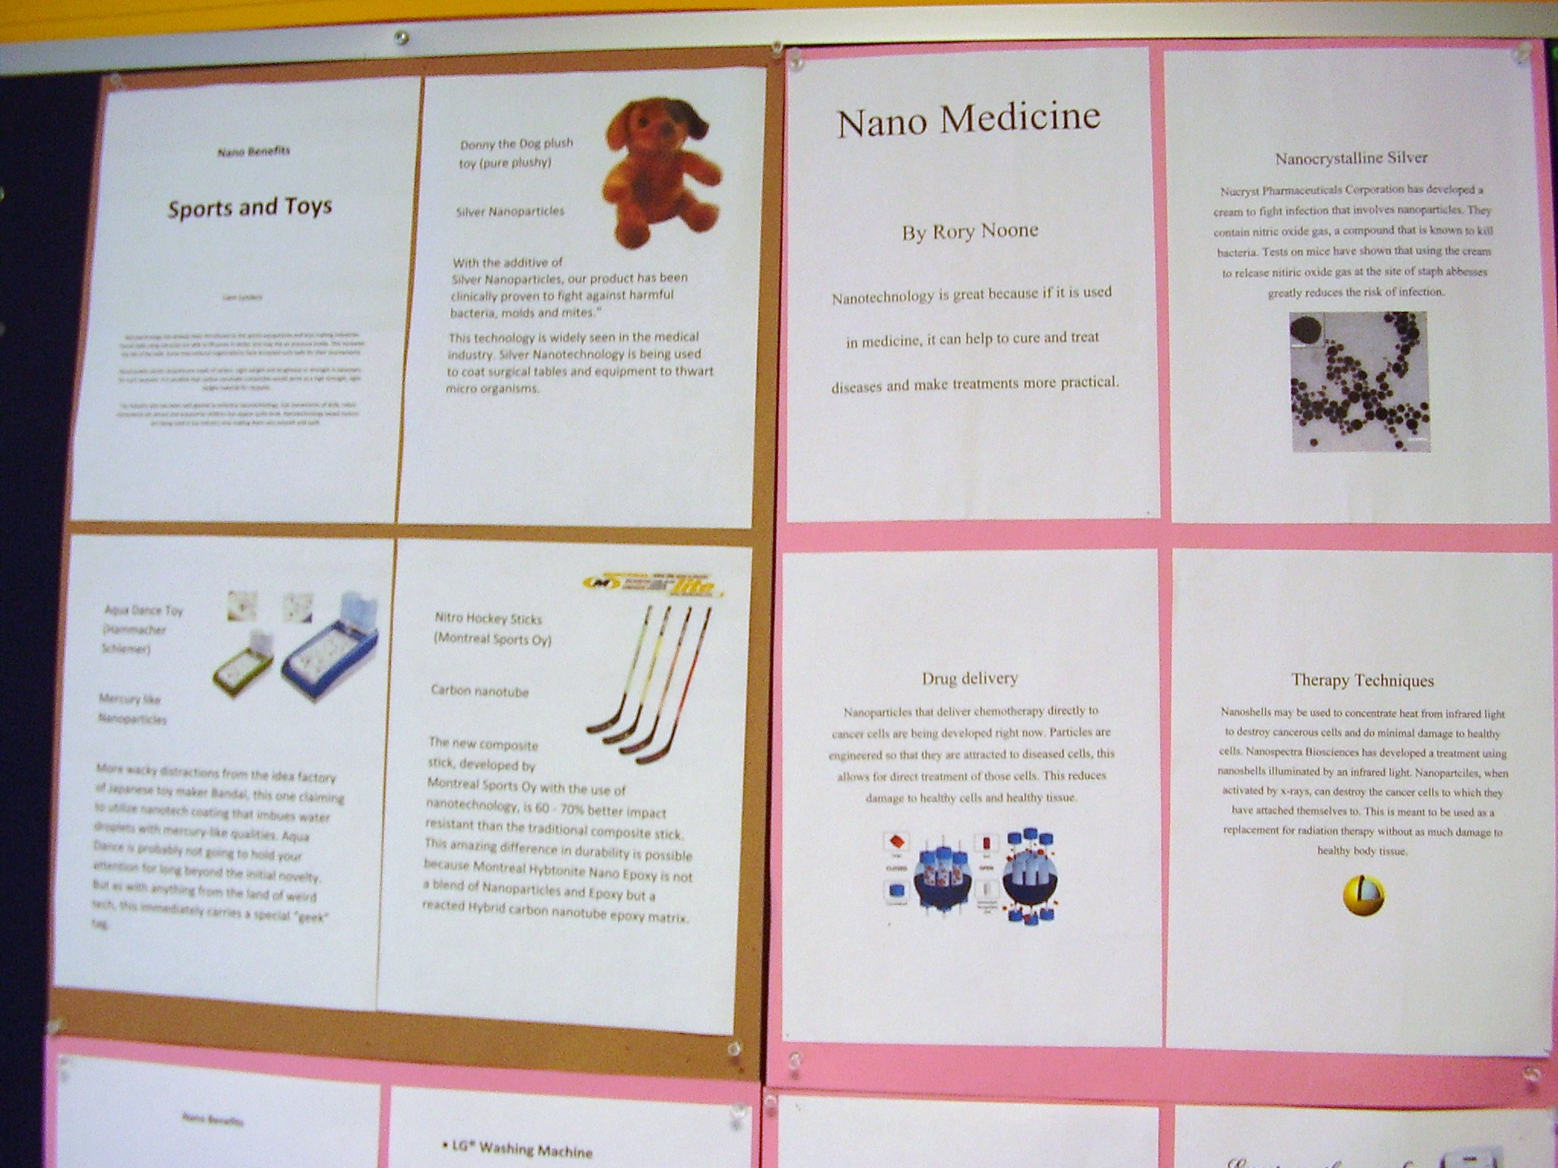
This project was generously funded by Science Education Partnership Award R25RR023285 from the National Center for Research Resources. The content is solely the responsibility of the authors and does not necessarily represent the official views of the National Center for Research Resources or the National Institutes of Health.
Nano Benefits
____________________________________________________

Nanotechnology has great potential for making our lives healthier and more convenient. While most people think of nanotechnology products as things of the future, new “nanotech” products are currently being used in millions of homes. Many people are probably not even aware of many of the products that include nanoparticles.
Your class will develop a series of posters that could be used to make people in your community aware of the different types of nanotech products they may already be using. To share the work, each team in your class will be assigned a different product category to investigate.
Your team has been assigned product category:
# _______ Name of category ____________________________________

You will be responsible for creating a poster that shows examples of three products in the category assigned to you. You should select products that are likely to be used by people in your community. Your poster should include the following information on three products:
- Names and pictures of the products
- The type of nanoparticles included in the products
- The advantages for use of nanoparticles in these products
- Source of information (URL)

Follow the guidelines on the poster template so that the class poster series will have a professional and consistent appearance. Also be certain to refer to the Scoring Guide for Nano Benefits Poster to be certain you understand how your poster will be graded.
To create your poster, you may find the following websites helpful.
http://www.nanotechproject.org/inventories/
http://understandingNano.com/Nanotech-applications.html

Nano Benefits Poster Template
Create your poster by taping 4 sheets of paper together. The tape should go on the back side of the poster.

Nano Benefits

Your assigned nanotechnology category

Team Member’s Names

This nanotechnology is great
because…………………………
……………………………………….
………………………………………..

- Name of the product

- The type of nanoparticles included in the product

- The advantages for use of nanoparticles in these products

Picture of
the product

- Name of the product

- The type of nanoparticles included in the product

- The advantages for use of nanoparticles in these products

- Name of the product

- The type of nanoparticles included in the product

- The advantages for use of nanoparticles in these products

Picture of
the product

Picture of
the product
Source of information
Source of information
Source of information
Source of information
Scoring Guide for Nano Benefits Posters
Your score
Team made good use of class time 2 points
Team shared work fairly 2 points
Poster complete and handed in on due date 2 points
Proper poster format followed 2 points
Neat and visually appealing 2 points
Nanotechnology is great because…. 2 points
Creative 2 points
Sources cited for each product 3 points
Pictures of products 3 points
Names of products 3 points
Particles in product 3 points
Advantages of use of nanoparticles 6 points
Total possible points 32 points
Teacher Comments

Nano Benefits Category Assignment List
- Appliances Batteries, Heating, Cooling and Air Conditioning , Large Kitchen Appliances, Laundry and Clothing Care

- Home and Garden Cleaning, Construction Materials, Home Furnishings, Luggage, Paint, Pets

- Electronics Audio, Cameras and Film, Computer Hardware, Display, Mobile Devices and Communications, Television, Video

- Food and Beverage Food ingredients, Cooking, Food Storage, Supplements

- Industrial Coatings Films, Protective coatings

- Goods for Children Childcare products , Toys and Games

- Health and Fitness Clothing, Cosmetics, Filtration, Personal Care, Sporting Goods, Sunscreen

- Automotive Exterior, Maintenance and Accessories, Watercraft

- Medicine Drug delivery, Therapy, Diagnostics, Imaging, Anti-microbials, Cell repair

- Energy Fuel Production, Fuel Cells, Solar Cells, Batteries

- Air and Water Quality Catalysts, Nano-structured membranes, Decontamination, Filtering

Peer Review of Nano Benefits Posters
Your name ___________________________________________________________
Who created the poster? ___________________________________________________________
Poster topic _____________________________________________
Rating Scale
1 = Poor
3 = OK
5 = Excellent

Directions: Rate each poster for the characteristics listed. Place an X on each line in the location that represents your rating.

Poster format was followed
1
3
5

Neat and visually appealing
1
3
5

Products selected were interesting
1
3
5

Product information is informative
1
3
5

What did you like best about this poster?

How might this poster be improved?

