Activity 3:

Nano Particles
____________________________________________________

Key Concept:
Small particles have a greater surface area per unit mass and have increased potential for biological interactions that may lead to health problems.

Class time required:
Approximately 20 minutes of homework followed by 80 minutes of class time

Teacher Provides:
- Optional: 1 copy of the book Zoom by Istvan Banyai (available at www.amazon.com) . Also consider the book Rezoom by the same author. Tear the pages out of the book and ask students to arrange them in order from largest view to smallest view.
- A copy of student handout “Nano Particles” for each student.
For each team of students
- Zip top clear plastic sandwich bag containing 8 plastic centimeter cubes per team. It is important that all of the cubes in this bag are the same color. Plastic cubes can be ordered from www.learningresources.com. Approximate cost is $15.00 for 500 cubes. You may also substitute sugar cubes for this activity.
- Zip top clear plastic sandwich bag (use good quality bags) labeled “Large” containing 1 gram (approx 1/3 teaspoon) coarse gel granules. Granules may be ordered from www.water-keep.com. Select the “coarse” size gel granules. Approximately cost is $6.00 for a 12 ounce (340 grams) bag.
- Zip top clear plastic sandwich bag (use good quality bags) labeled “Small” containing 1 gram (approx 1/3 teaspoon) of medium gel granules. Granules may be ordered from www.water-keep.com. Select the “medium” size gel granules. Approximate cost is $6.00 for a 12 ounce (340 grams) bag.
- Plastic 1 ml graduated dropper for measuring the “Blue Dye” solution.
- Cup or beaker labeled “Water” that contains at least 100 ml of tap water.
- Small container (test tube or beaker) labeled “Blue Dye” that contains at least 5 ml of 0.1% bromothymol blue solution. Order from http://wardsci.com (catalog number 944 V 7106). Approximate cost of 500 ml bottle is $12.00. Add 3 drops of household ammonia to each 10 ml of bromothymol solution to keep the bromothymol from turning green when mixed with water and gel granules.
- Small container (test tube or beaker) labeled “Acid” that contains at least 60 ml of white vinegar. Purchase vinegar at a local grocery store.
- 50 ml graduated cylinder or 1 ounce plastic medicine cup with ml markings.
Suggested Class Procedure:
- Optional: Show selected pages from the book Zoom (going from large to small) to illustrate the fact that when you look at smaller and smaller things, the types (or details) of processes you can see change.
- Distribute copies of the student handout entitled “Nano Particles” to each student.
- Distribute to each team of students.
  - Bag labeled “Small” containing 1 gram of the medium granules.
  - Bag labeled “Large” containing 1 gram of coarse granules.
  - Tube of “Blue Dye”
  - 1 graduated (1 ml) plastic dropper
  - Cup labeled “Water” that contains tap water.
  - 50 ml graduated cylinder or 1 ounce plastic medicine cup with ml markings.
- Students complete the Introduction. It takes about ½ hour for the granules to completely absorb the blue dye. You may either have students:
  - Complete the introduction and then wait until the next class to complete the other parts of this activity, OR
  - Work on Part 1 and Part 2 to allow time for the granules to absorb the blue dye. This allows time for the granules to absorb the blue dye completely before they do Part 3.
- Students to read the information in Part 1 and answer the questions in Part 1 while the granules are absorbing the blue dye.
- Distribute to each team of students.
  - Bag containing 8 plastic centimeter cubes (or sugar cubes)
- Students to read the information in Part 2 and answer the questions in Part 2 while the granules are absorbing the blue dye.
- Distribute to each team of students.
  - Tube or cup or beaker labeled “Acid” that contains white vinegar
  - Cup labeled “Water” that contains tap water.
  - 50 ml graduated cylinder or 1 ounce plastic medicine cup with ml markings.
- Distribute tubes of “Acid” (vinegar) to students. Students complete Parts 3.
- When students have completed Part 3, they should be instructed to discard the bags containing fluid and gel particles into a waste container. DO NOT dispose of the contents of the gel bags in the sink.

Extensions:
- Ask students for other real-life examples in which small particles react differently than larger particles. You could model one answer such as “you can fit more kindergarteners than adults into a car” or “fine powdered sugar dissolves more rapidly than a sugar cube.”
- Ask students to explain how this activity could be used to explain why they are made of millions of microscopic cells rather than one large cell.

This project was generously funded by Science Education Partnership Award R25RR023285 from the National Center for Research Resources. The content is solely the responsibility of the authors and does not necessarily represent the official views of the National Center for Research Resources or the National Institutes of Health.
Nano Particles
____________________________________________________

Introduction

In this activity, you will use gel particles to explore how particle size affects two particle behaviors - absorbing and reacting.
1 gram of particles

Each of the two small plastic bags contains 1 gram of particles.

- Both of the bags contain the same mass of particles (1 gram). Which bag contains the largest number of particles per gram—large particles or small particles?

Small particles

- Use the small measuring cup to add 40 ml of water to each of the bags. Set each of the bags into cups to keep them from falling over.

- Use the graduated plastic dropper to add 2 mL of blue dye to each of the bags.
1 mL
mark

- Seal the bags to prevent spills.

- Observe the bags after 2 minutes. Which size of particles absorbed the blue dye solution more rapidly—small particles or large particles?

The small ones

- Go on to complete Parts 1 and 2 while you wait for all the particles to completely absorb the blue dye.

Part 1: Particles in the air you breathe

The particles found in air pollution that you inhale come in many different sizes. The size of inhaled particles determines how deeply they can penetrate the respiratory tract.
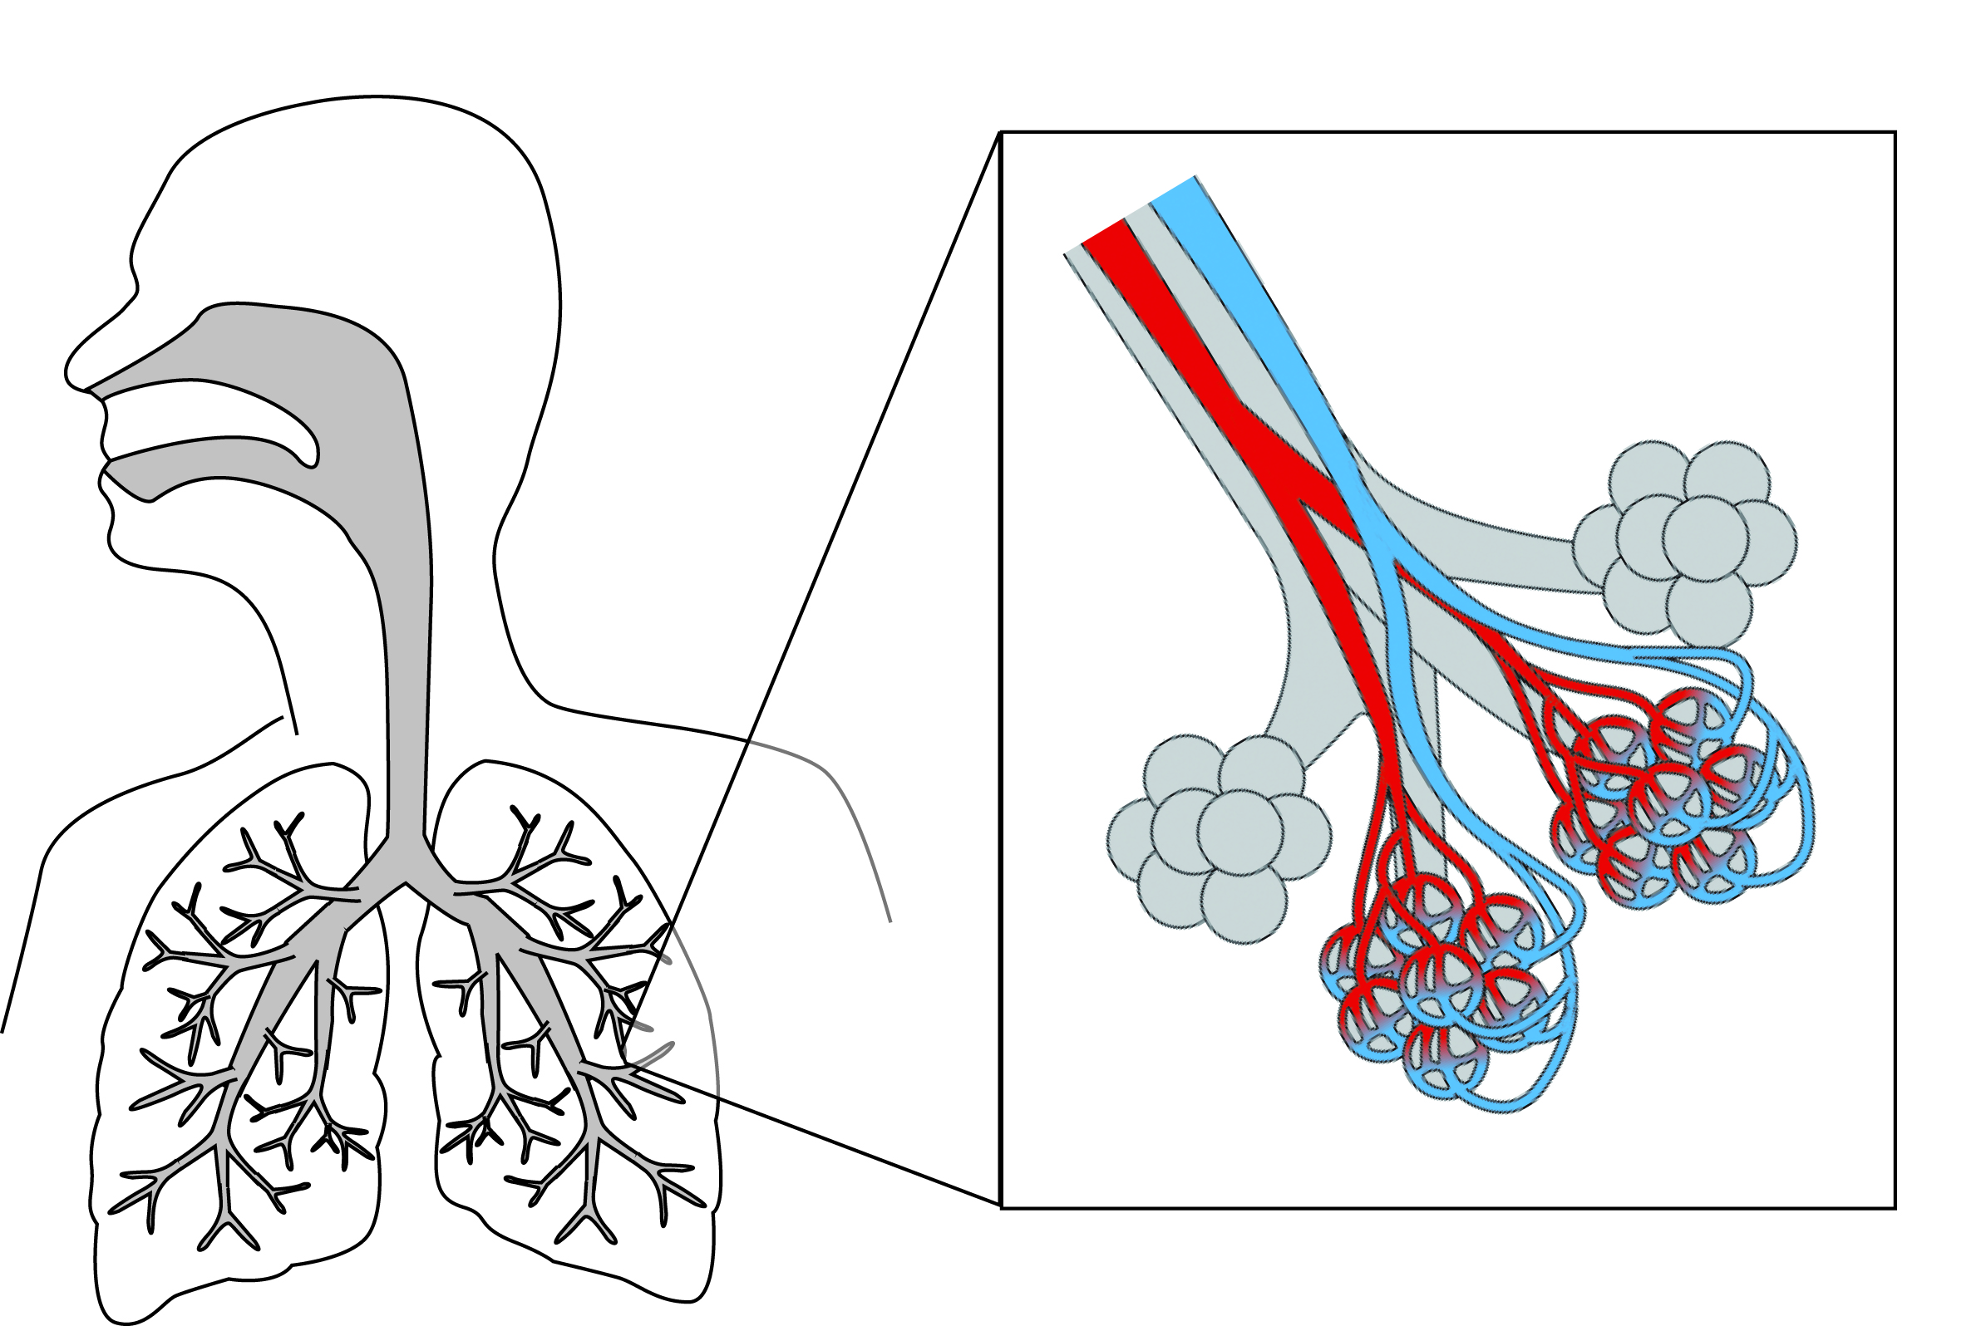

Large particles
Larger particles (10-30 micrometers) are usually filtered by the nose and throat.
Alveolus

Capillaries

PM_{2.5}
Particles smaller than about 2.5 micrometers, referred to as PM₁₀, can move into the trachea, bronchi and bronchioles.

Nanoparticles
Particles smaller than 0.1 micrometers, referred to as nanoparticles, can easily move into the alveoli and the capillaries and then accumulate in other organs, including the brain.

Research studies have shown that inhaling PM_{2.5} particles significantly increases the risks for respiratory diseases (such as asthma, emphysema, and lung cancer) and cardiovascular diseases (such as heart disease and strokes)—particularly for people with pre-existing conditions.
PM_{2.5}
Particles smaller than 2.5 micrometers, referred to as PM_{2.5}, can move into the alveoli, the small air sacs where gas-exchange occurs in the lungs
Scientists are concerned that nanoparticles that are less than 100 nanometers may be more damaging to the respiratory and cardiovascular system than PM_{2.5}. There is some evidence that nanoparticles can move from the respiratory system into the capillaries. Nanoparticles could be circulated to and accumulate in other organs, including the brain.
Scientists point out that there is an urgent need for research to determine the role of nanoparticles in cardiovascular disease and respiratory disease.

- To what does PM_{2.5} refer?
Particles which are smaller than 2.5 micrometers.
- A nanoparticle is smaller than 100 nanometers or 0.1 micrometers. What subscript should you use to express this as particulate matter size? PM __0.1_______
- List at least two cardiovascular problems and two respiratory problems that have been shown to be associated with particles smaller than 2.5 micrometers (2,500 nanometers), PM_{2.5}.
Cardiovascular problems—Heart attack and stroke
Respiratory problems—asthma, emphysema, and lung cancer.
- List all parts of the respiratory system in which you might find nanoparticles? Hint: See the diagram on page 2.
The nose, throat, trachea, bronchi, bronchioles, alveoli, and capillaries in the lungs
- Explain how it is possible to find inhaled nanoparticles in other organs of the body such as the brain and the liver.
Nanoparticles are small enough to enter blood vessels and be circulated throughout the body.

- Why are scientists concerned that nanoparticles (particles that are less than 100 nanometers) may be an even greater health problem than PM_{2.5} particles?
There is evidence that particles smaller than 100 nanometers can pass through pass through the membranes of the alveoli into the capillaries and then be circulated to and accumulate in other organs, including the brain.

Part 2: Particle Size and Surface Area

Nanoparticles absorb and react more rapidly than larger particles, because they have more surface are per unit volume. In this activity, you will use plastic cubes to help you visualize the relationship between particle size, volume and surface area.

- Use the 8 small cubes to build a large cube that is 2 cm X 2 cm X 2 cm.
2 cm

Each of the small plastic cubes has a mass of 1 g (gram) and has a volume of 1 cm³ (cubic centimeter).

Volume = length x width x height

Surface area of cube = length x width x 6
1 cm

- Complete only Column 1 (1 Large Cube) on the data table. You will use the instructions and hints on the next two page to complete Columns 2 and 3.
Hints: The large cube should be counted as 1 particle. Use the information in the box above.

 | Column 1 | Column 2 | Column 3
 | 1 Large Cube  (2 X 2 X 2 cm) | 8 Small Cubes  (1 X 1 X 1 cm each) | 8,000 Tiny Cubes  (1 X 1 X 1 mm each)
Number of particles | 1 | 8 | 8,000
Total Mass (grams) | 8 | 8 | 8
Total Volume (cm³) | 8 | 8 | 8
Total Surface area (cm² ) | 24 | 48 | 480
- Separate the cubes so that there are 8 small cubes. Complete Column 2 (8 Small Cubes) on the data table. Base your calculations on the total for all eight cubes. Hint: Each small cube should be counted as one particle. Calculate the surface area for one cube and then multiply by 8.

- Imagine that each of the centimeter cubes was cut into tiny cubes that were 1 millimeter X 1 millimeter X 1 millimeter.

  - You could fit 1,000 of the millimeter cubes into a one small cube. You could fit 8,000 of these tiny cubes into a large cube!

  - The total surface area of 8,000 of these tiny cubes would be 480 cm²
(Note: the surface area of one side of this sheet of paper is 580 cm²).

  - Use this information to complete Column 3 (8,000 Tiny Cubes) on the data table.

If you could cut one of the small plastic cubes into “nanocubes,” the total surface area of these nanocubes would be equal to the surface area of 4 hockey rinks!!!

If you could cut all eight of the small plastic cubes into “nanocubes,” the total surface area of these nanocubes would be equal to the surface area of 32 hockey rinks!!!

- What is the most important thing that you learned from this cube activity?
Student answers will vary but should indicate cutting large particles into many small particles increases the surface area.

Surface area of cube
= length X width X 6

Part 3: Particle Behavior—two bags of blue particles
The issue with nanoparticles is not simply how easily they enter the body. Once nanoparticles enter the body they behave differently from larger particles of the same material.

In this activity, you will observe and compare the behavior of large particles and small particles that are placed in acid. When you add acid to the bags of blue gel granules, the blue gel granules turn yellow when they absorb and react with the acid

- Use the small measuring cup to add 25 mL of acid to each of the bags of blue gel granules.

- When the particles react with acid, they turn yellow. Which particles reacted most rapidly with the acid—small particles or large particles?

The small particles turned yellow more rapidly than the larger ones.

- Use what you learned in Part 2 (the cube activity) to explain why small particles absorbed and reacted more rapidly.

Small particles have much more surface area for absorbing and reacting.

The blue gel particles that you used in these experiments were large enough to be seen with the naked eye. The small gel particles were approximately 1 millimeter across. If measured in micrometers the diameter of the small particle would be 1,000 micrometers or 1,000,000 nanometers.

A nanoparticle is an extremely small particle that is less than 100 nanometers in size. You could line up 10,000 nanoparticles across the diameter of one small particle.

Small blue gel particle

10,000 nanoparticles would fit in a line across the diameter of one small gel particle

- You don’t need to do the calculations to determine the answers to these questions. Just use your imagination! If you had a bag that contained one gram of nanoparticles,

- Imagine how many nanoparticles the bag would contain. Millions and millions!

- Imagine how rapidly the nanoparticles would absorb the blue dye. Extremely rapidly—in a fraction of a second!

- Imagine how rapidly the nanoparticles would react with substances around them. Extremely rapidly—in a fraction of a second!
EPA Air Quality Standards
Air particle pollution, also called particulate matter or PM, is a complex mixture of extremely small particles and liquid droplets in the air. When breathed in, these particles can reach the deepest regions of the lungs. Exposure to air particle pollution is linked to a variety of significant health problems, ranging from aggravated asthma to premature death in people with heart and lung disease.
To protect public health and welfare, the US Environmental Protection Agency (EPA) issues air quality standards for particulate matter. According to the 2006 EPA air quality standards, the concentration of inhalable coarse particles (PM₁₀) in air should be less than 15 micrograms per cubic meter. The concentration of fine particles (PM_{2.5}) should be less than 65 micrograms per cubic meter.
Some scientists are concerned that the EPA standards for air pollution, which are expressed in terms of mass (micrograms), are not a proper measure of the health hazards of very tiny particles such as nanoparticles. They point out, for example, that 1 million nanoparticles have about the same mass as one large particle of 10 µm diameter. These scientists suggest that particle number or particle surface area per cubic meter of air would be more effective measures of the potential for small particles to cause health problems.
Source: http://epa.gov/pm/naaqsrev2006.html
- Why is a microgram (µg) of nanoparticles more likely to lead to cardiovascular disease than a microgram (µg) of larger particles?
Because 1 million nanoparticles have about the same mass as one particle of 10 µm diameter. OR There are many more particles (or surface area) in one gram of nanoparticles than there are in one gram of 10 µm diameter particles.

- What measurement standard might be a more effective measure of the potential for small particles to cause health problems?
Particle number or particle surface area per cubic meter might be a more effective measure of the potential for small particles to cause health problems.

