Nano Particles
____________________________________________________

Introduction

In this activity, you will use gel particles to explore how particle size affects two particle behaviors - absorbing and reacting.
1 gram of particles

Each of the two small plastic bags contains 1 gram of particles.

- Both of the bags contain the same mass of particles (1 gram). Which bag contains the largest number of particles per gram—large particles or small particles?
____________________________

- Use the small measuring cup to add 40 ml of water to each of the bags. Set each of the bags into cups to keep them from falling over.

- Use the graduated plastic dropper to add 2 mL of blue dye to each of the bags.
1 mL
mark

- Seal the bags to prevent spills.

- Observe the bags after 2 minutes. Which size of particles absorbed the blue dye solution more rapidly—small particles or large particles?
____________________________

- Go on to complete Parts 1 and 2 while you wait for all the particles to completely absorb the blue dye.

Part 1: Particles in the air you breathe

The particles found in air pollution that you inhale come in many different sizes. The size of inhaled particles determines how deeply they can penetrate the respiratory tract.
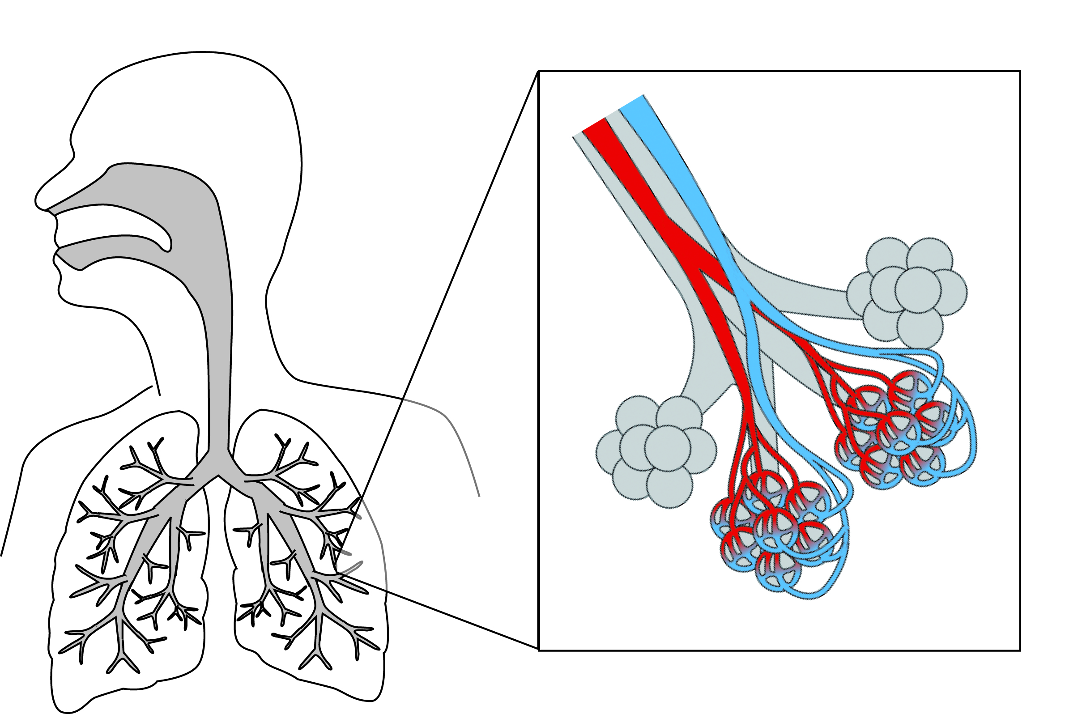

Large particles
Larger particles (10-30 micrometers) are usually filtered by the nose and throat.
Alveolus

Capillaries

PM_{2.5}
Particles smaller than about 2.5 micrometers, referred to as PM₁₀, can move into the trachea, bronchi and bronchioles.

Nanoparticles
Particles smaller than 0.1 micrometers, referred to as nanoparticles, can easily move into the alveoli and the capillaries and then accumulate in other organs, including the brain.

Research studies have shown that inhaling PM_{2.5} particles significantly increases the risks for respiratory diseases (such as asthma, emphysema, and lung cancer) and cardiovascular diseases (such as heart disease and strokes)—particularly for people with pre-existing conditions.
PM_{2.5}
Particles smaller than 2.5 micrometers, referred to as PM_{2.5}, can move into the alveoli, the small air sacs where gas-exchange occurs in the lungs
Scientists are concerned that nanoparticles that are less than 100 nanometers may be more damaging to the respiratory and cardiovascular system than PM_{2.5}. There is some evidence that nanoparticles can move from the respiratory system into the capillaries. Nanoparticles could be circulated to and accumulate in other organs, including the brain.
Scientists point out that there is an urgent need for research to determine the role of nanoparticles in cardiovascular disease and respiratory disease.

- To what does PM_{2.5} refer?
_________________________________________________________________________
- A nanoparticle is smaller than 100 nanometers or 0.1 micrometers. What subscript should you use to express this as particulate matter size? PM _________
- List at least two cardiovascular problems and two respiratory problems that have been shown to be associated with particles smaller than 2.5 micrometers (2,500 nanometers), PM_{2.5}.
_________________________________________________________________________
_________________________________________________________________________

- List all parts of the respiratory system in which you might find nanoparticles? Hint: See the diagram on page 2.
_________________________________________________________________________
_________________________________________________________________________
- Explain how it is possible to find inhaled nanoparticles in other organs of the body such as the brain and the liver.
_________________________________________________________________________
_________________________________________________________________________

- Why are scientists concerned that nanoparticles (particles that are less than 100 nanometers) may be an even greater health problem than PM_{2.5} particles?
_________________________________________________________________________
_________________________________________________________________________

Part 2: Particle Size and Surface Area

Nanoparticles absorb and react more rapidly than larger particles, because they have more surface are per unit volume. In this activity, you will use plastic cubes to help you visualize the relationship between particle size, volume and surface area.

- Use the 8 small cubes to build a large cube that is 2 cm X 2 cm X 2 cm.
2 cm

Each of the small plastic cubes has a mass of 1 g (gram) and has a volume of 1 cm³ (cubic centimeter).

Volume = length x width x height

Surface area of cube = length x width x 6
1 cm

- Complete only Column 1 (1 Large Cube) on the data table. You will use the instructions and hints on the next two page to complete Columns 2 and 3.
Hints: The large cube should be counted as 1 particle. Use the information in the box above.

 | Column 1 | Column 2 | Column 3
 | 1 Large Cube  (2 X 2 X 2 cm) | 8 Small Cubes  (1 X 1 X 1 cm each) | 8,000 Tiny Cubes  (1 X 1 X 1 mm each)
Number of particles | 1 | 8 | 8,000
Total Mass (grams)
Total Volume (cm³)
Total Surface area (cm² )
- Separate the cubes so that there are 8 small cubes. Complete Column 2 (8 Small Cubes) on the data table. Base your calculations on the total for all eight cubes. Hint: Each small cube should be counted as one particle. Calculate the surface area for one cube and then multiply by 8.

- Imagine that each of the centimeter cubes was cut into tiny cubes that were 1 millimeter X 1 millimeter X 1 millimeter.

  - You could fit 1,000 of the millimeter cubes into a one small cube. You could fit 8,000 of these tiny cubes into a large cube!

  - The total surface area of 8,000 of these tiny cubes would be 480 cm²
(Note: the surface area of one side of this sheet of paper is 580 cm²).

  - Use this information to complete Column 3 (8,000 Tiny Cubes) on the data table.

If you could cut one of the small plastic cubes into “nanocubes,” the total surface area of these nanocubes would be equal to the surface area of 4 hockey rinks!!!

If you could cut all eight of the small plastic cubes into “nanocubes,” the total surface area of these nanocubes would be equal to the surface area of 32 hockey rinks!!!

- What is the most important thing that you learned from this cube activity?
_________________________________________________________________________
_________________________________________________________________________

Surface area of cube
= length X width X 6

Part 3: Particle Behavior—two bags of blue particles
The issue with nanoparticles is not simply how easily they enter the body. Once nanoparticles enter the body they behave differently from larger particles of the same material.

In this activity, you will observe and compare the behavior of large particles and small particles that are placed in acid. When you add acid to the bags of blue gel granules, the blue gel granules turn yellow when they absorb and react with the acid

- Use the small measuring cup to add 25 mL of acid to each of the bags of blue gel granules.

- When the particles react with acid, they turn yellow. Which particles reacted most rapidly with the acid—small particles or large particles?
_________________________________

- Use what you learned in Part 2 (the cube activity) to explain why small particles absorbed and reacted more rapidly.
_________________________________________________________________________
_________________________________________________________________________

The blue gel particles that you used in these experiments were large enough to be seen with the naked eye. The small gel particles were approximately 1 millimeter across. If measured in micrometers the diameter of the small particle would be 1,000 micrometers or 1,000,000 nanometers.

A nanoparticle is an extremely small particle that is less than 100 nanometers in size. You could line up 10,000 nanoparticles across the diameter of one small particle.

Small blue gel particle

10,000 nanoparticles would fit in a line across the diameter of one small gel particle

- You don’t need to do the calculations to determine the answers to these questions. Just use your imagination! If you had a bag that contained one gram of nanoparticles,

- Imagine how many nanoparticles the bag would contain. Millions and millions!

- Imagine how rapidly the nanoparticles would absorb the blue dye. Extremely rapidly—in a fraction of a second!

- Imagine how rapidly the nanoparticles would react with substances around them. Extremely rapidly—in a fraction of a second!
EPA Air Quality Standards
Air particle pollution, also called particulate matter or PM, is a complex mixture of extremely small particles and liquid droplets in the air. When breathed in, these particles can reach the deepest regions of the lungs. Exposure to air particle pollution is linked to a variety of significant health problems, ranging from aggravated asthma to premature death in people with heart and lung disease.
To protect public health and welfare, the US Environmental Protection Agency (EPA) issues air quality standards for particulate matter. According to the 2006 EPA air quality standards, the concentration of inhalable coarse particles (PM₁₀) in air should be less than 15 micrograms per cubic meter. The concentration of fine particles (PM_{2.5}) should be less than 65 micrograms per cubic meter.
Some scientists are concerned that the EPA standards for air pollution, which are expressed in terms of mass (micrograms), are not a proper measure of the health hazards of very tiny particles such as nanoparticles. They point out, for example, that 1 million nanoparticles have about the same mass as one large particle of 10 µm diameter. These scientists suggest that particle number or particle surface area per cubic meter of air would be more effective measures of the potential for small particles to cause health problems.
Source: http://epa.gov/pm/naaqsrev2006.html

- Why is a microgram (µg) of nanoparticles more likely to lead to cardiovascular disease than a microgram (µg) of larger particles?
_________________________________________________________________________
_________________________________________________________________________

- What measurement standard might be a more effective measure of the potential for small particles to cause health problems?
_________________________________________________________________________
_________________________________________________________________________

