Activity 2:

Nano Scale
____________________________________________________

Key Concept:
Nanoparticles are extremely tiny particles that have one dimension that is less than 100 nm in size.

Class time required:
Approximately 80 minutes of class time

Teacher Provides for each team of students:
- A copy of student handout “Nano Scale” for each student.
- 1 metric ruler. If you do not have wooden or metal meter sticks, you can print and tape together the paper meter ruler downloaded from: www.vendian.org/mncharity/dir3/paper_rulers/UnstableURL/meterstick_cm_mm.pdf
- A calculator
- Marker
- A large roll of crepe paper from a party or craft store. You may substitute adding machine tape or plastic flagging tape (from www.uline.com/BL_6423/Flagging-Tape).
- Optional but highly recommended: Computer access to explore the websites listed at the end of the student instructions.

Optional Introductory Activities:
- Consider a whimsical approach to the concept of size and scale by beginning with reading Horton Hears a Who! by Dr. Seuss or What’s Smaller Than a Pygmy Shrew by Robert E. Wells.
- Purchase copies of Zoom or ReZoom by Istvan Banyai (available at www.amazon.com). Tear out the pages of the book and place them in randomly numbered sheet protectors. Ask students to work to put the pages in the order from largest view to smallest view. This introductory activity is also appropriate for Activity 3: Nano Particles.

Suggested Class Procedure:
- Distribute copies of student handout “Nano Scale” to each student.
- Students will work in teams of 2-4 students.
- Distribute 1 meter/inch rulers or meter sticks, calculators and a roll of crepe paper to each team of students.
- Depending on your students’ math abilities, you may wish to stop to discuss answers after students complete each part of the activity.
This project was generously funded by Science Education Partnership Award R25RR023285 from the National Center for Research Resources. The content is solely the responsibility of the authors and does not necessarily represent the official views of the National Center for Research Resources or the National Institutes of Health.
Nano Scale
____________________________________________________

How small is “small”? It depends on your point of reference. A human is very small compared to the earth. A grain of salt is very small compared to a human. However, a grain of salt is very large compared to a cell. Even a microscopic cell is huge compared to a nanoparticle.

Nanotechnology is the study of incredibly small particles that are measured in nanometers.
A nanometer is one billionth of a meter. Nanoparticles are small particles having at least one dimension that is smaller than 100 nanometers.

Part 1: Measuring in nanometers
- Examine the metric ruler. This ruler is 1 meter long. The distance between two of the lines with numbers on this ruler is 1 centimeter.

- How many centimeters long is the ruler? _100__

- Millimeter A millimeter is 10 times smaller than a centimeter. The distance between the smaller lines (without numbers) is 1 millimeter. 1 centimeter = 10 mm.

- Draw two lines that are 1 mm apart in the box on the right.

- How many millimeters long is the paper ruler? __1000___

- Micrometer A micrometer (also called a micron) is 1000 times smaller than a millimeter. 1 millimeter (mm) = 1000 micrometers (μm).

- Can you draw two lines that are 1 micrometer (micrometer) apart? Explain why or why not.
No! A micrometer is 1000 times smaller than a millimeter. You can’t draw two lines that are that close together.

- How many micrometers long is the paper ruler? ___1,000,000____

- Nanometer A nanometer is 1000 times smaller than a micrometer. 1 micrometer (μm) = 1000 nanometers.

- How many nanometers long is the paper metric ruler? __1,000,000,000___

- If a nanoparticle is 100 nanometers in diameter, how many nanoparticles could you line up along the edge of the paper ruler? _____10,000,000______

Remember:
1 meter = 100 centimeters
1 centimeter = 10 millimeters
1 millimeter = 1000 micrometers
1 micron = 1000 nanometers

- One meter = ____100____ centimeters
One meter = ____100 X 10 = 1,000____ millimeters
One meter = ____100 X 10 X 1000 = 1,000,000_____ micrometers
One meter = ____100 X 10 X 1000 X 1000 = 1,000,000,000__ nanometers

- Measure the length of this paper in centimeters.___ approx 28_____cm
Measure the length of this paper in millimeters.__approx 280___mm
What is the length of this paper in microns (or micrometers)?_____ approx 280,000__μm
What is the length of this paper in nanometers? ___ approx 280,000,000_______nm

Part 2: Making a Super-size Ruler
To help you visualize how incredibly small a nanometer is compared to things that you can see, you will create a “super-sized” nanometer ruler using a roll of crepe paper. For your ruler, 1 nanometer will be “super-sized” to equal one inch.
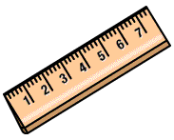
1 Super-sized Nanometer = 1 Inch
- Mark 2 lines on the end of the crepe paper that are 1 inch apart. Label one line “0” and the other line “1 nm” Imagine that the distance between the two lines represents 1 nanometer.
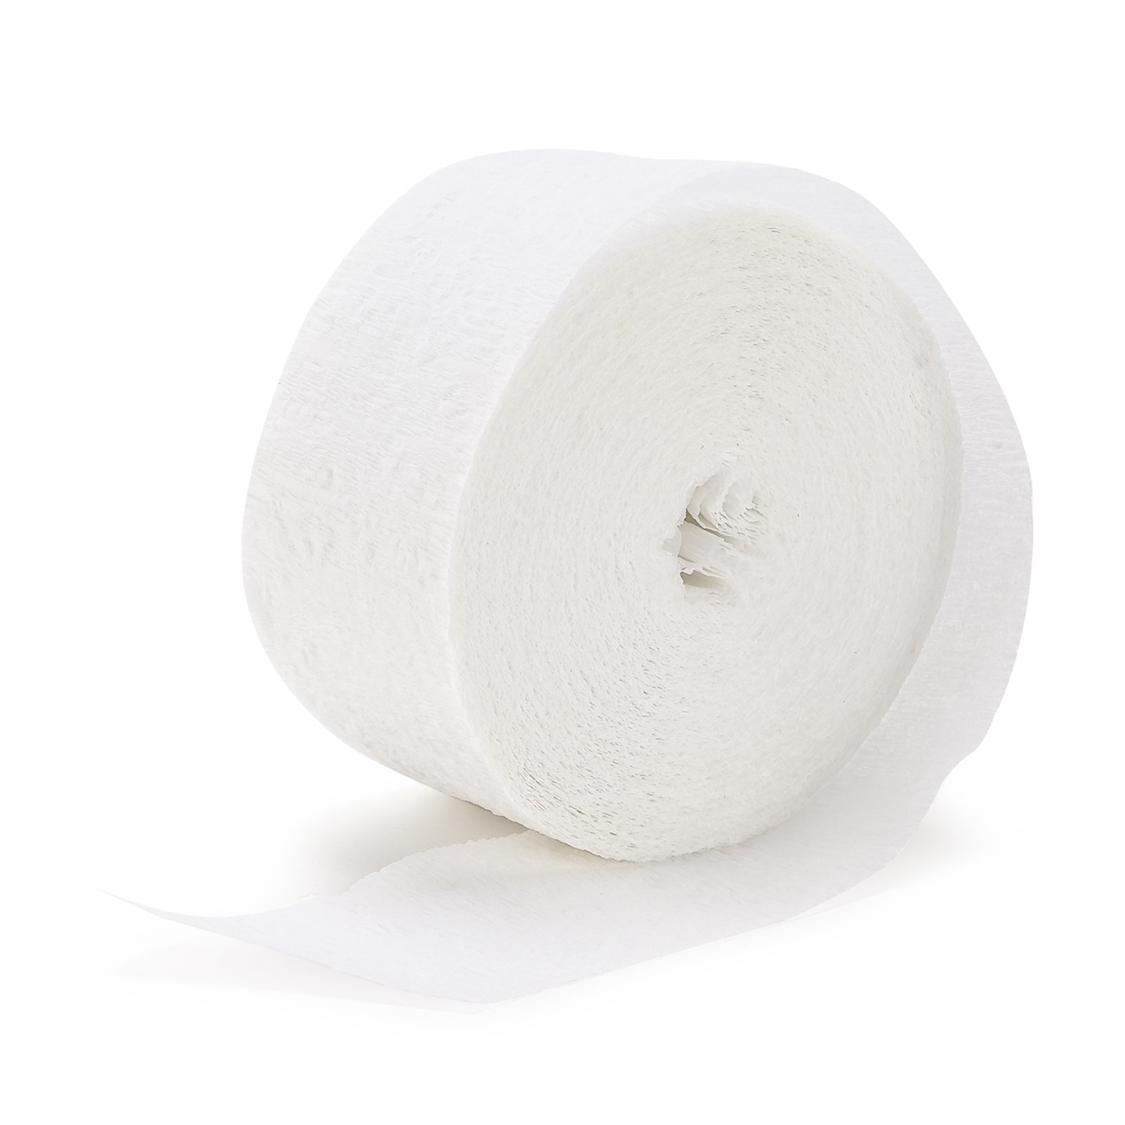
0
1
1 Super-sized Nanometer = 1 Inch

- Draw a third line on the crepe paper in the appropriate location to represent 10 nanometers. Label this line “10 nm.”
- Draw a fourth line on the crepe paper in the appropriate location to represent 100 nanometers. Label this line “100 nm.”
- Draw a fifth line on the crepe paper in the appropriate location to represent 1000 nanometers = 1 micrometer. Label this line “1000 nm or 1 micrometer.”
- How many of your super-sized rulers it would take to represent:
  - 1 millimeter? ___1,000___ super-sized rulers
  - 1 centimeter? ____10,000______ super-sized rulers
  - 1 meter? ______1,000,000____ super-sized rulers
Part 3: Nanoparticles, Cells, and Microscopes

Imagine what it would be like to make a “super-sized” model of a cell using your “super-sized” ruler instead of a real metric ruler.
The table below gives the approximate sizes of some cells and structures in cells in micrometers (µm) and nanometers.

Object | Size in Micrometers (µm) | Size of Object in Nanometers (nm)
Human cell diameter | 25 | 25,000
Cell nucleus diameter (control center of cell) | 5 | 5,000
Bacteria cell length | 2 | 2,000
Mitochondria length (powerhouse of cell) | 2 | 2,000
Ribosome diameter (protein factory in cell) | 0.03 | 30
Cell membrane thickness | 0.08 | 80
Silver nanoparticle diameter | 0.04 | 40

- Think what it would be like to make a “supersized” model of a human cell using your “supersized” ruler. The diameter of the human cell would need to be approximately 25,000 inches or 2083 feet (about 0.4 miles)! That’s a huge model so you don’t really have to make this human cell model. Use your creativity to name an object that you could use to represent each of the following in your model.
If the model of a human cell was 25,000 inches or 2083 feet or 0.4 miles in diameter, then:
- The nucleus (5,000 inches or 416 feet) could be represented by four football fields placed next to each other to form a large square
- The mitochondria (2,000 inches or 166 feet) could be represented by a _____A 16 story building or the width of a football field_______________
- A silver nanoparticle (40 inches or 3.3 feet) could be represented by a ____Student answers will vary—encourage them to share their answers______

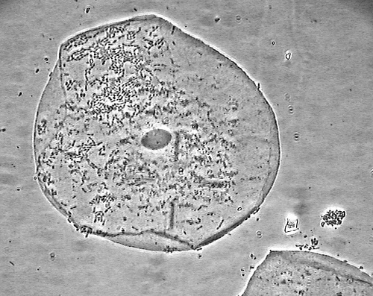
- The compound light microscope photo on the right shows a human cell magnified 1,000 times larger than you can see with your eyes. With a compound light microscope, you cannot see structures that are smaller than about 200 nanometers.

- Which of the objects listed in the table on page 4 would be large enough to be seen with a light microscope?

Human cell
Cell nucleus
Bacteria cell
Mitochondria
Photo credit: www.flickr.com/photos/eaj836/2559021910/
Teacher note: You may wish to discuss the fact that while the cell boundary appears in the photo, the structure of the membrane cannot be observed with a light microscope.
- Which of the objects listed in the table on page 4 would NOT be visible with a light microscope?
Ribosome, Silver nanoparticle, Cell membrane, DNA molecule, Glucose molecule
Teacher note: You may wish to discuss the fact that while the cell boundary appears in the photo, the structure of the membrane cannot be observed with a light microscope.

- An electron microscope can be used to observe tiny structures that are too small to be seen with a light microscope. The photo on the right shows a small part of a cell viewed with an electron microscope. The part of the cell is magnified 100,000 larger than we can see with our eyes. The tiny black dots in this electron microscope image are ribosomes (sites of protein synthesis).
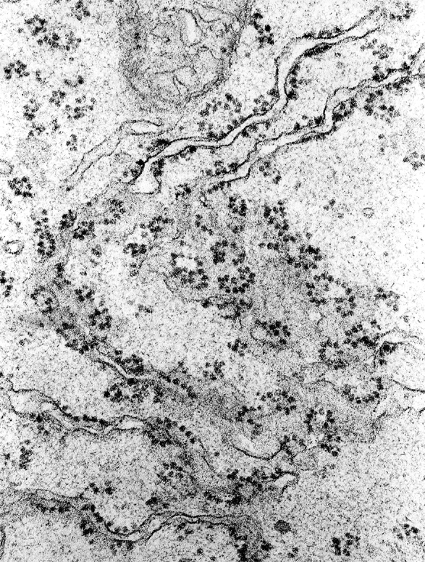

- Draw an appropriately scaled silver nanoparticle on the electron microscope photo on page 5. Explain how you determined how large to make your nanoparticle drawing.

A ribosome is about 30 nanometers and a silver nanoparticle is about 40 nanometers. So students should draw a dot that is a little larger than a ribosome.

- Some scientists are studying the effects of nanoparticles on cells. Why do you think this type of research might be difficult?

It would be very difficult to see nanoparticles because they are so small and because the cell is crowded with many small things.

If you have access to a computer,
- Visit http://learn.genetics.utah.edu/content/begin/cells/scale/ to zoom from objects you can see with the naked eye to the smallest objects in a cell.
- Visit http://www.purestcolloids.com/mesoworld.htm to see an animation that illustrates how magnification changes your view of objects from a pin head to a silver nanoparticle.
- Visit http://micro.magnet.fsu.edu/primer/java/scienceopticsu/powersof10/index.html to view Secret Worlds: The Universe Within

