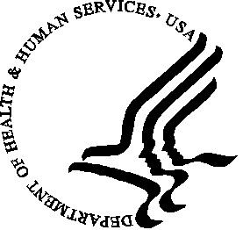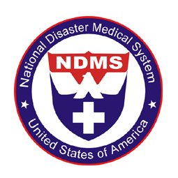
Disaster Medical Assistance Teams
DMAT NY 6
The National Disaster Medical System is a Federal organization that responds to disasters and other events of national interest. NDMS is a department within The Department of Health and Human Services. NDMS works closely with all HHS organizations, the Department of Defense, The Department of Homeland Security, The Federal Emergency Management Administration, The Department of Justice and all other organizations involved in the federal response to a disaster or event of special interest.
NDMS has approved the development of a new Disaster Medical Assistance Team based in central NY. Recruitment for this team includes all areas within 200 miles of Syracuse. This developmental team has been designated DMAT NY 6.
The mission of DMAT NY 6 is medical. Therefore we need to recruit Doctors, Nurses, Physician Assistants, Nurse Practitioners, Respiratory Therapists, Pharmacists, mental health specialists and paramedics. Recruits need to be physically fit and emotionally mature, able to respond to disaster areas, live in austere environment, carry their own equipment and work as a team during all aspects of an assigned mission. Members are intermittent federal employees with salary and coverage appropriate for each position. Deployment to a disaster is voluntary and requires a commitment of up to two weeks. Deployment is an expected responsibility of each member. If a member can’t make one deployment, they may be able to make the next.
In addition to the medical team, each deployment is supported by a command structure organized under the Incident Command System and the National Incident Management System. Training for members related to ICS and NIMS is a requirement for employment and necessary for maintaining an appropriate organizational structure. DMAT’s are uniformed for easy identification and for protection of team members.
If you are interested and feel you meet the requirements please contact the team leadership for more information and to begin the application process.
Joseph Markham, MD, Acting Deputy Commander: Joseph.Markham@hhs.gov
Robert Blair, Administrative Officer: Robert.Blair@hhs.gov

