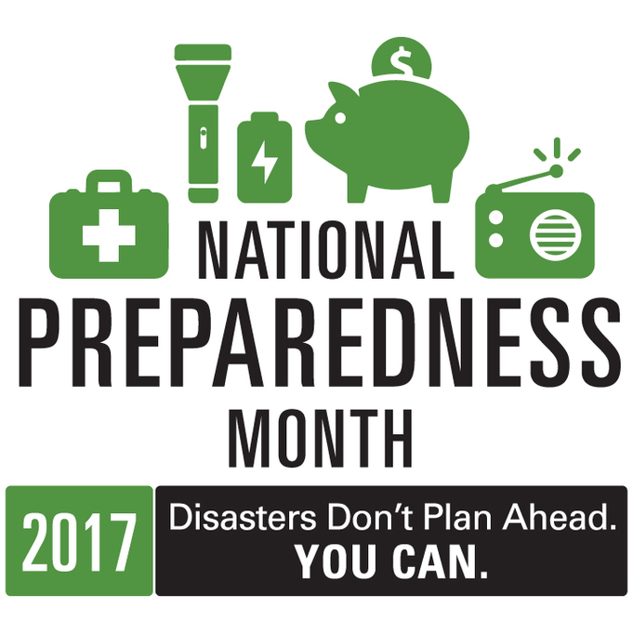

National Preparedness Month Packet
2017
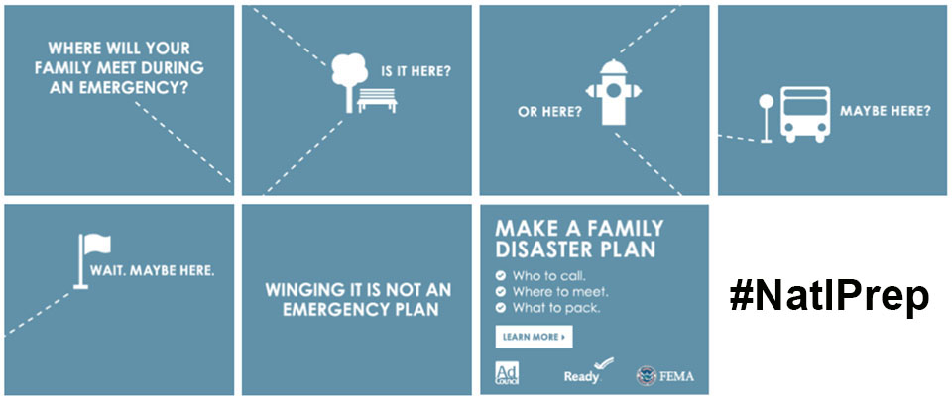

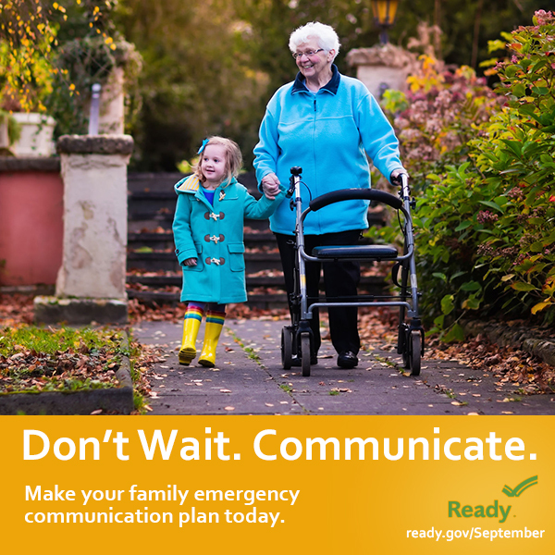

2017 National Preparedness Month Packet

Packet Table of Contents

Week 1- September 1-9 | Preparing Yourself, Family & Friends

Family Preparedness activities center around the how and why of developing a Family Emergency Communications Plan that will allow all members including parents, kids, relatives, and those with special care needs know how to get a hold of one another to assure their safety and well-being, even if usual communications methods, such as cell phone service, is interrupted. How to get Emergency Notifications and Alerts is discussed.

Making an Emergency Communications Plan.
- Attachments/ Tools for agency Staff; and Patients/ Families.
- Sign up for alerts and warnings in your area.
- Check your insurance coverage and review the Document and Insure Property guide.

Week 2: September 10-16| Plan to Help Your Neighbor/ Community
Help your Neighbors and Community. Almost half of Americans plan to rely on their neighbors after a disaster. Learn skills you need to help yourself and others until help can arrive.

- Learn skills you need to help yourself and others until help can arrive.
- Take Until Help Arrives training.
- Check on your neighbors.
- Talk with your Power Company about utility safety.

Week 3: Practice and Build Out your Plans

Practice and Build Your Plans includes building an Emergency Supplies Kit from a Checklist; Safety Tips information; and Special Planning Considerations for those with Functional and Medical Needs.

Be informed, make a plan, build a kit, get involved
- Download the FEMA app for disaster resources, weather alerts, and safety tips

Consider individuals with disabilities or access and functional needs

Safety Tips during a Disaster

Business Preparedness

Practice and Build Your Plans includes building an Emergency Supplies Kit from a Checklist; Safety Tips information; and Special Planning Considerations for those with Functional and Medical Needs.

Business Emergency Supplies (PDF)

Business Emergency Response Plans (PDF)

Tips for Retaining and Caring for Staff after an Emergency (PDF)

Healthcare Ready

Agency Checklist for Implementation

See the Agency Checklist for Implementation for developing your agency focus and tools.

Personalize the packet to the needs of your staff.

Personalize the packet to the needs of your patients.

Packet Tools/ Attachments
- Family Communication Plan for Parents and Kids (PDF)
- Family Emergency Communication Plan wallet card (PDF)

“Know Your Alerts and Warnings” (PDF)

Download the FEMA app (PDF)
- Consider individuals with disabilities or access and functional needs (PDF)
- Emergency Supply Checklist https://www.ready.gov/kit (PDF)
- Roads and Weather Resource Links (PDF)

Business Emergency Supplies (PDF)

Business Emergency Response Plans (PDF)

Tips for Retaining and Caring for Staff after an Emergency (PDF)

Healthcare Personal Plan Sample (PDF)

. 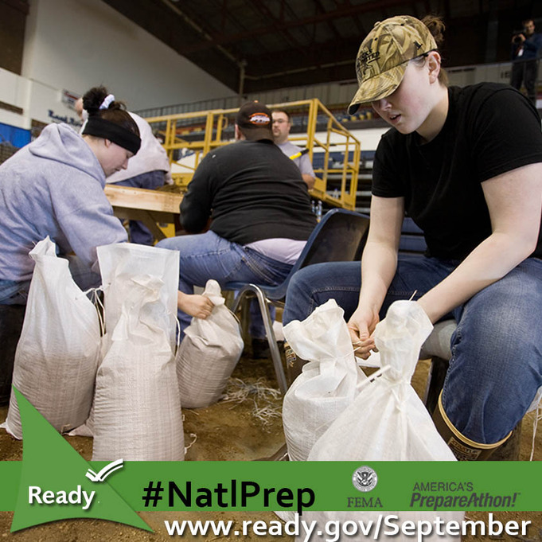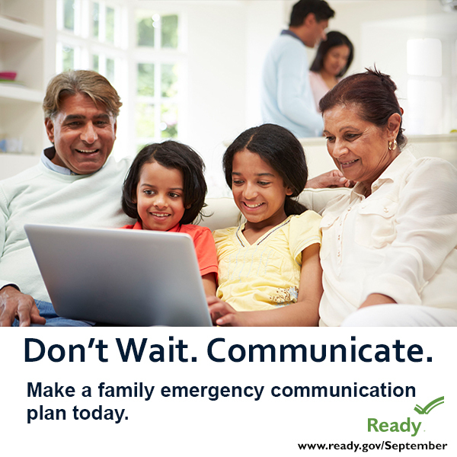

Week 1: September 1-9| Preparing Family & Friends

During this week, agencies can provide their staff with packet materials.
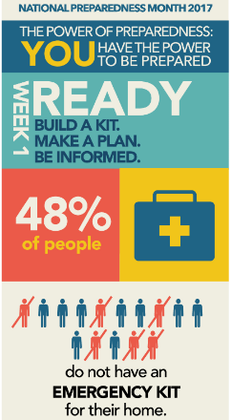

Homecare Staff can discuss Talking Points with their patients during visits, and provide the packet materials for personal/ family use:

- Making a Family/ Personal Emergency Communications Plan
  - https://www.ready.gov/make-a-plan
- Sign up for alerts and warnings in your area.
- Check your insurance coverage and review the Document and Insure Property guide.

Talking Points: Why Make A Plan?
Your family may not be together if a disaster strikes, so it is important to think about the following situations and plan just in case. Consider the following questions when making a plan:
- How will I contact family and friends before, during, and after an emergency;
  - Consider that your entire family may not be together during a disaster.
  - Make a plan of how you will reunite after an emergency.

- How will I prepare for the unique needs of family members?
- How will my family/household get emergency alerts and warnings?
- How will my family/household get to safe locations for relevant emergencies?
- How will my family/household get in touch if cell phone, internet, or landline doesn’t work?
- How will I let loved ones know I am safe?
- How will family/household get to a meeting place after the emergency?

Attachments/ Tools for agency Staff; and Patients/ Families
- Family Communication Plan for Parents and Kids (PDF)
- Family Emergency Communication Plan wallet card (PDF)
    - “Know Your Alerts and Warnings” (PDF); https://www.ready.gov/alerts
- https://www.fema.gov/national-flood-insurance-program #NatlPrep
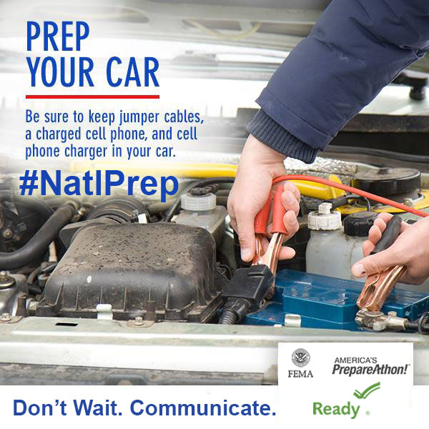

Week 2: September 10-16|Plan to Help your Neighbors/ Community
- Learn skills you need to help yourself and others until help can arrive.
- Take Until Help Arrives training.
- Check on your neighbors.
Talking Points
- Do you know what to do when an emergency happens? Learn the 5 key actions you can take to save a life #UntilHelpArrives here: www.ready.gov/untilhelparrives #NatlPrep
- Almost half of Americans expect to rely on their neighbors after a disaster. Plan today:
www.ready.gov/volunteer #NatlPrep
- Don’t wait until the next emergency to get involved, start today: www.ready.gov/citizen-corps #NatlPrep
- Did you know? @fema's online trainings to help get your community prepared. Take them today:
http://bit.ly/29VKBfU #NatlPrep
- Did you know? In the wake of an emergency, it’s okay to move the injured away from ongoing danger. Learn how you can help #UntilHelpArrives here: Ready.gov/UntilHelpArrives #NatlPrep

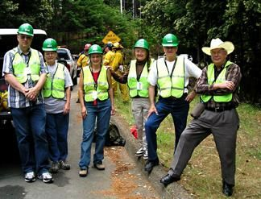

Week 3: September 17-23 | Practice and Build out Your Plans

Talking Points: During this week, activities for staff and patients help to:
- Understand actions they can take to be prepared for emergency.
- Be aware of specific needs they may have if an emergency strikes like: medication, power needs, eye glasses, devices that you may count on, pet needs, etc.
- Understand safety tips and protective actions to take before or during a disaster.
- Know how to access community resources (e.g., shelters, food banks)
- Plan for pets.
Activities
- Be informed, make a plan, build a kit. Everyone can take steps to prepare for an emergency:
  - Build a Kit: Emergency Supply Checklist (PDF)
https://www.ready.gov/kit
- Download the FEMA app (PDF) for disaster resources, weather alerts, and safety tips; https://www.fema.gov/mobile-app
- Consider individuals with disabilities or access and functional needs with planning for emergencies (PDF)
https://www.ready.gov/individuals-access-functional-needs
- Planning for pets (PDF).

Safety Tips during a Disaster
- Know what to do when roads are flooded: "Turn Around Don't Drown®! It may save your life!” #NatlPrep
- If you’re already on “high ground” during a flood, stay where you are. Be prepared by having your supplies already stored. #NatlPrep
- An emergency may knock out power. Prepare by stocking non-perishable food items & water (see “Emergency Supply Checklist”). #NatlPrep
- Don’t risk your family’s safety; follow the instructions of local officials – and if told to evacuate, evacuate! #HurricaneStrong
https://www.ready.gov/evacuating-yourself-and-your-family
https://www.ready.gov/utility-shut-safety

Business Preparedness

https://www.ready.gov/business

Preparedness Planning for Your Business
Businesses can do much to prepare for the impact of the many hazards they face in today’s world including natural hazards like floods, hurricanes, tornadoes, earthquakes and widespread serious illness such as the H1N1 flu virus pandemic. Human-caused hazards include accidents, acts of violence by people and acts of terrorism. Examples of technology-related hazards are the failure or malfunction of systems, equipment or software.
- Get your campus, business, faith-based organization and community organization prepared for an emergency
- Join Weather Ready Nation
- Sign up for Ready Business Workshop

Business Emergency Supplies (PDF)

Business Emergency Response Plans (PDF)

Tips for Retaining and Caring for Staff after an Emergency (PDF)

Healthcare Ready:

About Rx Open
Rx Open helps patients find nearby open pharmacies in areas impacted by disaster. Combining multiple data feeds from the pharmaceutical industry, Rx Open displays the precise location on Google Maps of open pharmacies, closed pharmacies, and those whose status is unknown. This critical information assists government officials in assessing an emergency's impact on public health in a disaster area.

See more at: https://www.healthcareready.org/rxopen#sthash.xUnz2cev.dpuf

Tool for Agency Packet Implementation

Use all or parts of this packet to introduce employees and Homecare patients to the National Preparedness Month key concepts.

You may personalize the packet by choosing the key documents to provide to your staff and/or patients. Check those that apply, and decide if they will be distributed paper, electronic, or both (recommended). The electronic documents can be found at the active links; also on the Finger Lakes Regional Training Center website.

Incentives throughout the weeks, such as drawings and prizes for those who can show their plan or preparedness product are helpful to raise awareness and buy-in.

During Week One, encourage employees to develop a written Family Communications Plan.

The Communications Plan documents are separate attachments available in PDF and some in Word format.

- Family Communication Plan for Parents and Kids (PDF/ Word)
- Family Emergency Communication Plan wallet card (PDF only)

“Know Your Alerts and Warnings” (PDF)

During Week Two, the emphasis is on helping Neighbors/ Community.

During Week Three, the emphasis is on activities to ensure adequate household supplies;

building a personal “Go Kit”; and personal safety tips, especially for those who must be on the road. Information on planning for persons with disabilities and functional medical needs may be appropriate for sharing with Homecare patients as well as staff.
- Emergency Supply Checklist (PDF)

Download the FEMA app (PDF)
- Consider individuals with disabilities or access and functional needs (PDF)
- Roads and Weather Resource Links (PDF)

Business Emergency Planning information may help agencies begin the process of continuity planning. Many tools are available for business continuity planning on the FEMA/ Ready.gov website.

Business Emergency Supplies (PDF)

Business Emergency Response Plans (PDF)

Tips for Retaining and Caring for Staff after an Emergency (PDF)

Healthcare Personal Plan Sample (PDF)

